
GROUND RISK
SNAPSHOT

CF10 1EP
CF10 1EP
OS NGR: 318200 175860

Prepared for: | Magnum GSI
Report Reference: | GEO-6BAD2C38
Date of Issue: | 13 August 2026
Version: | 1.0
Classification: | Indicative — Not for Design
Prepared by: | GeoScreen™ | Magnum GSI Ltd
Prepared by GeoScreen™, an automated reporting platform developed and operated by Magnum GSI Ltd

DOCUMENT CONTROL
Report Title | CF10 1EP – Ground Risk Snapshot (Tier 0)
Client | Magnum GSI
Site Address | CF10 1EP
OS National Grid Reference | 318200 175860
Report Reference | GEO-6BAD2C38
Date of Issue | 13 August 2026
Data Collection Date | 13 August 2026

DISCLAIMER AND SCOPE LIMITATIONS
IMPORTANT NOTICE — PLEASE READ BEFORE USING THIS REPORT
This report has been prepared using GeoScreen™, an automated ground risk screening platform developed and operated by Magnum GSI Ltd.

The report provides an indicative, desk-based assessment of ground conditions and associated constraints based solely on the interrogation and interpretation of publicly available datasets, including but not limited to British Geological Survey (BGS), Natural Resources Wales (NRW), Mining Remediation Authority (MRA), and Cadw data sources.

This report:
• DOES NOT constitute a professional geotechnical assessment or a BS 5930:2015+A1:2020 compliant desk study
• DOES NOT include intrusive ground investigation, site walkover, or statutory searches
• IS informed by general principles derived from relevant UK geotechnical guidance, but does not constitute a desk study compliant with BS 5930:2015+A1:2020
• IS intended solely for early-stage feasibility, due diligence, and preliminary risk screening purposes

The findings presented are indicative only. Site-specific ground conditions may vary and can only be reliably established through an appropriately scoped ground investigation and professional interpretation by a suitably qualified and experienced geotechnical engineer.

1 SITE INFORMATION AND CONTEXT
The site is located at CF10 1EP, within the administrative area of Cardiff Council. The OS National Grid Reference (NGR) is 318200 E, 175860 N. This Ground Risk Snapshot has been prepared in the context of Residential development.

2 DATA SOURCES ASSESSED
The following publicly available datasets were interrogated automatically during preparation of this Ground Risk Snapshot. All data were collected on 13 August 2026.

Data Source | Information Provided
Ordnance Survey (OS) Names API | Geocoding, site location, Local Planning Authority (Appendix A)
BGS 1:625,000 Bedrock Geology WMS | Bedrock geology and formation identification (Appendix B)
BGS 1:625,000 Superficial Deposits WMS | Superficial geology and drift deposits (Appendix C)
BGS Faults OGC API | Fault lines within 1 km of site
BGS SOBI Borehole Database | Proximate borehole records (SOBI)
BGS Radon Potential WMS | Radon potential class and protective measures flag (Appendix H)
Natural Resources Wales (NRW) Flood Map for Planning WMS | Flood Zones 2 and 3 (Appendix D)
NRW Flood Map for Planning (FMfP) — surface water | Surface water flood depth and extent (Appendix L)
NRW Source Protection Zones | Groundwater source protection zone designation (Appendix M)
NRW Authorised and Historic Landfill (DataMapWales WFS) | Landfill sites within 500 m. Contains Natural Resources Wales information © Natural Resources Wales and Database Right. All rights Reserved.
Mining Remediation Authority (MRA) WMS | Coal Mining Reporting Area, mining risk class (Appendix G)
Cadw open data (local dataset) | Listed buildings, scheduled monuments, conservation areas, battlefields, and parks and gardens within 500 m (Appendix E)
Natural Resources Wales (NRW) DataMapWales WFS | SSSIs, SACs, SPAs, Ramsar sites, NNRs, AONBs, and National Parks within 2 km (Appendix F)
BGS 1km Non-Coal Mining Hazard Hex Grid v8 | Non-coal underground mining hazard classification (Appendix G)
OpenStreetMap (local extract, amenity=fuel) | Petrol filling stations within 500 m (Appendix O)
Natural Resources Wales (NRW) / Welsh Government LiDAR DTM (COG, 1m resolution) | Site topography, terrain descriptor, slope analysis (Appendix N)
NRW Environmental Permitting Regulations (EPR) Waste Sites (DataMapWales WFS) + OpenStreetMap fuel forecourts — EPR limited to waste sites (other EPR categories not yet available for Wales) | Environmental permits, registered facilities and flood defence assets within 1 km (Appendix O). EPR portion contains Natural Resources Wales information © Natural Resources Wales and Database Right. All rights Reserved.
GB1900 Historical Gazetteer (CC-BY-SA 4.0, Great Britain Historical GIS / GB1900 partners and volunteers) | Historical map feature and tunnel/subway portal positioning, OS Six-Inch County Series 1888-1913 (Appendix P, Q)
OpenStreetMap (local extract, infrastructure and land-use sites) | Current infrastructure and land-use feature positioning (Appendix P)
OpenStreetMap (local extract, tunnel/subway geometry) | Underground and buried structure positioning (Appendix Q)
NRW Flood Risk Assessment Wales (FRAW) – Rivers/Sea and Surface Water (defended/residual risk) | Defended/residual flood risk, reference only (Appendix R) – does not affect the ratings in the table above

3 GEOHAZARD RISK SUMMARY
The table below summarises the geohazard risk rating and data confidence level for each hazard assessed. The overall ground risk classification for the site is High.

Ref. | Geohazard | Risk Rating | Data Confidence
GH01 | Mining Legacy (Appendix G) | Low | High
GH02 | Compressible Ground | Low | Medium
GH03 | Shrink-Swell Clays | Low | Medium
GH04 | Slope Instability | Low | Low
GH05 | Dissolution Features | Low | Medium
GH06 | Made Ground | Low | Medium
GH07 | River and Coastal Flood Risk (Appendix D) | High | High
GH08 | Surface Water Flood Risk (Appendix L) | High | High
GH09 | Radon (Appendix H) | Low | High
GH10 | Ground Gas | Low | High
GH12 | Aggressive Ground Conditions | Low | Medium
SPZ | Source Protection Zone (Appendix M) | Not identified | High

The overall risk classification reflects the highest-rated hazard, with adjustment where multiple Medium-rated hazards collectively indicate increased development sensitivity at this preliminary screening stage.
Flood-risk ratings are based on the geocoded site point used for this Tier 0 screening. Mapped flood extents may be present within the surrounding area but not at the assessed site location. Where the site boundary is materially larger than the assessed point, flood-zone and surface-water risk should be verified across the full boundary during Tier 1 review.

4 RISK RATING AND CONFIDENCE DEFINITIONS

4.1 Risk Rating Scale
Risk Rating | Description
Very High | A major geohazard has been identified at or close to the site. Development is feasible subject to appropriate mitigation of the identified geotechnical risks and subject to confirmation by intrusive ground investigation.
High | A significant geohazard has been identified that is likely to influence the development. Targeted ground investigation and specialist assessment are recommended.
Medium | A geohazard has been identified that may influence the development. Mitigation measures may be required; targeted investigation is advisable to confirm or refine the rating.
Low | No significant geohazard has been identified from available data at this desk-based stage. No specific mitigation measures are anticipated at this stage, subject to confirmation by ground investigation.

4.2 Data Confidence Level
Confidence Level | Definition
High | Multiple corroborating data sources; data returned successfully with high spatial resolution and dataset coverage at this location.
Medium | Single primary data source; partial data available; some spatial uncertainty or limited dataset coverage. Rating reflects most probable scenario.
Low | Limited data available; API query returned no data or fell back to default. Treat the rating with caution and verify through further investigation.

5 NRW REGISTERED PERMITTED WASTE SITES AND FUEL STATIONS
NRW-registered EPR waste sites and OpenStreetMap fuel stations identified within 1km of the assessed site location (EPR limited to waste sites) are listed below. See Appendix O for mapped locations.
Facility Name | Category / Type | Distance | Direction
Cardiff Arms Salvage | 5 permit activities | 777m | S
Texaco | Active fuel forecourt | 406m | W

GROUND RISK KEY TAKEAWAY
The site is assessed as High geotechnical risk, driven by River and Coastal Flood Risk and Surface Water Flood Risk, both rated High. A GeoScreen Tier 1 Preliminary Ground Risk Screening Report is recommended for detailed geohazard narrative, site investigation recommendations, and a Conceptual Site Model.

6 LIMITATIONS AND LIABILITY STATEMENT
This report has been prepared using GeoScreen™, an automated ground risk screening platform developed and operated by Magnum GSI Ltd, for the sole benefit of the named client, Magnum GSI, for the specific purpose of preliminary, indicative desk-based appraisal of land at CF10 1EP.

The report is based entirely on a desk-based review, drawing upon publicly available information, mapping, and datasets as listed in Section 4. No intrusive investigations, physical site inspection, utilities searches, ecological surveys, or statutory authority searches have been undertaken. Accordingly, actual site conditions may differ materially from those described.

The findings and opinions expressed in this report are indicative and do not constitute a guarantee of planning permission, development feasibility, ground conditions, environmental status, or contamination status. The risks identified are perceived risks based on available information and are not exhaustive. Actual risks can only be assessed through site-specific intrusive investigation and professional interpretation.

This report has been generated using automated, rule-based analysis. AI-assisted interpretation is used solely to generate the short Ground Risk Key Takeaway summary above; all geohazard ratings and other report content are produced by deterministic, rule-based logic, not AI narrative. It does not constitute site-specific advice issued by a Chartered Geotechnical Engineer or other qualified professional, and should be read alongside the limitations set out in this section.

This report has been prepared exclusively for the named client. No responsibility or liability is accepted for reliance placed on this report by any third party — including purchasers, lenders, solicitors, planners, designers, or contractors — without prior written consent.

The information contained herein reflects the state of publicly available data at the time of automated data retrieval on 13 August 2026. No obligation is accepted to update this report for subsequent changes in circumstances, legislation, published datasets, or guidance.

To the fullest extent permitted by law, GeoScreen™ and Magnum GSI Ltd accept no liability for any loss, damage, cost, or expense arising from the use of this report beyond its stated purpose or intended use.

This report should not be relied upon as a substitute for a professional geotechnical desk study prepared and signed off by a Chartered Geotechnical Engineer in accordance with BS 5930:2015+A1:2020, nor for site-specific ground investigation or planning advice.

6.1 Limitations of Automated Assessment
This report has been generated using an automated, algorithm-based system which applies rule-based logic to available digital datasets. AI-assisted interpretation is limited to generating the short Ground Risk Key Takeaway summary from the automated findings.
While reasonable care has been taken in the development and operation of this platform:
• The assessment is inherently probabilistic in nature
• Not all site-specific hazards, anomalies, or constraints may be identified
• The system may not capture localised conditions or site-specific variations that are not represented in underlying datasets
Accordingly, the report should be treated as a screening tool only, and not as a substitute for professional advice.

6.2 Data Sources and Accuracy
All information used in the preparation of this report is obtained from third-party data providers.
Magnum GSI Ltd:
• Does not independently verify the accuracy, completeness, or currency of underlying datasets
• Accepts no responsibility for errors, omissions, or inaccuracies within source data
• Makes no representation that all relevant datasets or constraints have been identified
The report reflects the state of data at the time of retrieval only, and no obligation is accepted to update the report for subsequent changes.

6.3 Reliance and Use
This report is produced solely for the benefit of the named client for the stated purpose.
It:
• Should not be relied upon solely for design, planning submission, construction, or investment decisions without appropriate professional advice and intrusive ground investigation
• Should not be used as a substitute for a professional desk study or geotechnical investigation
• Should only be used as part of a wider risk assessment process
• Must not be altered, redacted, or modified from the version as originally delivered; the version delivered by email and archived by Magnum GSI Ltd constitutes the definitive record
Any decisions taken based on this report are made at the sole risk of the user. This report must not be reproduced, distributed, or relied upon by any party other than the named commissioning client without the prior written consent of Magnum GSI Ltd. This does not prevent the client sharing this report, unmodified, with professional advisers directly engaged on the Site (for example, an architect, planning consultant, lender, or contractor instructed by the client) for purposes connected with that engagement; such sharing does not extend any duty of care to, or permit reliance by, the recipient (see Section 6.5).

6.4 Professional Advice
Outputs generated by GeoScreen™:
• Do not constitute site-specific advice issued by a Chartered Geotechnical Engineer
• Do not replace the requirement for professional input in accordance with BS 5930:2015+A1:2020, Eurocode 7, and PPW Edition 12 requirements
Professional services, including detailed desk studies, ground investigations, and geotechnical design advice, should be commissioned where required.
Where this report is commissioned by or reviewed by a qualified geotechnical engineer or engineering geologist, that professional is responsible for applying independent judgement when interpreting these findings and for meeting their own duty of care when advising clients.

6.5 Liability
Nothing in this Section 6.5 excludes or limits liability for death or personal injury caused by negligence, fraud or fraudulent misrepresentation or any other liability that cannot lawfully be excluded or limited.
To the fullest extent permitted by law:
• Magnum GSI Ltd shall not be liable for any indirect, consequential, or economic loss arising from reliance upon this report, and accepts no liability for any loss, damage, cost, or expense arising from the use of this report beyond its stated purpose or intended use
• No duty of care is owed to any third party, and no reliance may be placed upon this report by any party other than the named client without prior written consent of Magnum GSI Ltd
• The report is provided on an “as is” basis without warranty, express or implied. No warranty is given that all risks, constraints, or site conditions have been identified
Where liability cannot be lawfully excluded, the total liability of Magnum GSI Ltd shall not exceed the cap set out in Clause 12.1 of the Company’s Terms of Service (available at geoscreen.uk) in effect at the date of this report.

APPENDICES
Map extracts are provided for indicative purposes only. All maps are generated from publicly available data sources as listed in Section 4. Users should refer to the original data sources for authoritative information. Scales and extents are approximate.
Appendix A: Site Location Plan
OS base mapping showing site location and surroundings
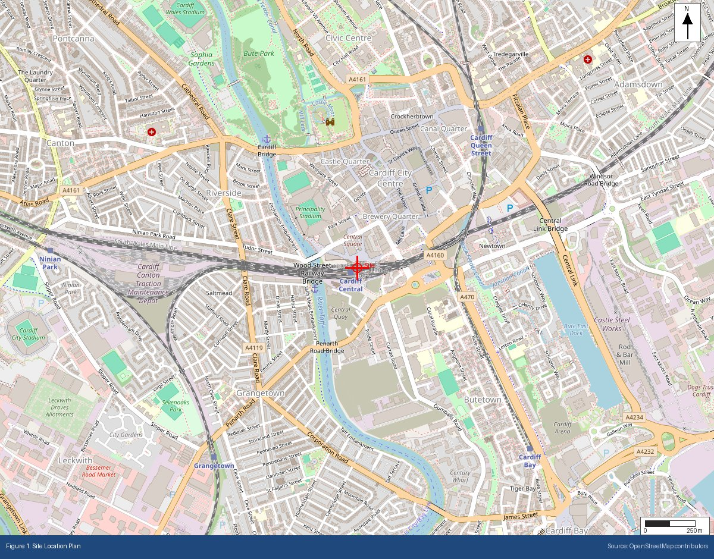

Appendix B: BGS Bedrock Geology Extract
BGS 1:625,000 bedrock geology at site location
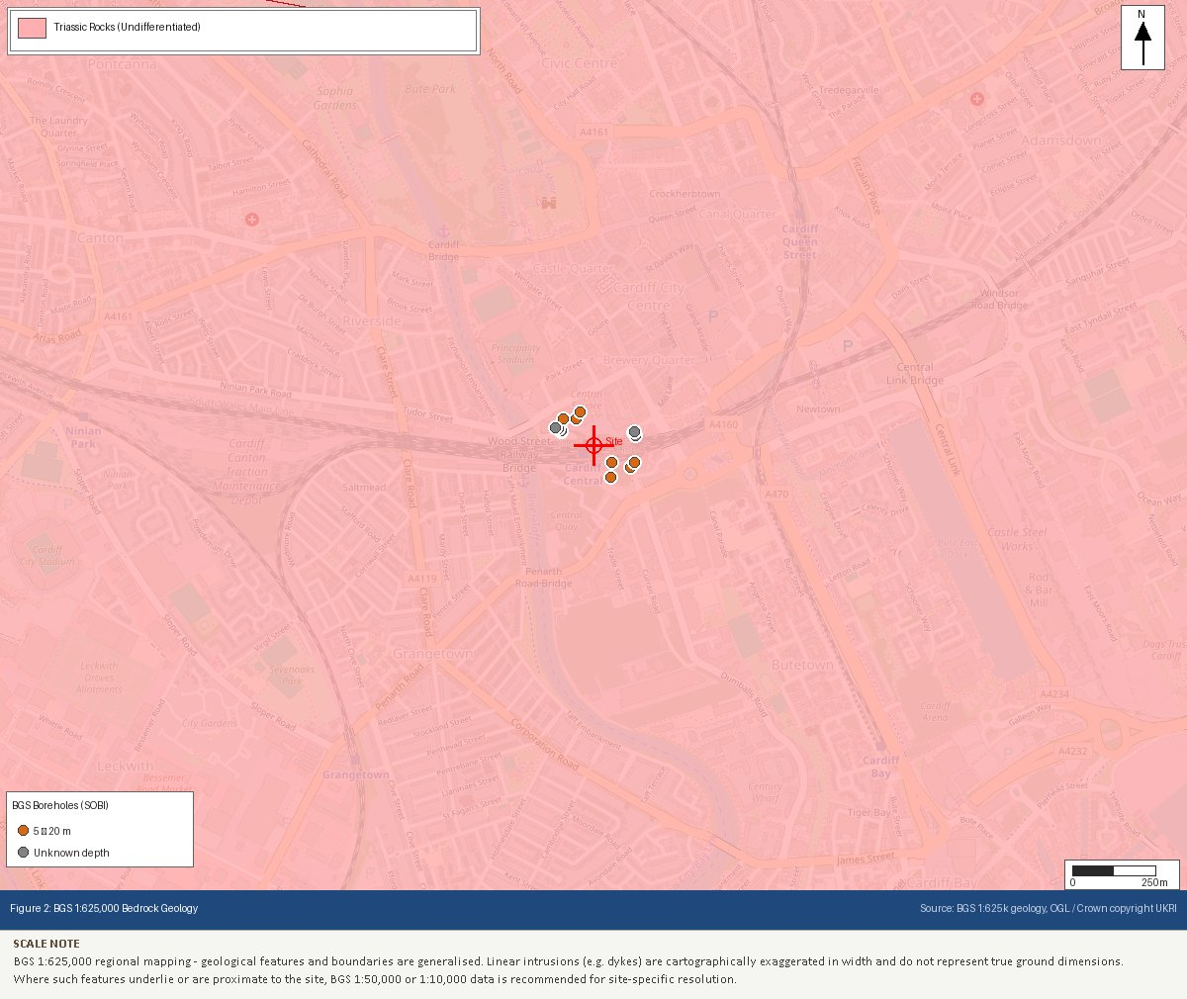

Appendix C: BGS Superficial Geology Extract
BGS 1:625,000 superficial deposits at site location
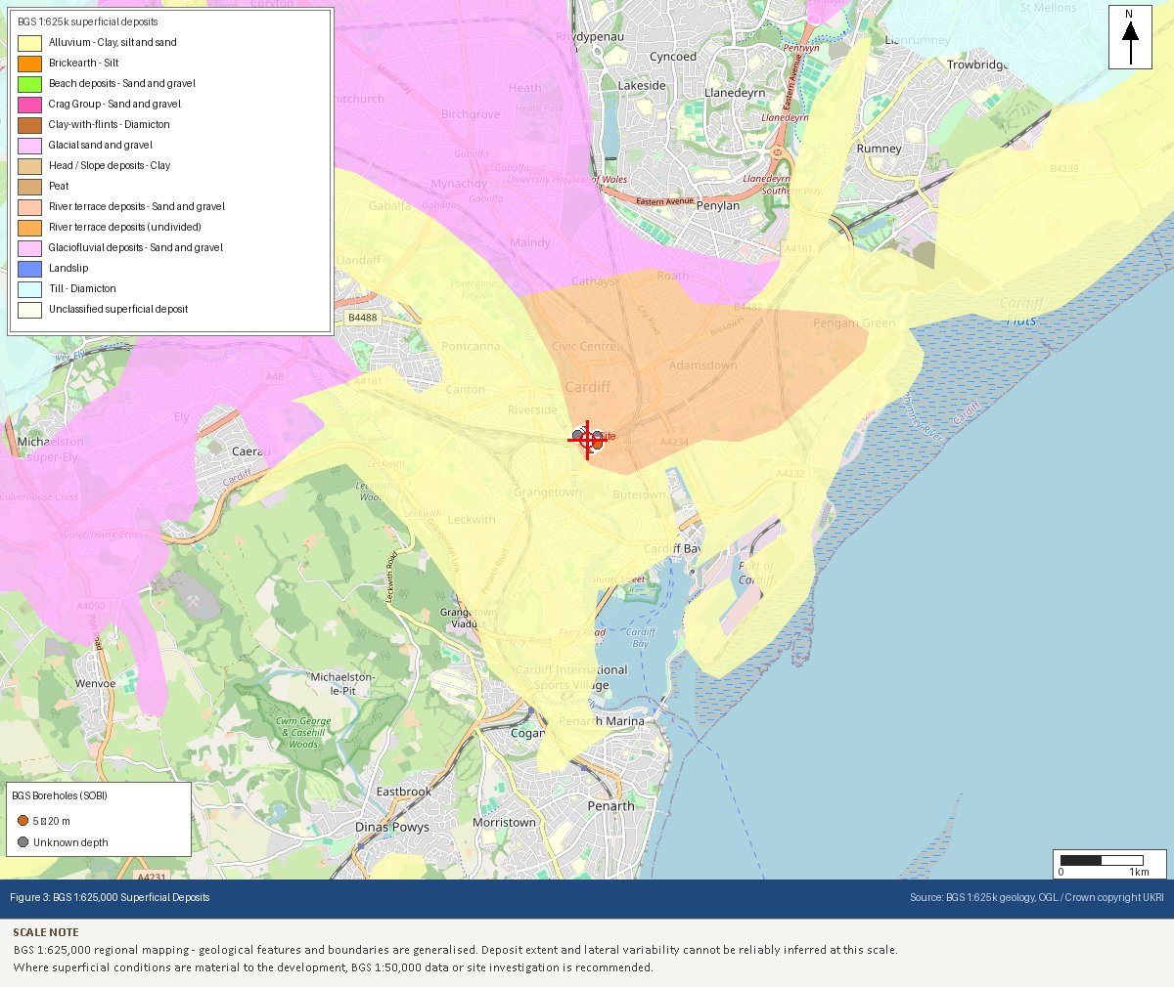

Appendix D: NRW Flood Map for Planning Extract
Natural Resources Wales (NRW) flood zone classification
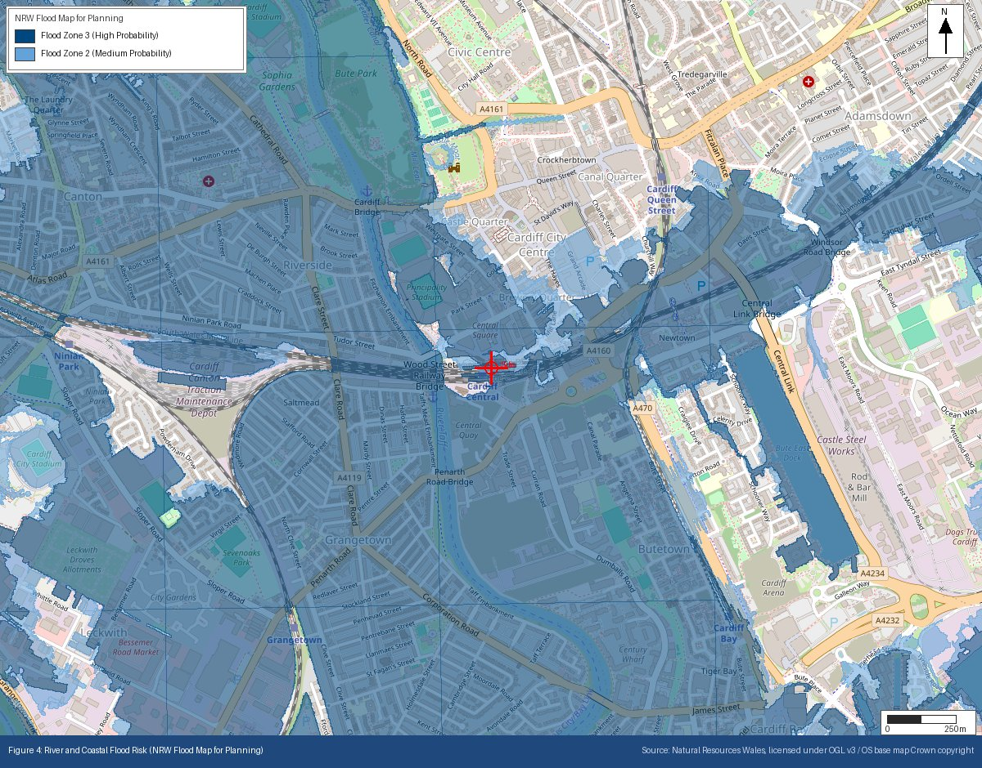

Appendix E: Heritage Designations (Cadw)
Listed buildings, scheduled monuments and conservation areas within 500m
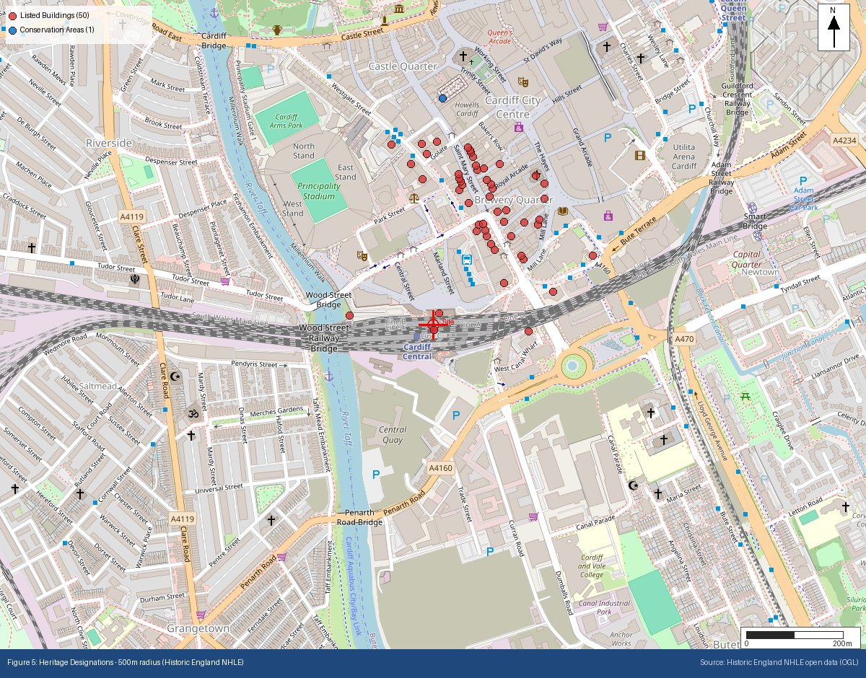

Appendix F: Ecological Designations (Natural Resources Wales (NRW))
SSSI, SAC, SPA, Ramsar, AONB and National Park designations within search radii
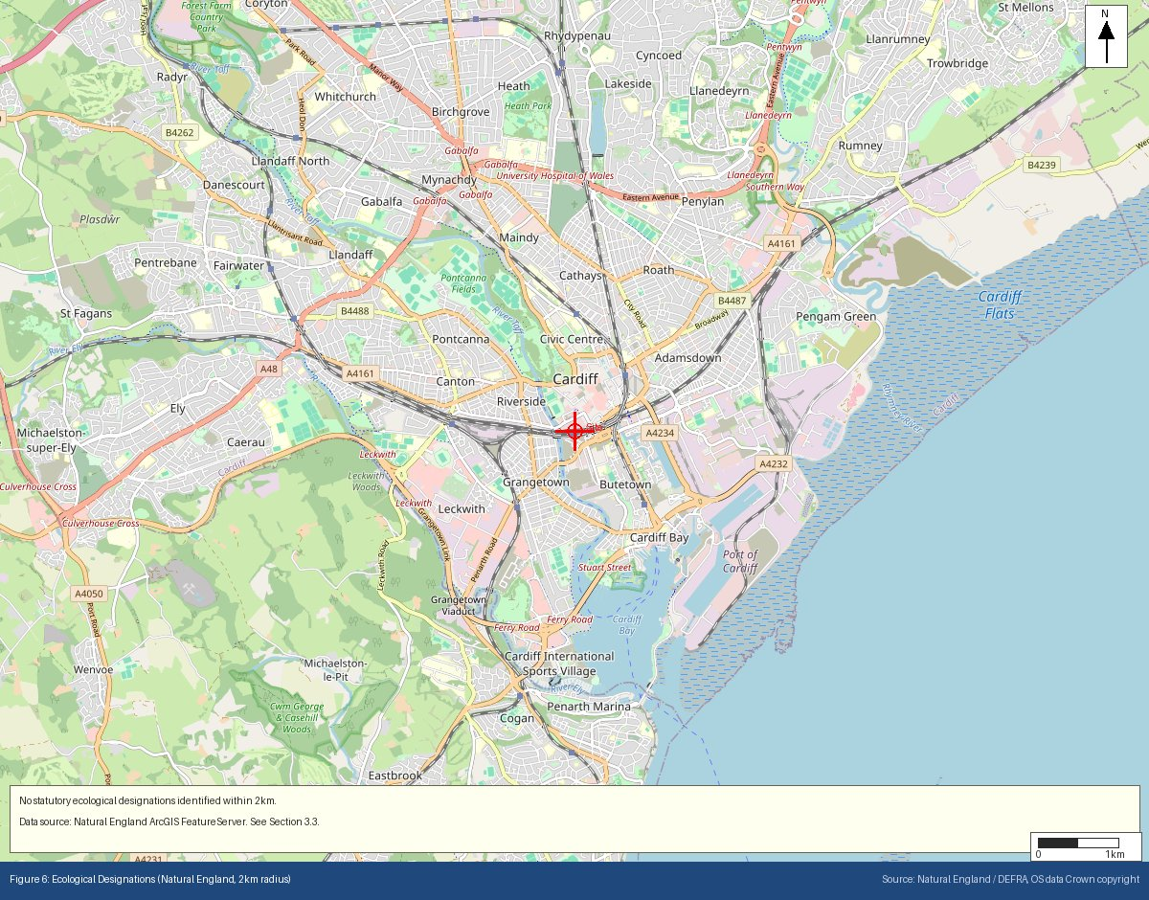

Appendix G: Mining Remediation Authority Output
MRA development risk and mine entries data
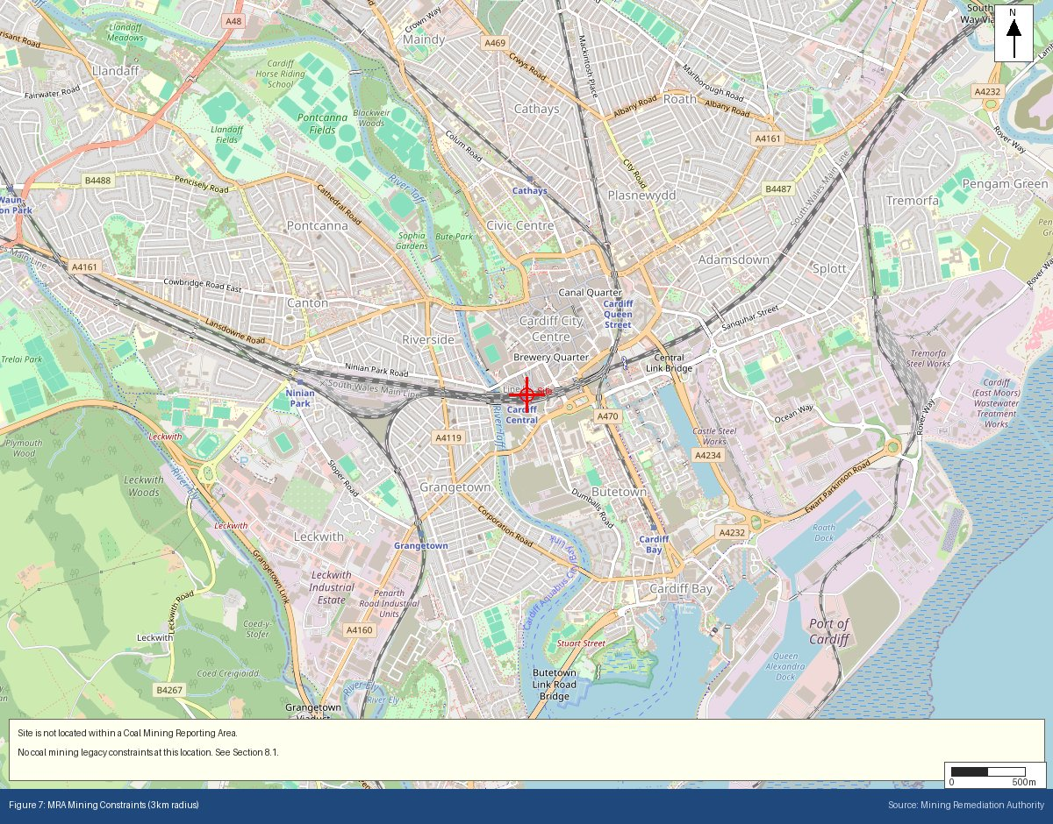

Appendix H: BGS/UKHSA Radon Potential Extract
Radon potential classification at site location
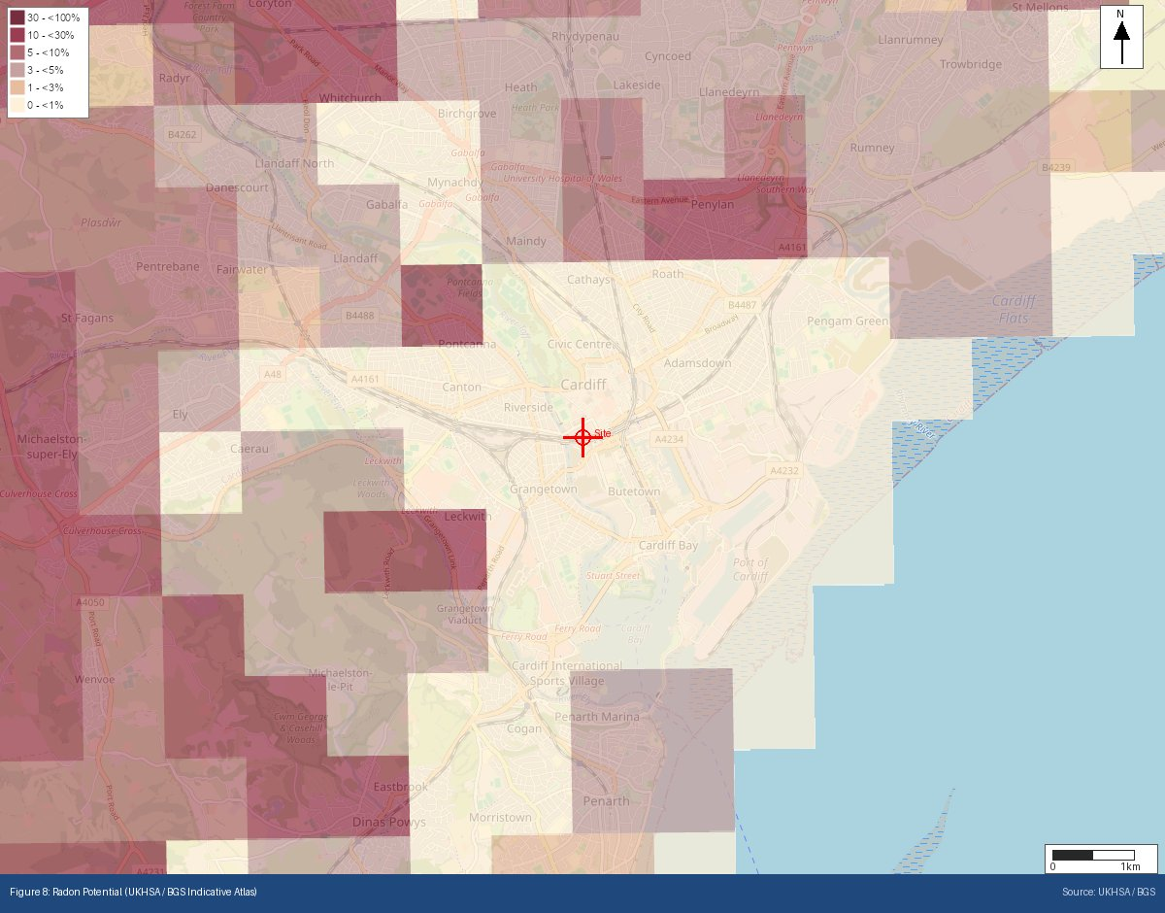
Appendix I: Historical OS Mapping (1885–1903)
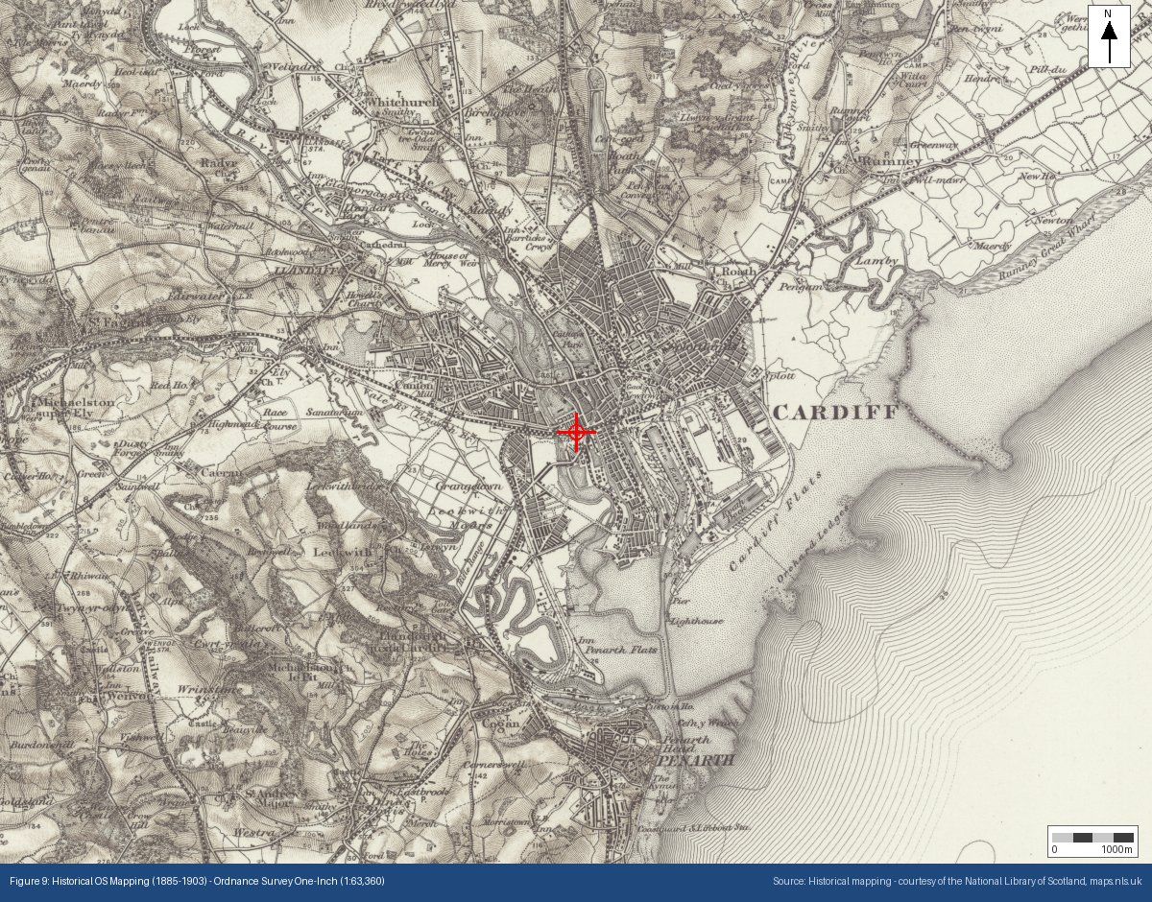

Appendix J: Historical OS Mapping (1888–1913)
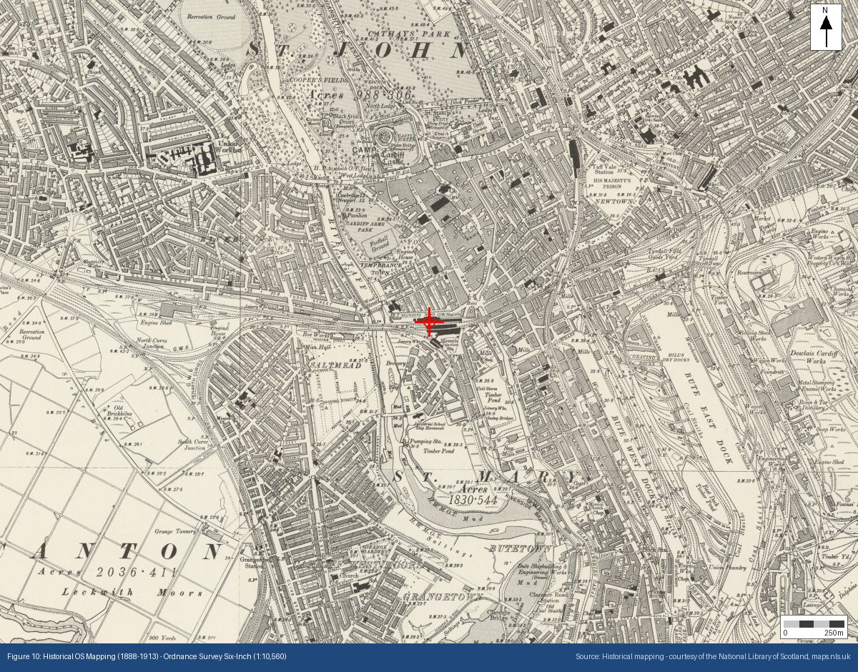

Appendix K: Historical OS Mapping (1919–1947)
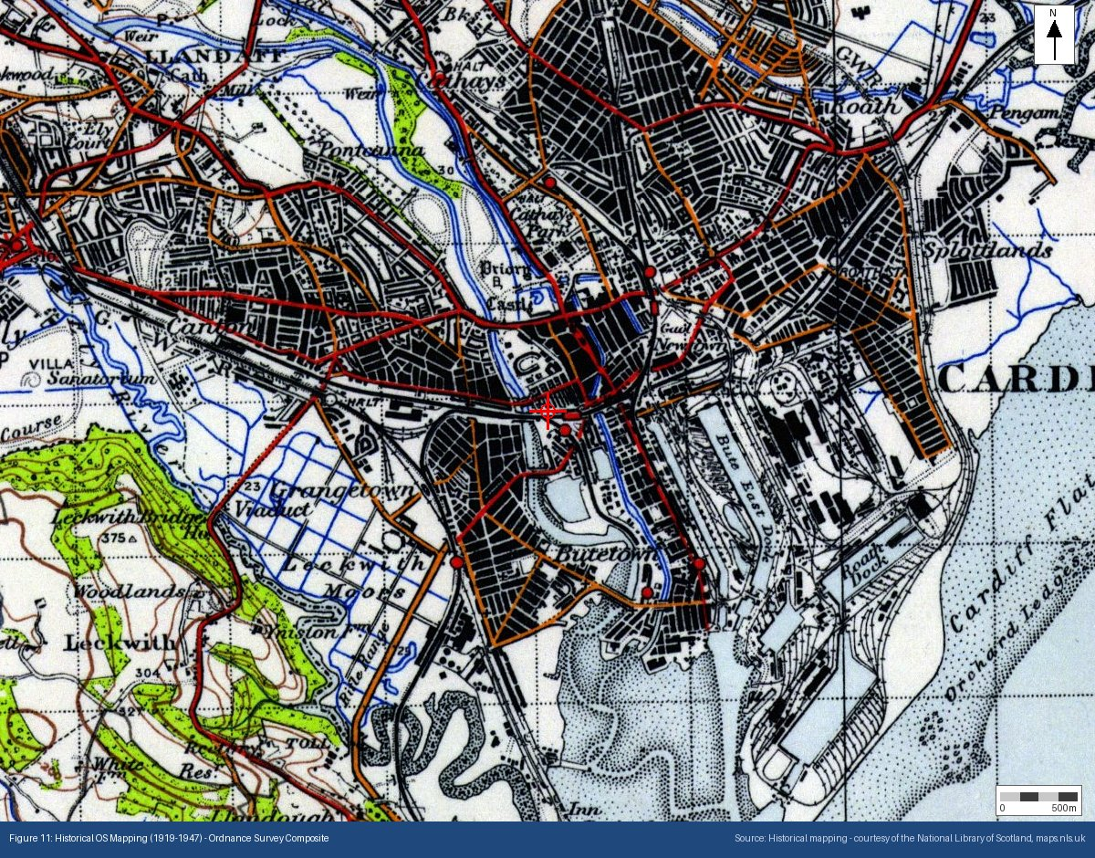

Appendix L: Surface Water Flood Risk (NAFRA2)
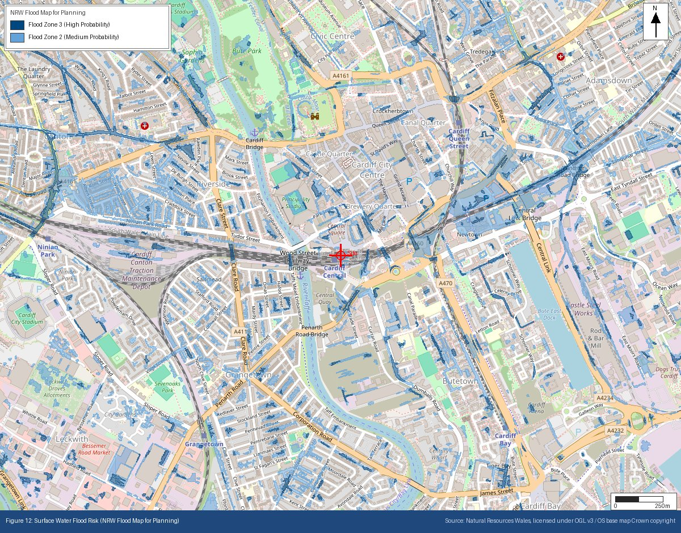
Appendix M: Source Protection Zones (Natural Resources Wales (NRW))
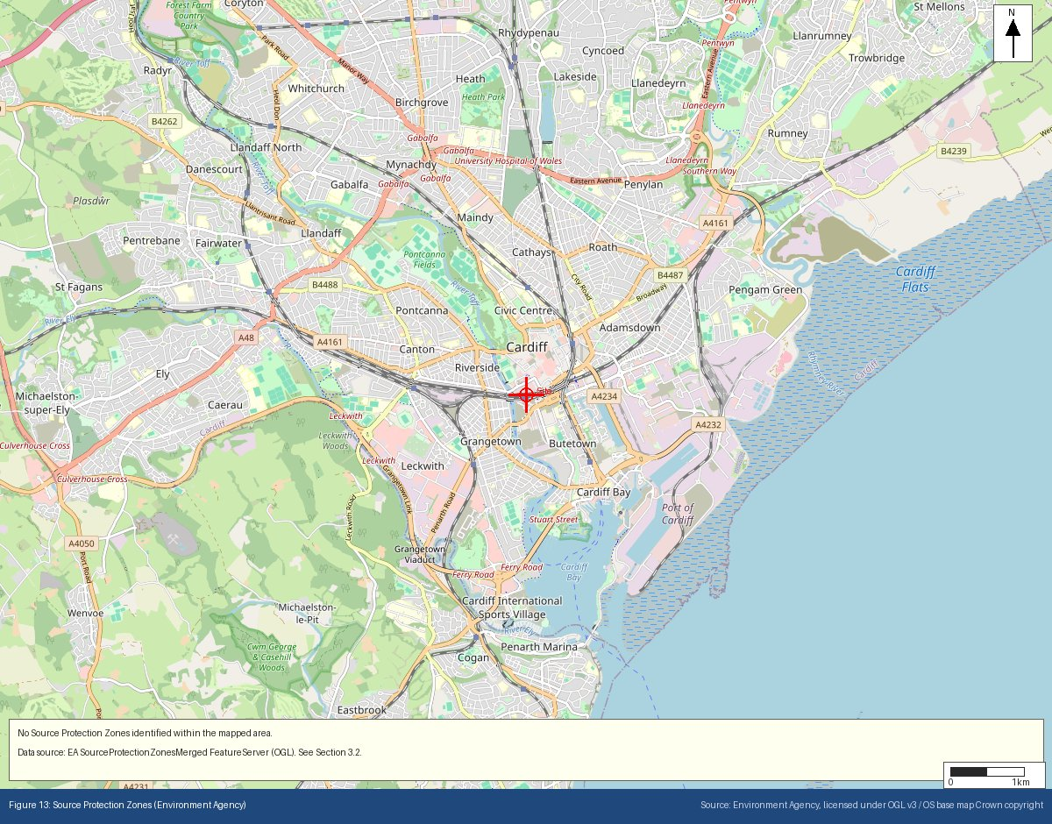
Appendix N: Site Topography — NRW LiDAR Digital Terrain Model
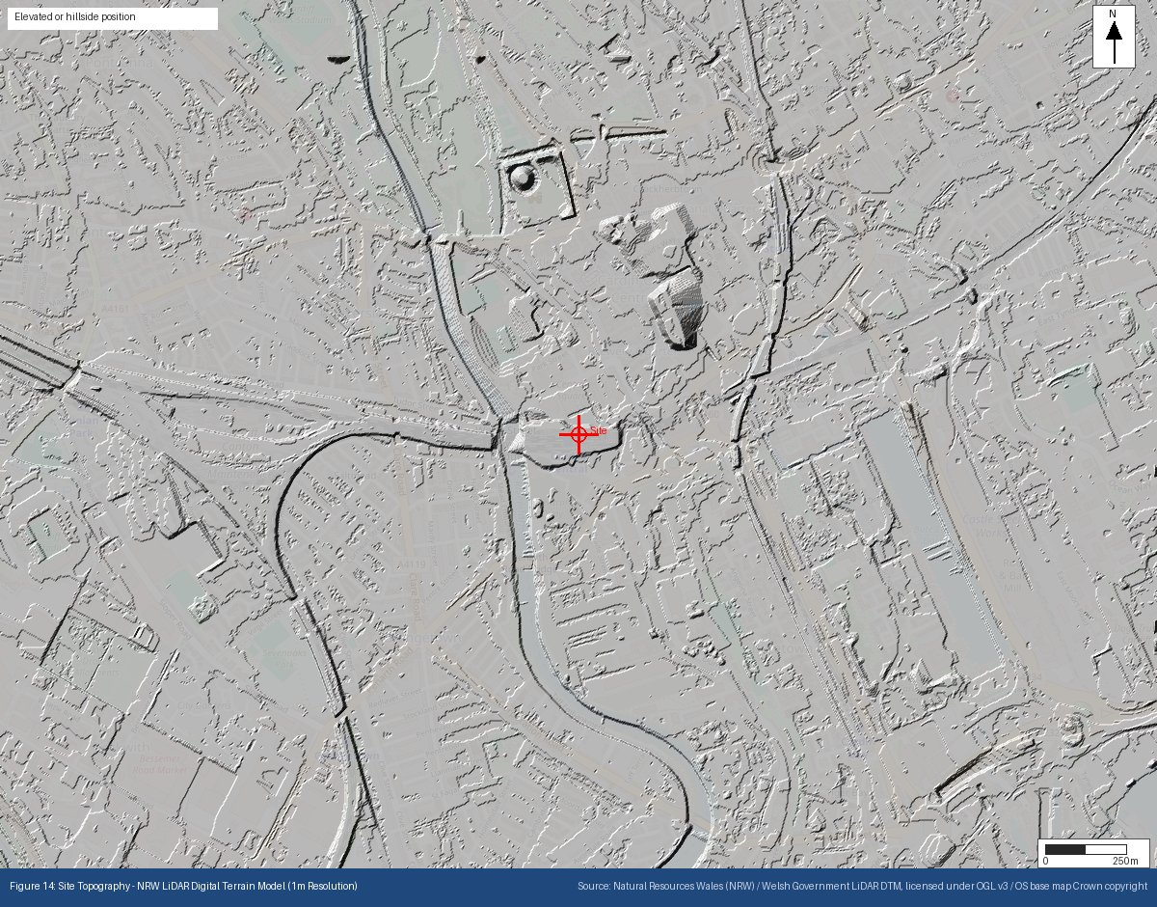
Appendix O: Permitted Regulated Facilities — NRW Environmental Permitting Regulations (EPR) Waste Sites + OpenStreetMap
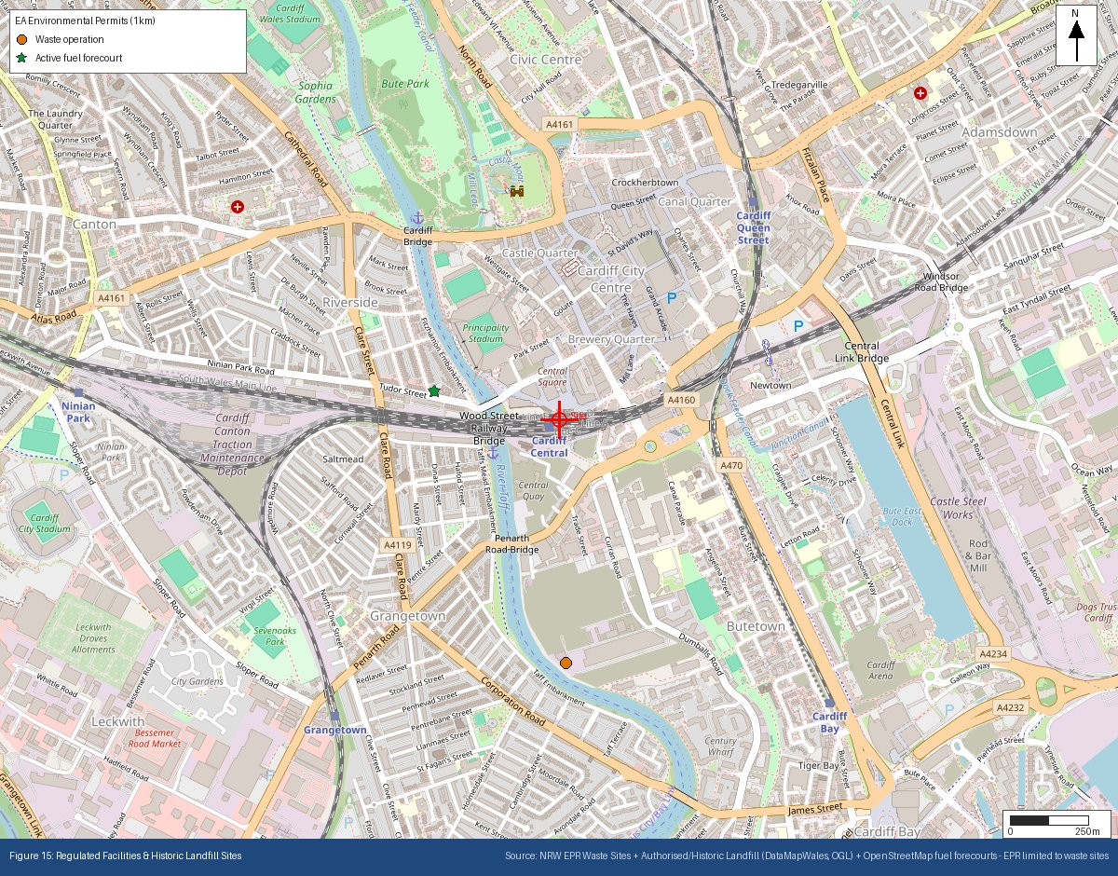
Appendix P: Historical & Current Map Features
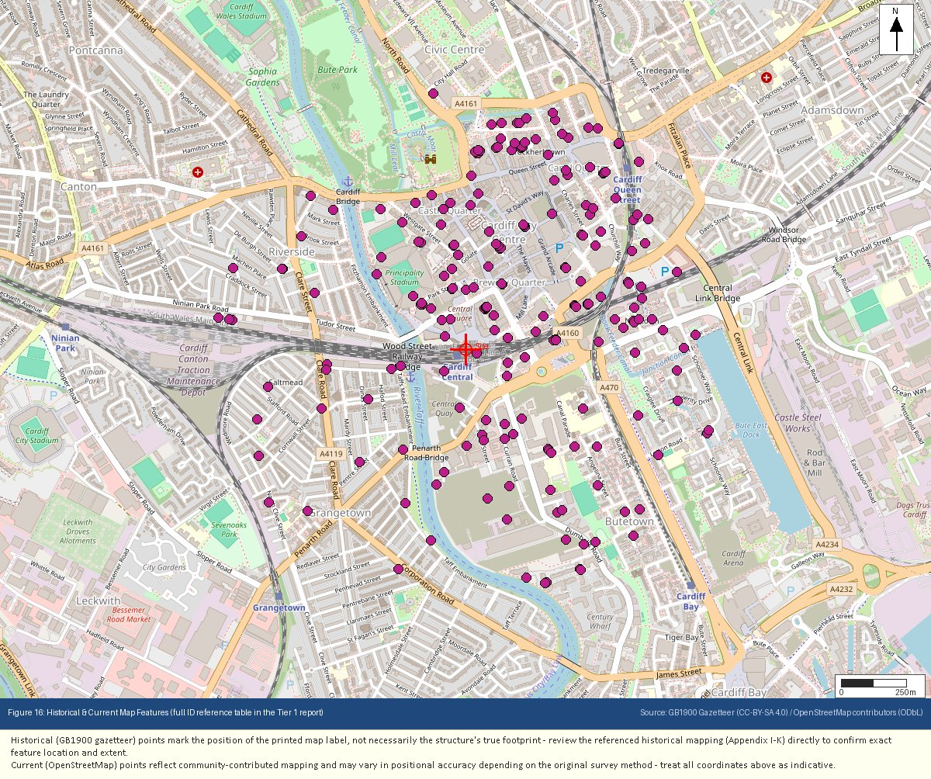
Appendix Q: Underground & Buried Structures
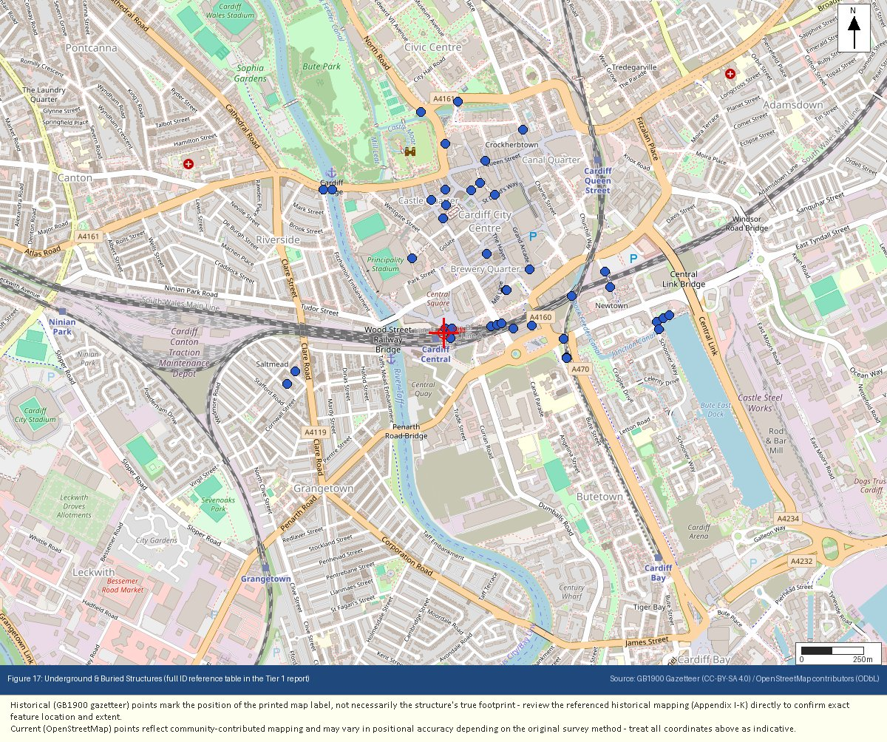
Appendix R: Flood Risk – Reference (Defended / Residual Risk)
