
PRELIMINARY GEOTECHNICAL
GROUND RISK SCREENING REPORT

G1 1XQ
G1 1XQ
OS NGR: 259609 665397

Prepared for: | Magnum GSI
Report Reference: | GEO-2B770983
Date of Issue: | 07 October 2026
Version: | 1.0
Classification: | Indicative — Not for Design
Prepared by: | GeoScreen® | Magnum GSI Ltd
Prepared by GeoScreen®, an automated reporting platform developed and operated by Magnum GSI Ltd

DOCUMENT CONTROL
Report Title | G1 1XQ — Preliminary Ground Risk Screening Report
Client | Magnum GSI
Site Address | G1 1XQ
OS National Grid Reference | 259609 665397
Report Reference | GEO-2B770983
Date of Issue | 07 October 2026
Data Collection Date | 07 October 2026

DISCLAIMER AND SCOPE LIMITATIONS
IMPORTANT NOTICE — PLEASE READ BEFORE USING THIS REPORT
This report has been prepared using GeoScreen®, an automated ground risk screening platform developed and operated by Magnum GSI Ltd.

The report provides an indicative, desk-based assessment of ground conditions and associated constraints based solely on the interrogation and interpretation of publicly available datasets, including but not limited to British Geological Survey (BGS), Scottish Environment Protection Agency (SEPA), Mining Remediation Authority (MRA), Historic Environment Scotland (HES), and NatureScot data sources.

This report:
• DOES NOT constitute a professional geotechnical assessment or a BS 5930:2015+A1:2020 compliant desk study
• DOES NOT include intrusive ground investigation, site walkover, or statutory searches
• IS informed by general principles derived from relevant UK geotechnical guidance, but does not constitute a desk study compliant with BS 5930:2015+A1:2020
• IS intended solely for early-stage feasibility, due diligence, and preliminary risk screening purposes

The findings presented are indicative only. Site-specific ground conditions may vary and can only be reliably established through an appropriately scoped ground investigation and professional interpretation by a suitably qualified and experienced geotechnical engineer.

CONTENTS

Executive Summary
1 Introduction
2 Site Setting
3 Planning Context
4 Sources of Information
5 Site History
6 Geology and Ground Conditions
7 Hydrogeology and Hydrology
8 Geohazard Assessment
9 Foundation and Drainage Considerations
10 Conclusions
11 Recommendations
12 Limitations and Liability Statement

Appendices A–R

EXECUTIVE SUMMARY
Site address | G1 1XQ
Current use | Not confirmed
Proposed development | Residential development
OS Grid Reference | 259609 665397
Local Planning Authority | Glasgow City
Geological setting (bedrock) | Clackmannan Group - Sedimentary Rock Cycles, Clackmannan Group Type (CKN)
Geological setting (superficial) | Raised Marine Deposits (Undifferentiated)
Overall risk rating | High

Key takeaway: The site is assessed as High geotechnical risk, driven primarily by Mining Legacy (see Appendix G), with Surface Water Flood Risk (see Appendix L) as an additional consideration.
Primary constraint:
Significant non-coal underground mining hazard requiring specialist assessment.
Implication:
Potential for ground instability and surface water flooding, with associated implications for design, cost, and programme.
Required next step:
Undertake intrusive ground investigation to characterise ground conditions and assess mining-related risk; commission specialist mining assessment and confirm surface water drainage strategy during detailed design.
Overall risk:
High.
The site at G1 1XQ in Glasgow is proposed for residential development and is underlain by the Clackmannan Group, a sequence of sedimentary rock cycles. The mining hazard arises from non-coal underground workings, which could cause ground movement beneath or near the site and require specialist assessment, although no mine entries were recorded within 1000m. Compressible ground, dissolution features, ground gas, and aggressive ground conditions are secondary considerations requiring verification through intrusive investigation. SEPA mapping shows no river or coastal flood extents at the site, and no statutory ecological designations were identified within the search radii.

Geohazard Overview
Geohazard | Risk Rating | Key Data Source
Mining Legacy | High | Mining Remediation Authority (Appendix G)
Compressible Ground | Medium | BGS 1:625,000 geological mapping (formation analysis)
Shrink-Swell Clays | Low | BGS 1:625,000 geological mapping (formation analysis)
Slope Instability | Low | BGS 1:625,000 geological mapping + Scottish LiDAR DTM
Dissolution Features | Medium | BGS 1:625,000 geological mapping (formation analysis)
Made Ground | Low | BGS Superficial Geology / Address context
River and Coastal Flood Risk | Low | SEPA flood maps - river and coastal (Appendix D)
Surface Water Flood Risk | High | SEPA flood maps - surface water and small watercourses (Appendix L)
Radon | Low | BGS/UKHSA Radon Atlas (Appendix H)
Ground Gas | Medium | SEPA Licensed Landfill + Council Historic Landfill Records (500m)
Aggressive Ground | Medium | BGS Geology / Formation lookup
Public Water Supply Catchment | Not identified | Scottish Water / SEPA water supply catchments (Appendix M)
Note: Geohazard numbering follows the GeoScreen reference scheme. GH11 (Unexploded Ordnance) is not assessed in this Tier 1 report; this hazard will be incorporated in a future GeoScreen platform release.
Recommendations
– Undertake a site walkover, together with a professional BS 5930:2015+A1:2020 desk study and utility searches, to verify ground, drainage, and services conditions before design proceeds.
– Commission a specialist non-coal underground mining hazard assessment, including an MRA coal mining report and review of historic mining records, as this is a significant constraint requiring specialist input before development is progressed.
– Undertake an intrusive ground investigation in accordance with BS 5930:2015+A1:2020 to characterise mine workings and voids, compressible ground, dissolution-related features, ground gas, and aggressive ground conditions.
– Commission a site-specific flood risk and surface water drainage assessment, with SEPA and the planning authority consulted, to address the High surface water flood risk identified.
– Commission a heritage impact assessment, consulting Historic Environment Scotland and the planning authority, to inform design and planning decisions given the high-significance heritage assets identified.
Development Implications
Foundation type: Deeper or engineered foundation solutions are likely to be required in areas affected by mining legacy, subject to structural loading details and ground investigation confirmation, with shallow foundations possibly suitable elsewhere on the site where ground stability can be demonstrated.
Key cost risk: Mining Legacy (High) is the most significant cost risk, as potential voids or unstable ground associated with underground workings could require specialist investigation, stabilisation, or engineered foundation measures.
Planning constraints: A significant non-coal underground mining hazard has been identified, and specialist assessment is required; no European or national ecological designations were recorded within 2km of the site, although the planning authority may request further assessment of this constraint.
Overall suitability: Development is feasible subject to appropriate mitigation of the identified geotechnical risks, principally Mining Legacy, Surface Water Flood Risk, and subject to confirmation by intrusive ground investigation.

1 INTRODUCTION

1.1 Scope and Purpose
This preliminary ground risk screening report has been prepared for Magnum GSI in respect of land at G1 1XQ (hereafter referred to as 'the Site'). The report has been prepared by GeoScreen using automated interrogation of publicly available geotechnical and environmental datasets.
The purpose of this report is to provide a high-level, indicative assessment of the ground conditions, environmental constraints, and planning context relevant to the Site, based solely on a review of publicly available data. The report is intended to support early-stage site appraisal, land acquisition decisions, and pre-planning risk screening, and to inform the scope of any subsequent professional ground investigation or planning submission.
This assessment does not include intrusive ground investigation, physical site walkover, statutory environmental searches, or utilities searches. Accordingly, actual site conditions may differ from those described. A professional desk study prepared by a suitably qualified Chartered Geotechnical Engineer, followed by site-specific ground investigation, is recommended to inform design, planning, and construction decisions.

1.2 Site Details
The Site is located at G1 1XQ. The approximate OS National Grid Reference for the centre of the Site is Easting 259609, Northing 665397.

1.3 Proposed Development
Residential development

1.4 Assessment Methodology
This report has been prepared by automated interrogation of publicly available digital datasets, including those listed in Section 4. Data was collected automatically from each source using the site's OS National Grid Reference as the search point. The findings have been interpreted using AI-assisted interpretation and structured report generation informed by applicable UK standards and guidance.
Each geohazard is assigned a risk rating (Low, Medium, High, or Very High) and a data confidence level. Confidence levels reflect the reliability and completeness of the available data for the assessed geohazard, as defined in Table 2 below.
Table 1 – Geohazard Risk Rating Scale
Risk Rating | Description | Development Implication
Very High | A major geohazard has been identified at or close to the site. The hazard presents a significant constraint to development based on available data. | Comprehensive ground investigation and specialist assessment required. Significant design mitigation or planning constraint is anticipated.
High | A significant geohazard has been identified that is likely to affect the development and requires further investigation. | Targeted ground investigation and specialist assessment required. Design mitigation measures should be anticipated.
Medium | A geohazard has been identified that may influence the development. Further assessment during detailed design is recommended. | Mitigation measures may be required; targeted investigation or specialist assessment is advised.
Low | No significant geohazard has been identified from available data. The hazard is unlikely to materially affect development, subject to confirmation by ground investigation. | No specific mitigation measures are anticipated at this stage; standard design approaches are likely to be suitable.
Table 2 – Data Confidence Levels
Confidence Level | Definition
High | Multiple corroborating data sources; data returned successfully from API; formation or constraint well characterised in national datasets.
Medium | Single primary data source; partial data available; some interpretation assumptions required; formation boundary may be uncertain.
Low | Limited data available; API query returned no data or failed; significant uncertainty in the basis of the assessment.

2 SITE SETTING

2.1 Location and Topography
2.1.1 The site is located at postcode G1 1XQ in the city centre of Glasgow, within the administrative area of Glasgow City Council, and is centred at Ordnance Survey National Grid Reference E259609 N665397 (latitude 55.86124, longitude -4.24469). The site lies within the central urban core of Glasgow, on the north bank of the River Clyde, in the central belt of Scotland. The proposed development comprises a residential development, and this report considers the geotechnical setting appropriate to that use.
2.1.2 The Scottish Public Sector LiDAR Digital Terrain Model indicates that the site occupies sloping terrain. The wider setting is typical of central Glasgow, where the ground rises northwards from the low-lying floodplain of the River Clyde towards the elevated ground of the city's drumlin-influenced northern districts. This regional gradient is a recognised characteristic of the city centre, and the sloping ground at the site is consistent with this broader landscape character. The slope may be relevant to earthworks, drainage design, and foundation levels, and should be considered in any subsequent design development. No specific ground levels are quoted here, as this assessment is based on desk-based review only.
2.1.3 Review of current Ordnance Survey mapping indicates that the site lies within a densely developed urban environment dominated by institutional and civic land uses. The University of Strathclyde campus occupies land on and adjacent to the site, extending to the east and north, with the City of Glasgow College also identified in the immediate vicinity. George Square, a public park and civic open space, lies approximately 360 m to the west. The North Clyde railway line and High Street Station lie approximately 450 m to the east-south-east, and the River Clyde lies more than 1 km to the south. The large institutional campus use on and adjacent to the site is considered to have a potentially direct geotechnical relevance, as phased redevelopment and laboratory or fuel storage legacy may be associated with made ground and localised contamination. Other surrounding features are routine components of the urban setting and are not considered to carry specific geotechnical implications at this stage. This description is based on desk study mapping review only, and no site walkover has been undertaken.

3 PLANNING CONTEXT

3.1 Local Planning Authority
Planning decisions at the Site are made by Glasgow City, which acts as the Local Planning Authority (LPA) for the area.
LPA Name | Glasgow City
Planning portal | https://www.planningportal.co.uk
General enquiries | Contact via LPA website

Note: LPA contact details should be verified directly via the planning portal before submission of any pre-application enquiry or planning application.
3.1.1 The site lies in Scotland, where the national planning policy framework is National Planning Framework 4 (NPF4, February 2023), which forms part of the statutory development plan alongside the Glasgow City Local Development Plan. Based on the desk-based data reviewed, several NPF4 policies are directly triggered. Policy 7 (Historic assets and places) applies because 50 listed buildings and one conservation area lie within 500m of the site. Policy 9 (Brownfield, vacant and derelict land and empty buildings) applies because the site is identified as subject to a significant non-coal underground mining hazard, and land known or suspected to be unstable or contaminated must be shown to be safe and suitable for the proposed residential use.
3.1.2 Based on the data reviewed, the Local Planning Authority may require, subject to confirmation, a range of technical documents as part of the planning process. These may include a Heritage Impact Assessment addressing the nearby listed buildings and conservation area, and a professional desk study followed by an intrusive ground investigation with specialist assessment of the non-coal underground mining hazard, to demonstrate that the land is safe and suitable for residential use. Consultation with Historic Environment Scotland may also be appropriate. These requirements are indicative and desk-based only, and pre-application guidance should be confirmed directly with Glasgow City Council.

3.2 Heritage Designations
3.2.1 Review of Historic Environment Scotland (HES) designations data indicated that 50 listed buildings lie within 500m of the site, comprising 9 Category A, 38 Category B, and 3 Category C structures. One conservation area, the Central Area, was recorded within the same search radius. No scheduled monuments, Inventory gardens and designed landscapes, or Inventory historic battlefields were identified within 500m, and no World Heritage Sites were recorded within 5km. The data confidence for this review is High. HES covers designated heritage assets only; undesignated features of local or archaeological interest are not captured by this review, and the findings are desk-based and indicative.
3.2.2 The proposed residential development lies within an area of dense designated heritage interest, and heritage considerations are likely to be a material factor in the planning process. NPF4 Policy 7 (Historic assets and places) requires development proposals affecting listed buildings, conservation areas, or their settings to protect and, where possible, enhance their special character, with the Historic Environment Policy for Scotland (HEPS) providing the supporting framework. The Planning (Listed Buildings and Conservation Areas) (Scotland) Act 1997 places statutory duties on planning authorities to have special regard to the desirability of preserving listed buildings and their settings, and to pay special attention to preserving or enhancing the character and appearance of conservation areas. Historic Environment Scotland is consulted on proposals likely to affect nationally important assets, including Category A listed buildings and their settings. Given the number of listed buildings and the presence of the Central Area Conservation Area, a Heritage Impact Assessment is likely to be required to inform the planning authority's consideration of the proposals. Early engagement with the planning authority is recommended to confirm the scope of any assessment needed.
3.2.3 Nine Category A listed buildings, which are of national or international importance, were identified within the search radius. Those recorded by name include 98 Ingram Street, the University of Strathclyde, the Ramshorn Theatre, the former St Paul's and St David's Church (Church of Scotland) with its churchyard and boundary railings, 145-195 (odd numbers) Albion Street, 20-40 (even numbers) Cochrane Street, 20 John Street with 233-235 (odd numbers) George Street, and the Extension to the City Chambers together with the Paired Screen Archways over John Street. The setting of these assets, together with the character of the Central Area Conservation Area, is likely to be sensitive to the scale, massing, materials, and construction methods of new development. In addition to visual and settings considerations, groundworks, excavation, and construction-phase vibration in close proximity to historic structures may require specific control measures, which should be considered during detailed design. This review covers designated assets only, and the extent of any impact would need to be assessed on the basis of the final design proposals.

3.3 Ecological Designations
3.3.1 Statutory ecological designation data were reviewed using NatureScot and Scottish Government datasets, covering Sites of Special Scientific Interest, Special Areas of Conservation, Special Protection Areas, Ramsar sites, National Nature Reserves, National Scenic Areas, and National Parks within a 2km search radius of the site. No such designations were identified within this radius. The data confidence for this review is high. This review covers statutory designated sites only; protected species, non-statutory habitats, and Biodiversity Net Gain considerations were not assessed.
3.3.2 No statutory ecological designations were identified within the search radii at this desk-based stage. This does not preclude the presence of protected species, habitats, or other ecological sensitivities not assessed by this review; an ecological appraisal may be required at planning stage. For the proposed residential development, the relevant statutory framework comprises the Conservation (Natural Habitats, &c.) Regulations 1994, the Nature Conservation (Scotland) Act 2004, and NPF4 Policy 4 (Natural places), which together require proposals to protect biodiversity and avoid unacceptable impacts on natural heritage interests. As no European sites (SAC, SPA, or Ramsar) were identified within 2km, Habitats Regulations Appraisal screening is not indicated on the basis of this desk-based review. Early consultation with the planning authority is nevertheless recommended to confirm whether any further ecological survey work will be required to support the proposed development.

4 SOURCES OF INFORMATION

4.1 Data Sources Consulted
All data was collected automatically on 07 October 2026 using the site's National Grid Reference as the search point.
Table 3 — Data Sources Consulted
# | Data Source | Provider | Purpose
DS01 | BGS 1:625,000 Bedrock Geology | British Geological Survey | Bedrock geology  (Appendix B)
DS02 | BGS 1:625,000 Superficial Deposits | British Geological Survey | Superficial deposits  (Appendix C)
DS03 | BGS 1:625,000 Formation Analysis | British Geological Survey | Formation-based ground stability assessment (GH02-GH05)
DS04 | BGS Borehole Index (SOBI) | British Geological Survey | Historical borehole records
DS05 | BGS 1:625,000 Geological Faults (OGC API) | British Geological Survey | Major geological fault lines (structural context and figure overlay)
DS06 | SEPA flood maps | Scottish Environment Protection Agency (SEPA) (OGL v3) | Flood likelihood classification (Appendix D)
DS07 | BGS Mining Hazard (Non-Coal) 1km Hex Grid v8 | British Geological Survey / UKRI | Non-coal mining hazard (vein minerals, chalk, evaporites, building stone)
DS08 | Mining Remediation Authority open data: Development High/Low Risk Areas and Mine Entries | Mining Remediation Authority (OGL v3). Contains Mining Remediation Authority information © Mining Remediation Authority, 2026 | Mining legacy (Appendix G)
DS09 | NLS Historical OS Mapping (via MapTiler Cloud) | National Library of Scotland | Historical OS mapping c.1885, 1888–1913 and 1919–1947 (Figs 9–11) (Appendix I-K)
DS10 | Historic Environment Scotland designations (local dataset; World Heritage Sites and Inventories queried live) | Historic Environment Scotland (OGL v3) - Contains Historic Environment Scotland data © Historic Environment Scotland | Heritage designations (listed buildings, scheduled monuments, WHS, conservation areas)  (Appendix E)
DS11 | NatureScot and Scottish Government (ArcGIS REST) | NatureScot (OGL v3); Scottish Government (OGL v3) - © Scottish Government | Ecological designations (SSSI, SAC, SPA, Ramsar, National Scenic Areas, National Parks) (Appendix F)
DS12 | BGS/UKHSA Radon Indicative Atlas | BGS / UKHSA | Radon potential (Appendix H)
DS14 | OS Names API | Ordnance Survey | Geocoding and LPA lookup (Appendix A)
DS15 | SEPA Licensed Landfill Sites (SEPA granted authorisations) | Scottish Environment Protection Agency (SEPA) (OGL v3) | Ground gas / landfill proximity (500m buffer). Data reflects SEPA and council records at the time this report was generated and may be subject to change (e.g. new or updated permits).
DS16 | Council Historic Landfill Records (where published; e.g. City of Edinburgh Council) | City of Edinburgh Council; Improvement Service (Spatial Hub Scotland) - council-held records (OGL v3). Copyright City of Edinburgh Council, contains Ordnance Survey data © Crown copyright and database right (2026). Contains OS data © Crown copyright and database right 2026 and Scottish local authority data from the Spatial Hub. | Ground gas / landfill proximity (500m buffer). Data reflects SEPA and council records at the time this report was generated and may be subject to change (e.g. new or updated permits). Council historic landfill records are published by only a minority of Scottish councils; where a council publishes none, the search covers SEPA-licensed landfill sites only, so historic or closed landfill sites may be present that are not recorded.
DS17 | BGS GeoIndex Hydrogeology (ArcGIS REST identify) | British Geological Survey | BGS aquifer productivity (Scotland has no aquifer designations; groundwater lies within a SEPA DWPA)
DS18 | Scottish Water Water Supply Catchments and SEPA Drinking Water Protected Area catchments | Scottish Water; Scottish Environment Protection Agency (SEPA) (OGL v3) | Groundwater source protection zone designation (S3 planning context / S7 hydrogeology) (Appendix M)
DS19 | SEPA flood maps - surface water and small watercourses | Scottish Environment Protection Agency (SEPA) (OGL v3) | Pluvial / surface water flood risk (GH08 geohazard)  (Appendix L)
DS20 | SEPA water body classification - rivers, lochs, estuaries and coastal waters (ArcGIS REST) | Scottish Environment Protection Agency (SEPA) (OGL v3) | Named receiving watercourse identification (S7 hydrogeology)
DS21 | OpenStreetMap (local extract, amenity=fuel) | OpenStreetMap contributors (ODbL) | Petrol filling stations within 500m (S5 site history / CSM)
DS22 | Scottish Public Sector LiDAR - DTM tiles (0.25-1m, AWS Open Data) | Scottish Government (OGL v3) - Contains public sector information licensed under the Open Government Licence v3.0 | Site topography, terrain descriptor, slope analysis (S2 site setting, Figure 14 Appendix N)
DS23 | SEPA Granted Authorisations (permits: waste, PPC, radioactive substances and water discharges; ArcGIS REST) + OpenStreetMap fuel forecourts | Scottish Environment Protection Agency (SEPA) (OGL v3) | Environmental permits, registered facilities and flood defence assets within 1km (S5.3, Figure 15 Appendix O). Data reflects SEPA and council records at the time this report was generated and may be subject to change (e.g. new or updated permits).
DS24 | OpenStreetMap (local extract) — infrastructure and land-use sites | OpenStreetMap contributors (ODbL) | Gas holders, sewage/water works, sub-stations, power stations, emergency services, military, aviation, port, quarry and industrial sites within 1km (S5 Historical Features table, Figure 16 Appendix P / S8 CSM sources)
DS25 | Historical Map Feature Positioning (derived from GB1900 Gazetteer, abridged) | Great Britain Historical GIS / GB1900 partners and volunteers (CC-BY-SA 4.0, creativecommons.org/licenses/by-sa/4.0/legalcode) | Historical map feature position (distance/bearing derived from GB1900 gazetteer label coordinates, OS Six-Inch County Series 1888-1913) for S5 Historical Features table, Figure 16 Appendix P
DS26 | OpenStreetMap (local extract) — tunnel, subway and underground structure geometry | OpenStreetMap contributors (ODbL) | Tunnel, subway and underground structure entry/midpoint/exit points within 1km (S5.2 Underground and Buried Structures table, Figure 17 Appendix Q)
DS27 | SEPA Future Flood Maps – River, Coastal and Surface Water (Medium likelihood with climate change) | Scottish Environment Protection Agency (SEPA) (OGL v3) | Flood extent with climate change shown for reference only in Figure 18 (Appendix R) – does not affect the GH07/GH08 ratings above

5 SITE HISTORY

5.1 Historical Land Use Review
A limited AI-assisted historical mapping review has been undertaken using Ordnance Survey mapping from three historical epochs (c.—1885, c.—1888–1913, and c.—1919–1947), accessed via the National Library of Scotland (NLS). Historical mapping provides indicative information regarding former land uses, structures, watercourses, and potential ground disturbance not evident from current mapping. Key features identified are summarised in Table 4 below. See Appendix P for mapped locations.
The AI-assisted review included in this report is indicative only and has not been verified by a competent professional. It does not constitute a formal historical land use survey. Where a more detailed professional historical mapping review is required — for example to confirm made ground extent and inform design and planning decisions — this should be commissioned as part of a professional desk study or Tier 2/3 report service.
5.1.1 Historical mapping was reviewed for the site at G1 1XQ (E259609 N665397) using National Library of Scotland (NLS) Ordnance Survey (OS) mapping accessed via MapTiler Cloud. The mapping comprised the OS Six-Inch series (1:10,560, 1888-1913), the OS One-Inch series (1:63,360, 1885-1903), and the OS Composite series (1919-1947, various scales). The maps are provided as figures in Appendix I (1888-1913), Appendix J (1885-1903), and Appendix K (1919-1947). Post-war Ordnance Survey mapping (post-1947) has not been reviewed as part of this assessment.
5.1.2 Historical mapping indicates that the site and its surroundings lay within a densely developed commercial and industrial urban core, with closely packed warehouses and works suggesting made ground of considerable depth and historic basements. Railway sidings and a goods yard lay approximately 300-600m to the south-east, and institutional uses, including a prison, an infirmary, and a fever hospital, lay to the east and north. Canal-related features lay at the north-eastern margin of the study area. These uses suggest potential for made ground, infilled structures, and localised contamination relevant to residential development.
5.1.3 This is an automated assessment. The maps have been analysed by AI but not verified by a qualified engineer, and a thorough manual review by a geotechnical professional is recommended as part of a BS 5930-compliant desk study. The six-inch mapping (1888-1913) provides the highest spatial resolution for site-specific interpretation. Post-war Ordnance Survey mapping (post-1947) has not been reviewed, as it requires a licence from a commercial data supplier and falls outside the scope of this automated desk study. Current OS 1:25,000 mapping has been checked for references to former, old, and disused land uses; however, historical land uses that were active after 1947 and have subsequently been cleared may not be identifiable from current mapping and could therefore be missed by this assessment. A detailed review of post-war mapping should be undertaken as part of a detailed desk study prepared in accordance with BS 5930, ahead of any intrusive ground investigation.
Table 4 — Historical and Current Map Features of Note (indicative — AI-assisted review of NLS/OS mapping and OpenStreetMap data; requires professional verification)
ID | Feature / Land Use | Type | Proximity to Site | Grid Ref | Map Period | Geotechnical Note
001 | Dense commercial/industrial warehousing (Merchant City) | Industrial | On site |  | Six-inch OS 1888-1913; OS Composite 1919-1947 | Densely developed urban area with closely packed warehouses and works; likely made ground of considerable depth, historic basements and potential general contamination.
002 | Higher education campus (University of Strathclyde / City of Glasgow College) | Institutional | On site |  | Current (OS mapping) | Large institutional campus; potential for laboratory chemical storage legacy, fuel tanks and made ground from phased redevelopment.
003 | Church (Ch.) | Structure | ~100m |  | Six-inch OS 1888-1913 | Church with associated grounds; possible historic burial ground and made ground/foundations.
004 | Industrial Works (Dennistoun area) | Industrial | ~151m N | E259631 N665547 | Six-inch OS 1888-1913 | Works labelled on the historical map at the tile margin; potential ground contamination and made ground. Located near the 1km study boundary.
005 | General Post Office (G.P.O.) | Public Services | ~350m |  | Six-inch OS 1888-1913 | Post office/sorting facility; potential fuel storage and vehicle servicing legacy.
006 | Public Park / Garden (George Square) | Other | ~360m W | E259253 N665411 | Current (OS mapping) | Open space within the urban core; may overlie made ground and old foundations.
007 | Post Depot / Sorting Office (Merchant City Post Office) | Public Services | ~398m SW | E259321 N665121 | Current (OpenStreetMap data) | Vehicle fleet fuel storage — potential hydrocarbon contamination.
008 | Electricity Sub-Station (Candleriggs South No 1) | Utility | ~423m S | E259503 N664986 | Current (OpenStreetMap data) | Electrical infrastructure — potential historic oil-based contamination from transformer equipment.
009 | Electricity Sub-Station (Candleriggs South No 2) | Utility | ~445m S | E259497 N664965 | Current (OpenStreetMap data) | Electrical infrastructure — potential historic oil-based contamination from transformer equipment.
010 | Railway cutting / lines (North Clyde line) (High Street Station / North Clyde Line) | Railway | ~450m |  | Current (OS mapping) | Operational railway corridor with cuttings and embankments; potential for made ground and settlement/stability constraints on adjacent development.
011 | Her Majesty's Prison | Institutional | ~530m ESE | E260118 N665260 | Six-inch OS 1888-1913 | Large institutional site east of the site, adjacent to the Cathedral/Necropolis area; historic institutional use with potential made ground and former below-ground structures. Not labelled on the later 1919-1947 map.
012 | Electricity Sub-Station | Utility | ~554m W | E259055 N665352 | Current (OpenStreetMap data) | Electrical infrastructure — potential historic oil-based contamination from transformer equipment.
013 | Railway goods yard / sidings (High Street area) (City (goods station)) | Railway | ~300–600m SE |  | Six-inch OS 1888-1913; One-inch OS 1885-1903; OS Composite 1919-1947 | Extensive railway sidings and goods yard; potential made ground and contamination from fuel, oils, ash and cinders.
014 | Infirmary | Institutional | ~650m ENE | E260202 N665670 | Six-inch OS 1888-1913 | Hospital/infirmary use; potential for made ground, fuel storage tanks and clinical or chemical waste legacy.
015 | Post Depot / Sorting Office (Glasgow Post Office) | Public Services | ~657m NW | E259031 N665712 | Current (OpenStreetMap data) | Vehicle fleet fuel storage — potential hydrocarbon contamination.
016 | Electricity Sub-Station (Charlotte Street Substation) | Utility | ~691m SE | E259887 N664761 | Current (OpenStreetMap data) | Electrical infrastructure — potential historic oil-based contamination from transformer equipment.
017 | Police Station | Public Services | ~698m S | E259603 N664697 | Current (OpenStreetMap data) | Vehicle fleet fuel/maintenance storage — potential hydrocarbon contamination.
018 | Post Depot / Sorting Office (Mail Boxes Etc.) | Public Services | ~699m W | E258919 N665521 | Current (OpenStreetMap data) | Vehicle fleet fuel storage — potential hydrocarbon contamination.
019 | Electricity Sub-Station | Utility | ~713m S | E259440 N664702 | Current (OpenStreetMap data) | Electrical infrastructure — potential historic oil-based contamination from transformer equipment.
020 | Electricity Sub-Station | Utility | ~739m SW | E259275 N664736 | Current (OpenStreetMap data) | Electrical infrastructure — potential historic oil-based contamination from transformer equipment.
021 | Fever Hospital | Institutional | ~790m NNE | E259895 N666137 | Six-inch OS 1888-1913 | Institutional hospital site labelled on the historical map; potential basement structures, underground tanks and former institutional infrastructure.
022 | Police Station (British Transport Police) | Public Services | ~806m NW | E259115 N666035 | Current (OpenStreetMap data) | Vehicle fleet fuel/maintenance storage — potential hydrocarbon contamination.
023 | Fire Station (Calton Community Fire Station) | Public Services | ~833m SE | E260154 N664762 | Current (OpenStreetMap data) | Historic firefighting foam (AFFF/PFAS) and fuel storage — recognised persistent contamination source.
024 | Electricity Sub-Station | Utility | ~857m SE | E260391 N665038 | Current (OpenStreetMap data) | Electrical infrastructure — potential historic oil-based contamination from transformer equipment.
025 | Drill Hall | Military | ~880m S | E259719 N664523 | Six-inch OS 1888-1913 | Military drill hall; potential made ground and ordnance-related storage. Located near the 1km study boundary.
026 | Electricity Sub-Station (Bath Street 87) | Utility | ~881m W | E258778 N665697 | Current (OpenStreetMap data) | Electrical infrastructure — potential historic oil-based contamination from transformer equipment.
027 | Canal Basin (St. Rollox Basin) | Water | ~890m NNE | E260014 N666189 | Six-inch OS 1888-1913 | Canal basin with associated wharves; potential made ground from basin construction and bulk cargo spillage. Located near the 1km study boundary.
028 | Electricity Sub-Station (Morrisons (Gallowgate)) | Utility | ~896m SE | E260251 N664767 | Current (OpenStreetMap data) | Electrical infrastructure — potential historic oil-based contamination from transformer equipment.
029 | Cathedral and Necropolis (Cathedral / Necropolis) | Structure | ~600–900m E |  | Six-inch OS 1888-1913; OS Composite 1919-1947 | Elevated burial ground with extensive contouring and steep slopes to the east; potential for slope instability and disturbed ground.
030 | Police Station (British Transport Police) | Public Services | ~906m W | E258720 N665208 | Current (OpenStreetMap data) | Vehicle fleet fuel/maintenance storage — potential hydrocarbon contamination.
031 | Electricity Sub-Station (30 Jamaica St) | Utility | ~926m SW | E258791 N664958 | Current (OpenStreetMap data) | Electrical infrastructure — potential historic oil-based contamination from transformer equipment.
032 | Monkland Canal / watercourse | Water | ~950m |  | Six-inch OS 1888-1913 | Canal/water channel at NE margin of study area; potential infilled sections, soft ground and made ground.
Note: entries above showing an approximate distance with no compass direction and no Grid Ref are based solely on AI-assisted interpretation of historical map imagery, with no independent positional cross-check available (e.g. from the GB1900 historical gazetteer or OS/OpenStreetMap current mapping) for these specific features. No coordinate can be provided for these entries — only an approximate distance radius — due to reduced positional reliability, and they are not plotted on Figure 16 (Appendix P). These entries should be verified against the referenced source mapping (Appendix I-K) by a qualified person before being relied upon.

5.2 Underground and Buried Structures
Tunnels, subway lines, and underground passages within 1000m of the site have been identified from historical Ordnance Survey mapping (1888–1913, via the GB1900 gazetteer) and current OpenStreetMap data. Reported positions represent surveyed historical portal locations or, for current infrastructure, entry, midpoint and exit points sampled from the mapped route — indicative of a structure’s presence and approximate alignment only, not a precise underground survey.
This is a partial dataset: the absence of a feature here does not indicate the absence of underground structures at or near the site. It does not capture all historical tunnels, privately-held structures, or utility and service tunnel infrastructure, which requires a dedicated utility search. Key features identified are summarised in Table 5 below. See Appendix Q for mapped locations.
Table 5 — Underground and Buried Structures (indicative — derived from GB1900 historical gazetteer and OpenStreetMap current mapping; entry/exit/midpoint point data, not a precise underground survey)
ID | Structure / Name | Type | Proximity to Site | Grid Ref | Source | Note
001 | Road Tunnel | Buried Structure | ~33m E | E259642 N665401 | Current (OpenStreetMap data) | Current buried structure identified via OpenStreetMap tunnel tagging — potential for made ground, voids, or design constraints near its route; exact alignment, depth, and construction not confirmed by this desk-based review.
002 | Rail Tunnel (North Clyde Line) | Buried Structure | ~100m E | E259709 N665398 | Current (OpenStreetMap data) | Current buried structure identified via OpenStreetMap tunnel tagging — potential for made ground, voids, or design constraints near its route; exact alignment, depth, and construction not confirmed by this desk-based review.
003 | Pedestrian Underpass | Buried Structure | ~119m N | E259633 N665514 | Current (OpenStreetMap data) | Current buried structure identified via OpenStreetMap tunnel tagging — potential for made ground, voids, or design constraints near its route; exact alignment, depth, and construction not confirmed by this desk-based review.
004 | Road Tunnel | Buried Structure | ~120m ESE | E259724 N665363 | Current (OpenStreetMap data) | Current buried structure identified via OpenStreetMap tunnel tagging — potential for made ground, voids, or design constraints near its route; exact alignment, depth, and construction not confirmed by this desk-based review.
005 | Pedestrian Underpass | Buried Structure | ~125m NE | E259690 N665493 | Current (OpenStreetMap data) | Current buried structure identified via OpenStreetMap tunnel tagging — potential for made ground, voids, or design constraints near its route; exact alignment, depth, and construction not confirmed by this desk-based review.
006 | Road Tunnel | Buried Structure | ~138m W | E259473 N665421 | Current (OpenStreetMap data) | Current buried structure identified via OpenStreetMap tunnel tagging — potential for made ground, voids, or design constraints near its route; exact alignment, depth, and construction not confirmed by this desk-based review.
007 | Road Tunnel | Buried Structure | ~161m NW | E259511 N665526 | Current (OpenStreetMap data) | Current buried structure identified via OpenStreetMap tunnel tagging — potential for made ground, voids, or design constraints near its route; exact alignment, depth, and construction not confirmed by this desk-based review.
008 | Road Tunnel | Buried Structure | ~169m SW | E259478 N665290 | Current (OpenStreetMap data) | Current buried structure identified via OpenStreetMap tunnel tagging — potential for made ground, voids, or design constraints near its route; exact alignment, depth, and construction not confirmed by this desk-based review.
009 | Road Tunnel | Buried Structure | ~170m SSW | E259523 N665250 | Current (OpenStreetMap data) | Current buried structure identified via OpenStreetMap tunnel tagging — potential for made ground, voids, or design constraints near its route; exact alignment, depth, and construction not confirmed by this desk-based review.
010 | Road Tunnel | Buried Structure | ~187m SW | E259451 N665297 | Current (OpenStreetMap data) | Current buried structure identified via OpenStreetMap tunnel tagging — potential for made ground, voids, or design constraints near its route; exact alignment, depth, and construction not confirmed by this desk-based review.
011 | Road Tunnel | Buried Structure | ~203m SW | E259467 N665250 | Current (OpenStreetMap data) | Current buried structure identified via OpenStreetMap tunnel tagging — potential for made ground, voids, or design constraints near its route; exact alignment, depth, and construction not confirmed by this desk-based review.
012 | Pedestrian Underpass | Buried Structure | ~231m WSW | E259404 N665290 | Current (OpenStreetMap data) | Current buried structure identified via OpenStreetMap tunnel tagging — potential for made ground, voids, or design constraints near its route; exact alignment, depth, and construction not confirmed by this desk-based review.
013 | Pedestrian Underpass | Buried Structure | ~240m WSW | E259383 N665313 | Current (OpenStreetMap data) | Current buried structure identified via OpenStreetMap tunnel tagging — potential for made ground, voids, or design constraints near its route; exact alignment, depth, and construction not confirmed by this desk-based review.
014 | Pedestrian Underpass (Rottenrow East) | Buried Structure | ~244m ENE | E259849 N665443 | Current (OpenStreetMap data) | Current buried structure identified via OpenStreetMap tunnel tagging — potential for made ground, voids, or design constraints near its route; exact alignment, depth, and construction not confirmed by this desk-based review.
015 | Road Tunnel | Buried Structure | ~248m NE | E259802 N665554 | Current (OpenStreetMap data) | Current buried structure identified via OpenStreetMap tunnel tagging — potential for made ground, voids, or design constraints near its route; exact alignment, depth, and construction not confirmed by this desk-based review.
016 | Pedestrian Underpass | Buried Structure | ~256m E | E259864 N665424 | Current (OpenStreetMap data) | Current buried structure identified via OpenStreetMap tunnel tagging — potential for made ground, voids, or design constraints near its route; exact alignment, depth, and construction not confirmed by this desk-based review.
017 | Road Tunnel (Albion Gate) | Buried Structure | ~265m SSE | E259667 N665138 | Current (OpenStreetMap data) | Current buried structure identified via OpenStreetMap tunnel tagging — potential for made ground, voids, or design constraints near its route; exact alignment, depth, and construction not confirmed by this desk-based review.
018 | Pedestrian Underpass | Buried Structure | ~269m WSW | E259373 N665268 | Current (OpenStreetMap data) | Current buried structure identified via OpenStreetMap tunnel tagging — potential for made ground, voids, or design constraints near its route; exact alignment, depth, and construction not confirmed by this desk-based review.
019 | Road Tunnel | Buried Structure | ~269m NE | E259830 N665551 | Current (OpenStreetMap data) | Current buried structure identified via OpenStreetMap tunnel tagging — potential for made ground, voids, or design constraints near its route; exact alignment, depth, and construction not confirmed by this desk-based review.
020 | Pedestrian Underpass | Buried Structure | ~330m SSE | E259689 N665077 | Current (OpenStreetMap data) | Current buried structure identified via OpenStreetMap tunnel tagging — potential for made ground, voids, or design constraints near its route; exact alignment, depth, and construction not confirmed by this desk-based review.
021 | Pedestrian Underpass | Buried Structure | ~340m SSE | E259723 N665076 | Current (OpenStreetMap data) | Current buried structure identified via OpenStreetMap tunnel tagging — potential for made ground, voids, or design constraints near its route; exact alignment, depth, and construction not confirmed by this desk-based review.
022 | Pedestrian Underpass | Buried Structure | ~346m WNW | E259282 N665516 | Current (OpenStreetMap data) | Current buried structure identified via OpenStreetMap tunnel tagging — potential for made ground, voids, or design constraints near its route; exact alignment, depth, and construction not confirmed by this desk-based review.
023 | Pedestrian Underpass | Buried Structure | ~348m WNW | E259290 N665540 | Current (OpenStreetMap data) | Current buried structure identified via OpenStreetMap tunnel tagging — potential for made ground, voids, or design constraints near its route; exact alignment, depth, and construction not confirmed by this desk-based review.
024 | Road Tunnel | Buried Structure | ~350m E | E259955 N665337 | Current (OpenStreetMap data) | Current buried structure identified via OpenStreetMap tunnel tagging — potential for made ground, voids, or design constraints near its route; exact alignment, depth, and construction not confirmed by this desk-based review.
025 | Rail Tunnel (9) | Buried Structure | ~351m WNW | E259287 N665540 | Current (OpenStreetMap data) | Current buried structure identified via OpenStreetMap tunnel tagging — potential for made ground, voids, or design constraints near its route; exact alignment, depth, and construction not confirmed by this desk-based review.
026 | Pedestrian Underpass | Buried Structure | ~386m SSE | E259695 N665021 | Current (OpenStreetMap data) | Current buried structure identified via OpenStreetMap tunnel tagging — potential for made ground, voids, or design constraints near its route; exact alignment, depth, and construction not confirmed by this desk-based review.
027 | Subway Entrance | Buried Structure | ~395m WNW | E259228 N665505 | Current (OpenStreetMap data) | Current buried structure identified via OpenStreetMap tunnel tagging — potential for made ground, voids, or design constraints near its route; exact alignment, depth, and construction not confirmed by this desk-based review.
028 | Road Tunnel (Tontine Lane) | Buried Structure | ~395m S | E259654 N665004 | Current (OpenStreetMap data) | Current buried structure identified via OpenStreetMap tunnel tagging — potential for made ground, voids, or design constraints near its route; exact alignment, depth, and construction not confirmed by this desk-based review.
029 | Rail Tunnel (8) | Buried Structure | ~397m WNW | E259232 N665527 | Current (OpenStreetMap data) | Current buried structure identified via OpenStreetMap tunnel tagging — potential for made ground, voids, or design constraints near its route; exact alignment, depth, and construction not confirmed by this desk-based review.
030 | Pedestrian Underpass | Buried Structure | ~399m ENE | E259971 N665567 | Current (OpenStreetMap data) | Current buried structure identified via OpenStreetMap tunnel tagging — potential for made ground, voids, or design constraints near its route; exact alignment, depth, and construction not confirmed by this desk-based review.
031 | Culverted Watercourse (Saint Enoch Burn) | Buried Structure | ~408m NNW | E259522 N665796 | Current (OpenStreetMap data) | Current buried structure identified via OpenStreetMap tunnel tagging — potential for made ground, voids, or design constraints near its route; exact alignment, depth, and construction not confirmed by this desk-based review.
032 | Rail Tunnel (Edinburgh and Glasgow Main Line) | Buried Structure | ~457m NW | E259262 N665696 | Current (OpenStreetMap data) | Current buried structure identified via OpenStreetMap tunnel tagging — potential for made ground, voids, or design constraints near its route; exact alignment, depth, and construction not confirmed by this desk-based review.
033 | Pedestrian Underpass | Buried Structure | ~462m WNW | E259175 N665558 | Current (OpenStreetMap data) | Current buried structure identified via OpenStreetMap tunnel tagging — potential for made ground, voids, or design constraints near its route; exact alignment, depth, and construction not confirmed by this desk-based review.
034 | Pedestrian Underpass (Steps to Low Level Patforms) | Buried Structure | ~466m WNW | E259164 N665541 | Current (OpenStreetMap data) | Current buried structure identified via OpenStreetMap tunnel tagging — potential for made ground, voids, or design constraints near its route; exact alignment, depth, and construction not confirmed by this desk-based review.
035 | Rail Tunnel (Argyle Line) | Buried Structure | ~473m S | E259536 N664929 | Current (OpenStreetMap data) | Current buried structure identified via OpenStreetMap tunnel tagging — potential for made ground, voids, or design constraints near its route; exact alignment, depth, and construction not confirmed by this desk-based review.
036 | Subway Entrance | Buried Structure | ~476m WNW | E259153 N665540 | Current (OpenStreetMap data) | Current buried structure identified via OpenStreetMap tunnel tagging — potential for made ground, voids, or design constraints near its route; exact alignment, depth, and construction not confirmed by this desk-based review.
037 | Road Tunnel | Buried Structure | ~480m ESE | E260076 N665280 | Current (OpenStreetMap data) | Current buried structure identified via OpenStreetMap tunnel tagging — potential for made ground, voids, or design constraints near its route; exact alignment, depth, and construction not confirmed by this desk-based review.
038 | Pedestrian Underpass (Old Wynd) | Buried Structure | ~491m SSW | E259387 N664958 | Current (OpenStreetMap data) | Current buried structure identified via OpenStreetMap tunnel tagging — potential for made ground, voids, or design constraints near its route; exact alignment, depth, and construction not confirmed by this desk-based review.
039 | Subway Entrance (Buchanan Street) | Buried Structure | ~497m WNW | E259133 N665545 | Current (OpenStreetMap data) | Current buried structure identified via OpenStreetMap tunnel tagging — potential for made ground, voids, or design constraints near its route; exact alignment, depth, and construction not confirmed by this desk-based review.
040 | Pedestrian Underpass | Buried Structure | ~497m WNW | E259133 N665545 | Current (OpenStreetMap data) | Current buried structure identified via OpenStreetMap tunnel tagging — potential for made ground, voids, or design constraints near its route; exact alignment, depth, and construction not confirmed by this desk-based review.
041 | Road Tunnel | Buried Structure | ~502m SSE | E259793 N664929 | Current (OpenStreetMap data) | Current buried structure identified via OpenStreetMap tunnel tagging — potential for made ground, voids, or design constraints near its route; exact alignment, depth, and construction not confirmed by this desk-based review.
042 | Road Tunnel (Bath Street) | Buried Structure | ~505m WNW | E259167 N665644 | Current (OpenStreetMap data) | Current buried structure identified via OpenStreetMap tunnel tagging — potential for made ground, voids, or design constraints near its route; exact alignment, depth, and construction not confirmed by this desk-based review.
043 | Pedestrian Underpass | Buried Structure | ~509m W | E259102 N665339 | Current (OpenStreetMap data) | Current buried structure identified via OpenStreetMap tunnel tagging — potential for made ground, voids, or design constraints near its route; exact alignment, depth, and construction not confirmed by this desk-based review.
044 | Pedestrian Underpass | Buried Structure | ~518m E | E260128 N665361 | Current (OpenStreetMap data) | Current buried structure identified via OpenStreetMap tunnel tagging — potential for made ground, voids, or design constraints near its route; exact alignment, depth, and construction not confirmed by this desk-based review.
045 | Pedestrian Underpass | Buried Structure | ~530m E | E260137 N665330 | Current (OpenStreetMap data) | Current buried structure identified via OpenStreetMap tunnel tagging — potential for made ground, voids, or design constraints near its route; exact alignment, depth, and construction not confirmed by this desk-based review.
046 | Rail Tunnel (2) | Buried Structure | ~531m SW | E259255 N664999 | Current (OpenStreetMap data) | Current buried structure identified via OpenStreetMap tunnel tagging — potential for made ground, voids, or design constraints near its route; exact alignment, depth, and construction not confirmed by this desk-based review.
047 | Rail Tunnel (1) | Buried Structure | ~533m SW | E259255 N664997 | Current (OpenStreetMap data) | Current buried structure identified via OpenStreetMap tunnel tagging — potential for made ground, voids, or design constraints near its route; exact alignment, depth, and construction not confirmed by this desk-based review.
048 | Pedestrian Underpass | Buried Structure | ~540m WNW | E259120 N665629 | Current (OpenStreetMap data) | Current buried structure identified via OpenStreetMap tunnel tagging — potential for made ground, voids, or design constraints near its route; exact alignment, depth, and construction not confirmed by this desk-based review.
049 | Pedestrian Underpass | Buried Structure | ~544m SW | E259227 N665008 | Current (OpenStreetMap data) | Current buried structure identified via OpenStreetMap tunnel tagging — potential for made ground, voids, or design constraints near its route; exact alignment, depth, and construction not confirmed by this desk-based review.
050 | Pedestrian Underpass | Buried Structure | ~553m W | E259068 N665519 | Current (OpenStreetMap data) | Current buried structure identified via OpenStreetMap tunnel tagging — potential for made ground, voids, or design constraints near its route; exact alignment, depth, and construction not confirmed by this desk-based review.
Note: 89 tunnels, subways, and underground passages were identified within 1000m of the site. This table shows the 50 closest entries only, for readability — the 39 not shown here does not indicate their absence; a dense concentration of buried structures was identified in the wider vicinity.

5.3 Current Regulatory Context
SEPA-authorised permitted facilities and OpenStreetMap fuel stations identified within 1km of the assessed site location are summarised in Table 6 below. See Appendix O for mapped locations.
Table 6 — SEPA Authorised Permitted Facilities and Fuel Stations (1km radius)
Facility Name | Category / Type | Distance | Direction
University of Strathclyde, Glasgow, G1 1XQ | Radioactive substances | 11m | SW
University of Strathclyde Campus Energy Centre, 90 John Street, Glasgow, G1 1JH | Industrial activity (PPC Part B) | 134m | NW
Uni of Strathclyde, Glasgow, G4 0NR | Radioactive substances | 266m | NE
Riggs Dry Cleaners Glasgow | Industrial activity (PPC Part B) | 295m | S
Glasgow Royal Infirmary, Denniston, G4 0SF | Radioactive substances | 585m | NE
Glasgow Royal Infirmary, Dennistoun | Industrial installation (PPC Part A) | 585m | NE
Glasgow Royal Infirmary, Denniston, G4 0SF | Radioactive substances | 651m | NE
274 Bell Street, Glasgow | Metal recycler | 671m | SE
Glasgow Caledonian University, G4 0BA | Radioactive substances | 692m | NW
Wellpark Brewery, 161 Duke Street, Glasgow, G31 1JD | Industrial installation (PPC Part A) | 854m | E

5.4 Recorded Mine Shafts
Mine entries (shafts, adits, and gutter pits) recorded by the Mining Remediation Authority within 500m of the assessed site location are summarised in Table 7 below. See Figure 7 (Appendix G) for mapped locations.
Mine entry positions are approximate, derived from automated analysis of the Mining Remediation Authority’s Mine Entry map layer image rather than a surveyed or attribute-based query — the underlying service does not currently support direct coordinate or attribute retrieval.
Each position is accurate to within approximately 50m. No depth, diameter, treatment status, or colliery name is available from this dataset; to obtain this information, it is recommended that an MRA coal mining report and, where more detail is required, a Consultants Coal Mining Report are obtained from the Mining Remediation Authority. This table lists entries within 500m of the site; the GH01 Mining Legacy rating in Section 8 considers a wider 1000m radius, so an entry between 500m and 1000m may be referenced there without appearing in this table.
Table 7 — Recorded Mine Shafts (500m radius)
ID | Type | Proximity | Grid Reference
No mine entries (shafts, adits, or gutter pits) were recorded by the Mining Remediation Authority within 500m of the site at the time of this assessment.

6 GEOLOGY AND GROUND CONDITIONS

6.1 Data Sources
The geological assessment is based on a review of BGS 1:625,000 digital geological map (OpenGeoscience WMS) and the BGS Single Onshore Borehole Index (SOBI). No intrusive investigation or site-specific borehole data has been reviewed as part of this study.

6.2 Geological Assessment
6.2.1 The geological assessment is based on BGS regional-scale 1:625,000 digital mapping, which is indicative only. The Clackmannan Group (CKN) — sedimentary rock cycles of mudstone, siltstone, sandstone, limestone, and coal seams — forms the bedrock at the site. This is a Carboniferous cyclic succession in which the individual rock types alternate over short vertical distances. Sandstone and limestone beds are generally competent, whereas mudstone and siltstone units may be weaker and prone to softening on exposure and weathering. Bearing conditions are therefore likely to be variable, depending on the rock type encountered at foundation level and its degree of weathering. Coal-bearing strata are also capable of containing unrecorded workings or seat earth horizons of low strength, which are considered in the geohazard assessment in Section 8. A ground investigation would be needed to establish rock type, strength, and weathering profile at foundation level for the proposed residential development.
6.2.2 The BGS 1:625,000 dataset identified no additional bedrock formations within 1km of the site, indicating that the mapped geology is relatively uniform at this regional scale. The Clackmannan Group was deposited during the Carboniferous period in a repeated sequence of fluvial, deltaic, and shallow marine environments. These conditions produced the characteristic cyclic alternation of sandstone, mudstone, limestone, and coal. At this mapping scale, local variations in lithology, faulting, and the thickness of individual beds cannot be resolved. The apparent uniformity of the mapped bedrock should not be taken to imply uniform ground conditions across the site, and lateral and vertical changes in rock type are likely over short distances.
6.2.3 Superficial deposits are mapped at the site as Raised Marine Deposits (Undifferentiated) of Quaternary age. These deposits were laid down in coastal and shallow marine settings when relative sea levels were higher than at present. They typically comprise variable sequences of sand, silt, clay, and gravel, and their thickness and composition can change considerably over short distances. Where fine-grained, they may be soft or compressible and could affect foundation design for the residential development, while granular horizons may be more competent but variable in density. Thickness, composition, and the nature of the contact with the underlying bedrock cannot be established from regional mapping. Shallow excavations may therefore encounter variable conditions, including soft or loose horizons and groundwater, and these will require confirmation by intrusive investigation.
6.2.4 A total of 565 BGS borehole records were identified within 500m of the site, and the nearest 10 are listed in Table 3. The closest record, J. & J. Campbell's BH1, lies approximately 9m from the site and was drilled in 1898 to a depth of 22.7m. The deepest nearby record, J. & J. Campbell's BH2, reached 26.5m. The large number of records suggests that the area has been subject to historical investigation, possibly in connection with past mineral extraction or industrial activity, and this density of data is potentially valuable. The nearest records are, however, historical and of uncertain reliability, as older logs may use non-standard descriptions, lack groundwater information, and carry positional uncertainty. The records can inform preliminary interpretation of the ground profile and the thickness of superficial deposits, but they are not a substitute for modern investigation. This desk-based assessment cannot establish site-specific ground conditions, and an intrusive ground investigation designed to BS 5930:2015+A1:2020 and EN 1997-1:2004 (Eurocode 7) will be required to confirm subsurface conditions.

6.3 Historical Borehole Records
The table below summarises BGS borehole records identified within 500m of the site from the BGS Single Onshore Borehole Index (SOBI). Where scan records are available, these can be accessed via the BGS borehole viewer. All borehole data is indicative and should be verified against original records.
Table 8 — Historical Borehole Records (BGS SOBI, 500m radius. Borehole records can be searched via BGS GeoIndex Onshore)
BGS Reference | Name | Approx. NGR | Distance | Depth (m) | Year
NS56NE2591 | J. & J. Campbell'S BH1 | E259600 N665400 | 9m | 22.7m | 1898
NS56NE2592 | J. & J. Campbell'S, BH2 | E259600 N665400 | 9m | 26.5m | 1898
NS56NE3306/A | Townhead Richmond Street | E259610 N665410 | 13m | 7.0m | 1962
NS56NE3306/C | Townhead Richmond Street | E259610 N665380 | 17m | 1.0m | 1962
NS56NE752 | Glasgow Railway 8 | E259630 N665440 | 48m | 6.0m | 1882
NS56NE849 | Montrose Street | E259560 N665380 | 52m | 9.0m | 1949
NS56NE751 | Glasgow Railway 7 | E259580 N665450 | 60m | 11.0m | 1882
NS56NE3306/B | Townhead Richmond Street | E259670 N665390 | 61m | 7.0m | 1962
NS56NE9463/5 | George St/Albion St 5 | E259641 N665317 | 86m | 7.0m | Unknown
NS56NE9463/1 | George St/Albion St 1 | E259639 N665308 | 94m | 7.0m | Unknown
Note: Table shows the 8 nearest borehole records within 500m, plus the 2 deepest record(s) from the same radius not already listed, sorted by distance. Records with recorded depth data and an available scan log are prioritised over nearby records without, where available. BGS References are hyperlinked to available scan logs where shown. Source: BGS Single Onshore Borehole Index (SOBI).

7 HYDROGEOLOGY AND HYDROLOGY
7.1.1 SEPA flood mapping shows that the site lies outside the river and coastal flood extents for all likelihoods, including the climate change extent. The nearest named watercourse is the Molendinar Burn, approximately 550m from the site, with the Clyde Estuary (Inner) approximately 862m away, although neither is indicated to affect the site on the mapping reviewed. A Flood Risk Assessment is therefore not indicated by the river and coastal data alone, although this remains a matter for the planning authority, with SEPA as consultee, under NPF4 Policy 22 (Flood risk and water management). Surface water flood risk is assessed separately under Section 8.
7.1.2 BGS 1:625,000 hydrogeological mapping classifies the underlying bedrock as a moderately productive aquifer in which groundwater flow is predominantly through fissures. Scotland does not apply the aquifer designations used in England and Wales, and all groundwater lies within a Drinking Water Protected Area (Groundwater) designated by SEPA. No site-specific groundwater level data were available for this desk-based review, so depth to groundwater and seasonal variation remain unknown at this stage. Groundwater sensitivity, and any requirement for authorisation of discharges to ground or dewatering, should be confirmed with SEPA prior to finalising drainage strategy or where infiltration drainage or dewatering is proposed.
7.1.3 The Molendinar Burn, approximately 550m from the site, is the nearest named watercourse and is the likely receiving watercourse for surface water discharge. The Clyde Estuary (Inner) lies further away and would be the ultimate downstream receptor. No Source Protection Zone is recorded for the site, and the drainage strategy should be agreed with the Local Planning Authority and, where relevant, SEPA. Where discharge to a watercourse or sewer is proposed, SEPA consent or permits may be required depending on the receiving watercourse and discharge route. Findings are indicative only and are based on desk-based mapping, without site-specific hydrological or hydrogeological investigation.

8 GEOHAZARD ASSESSMENT
The following sections assess each principal geohazard category relevant to the Site. Risk ratings are based on desk-based data only and should be treated as indicative. Actual risk levels can only be determined following site-specific intrusive investigation.
8.1 Mining Legacy (including subsidence and instability): The site is rated High for this hazard, with High confidence. BGS 1km hex grid mapping (Version 8) shows that underground non-coal mining is known or considered likely to have occurred in the area, and this non-coal mining class is the sole driver of the High rating. The commodity cannot be determined from the data reviewed, but historic mineral workings in this part of central Scotland commonly involved ironstone, limestone, or building stone, and ground instability risk associated with historic mineral mine workings cannot be discounted. MRA open data records no Development High Risk Area at the site and no recorded mine entries within 1000m, and these coal-related findings are reported separately from the non-coal risk. The site does lie within the MRA Coal Mining Reporting Area. The mapped bedrock, the Clackmannan Group - Sedimentary Rock Cycles, Clackmannan Group Type, is not itself coal-bearing, although coal-bearing strata may be present at depth beneath it. For a residential development, undocumented shallow workings could give rise to crown holes or localised settlement beneath foundations and services. Specialist geotechnical assessment is recommended, and an MRA coal mining report should be obtained to inform design and planning decisions. The extent and depth of any workings remain unknown at this desk-based stage.
8.2 Compressible Ground: The site is rated Medium for this hazard, with Medium confidence. The rating derives from BGS 1:625,000 digital geological mapping and formation analysis. As described in Section 6, the site is underlain by the Clackmannan Group - Sedimentary Rock Cycles, Clackmannan Group Type, which is not typically associated with significant primary compressibility. The Medium rating reflects the possibility of localised soft or organic-rich superficial deposits, or weathered mudstone horizons, that could exhibit variable compressibility and the potential for differential settlement beneath residential foundations. The coarse scale of the mapping means that such localised deposits may not be represented, and the rating is indicative only. This hazard should be reviewed alongside the foundation considerations in Section 9 once site-specific ground conditions are better understood.
8.3 Shrink-swell Clay: The site is rated Low for this hazard, with Medium confidence. The rating derives from BGS 1:625,000 digital geological mapping and formation analysis, which suggests that the ground is unlikely to contain significant thicknesses of highly plastic, volumetrically unstable clay. The potential for seasonal shrink-swell movement affecting shallow residential foundations is therefore considered limited. Localised clay-rich horizons within the bedrock weathering profile or superficial cover cannot be excluded at this scale of mapping. The rating does not imply that shrink-swell behaviour is entirely absent, but the hazard is not expected to be a significant constraint on residential development. Standard foundation depth and tree-proximity considerations would still be appropriate during detailed design.
8.4 Slope Instability: The site is rated Low for this hazard, with Low confidence. The assessment is based on desk-based LiDAR terrain analysis only, using Scottish Public Sector LiDAR DTM data, which shows sloping terrain across the site. No site walkover or geomorphological inspection has been undertaken, which accounts for the Low confidence in the rating. The available data do not indicate mapped landslips or other evidence of active slope movement, and the Low rating suggests that large-scale instability is unlikely under existing conditions. Earthworks, cut-and-fill, or the loading of slopes for residential platforms could nevertheless alter the stability regime locally. A site walkover is recommended to confirm slope geometry and ground conditions in the field.
8.5 Dissolution Features: The Dissolution Features hazard is rated Medium, with Medium confidence. BGS 1:625,000 digital geological mapping identifies the bedrock as the Clackmannan Group, a Carboniferous cyclic sequence of sedimentary rocks. As described in Section 6, the site is underlain by this group, which includes limestone horizons that are susceptible to dissolution, alongside clastic units (sandstone, siltstone, and mudstone) that are not. The Medium rating reflects the possible presence of soluble limestone beds within the sequence, while the limited thickness and discontinuous nature of such horizons suggest that dissolution features are unlikely to be extensive. At this mapping scale, the thickness and lateral extent of any limestone beds beneath the site cannot be established, so this assessment is indicative only. The hazard is therefore not considered a significant constraint on residential development at this preliminary stage.
8.6 Made Ground: The Made Ground hazard is rated Low, with Medium confidence. BGS 1:625,000 mapping records superficial deposits at the site, and the Mining Remediation Authority (MRA) data indicates that the site does not lie within a Development High Risk Area. The mapping scale does not permit the identification of localised made ground, and any historical land use information from Section 5 is based on an AI-assisted review that has not been verified by a competent professional and should not be solely relied upon. On this basis, no widespread made ground or significant former land use is evident from the available datasets, although small areas of fill, such as those associated with former structures, roads, or services, cannot be excluded. The implication for residential development is limited, as the low rating suggests that made ground is unlikely to be a significant constraint, subject to verification during later stages of assessment.
8.7 River and Coastal Flood Risk: The River and Coastal Flood Risk hazard is rated Low, with High confidence. SEPA flood maps show that the site lies outside the river and coastal flood extents for all likelihood scenarios, including the climate change extent. The site is therefore not identified as being at risk of flooding from rivers or the sea. The implication for residential development is that river and coastal flooding is not expected to be a constraint, based on the data reviewed.
8.8 Surface Water Flood Risk: The Surface Water Flood Risk hazard is rated High, with High confidence. SEPA surface water and small watercourses flood maps show that the site lies within the climate change (2070) Medium likelihood surface water extent, while the present-day extent is Low likelihood or none. Surface water (pluvial) flooding results from intense rainfall overwhelming drainage capacity rather than from river overtopping, and is therefore distinct from the river and coastal flood hazard assessed above. The High rating reflects the future climate change scenario rather than the current mapped likelihood. The implication for residential development is that a surface water drainage strategy incorporating Sustainable Drainage Systems (SuDS) is likely to be required, with consideration given to overland flow routes, finished floor levels, and the management of runoff from the development. For reference, SEPA climate change (future) flood extents are shown in Figure 18 (Appendix R); this does not alter the present-day flood likelihood used above.
8.9 Radon: Radon is rated Low (confidence: High). BGS radon mapping indicates that the site falls within a radon Class 1 area (see Figure 8, Appendix H), where fewer than 1% of homes are estimated to exceed the UKHSA Action Level. Radon protective measures are not required for this classification; however, radon potential should be reviewed during detailed design in accordance with BR 211:2023. Radon is therefore of informational significance only for the proposed residential development.
8.10 Ground Gas: Ground gas is rated Medium (confidence: Medium). The search of SEPA-licensed landfill sites (current and closed under licence) recorded no landfill or waste sites within 500m of the site. No council historic-landfill dataset is published for Glasgow City, and only a minority of Scottish councils publish such records, so the search covers SEPA-licensed sites only and historic or closed landfill sites may be present that are not recorded here. The Medium rating also reflects the coal-bearing strata of the Clackmannan Group and the planning constraint identified for significant non-coal underground mining hazard, both of which can act as potential sources of mine gas and other ground gases. The rating is indicative and desk-based, and ground gas conditions beneath the site remain unverified.
8.11 Aggressive Ground Conditions: Aggressive ground conditions are rated Medium (confidence: Medium). This assessment is based on the BGS 1:625,000 digital geological mapping and the rating provided, and no site-specific chemical testing data were available. Sedimentary strata such as those of the Clackmannan Group can contain sulphate- and sulphide-bearing horizons, which may be aggressive to buried concrete. The potential for aggressive ground chemistry should be considered when specifying buried concrete and below-ground services for the proposed residential development, and can be confirmed through chemical testing at the ground investigation stage.
8.12 Public Water Supply Catchment: No public water supply catchment constraint was identified within the data reviewed (confidence: Low). The confidence level is low because the available data provide limited coverage of private and public abstraction points. Scotland has no Source Protection Zone designations, and all groundwater lies within a SEPA Drinking Water Protected Area. Scottish Water may be consulted regarding any risk to public water supplies as the proposals develop.
8.13 Heritage Assessment: Historic Environment Scotland (HES) designations data show 50 listed buildings within 500m of the site, comprising 9 Category A, 38 Category B, and 3 Category C. The Category A buildings include 98 Ingram Street, the University of Strathclyde, and the Ramshorn Theatre. One conservation area, the Central Area, lies within 500m. No scheduled monuments, World Heritage Sites, Inventory gardens and designed landscapes, or Inventory historic battlefields were identified within the search distances. The presence of listed buildings and a conservation area does not preclude development, but may require assessment of impacts on their setting. The full heritage assessment is provided in Section 3.2.
8.14 Ecological Designations: NatureScot and Scottish Government data show no ecological designations within 2km of the site. No Sites of Special Scientific Interest, Special Areas of Conservation, Special Protection Areas, Ramsar sites, National Nature Reserves, National Scenic Areas, or National Parks were identified within this distance. The data confidence is high. Ecological constraints from statutory designations therefore appear limited, although protected species and habitats are not covered by this dataset. The full ecological assessment is provided in Section 3.3.
8.15 Unexploded Ordnance: The risk of unexploded ordnance (UXO) has not been assessed as part of this automated desk study and cannot be ruled out. A specialist UXO Preliminary Risk Assessment (PRA) may be required depending on site-specific risk factors. Specialist providers include Igne (www.igne.com) and Zetica (www.zetica.com).

Table 9 — Geohazard Risk Assessment Summary
Ref | Geohazard | Risk Rating | Data Confidence | Recommended Action
GH01 | Mining Legacy | High | High | See Section 11
GH02 | Compressible Ground | Medium | Medium | Monitor / confirm by investigation
GH03 | Shrink-Swell Clays | Low | Medium | No action required
GH04 | Slope Instability | Low | Low | No action required
GH05 | Dissolution Features | Medium | Medium | Monitor / confirm by investigation
GH06 | Made Ground | Low | Medium | No action required
GH07 | River and Coastal Flood Risk | Low | High | No action required
GH08 | Surface Water Flood Risk | High | High | See Section 11
GH09 | Radon | Low | High | No action required
GH10 | Ground Gas | Medium | Medium | Monitor / confirm by investigation
GH12 | Aggressive Ground | Medium | Medium | Monitor / confirm by investigation
PWS | Public Water Supply Catchment | Not identified | Low | No action required

9 FOUNDATION AND DRAINAGE CONSIDERATIONS
This section provides a preliminary, desk-based assessment of foundation suitability based on the geological findings in Section 6. This assessment is indicative only and must be confirmed through site-specific ground investigation.
9.1.1 Based on the identified geology (Section 6) and geohazard assessment (Section 8), foundation design should consider the High Mining Legacy rating, the Medium rating for compressible ground, and the Medium rating for aggressive ground. Shallow foundations may be feasible for the proposed residential development, subject to confirmation of ground stability and absence of voids; engineered or deeper foundation solutions may be required where mining influence is confirmed at depth or where soft, compressible raised marine deposits are present beneath founding level. Shrink-swell potential is rated Low and is not expected to be a governing foundation constraint. Concrete in contact with the ground should be designed with reference to BRE Special Digest 1:2005, subject to confirmation of the Design Sulfate Class by site-specific chemical testing. All conclusions are indicative and subject to confirmation by intrusive ground investigation.
9.1.2 The permeability characteristics of the bedrock and superficial deposits described in Section 6 suggest that infiltration rates may be variable and potentially limited where finer-grained raised marine deposits or low-permeability sedimentary strata are present. The suitability of soakaways and other infiltration-based drainage cannot be established from the available desk-based data, and no infiltration test data are available for the site. Infiltration testing in accordance with recognised guidance would be required to establish whether infiltration is viable. Where infiltration proves unsuitable, attenuated discharge to a watercourse or sewer should be considered. Sustainable drainage systems (SuDS) should be considered at the design stage in accordance with NPF4 Policy 22, with the form of any SuDS features informed by ground investigation and by the potential influence of mining legacy on ground stability and water movement. SEPA flood maps indicate that the site lies outside the mapped river and coastal flood extents for all likelihoods, including the climate change extent.
9.1.3 No statutory utility searches were undertaken as part of this desk-based study, and the review does not include utility records. The presence, location, depth, and condition of existing services, including water, foul and surface water drainage, gas, electricity, and telecommunications apparatus, should be established through statutory searches with the relevant utility providers, including Scottish Water, before design and construction proceed. Buried services should be considered in conjunction with the High Mining Legacy rating, as ground movement associated with mining influence could affect pipe and cable integrity and the design of connections to the development.

10 CONCLUSIONS
10.1.1 This automated Tier 1 preliminary desk study has been prepared to inform early-stage planning and development considerations for a proposed residential development at G1 1XQ, within the Glasgow City planning authority area. The assessment is based on desk-based review of publicly available datasets collected on 07 October 2026, with reference to the principles of BS 5930:2015+A1:2020, and its findings are indicative only. No site-specific ground investigation data, site inspection, or historical mapping interpretation by a competent geotechnical engineer has informed this report. It does not replace the requirement for professional input and intrusive ground investigation.
10.1.2 Historic Environment Scotland data records 50 listed buildings within 500m of the site, comprising 9 Category A, 38 Category B, and 3 Category C structures, together with one conservation area (Central Area) within 500m. No scheduled monuments, inventory gardens and designed landscapes, or inventory historic battlefields were recorded within 500m, and no World Heritage Sites lie within 5km. The presence of a listed building does not preclude development, but may require assessment of impacts on its setting, and the proximity of the Central Area Conservation Area suggests that early engagement with the planning authority and Historic Environment Scotland may be beneficial (see Section 3.2). NatureScot and Scottish Government data record no Sites of Special Scientific Interest, Special Areas of Conservation, Special Protection Areas, Ramsar sites, National Nature Reserves, National Scenic Areas, or National Parks within 2km, and no significant ecological designation constraint was identified at this stage (see Section 3.3).
10.1.3 BGS 1:625,000 digital geological mapping indicates that the site is underlain by the Clackmannan Group - Sedimentary Rock Cycles, Clackmannan Group Type (CKN), a bedrock sequence of Carboniferous age. Superficial deposits are mapped as Raised Marine Deposits (Undifferentiated), which may comprise variable granular and fine-grained soils of differing thickness and consistency. The mapping scale is regional and the actual ground conditions beneath the site may differ locally from this broad characterisation. The implications of the geological setting for foundation design are discussed in Section 9, and the geological findings are set out in Section 6.
10.1.4 SEPA flood mapping shows that the site lies outside the river and coastal flood extents for all likelihoods, including the climate change extent, although this does not remove the need to consider surface water and drainage design during detailed planning (see Section 7). BGS 1:625k hydrogeological mapping suggests moderate groundwater productivity in the area, and this is indicative only; the mapping is regional in scale and has not been verified for this specific site. Scotland does not use Principal or Secondary aquifer designations, and groundwater in the area lies within a SEPA Drinking Water Protected Area, so Scottish Water and SEPA would be relevant consultees on any proposals affecting groundwater. Groundwater levels and flow conditions should be established through site-specific monitoring as part of any ground investigation.
10.1.5 The dominant geohazards identified at this desk-based stage are Mining Legacy and Surface Water Flood Risk, each rated High. The MRA open data shows that there are no recorded mine entries within 1000m and that the site does not lie within a Development High Risk Area. The High rating therefore reflects the underlying coal-bearing geology of the Clackmannan Group and the planning constraint for significant non-coal underground mining hazard, for which specialist assessment is required before the proposed residential development progresses. Surface Water Flood Risk is also rated High, and SEPA mapping should be reviewed in detail to inform site layout, finished floor levels, and drainage design. Compressible Ground, Dissolution Features, Ground Gas, and Aggressive Ground Conditions are each rated Medium and are expected to be addressed through intrusive ground investigation and appropriate foundation and ground gas design. River and Coastal Flood Risk is rated Low. Radon is rated Low, with a Class 1 classification (less than 1% of homes above the action level). Radon protective measures are not required for this classification; however, radon potential should be reviewed during detailed design in accordance with BR 211:2023. These findings are indicative and desk-based, and they are based on BGS 1:625,000 digital geological mapping and the other data sources reviewed.
10.1.6 No designated ecological sites (SSSI, SAC, SPA, Ramsar, National Scenic Area, National Park, or National Nature Reserve) were identified within 2km of the site, and consequently Habitats Regulations Appraisal screening is not anticipated on the basis of the data reviewed. A total of 51 heritage assets were identified within 500m of the site, comprising 50 listed buildings, no scheduled monuments, and one conservation area. The presence of a listed building does not preclude development, but may require assessment of impacts on its setting, and the proximity of the conservation area is likely to be a material consideration under NPF4 Policy 7. A Heritage Impact Assessment may therefore be required, and early pre-application engagement with the planning authority and Historic Environment Scotland is recommended. The planning constraint relating to significant non-coal underground mining hazard should also be raised with the planning authority at an early stage, as specialist assessment is required to demonstrate that the land is safe and suitable for residential use in accordance with NPF4 Policy 9. Flood risk should be considered against NPF4 Policy 22, and a Flood Risk Assessment may be required by the planning authority, with SEPA as consultee.
10.1.7 The site is assigned a High overall geotechnical risk rating, driven primarily by Mining Legacy and Surface Water Flood Risk, which are both rated High. The site lies within the MRA Coal Mining Reporting Area and is underlain by coal-bearing geology of the Clackmannan Group, so the potential for historical underground workings cannot be discounted, although no recorded mine entries were identified within 1000m and the site does not lie within an MRA Development High Risk Area. Compressible Ground, Dissolution Features, Ground Gas, and Aggressive Ground Conditions are each rated Medium and should be reviewed during design. Radon is rated Low (Class 1, fewer than 1 per cent of homes above the action level); radon protective measures are not required for this classification; however, radon potential should be reviewed during detailed design in accordance with BR 211:2023. For the proposed residential development, the principal implications are the need to establish the extent of any mining-related ground instability and to address surface water drainage and flood resilience in the layout and foundation design.
10.1.8 Confidence in the findings is generally Medium to High, but the assessment is an automated, desk-based review only and no site-specific ground investigation has been undertaken. Historical mapping was consulted but has not been manually interpreted, groundwater levels, flow direction, and quality have not been measured, and the risk of unexploded ordnance has not been assessed, for which a specialist pre-construction risk assessment is recommended. Landfill screening covered SEPA-licensed sites only, as no council historic landfill dataset is published for Glasgow City, so historic or closed landfill sites may be present that are not recorded here. As the site lies within the MRA Coal Mining Reporting Area, it is recommended that a MRA coal mining report and a Consultants Coal Mining Report are obtained as part of a detailed desk study. It is further recommended that this is followed by an intrusive ground investigation designed in accordance with BS 5930:2015+A1:2020, together with a flood risk and drainage assessment, to inform design and planning decisions.
Table 10 — Preliminary Source-Pathway-Receptor Conceptual Site Model (indicative — desk-based only; subject to revision following ground investigation)
Category | Principal Features Identified
Sources | • Potential former industrial sources associated with the Infirmary (possible clinical waste residues, made ground, or demolition material)  • Former railway goods yard/sidings (High Street area) and North Clyde line cutting with potential for fuel, oil and ballast-related sources  • Former dense commercial/industrial warehousing (Merchant City) with potential for made ground and storage-related sources  • Potential sub-station contamination from older oil-filled electrical infrastructure (SP Energy Networks, c.151m)  • Potential vehicle fleet fuel storage contamination associated with Merchant City Post Office depot (c.398m)
Pathways | • Direct contact, ingestion and inhalation of dust by site users via shallow made ground and raised marine deposits  • Ground gas migration through made ground and mining-related voids into buildings and service trenches  • Leaching to groundwater and lateral migration through permeable superficial deposits and bedrock fractures  • Surface water runoff and infiltration given high surface water flood risk, mobilising contaminants  • Preferential flow along dissolution features, shallow mine workings and buried utility corridors
Receptors | • Future site occupants and users of the development  • Construction workers and maintenance personnel during groundworks  • Adjacent residential and commercial land users  • Groundwater within superficial deposits and Clackmannan Group bedrock aquifer  • Buried concrete, building foundations and service infrastructure (aggressive ground conditions)

11 RECOMMENDATIONS
11.1.1 Physical Site Walkover: A walkover should be carried out by a suitably experienced geotechnical engineer to check for surface evidence of past underground workings, such as depressions, cracking, spoil, or shaft capping, and to compare any observations with the mining legacy indicated by this desk-based review. The inspection should also record the drainage pathways, low points, and flow routes that contribute to the High surface water flood risk, together with any existing drainage infrastructure. Its findings should be used to inform the scope of intrusive ground investigation, including the targeting of exploratory positions.
11.1.2 Professional Desk Study: Where this report is to be used to inform design, planning submission, lending, or construction decisions, a professional desk study should be commissioned, prepared in accordance with BS 5930:2015+A1:2020 and EN 1997-2, to provide more detailed review of historical mapping, MRA mine abandonment plans, and records of non-coal underground workings. As the site lies within an MRA Coal Mining Reporting Area, a MRA coal mining report and a Consultants Coal Mining Report should be obtained as part of that desk study, to provide detailed historic coal mining activity data. The desk study should also review available flood and surface water records, including data held by the Scottish Environment Protection Agency (SEPA), so that the mining legacy and drainage constraints can be assessed in more detail.
11.1.3 Pre-Application Planning Engagement: Early engagement with the local planning authority is recommended to discuss the constraints identified, in particular the significant non-coal underground mining hazard, for which specialist assessment is required, and the High surface water flood risk. Such discussions should seek to establish the expected scope of ground stability, drainage, and flood risk information that the authority will require for the proposed residential development. This would allow the investigation and design work to be planned to inform design and planning decisions at an early stage.
11.1.4 Heritage Impact Assessment: Fifty listed buildings were recorded within 500m of the site boundary, and a Heritage Impact Assessment should therefore be commissioned to establish which of these may be affected by the proposed residential development. The assessment should focus on the potential effects on the setting of the listed buildings, including views, historic character, and the relationship of the site to its surroundings. The presence of listed buildings does not preclude development, but their setting may need to be considered through design, layout, and mitigation proposals as part of the planning process.
11.1.5 Ground Investigation: An intrusive ground investigation, designed in accordance with BS 5930:2015+A1:2020, should be undertaken to inform design and planning decisions for the proposed residential development. The investigation should screen for potential unrecorded shallow coal workings and, where indicated, include rotary boreholes, dynamic probing, and geophysical survey to confirm rockhead profile, the stability of any near-surface voids, and the extent of any previously worked ground. It should also establish the depth, thickness, and compressibility of any soft or organic layers within the Raised Marine Deposits, identify any dissolution features and assess the continuity of the founding horizon within the Clackmannan Group, and obtain samples for sulphate and sulphide classification in accordance with BRE Special Digest 1 to assess aggressive ground conditions. The investigation should confirm the founding stratum, establish groundwater conditions including seasonal variation, assess the chemical suitability of the ground for buried concrete, and include gas monitoring to characterise ground gas conditions.
11.1.6 Specialist Studies: A mining risk assessment, prepared in accordance with CIRIA C758D, should be undertaken to evaluate the potential for unrecorded shallow workings and associated ground movement given the site's location within an MRA Coal Mining Reporting Area. A ground gas risk assessment in accordance with CIRIA C665 should be completed using the monitoring data from the intrusive ground investigation, and a detailed drainage and surface water management strategy should be developed to address the High surface water flood risk rating. A geo-environmental investigation in accordance with BS 10175 should be undertaken where the site history review or ground investigation identifies potential contamination sources.
11.1.7 UXO Preliminary Risk Assessment: Unexploded ordnance (UXO) risk is not assessed by this automated platform. A specialist UXO Preliminary Risk Assessment may be required depending on site-specific risk factors, such as historical bombing records, former military land use, or the nature of the proposed ground-disturbing works. Specialist providers include Igne (www.igne.com) and Zetica (www.zetica.com).
11.1.8 Statutory Utility Searches: Statutory utility searches should be undertaken via LSBUD (Linear Sites Before U Dig) or by direct enquiry to individual undertakers, including Scottish Water, prior to any ground-disturbing works. This is required to identify buried services that may constrain the layout of the proposed residential development or pose a hazard during intrusive investigation.

12 LIMITATIONS AND LIABILITY STATEMENT
This report has been prepared using GeoScreen®, an automated ground risk screening platform developed and operated by Magnum GSI Ltd, for the sole benefit of the named client, Magnum GSI, for the specific purpose of preliminary, indicative desk-based appraisal of land at G1 1XQ.

The report is based entirely on a desk-based review, drawing upon publicly available information, mapping, and datasets as listed in Section 4. No intrusive investigations, physical site inspection, utilities searches, ecological surveys, or statutory authority searches have been undertaken. Accordingly, actual site conditions may differ materially from those described.

The findings and opinions expressed in this report are indicative and do not constitute a guarantee of planning permission, development feasibility, ground conditions, environmental status, or contamination status. The risks identified are perceived risks based on available information and are not exhaustive. Actual risks can only be assessed through site-specific intrusive investigation and professional interpretation.

This report has been generated using automated analysis and AI-assisted interpretation. It does not constitute site-specific advice issued by a Chartered Geotechnical Engineer or other qualified professional, and should be read alongside the limitations set out in this section.

This report has been prepared exclusively for the named client. No responsibility or liability is accepted for reliance placed on this report by any third party — including purchasers, lenders, solicitors, planners, designers, or contractors — without prior written consent.

The information contained herein reflects the state of publicly available data at the time of automated data retrieval on 07 October 2026. No obligation is accepted to update this report for subsequent changes in circumstances, legislation, published datasets, or guidance.

To the fullest extent permitted by law, GeoScreen® and Magnum GSI Ltd accept no liability for any loss, damage, cost, or expense arising from the use of this report beyond its stated purpose or intended use.

This report should not be relied upon as a substitute for a professional geotechnical desk study prepared and signed off by a Chartered Geotechnical Engineer in accordance with BS 5930:2015+A1:2020, nor for site-specific ground investigation or planning advice.

12.1 Limitations of Automated Assessment
This report has been generated using an automated, algorithm-based system which applies rule-based logic and AI-assisted interpretation to available digital datasets.
While reasonable care has been taken in the development and operation of this platform:
• The assessment is inherently probabilistic in nature
• Not all site-specific hazards, anomalies, or constraints may be identified
• The system may not capture localised conditions or site-specific variations that are not represented in underlying datasets
Accordingly, the report should be treated as a screening tool only, and not as a substitute for professional advice.

12.2 Data Sources and Accuracy
All information used in the preparation of this report is obtained from third-party data providers.
Magnum GSI Ltd:
• Does not independently verify the accuracy, completeness, or currency of underlying datasets
• Accepts no responsibility for errors, omissions, or inaccuracies within source data
• Makes no representation that all relevant datasets or constraints have been identified
The report reflects the state of data at the time of retrieval only, and no obligation is accepted to update the report for subsequent changes.

12.3 Reliance and Use
This report is produced solely for the benefit of the named client for the stated purpose.
It:
• Should not be relied upon solely for design, planning submission, construction, or investment decisions without appropriate professional advice and intrusive ground investigation
• Should not be used as a substitute for a professional desk study or geotechnical investigation
• Should only be used as part of a wider risk assessment process
• Must not be altered, redacted, or modified from the version as originally delivered; the version delivered by email and archived by Magnum GSI Ltd constitutes the definitive record
Any decisions taken based on this report are made at the sole risk of the user. This report must not be reproduced, distributed, or relied upon by any party other than the named commissioning client without the prior written consent of Magnum GSI Ltd. This does not prevent the client sharing this report, unmodified, with professional advisers directly engaged on the Site (for example, an architect, planning consultant, lender, or contractor instructed by the client) for purposes connected with that engagement; such sharing does not extend any duty of care to, or permit reliance by, the recipient (see Section 12.5).

12.4 Professional Advice
Outputs generated by GeoScreen®:
• Do not constitute site-specific advice issued by a Chartered Geotechnical Engineer
• Do not replace the requirement for professional input in accordance with BS 5930:2015+A1:2020, Eurocode 7, and NPF4 requirements
Professional services, including detailed desk studies, ground investigations, and geotechnical design advice, should be commissioned where required.
Where this report is commissioned by or reviewed by a qualified geotechnical engineer or engineering geologist, that professional is responsible for applying independent judgement when interpreting these findings and for meeting their own duty of care when advising clients.

12.5 Liability
Nothing in this Section 12.5 excludes or limits liability for death or personal injury caused by negligence, fraud or fraudulent misrepresentation or any other liability that cannot lawfully be excluded or limited.
To the fullest extent permitted by law:
• Magnum GSI Ltd shall not be liable for any indirect, consequential, or economic loss arising from reliance upon this report, and accepts no liability for any loss, damage, cost, or expense arising from the use of this report beyond its stated purpose or intended use
• No duty of care is owed to any third party, and no reliance may be placed upon this report by any party other than the named client without prior written consent of Magnum GSI Ltd
• The report is provided on an “as is” basis without warranty, express or implied. No warranty is given that all risks, constraints, or site conditions have been identified
Where liability cannot be lawfully excluded, the total liability of Magnum GSI Ltd shall not exceed the cap set out in Clause 12.1 of the Company’s Terms of Service (available at geoscreen.uk) in effect at the date of this report.

APPENDICES
Map extracts are provided for indicative purposes only. All maps are generated from publicly available data sources as listed in Section 4. Users should refer to the original data sources for authoritative information. Scales and extents are approximate.
Appendix A: Site Location Plan
OS base mapping showing site location and surroundings
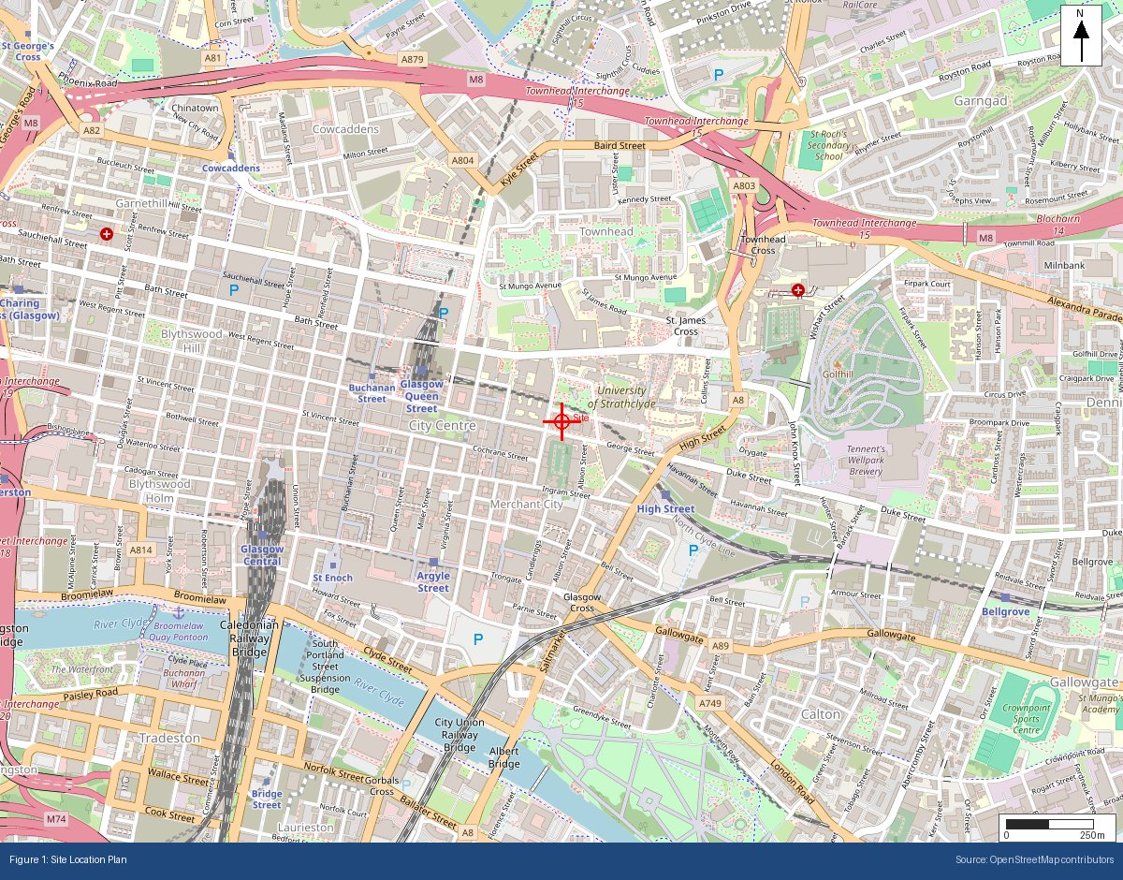

Appendix B: BGS Bedrock Geology Extract
BGS 1:625,000 bedrock geology at site location
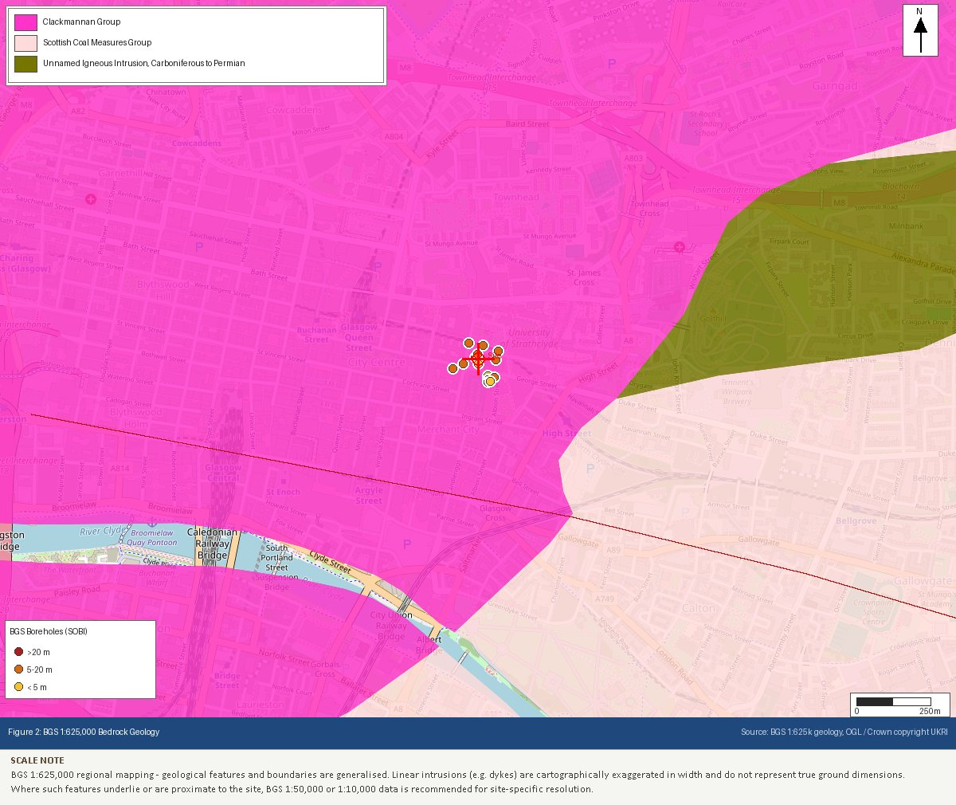

Appendix C: BGS Superficial Geology Extract
BGS 1:625,000 superficial deposits at site location
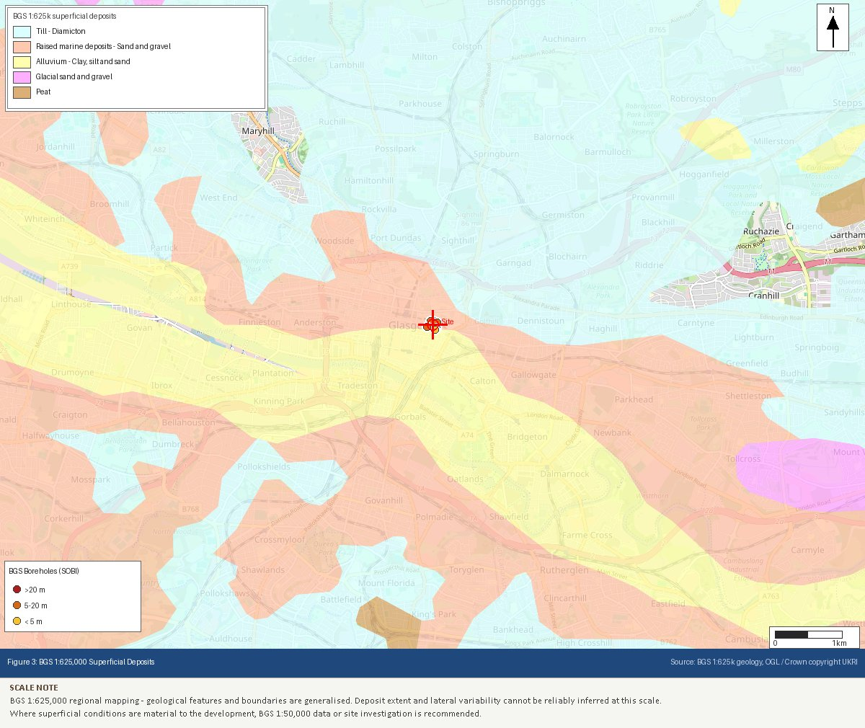

Appendix D: SEPA Flood Map Extract (River and Coastal)
SEPA flood map likelihood classification
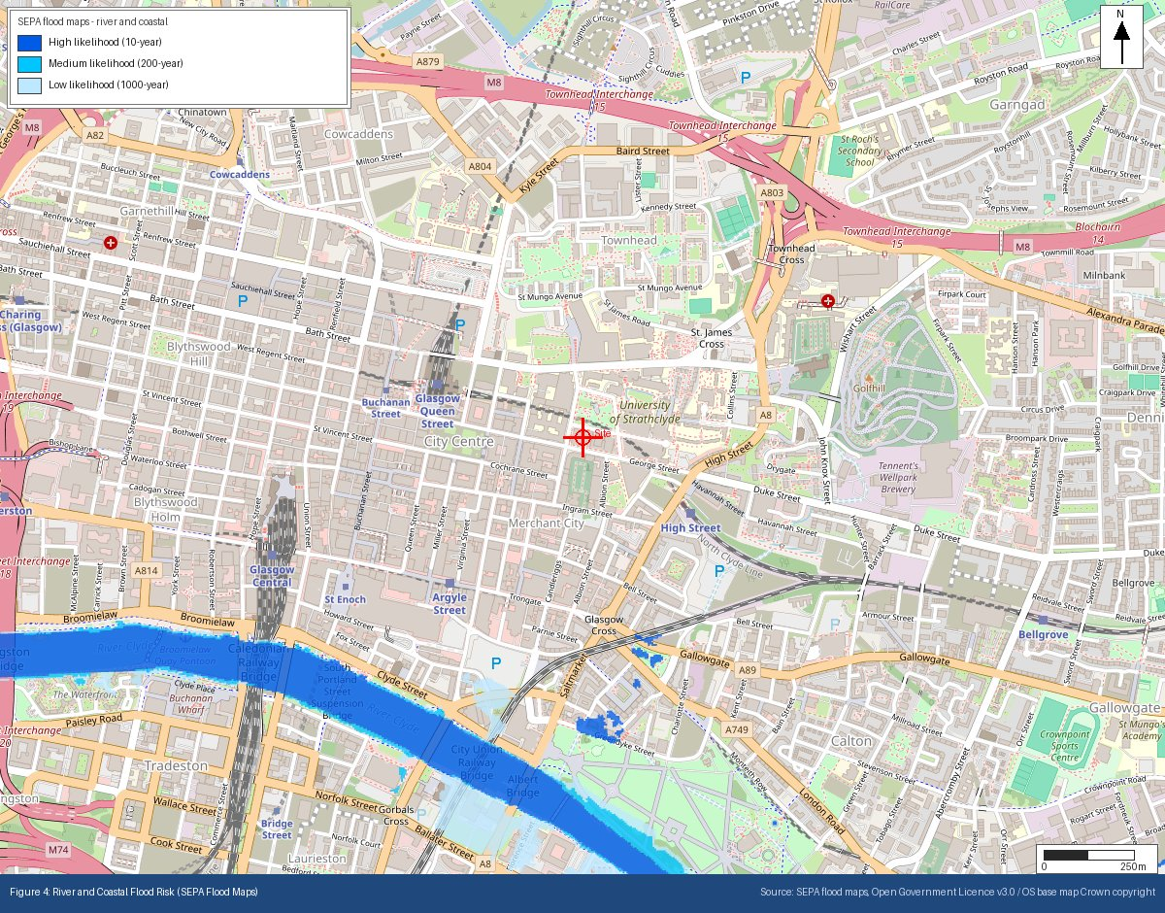

Appendix E: Heritage Designations (Historic Environment Scotland)
Listed buildings, scheduled monuments and conservation areas within 500m
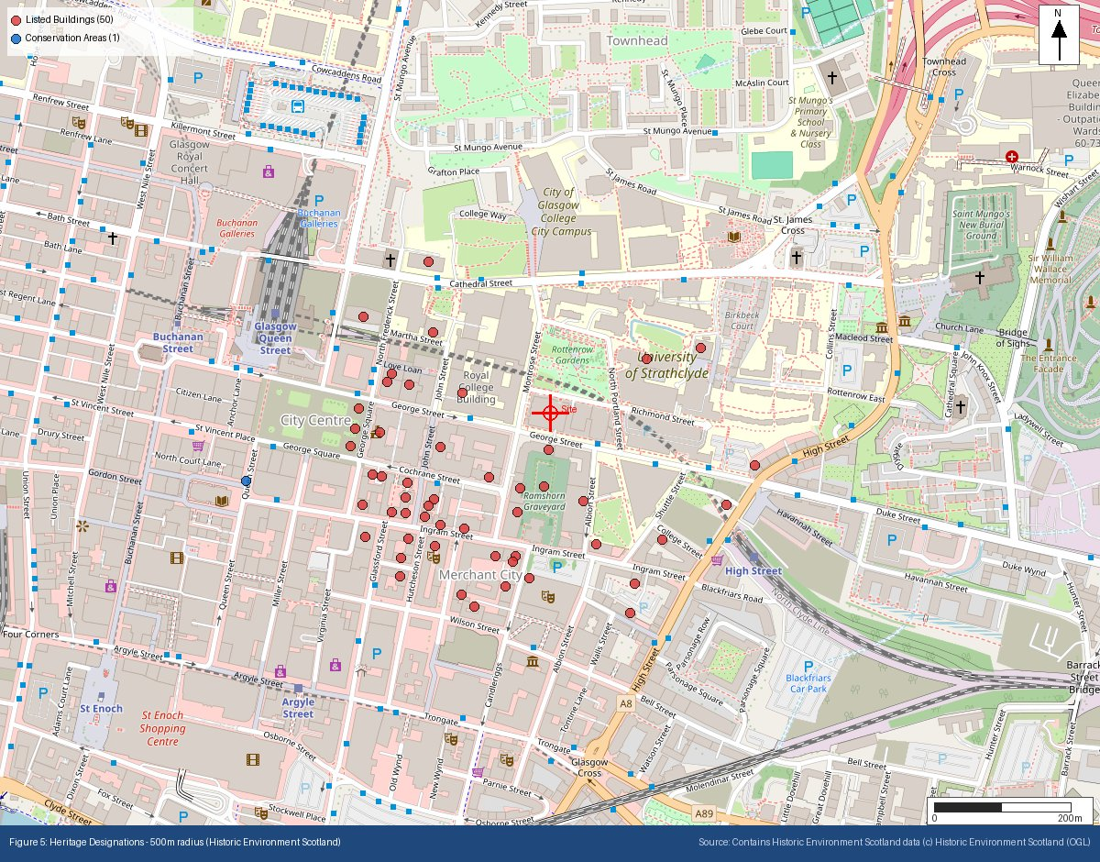

Appendix F: Ecological Designations (NatureScot)
SSSI, SAC, SPA, Ramsar, National Scenic Area and National Park designations within search radii
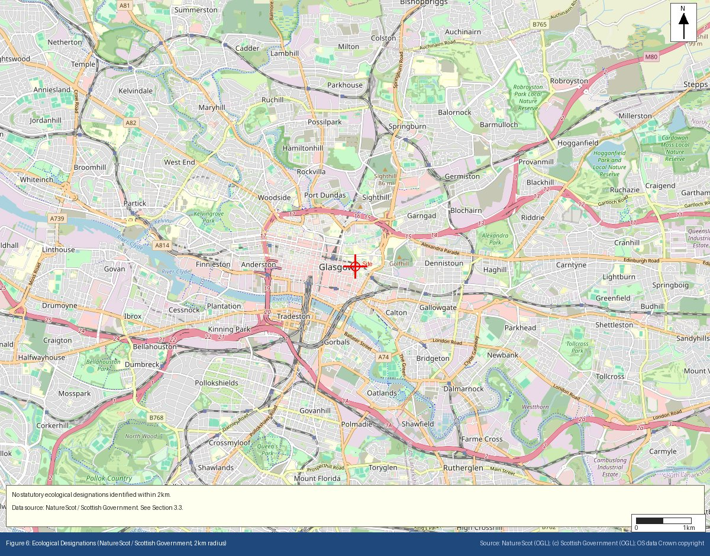

Appendix G: Mining Remediation Authority Output
MRA development risk and mine entries data
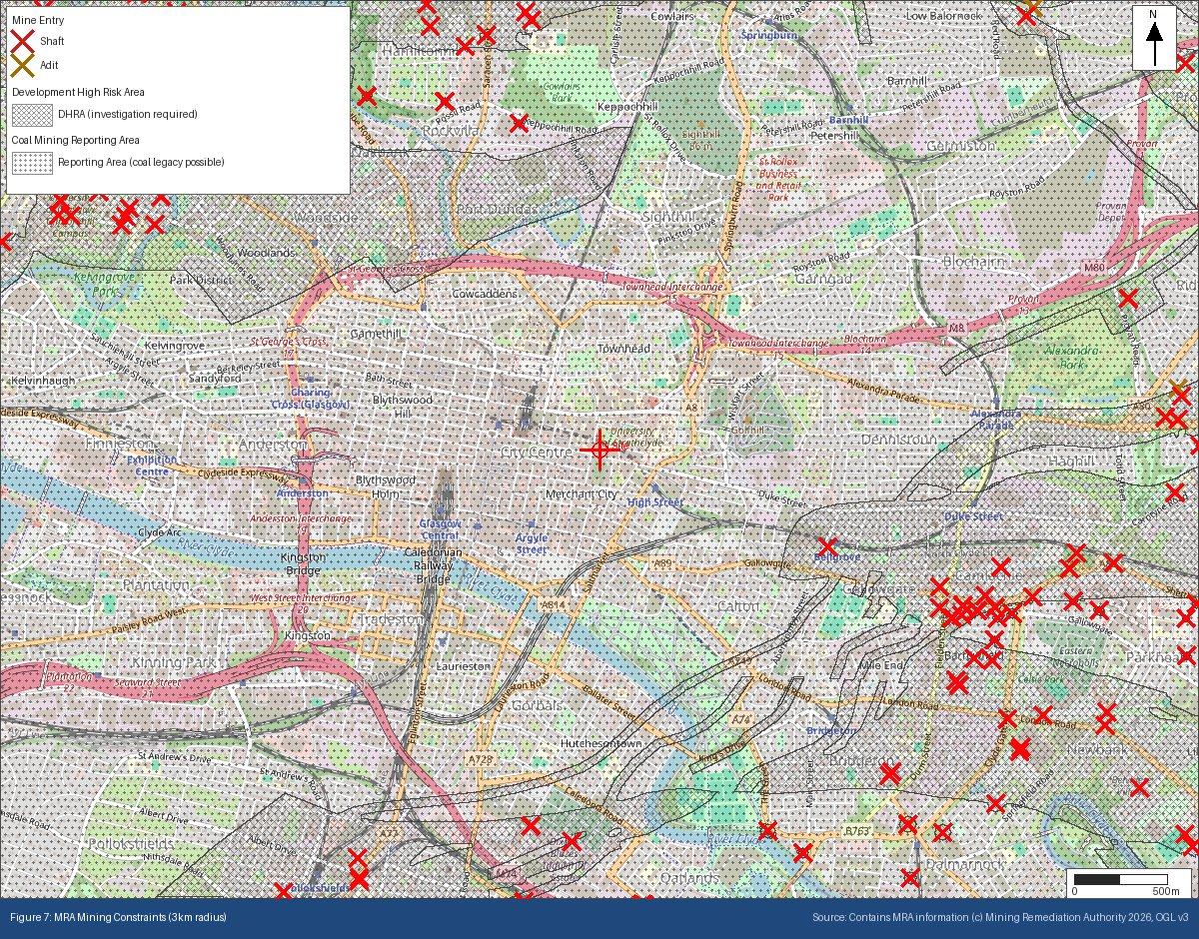

Appendix H: BGS/UKHSA Radon Potential Extract
Radon potential classification at site location
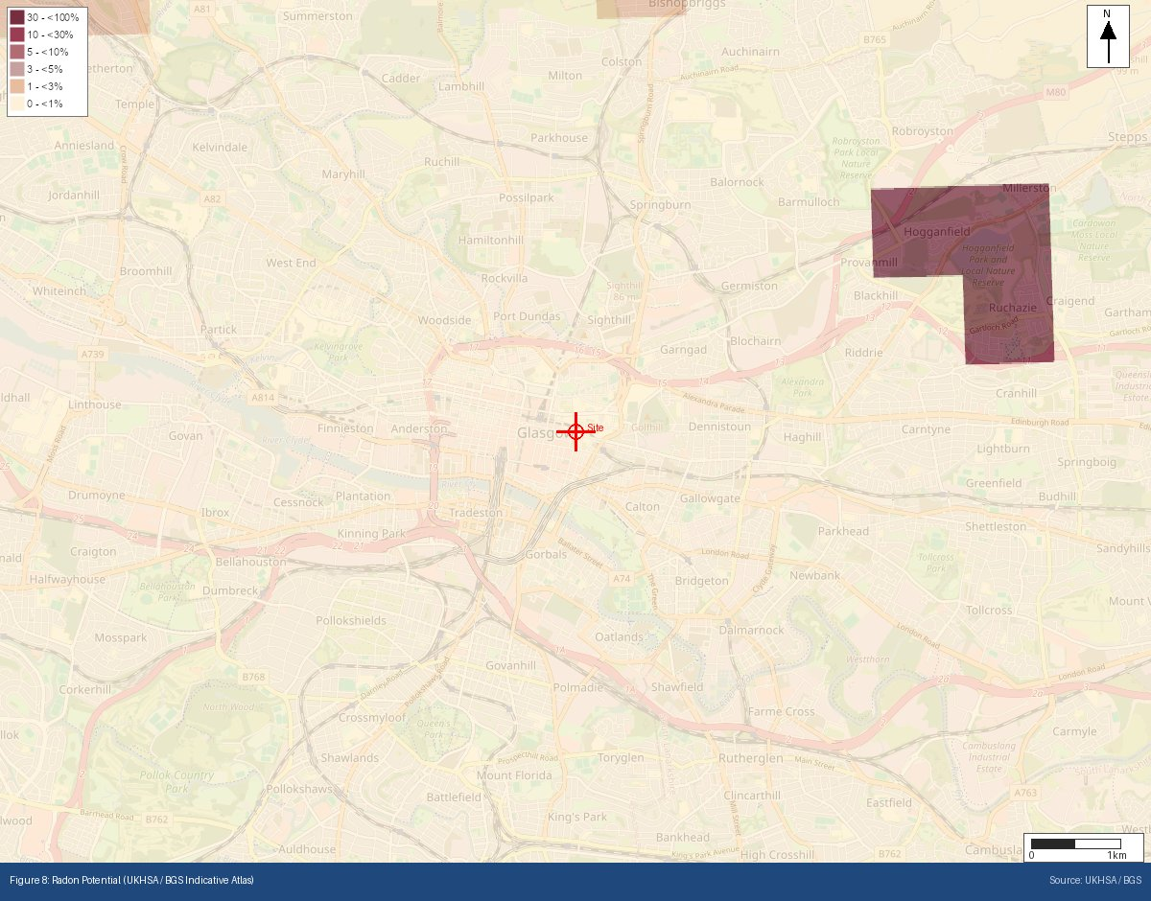
Appendix I: Historical OS Mapping (1885–1903)
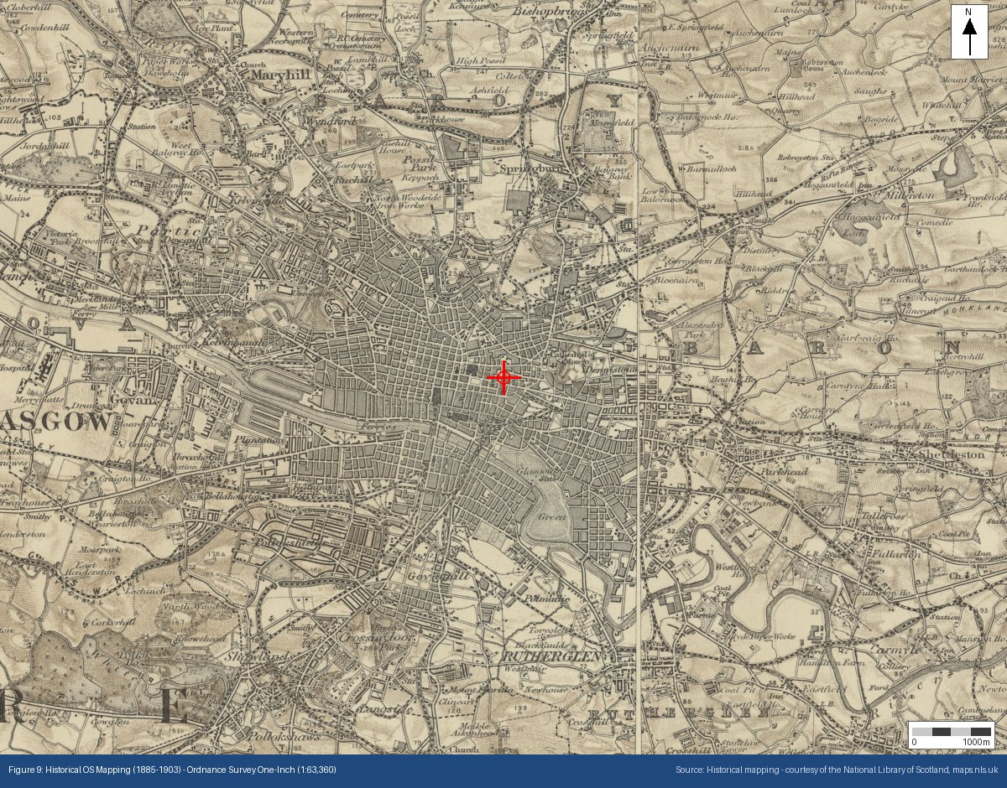

Appendix J: Historical OS Mapping (1888–1913)
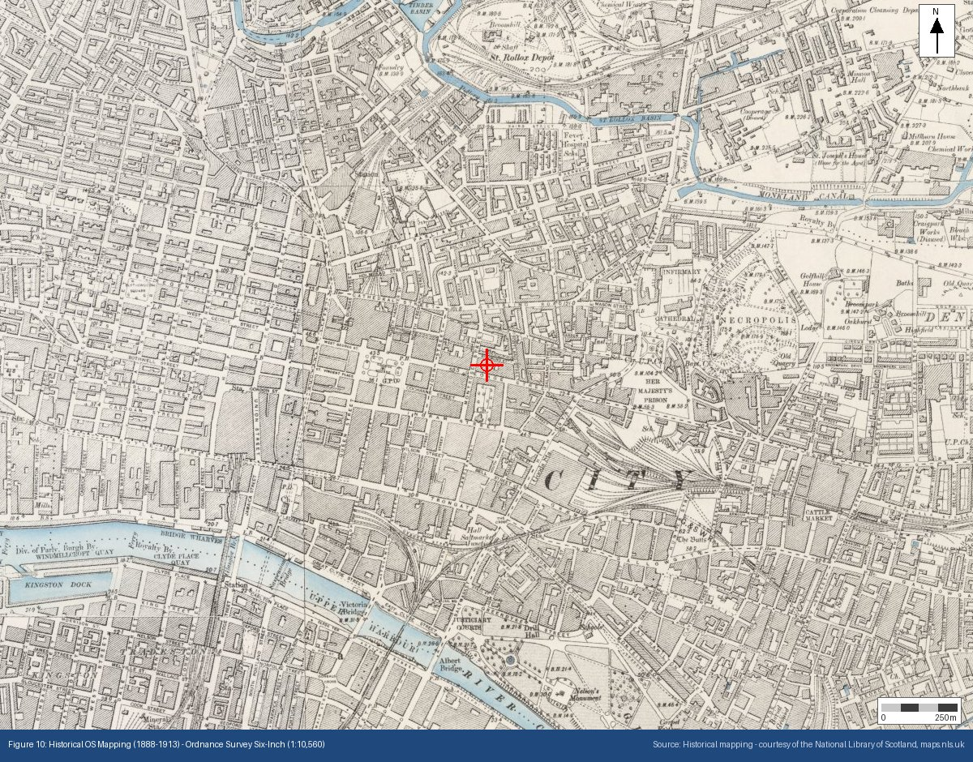

Appendix K: Historical OS Mapping (1919–1947)
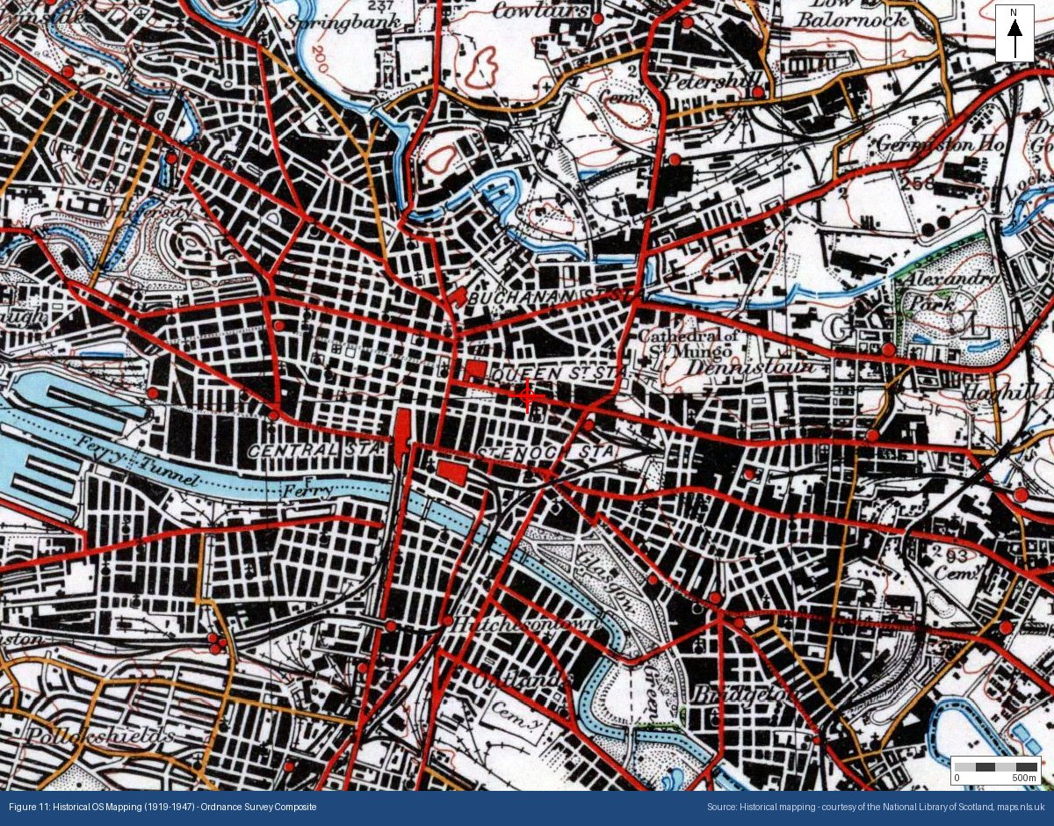

Appendix L: Surface Water Flood Risk (SEPA)
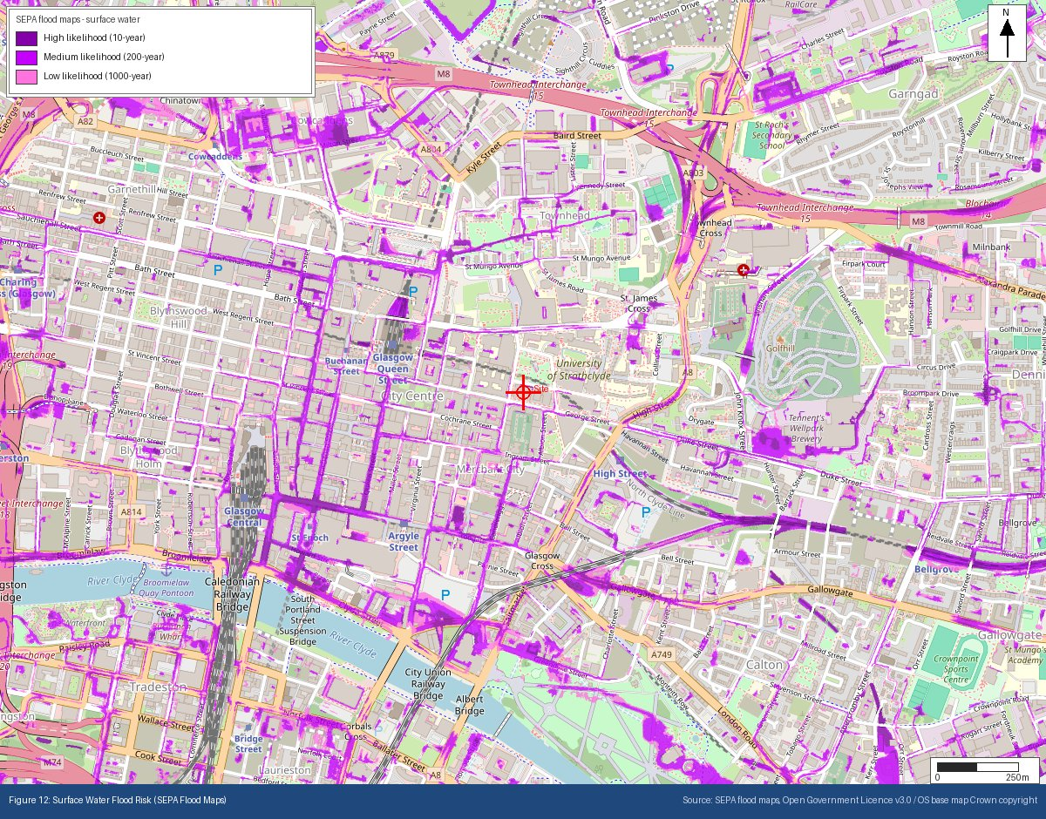
Appendix M: Public Water Supply Catchments (Scottish Water / SEPA)
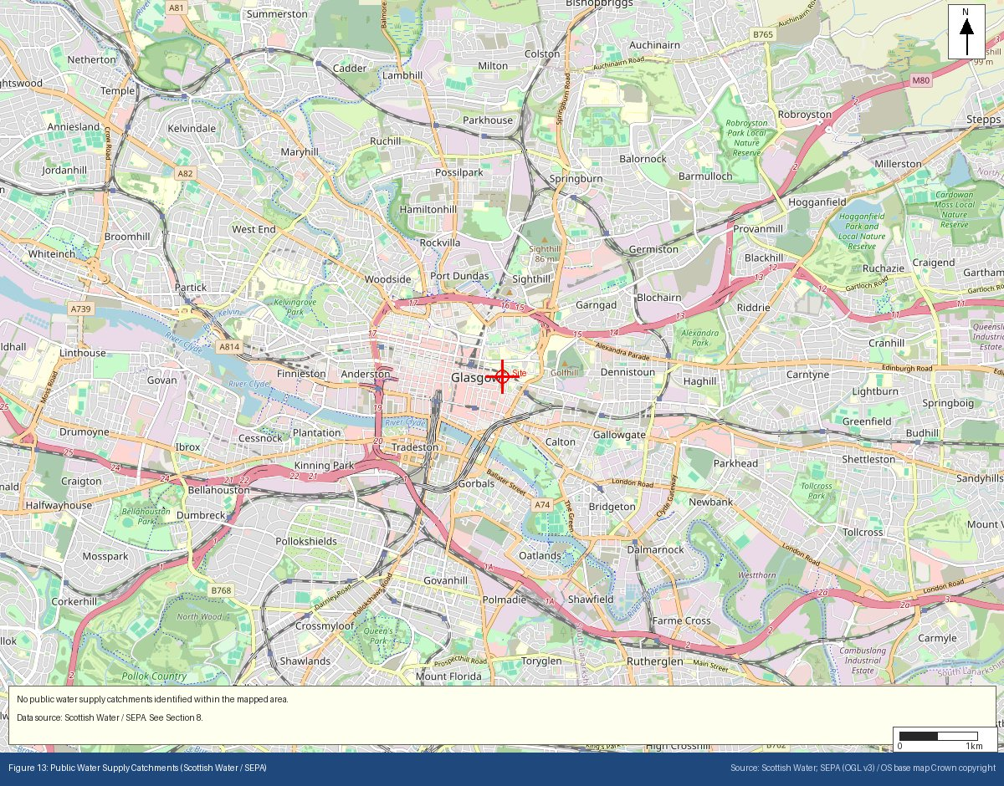
Appendix N: Site Topography — Scottish Public Sector LiDAR Digital Terrain Model
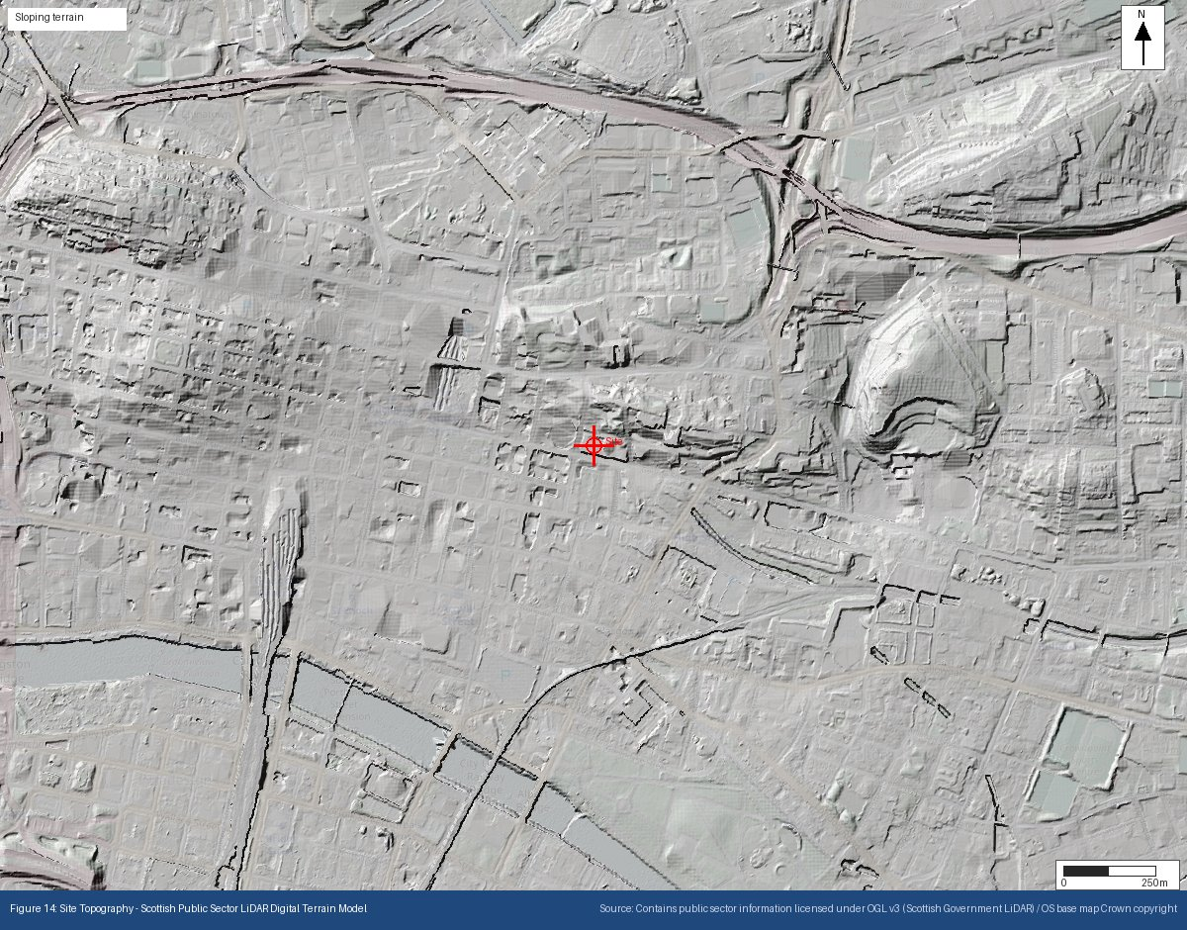
Appendix O: Permitted Regulated Facilities — SEPA Granted Authorisations
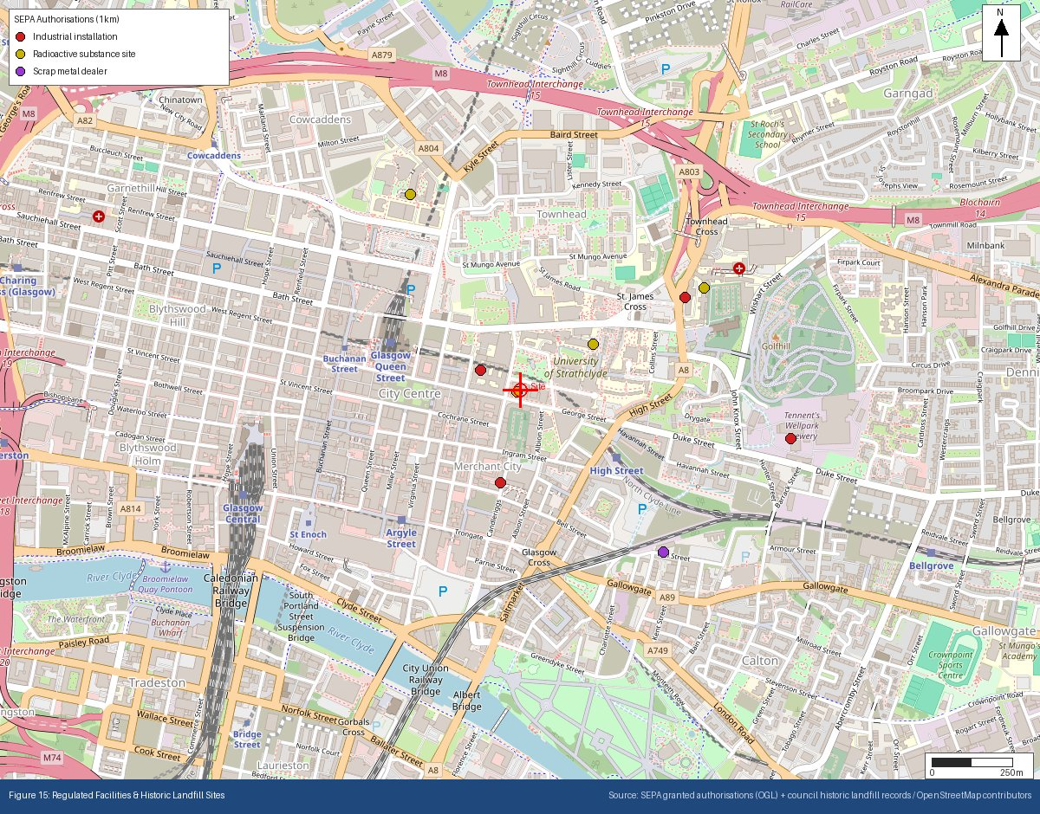
Appendix P: Historical & Current Map Features
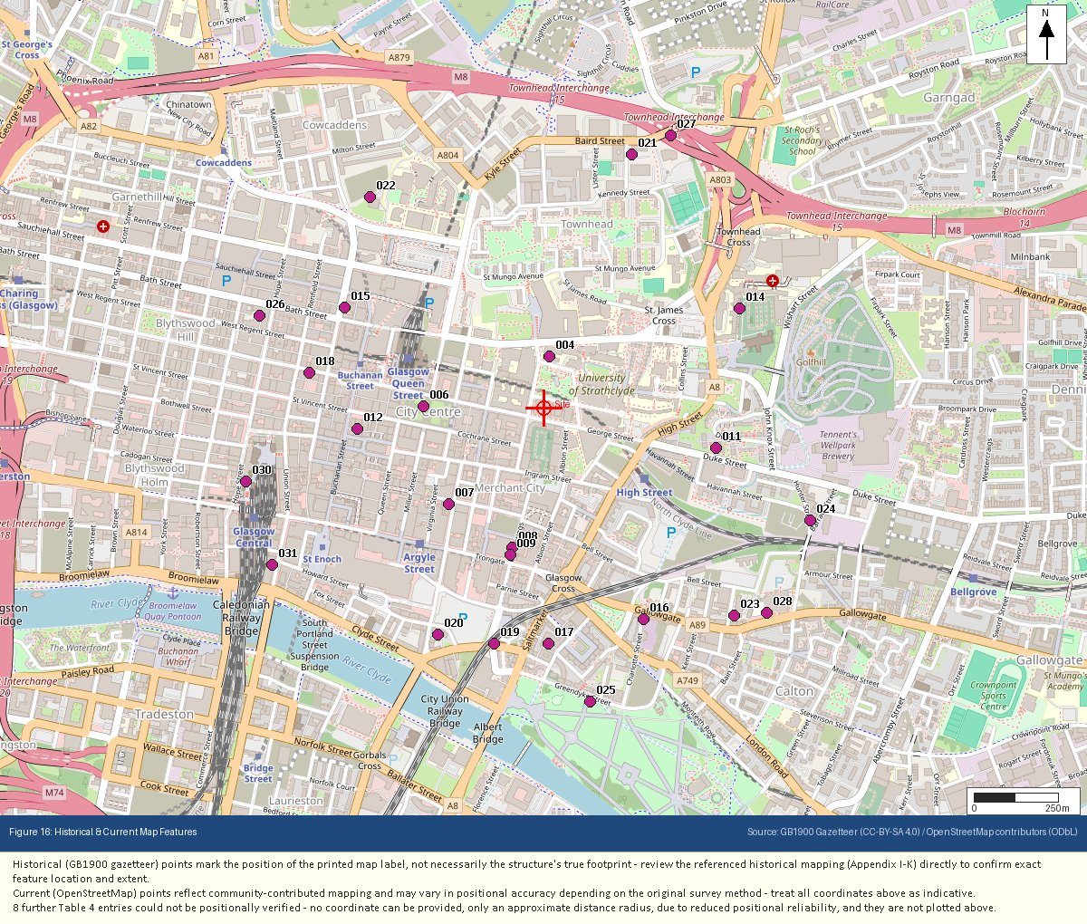
Appendix Q: Underground & Buried Structures
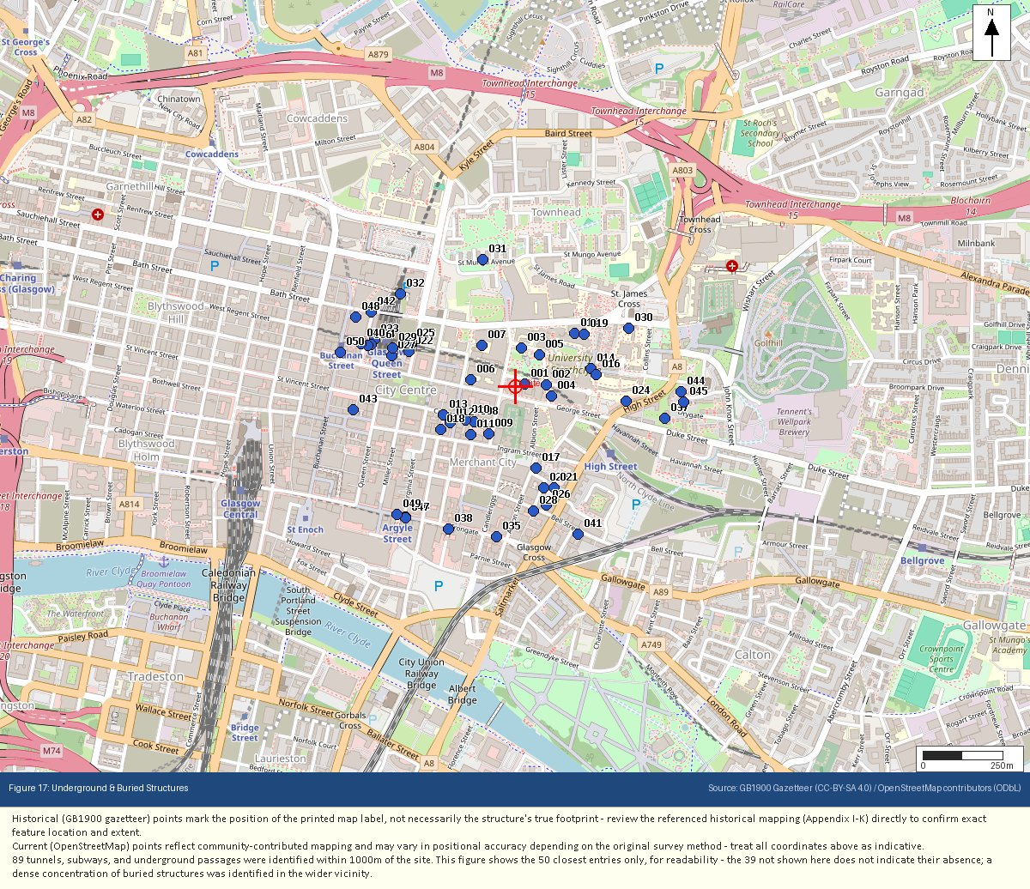
Appendix R: Flood Risk – Reference (Climate Change)
