
PRELIMINARY GEOTECHNICAL
GROUND RISK SCREENING REPORT

KY1 1XT
KY1 1XT (route c. 1.51 km, 10 m corridor)
OS NGR: 327747 691406

Prepared for: | Magnum GSI
Report Reference: | GEO-1D2DC9F4
Date of Issue: | 20 October 2026
Version: | 1.0
Classification: | Indicative — Not for Design
Prepared by: | GeoScreen® | Magnum GSI Ltd
Prepared by GeoScreen®, an automated reporting platform developed and operated by Magnum GSI Ltd

DOCUMENT CONTROL
Report Title | KY1 1XT — Preliminary Ground Risk Screening Report
Client | Magnum GSI
Site Address | KY1 1XT (route c. 1.51 km, 10 m corridor)
OS National Grid Reference | 327747 691406
Report Reference | GEO-1D2DC9F4
Date of Issue | 20 October 2026
Data Collection Date | 20 October 2026

DISCLAIMER AND SCOPE LIMITATIONS
IMPORTANT NOTICE — PLEASE READ BEFORE USING THIS REPORT
This report has been prepared using GeoScreen®, an automated ground risk screening platform developed and operated by Magnum GSI Ltd.

The report provides an indicative, desk-based assessment of ground conditions and associated constraints based solely on the interrogation and interpretation of publicly available datasets, including but not limited to British Geological Survey (BGS), Scottish Environment Protection Agency (SEPA), Mining Remediation Authority (MRA), Historic Environment Scotland (HES), and NatureScot data sources.

This report:
• DOES NOT constitute a professional geotechnical assessment or a BS 5930:2015+A1:2020 compliant desk study
• DOES NOT include intrusive ground investigation, site walkover, or statutory searches
• IS informed by general principles derived from relevant UK geotechnical guidance, but does not constitute a desk study compliant with BS 5930:2015+A1:2020
• IS intended solely for early-stage feasibility, due diligence, and preliminary risk screening purposes

The findings presented are indicative only. Site-specific ground conditions may vary and can only be reliably established through an appropriately scoped ground investigation and professional interpretation by a suitably qualified and experienced geotechnical engineer.

CONTENTS

Executive Summary
1 Introduction
2 Site Setting
3 Planning Context
4 Sources of Information
5 Site History
6 Geology and Ground Conditions
7 Hydrogeology and Hydrology
8 Geohazard Assessment
9 Foundation and Drainage Considerations
10 Conclusions
11 Recommendations
12 Limitations and Liability Statement

Appendices A–R

EXECUTIVE SUMMARY
Site address | KY1 1XT (route c. 1.51 km, 10 m corridor)
Current use | Not confirmed
Proposed development | Residential development
OS Grid Reference | 327747 691406
Local Planning Authority | Fife Council
Geological setting (bedrock) | Clackmannan Group - Sedimentary Rock Cycles, Clackmannan Group Type (CKN); Scottish Coal Measures Group - Mudstone, Siltstone, Sandstone, Coal, Ironstone (CMSC)
Geological setting (superficial) | Raised Marine Deposits (Undifferentiated)
Overall risk rating | High

Key takeaway: The site is assessed as High geotechnical risk, driven primarily by Mining Legacy (see Appendix G), River and Coastal Flood Risk (see Appendix D), and Surface Water Flood Risk (see Appendix L).
Primary constraint:
Mining Legacy, together with coastal and surface water flood exposure along the route.
Implication:
Elevated ground and flood risk is likely to affect design, cost, and programme, with SEPA and coal mining considerations requiring early resolution.
Required next step:
Undertake intrusive ground investigation to characterise ground conditions and mining legacy, and commission a Flood Risk Assessment, with HRA screening for the European sites the route passes through.
Overall risk:
High.
The route runs for about 1.5 km through KY1 1XT in Fife, the proposed use is residential development, and the bedrock is the Clackmannan Group, changing to Scottish Coal Measures Group strata towards the end of the route. The MRA records a Development High Risk Area with six mine entries within 1000 m, so past coal extraction could leave voids, shallow workings, or unstable ground. The seaward end of the route lies within the SEPA coastal High likelihood flood extent, and it passes through the Firth of Forth SSSI, SPA, and Ramsar site between Ch 1+284 and Ch 1+473, so Habitats Regulations Appraisal (HRA) screening may be required. Compressible ground, made ground, dissolution features, ground gas, and aggressive ground conditions are each rated Medium and should be checked during ground investigation.

Geohazard Overview
Geohazard | Risk Rating | Key Data Source
Mining Legacy | High | Mining Remediation Authority (Appendix G)
Compressible Ground | Medium | BGS 1:625,000 geological mapping (formation analysis)
Shrink-Swell Clays | Low | BGS 1:625,000 geological mapping (formation analysis)
Slope Instability | Low | BGS 1:625,000 geological mapping + Scottish LiDAR DTM
Dissolution Features | Medium | BGS 1:625,000 geological mapping (formation analysis)
Made Ground | Medium | BGS Superficial Geology / OSM railway land / Address context
River and Coastal Flood Risk | High | SEPA flood maps - river and coastal (Appendix D)
Surface Water Flood Risk | High | SEPA flood maps - surface water and small watercourses (Appendix L)
Radon | Low | BGS/UKHSA Radon Atlas (Appendix H)
Ground Gas | Medium | SEPA Landfill Sites Licensed Since 1996 + Council Historic Landfill Records (500m)
Aggressive Ground | Medium | BGS Geology / Formation lookup
Public Water Supply Catchment | Not identified | Scottish Water / SEPA water supply catchments (Appendix M)
Note: Geohazard numbering follows the GeoScreen reference scheme. GH11 (Unexploded Ordnance) is not assessed in this Tier 1 report; this hazard will be incorporated in a future GeoScreen platform release.
Recommendations
– Undertake a site walkover and a professional BS 5930 desk study, and obtain utility searches, to verify ground conditions and buried services along the route corridor before design proceeds.
– Commission an intrusive ground investigation, as overall geotechnical risk is High, to characterise the raised marine deposits, compressible and made ground, ground gas, and dissolution-related hazards along the route.
– Obtain an MRA coal mining report and commission a specialist mining legacy and subsidence assessment, particularly for the Scottish Coal Measures Group strata near the eastern end of the route (Ch 1+363 to Ch 1+515).
– Commission a Flood Risk Assessment and surface water drainage strategy to address the High river, coastal and surface water flood risk, with SEPA as consultee.
– Undertake an ecological assessment and Habitats Regulations Appraisal (HRA) screening, as the route passes through the Firth of Forth SPA, Ramsar site and SSSI (between about Ch 1+284 and Ch 1+473) and the Outer Firth of Forth and St Andrews Bay Complex SPA (between Ch 1+471 and Ch 1+515).
Development Implications
Foundation type: Deeper or engineered foundation solutions are likely to be required in areas affected by mining legacy and along the compressible coastal sections of the route, with shallow foundations possibly suitable elsewhere, subject to structural loading details and confirmation by intrusive ground investigation.
Key cost risk: Mining Legacy (High) is the most significant cost risk, as possible shallow workings or voids within the coal-bearing strata could require ground stability investigation, treatment, or foundation redesign; River and Coastal Flood Risk (High) and Surface Water Flood Risk (High) could also add cost through flood mitigation and drainage design.
Planning constraints: The route passes through the Firth of Forth SSSI, Special Protection Area (SPA) and Ramsar site, and through the Outer Firth of Forth and St Andrews Bay Complex SPA between Ch 1+471 and Ch 1+515, so Habitats Regulations Appraisal (HRA) screening may be required and early engagement with NatureScot and the planning authority is recommended.
Overall suitability: Development is feasible subject to appropriate mitigation of the identified geotechnical risks, principally Mining Legacy, River and Coastal Flood Risk, and subject to confirmation by intrusive ground investigation.

1 INTRODUCTION

1.1 Scope and Purpose
This preliminary ground risk screening report has been prepared for Magnum GSI in respect of land at KY1 1XT (route c. 1.51 km, 10 m corridor) (hereafter referred to as 'the Site'). The report has been prepared by GeoScreen using automated interrogation of publicly available geotechnical and environmental datasets.
The purpose of this report is to provide a high-level, indicative assessment of the ground conditions, environmental constraints, and planning context relevant to the Site, based solely on a review of publicly available data. The report is intended to support early-stage site appraisal, land acquisition decisions, and pre-planning risk screening, and to inform the scope of any subsequent professional ground investigation or planning submission.
This assessment does not include intrusive ground investigation, physical site walkover, statutory environmental searches, or utilities searches. Accordingly, actual site conditions may differ from those described. A professional desk study prepared by a suitably qualified Chartered Geotechnical Engineer, followed by site-specific ground investigation, is recommended to inform design, planning, and construction decisions.

1.2 Site Details
The Site is located at KY1 1XT (route c. 1.51 km, 10 m corridor). The approximate OS National Grid Reference for the centre of the Site is Easting 327747, Northing 691406.

1.3 Proposed Development
Residential development

1.4 Assessment Methodology
This report has been prepared by automated interrogation of publicly available digital datasets, including those listed in Section 4. Data was collected automatically from each source using the site's OS National Grid Reference as the search point. The findings have been interpreted using AI-assisted interpretation and structured report generation informed by applicable UK standards and guidance.
Each geohazard is assigned a risk rating (Low, Medium, High, or Very High) and a data confidence level. Confidence levels reflect the reliability and completeness of the available data for the assessed geohazard, as defined in Table 2 below.
Table 1 – Geohazard Risk Rating Scale
Risk Rating | Description | Development Implication
Very High | A major geohazard has been identified at or close to the site. The hazard presents a significant constraint to development based on available data. | Comprehensive ground investigation and specialist assessment required. Significant design mitigation or planning constraint is anticipated.
High | A significant geohazard has been identified that is likely to affect the development and requires further investigation. | Targeted ground investigation and specialist assessment required. Design mitigation measures should be anticipated.
Medium | A geohazard has been identified that may influence the development. Further assessment during detailed design is recommended. | Mitigation measures may be required; targeted investigation or specialist assessment is advised.
Low | No significant geohazard has been identified from available data. The hazard is unlikely to materially affect development, subject to confirmation by ground investigation. | No specific mitigation measures are anticipated at this stage; standard design approaches are likely to be suitable.
Table 2 – Data Confidence Levels
Confidence Level | Definition
High | Multiple corroborating data sources; data returned successfully from API; formation or constraint well characterised in national datasets.
Medium | Single primary data source; partial data available; some interpretation assumptions required; formation boundary may be uncertain.
Low | Limited data available; API query returned no data or failed; significant uncertainty in the basis of the assessment.

2 SITE SETTING

2.1 Location and Topography
2.1.1 The route is a linear corridor approximately 1.51 km long and 10 m wide (1.51 ha), extending from Ch 0+000 at E326990 N691405 to Ch 1+515 at E328490 N691555. It lies in Kirkcaldy, on the northern shore of the Firth of Forth in Fife, within the administrative area of Fife Council. The route runs broadly west to east through the urban centre of Kirkcaldy and ends on the seaward side at the Esplanade and the intertidal Kirkcaldy Sands. The proposed development is residential. BGS 1:625,000 mapping indicates that Raised Marine Deposits overlie the Clackmannan Group bedrock from Ch 0+000 to approximately Ch 1+363, with the Scottish Coal Measures Group mapped from approximately Ch 1+363 to Ch 1+515, where no superficial deposits are mapped.
2.1.2 The Scottish Public Sector LiDAR Digital Terrain Model indicates that the route occupies sloping terrain. The Fife coastal plain generally rises gently inland from the Firth of Forth, and the route follows this transition from the higher inland ground at its western end towards the low-lying shoreline and sea wall at its eastern end. The route is therefore likely to include a range of ground slopes along its length, with the lowest ground adjacent to the foreshore and the Esplanade. The broader landscape is that of a developed coastal town set on raised marine terraces above the Firth of Forth. The following sections treat slope and elevation qualitatively only, and detailed levels would need to be established by topographic survey.
2.1.3 OS mapping review indicates that the route passes through the built-up town centre and crosses the Fife Circle Line railway close to Kirkcaldy Station at approximately Ch 0+450. The Mercat Shopping Centre and the Merchants Quarter retail complex lie on or adjacent to the route at approximately Ch 0+900 to Ch 1+000. These large commercial developments are likely to have involved extensive foundations, basements, and made ground within the historic town core. Towards the eastern end, the route crosses the Esplanade and its coastal sea wall at approximately Ch 1+250 and reaches the intertidal Kirkcaldy Sands between approximately Ch 1+250 and Ch 1+515. Surrounding features include Abbotshall Parish Church and Kirkcaldy Bus Station about 20 m to the south, Forth Avenue Industrial Estate about 100 m to the north, and Beveridge Park with its boating lake and sports facilities to the south and south-west. The harbour, dock, and West Pier lie about 500 m north-east of the eastern end of the route. Kirkcaldy Wastewater Treatment Works lies about 800 m to the north-east, and East Burn flows about 307 m north-east of the eastern end. Raith Lake lies about 770 m to the west of the western end. The wastewater treatment works and the former industrial land associated with the harbour and the industrial estate are the features of most direct geotechnical relevance. This description is based on desk study mapping review only, and no site walkover has been undertaken.

3 PLANNING CONTEXT

3.1 Local Planning Authority
Planning decisions at the Site are made by Fife Council, which acts as the Local Planning Authority (LPA) for the area.
LPA Name | Fife Council
Planning portal | https://www.planningportal.co.uk
General enquiries | Contact via LPA website

Note: LPA contact details should be verified directly via the planning portal before submission of any pre-application enquiry or planning application.
3.1.1 National Planning Framework 4 (NPF4, February 2023) forms part of the statutory development plan alongside the Fife Council Local Development Plan. Based on the desk-based data reviewed, four NPF4 policies are directly triggered. Policy 22 (Flood risk and water management) applies because the route lies within the SEPA coastal High likelihood flood extent and the climate change (2080s) Medium likelihood extent. Policy 7 (Historic assets and places) applies because 50 listed buildings, two conservation areas, and one Inventory garden and designed landscape lie within 500m of the route. Policy 4 (Natural places) applies because the route passes through internationally and nationally designated sites. Policy 9 (Brownfield, vacant and derelict land and empty buildings) requires land known or suspected to be unstable or contaminated to be shown to be safe and suitable for the proposed residential development.
3.1.2 Based on the data reviewed, Fife Council may require, subject to confirmation with the Local Planning Authority, a Flood Risk Assessment, with SEPA as a consultee. A Heritage Impact Assessment may be required as part of the planning process, given the density of designated heritage assets near the route. An ecological appraisal, together with consideration of potential effects on the designated sites the route passes through, may also be required. A professional geotechnical and contamination desk study, followed by ground investigation, may be required for planning purposes to demonstrate that the ground is suitable for residential use. These requirements are indicative and based on desk-based information only, and pre-application guidance should be confirmed directly with Fife Council.
3.1.3 The route passes through the Firth of Forth SPA and Ramsar site, and through the Outer Firth of Forth and St Andrews Bay Complex SPA, so early consultation with Fife Council and NatureScot is strongly recommended. Habitats Regulations Appraisal (HRA) screening may be required as part of the planning process. Any requirement should be confirmed with the Local Planning Authority and NatureScot at the pre-application stage.

3.2 Heritage Designations
3.2.1 Historic Environment Scotland (HES) designation data indicates that the route corridor lies within a historically sensitive urban setting. Within 500 m of the route, the data records 50 listed buildings (none Category A, 26 Category B, and 24 Category C), two conservation areas (Abbotshall & Central Kirkcaldy, and Kirkcaldy Harbour and Port Brae), and one Inventory Garden and Designed Landscape (Raith Park and Beveridge Park, approximately 91 m from the route). No scheduled monuments or Inventory historic battlefields were recorded within 500 m, and no World Heritage Sites were recorded within 5 km. The data confidence is rated High. These findings are desk-based and indicative, relate to designated assets only, and do not address undesignated archaeological or built heritage features.
3.2.2 The proposed residential development lies close to a substantial number of designated assets, and heritage considerations are likely to form part of the planning assessment. Under NPF4 Policy 7 (Historic assets and places), development affecting listed buildings, conservation areas, or Inventory gardens and designed landscapes must preserve or enhance their character, setting, and special interest. This is supported by the Historic Environment Policy for Scotland (HEPS) and the Planning (Listed Buildings and Conservation Areas) (Scotland) Act 1997, which require special regard to the desirability of preserving listed buildings and their settings and to preserving or enhancing the character and appearance of conservation areas. Given the number of assets recorded and the proximity of the conservation areas and the Inventory landscape, a Heritage Impact Assessment is likely to be required to inform the planning submission. Historic Environment Scotland is a statutory consultee on proposals affecting nationally important assets such as Category A listed buildings and Inventory sites, and early engagement with the planning authority and HES is recommended.
3.2.3 The Inventory Garden and Designed Landscape of Raith Park and Beveridge Park lies approximately 91 m from the route and is the most sensitive nationally designated asset identified by the data. The principal sensitivities are likely to relate to the setting, designed views, and landscape character of the Inventory site, together with any effects of construction activity, ground disturbance, and drainage changes on its boundaries and approaches. The two conservation areas, Abbotshall & Central Kirkcaldy and Kirkcaldy Harbour and Port Brae, add sensitivity to the urban townscape through which the route passes or adjoins, where the character and appearance of the area and the settings of the many Category B and C listed buildings would need to be considered. The extent of any effect on these assets, and on undesignated archaeological remains, cannot be determined from this desk-based review and should be verified with the planning authority and HES.

3.3 Ecological Designations
3.3.1 The desk-based review of NatureScot data identified statutory ecological designations along and near the route corridor. Two Sites of Special Scientific Interest (SSSI) were recorded within 2 km: the route passes through the Firth of Forth SSSI between Ch 1+286 and Ch 1+473, while Invertiel Quarry SSSI lies about 1,550 m outside the route. Two Special Protection Areas (SPA) were recorded: the route passes through the Firth of Forth SPA between Ch 1+284 and Ch 1+473, and through the Outer Firth of Forth and St Andrews Bay Complex SPA between Ch 1+471 and Ch 1+515. One Ramsar site was recorded: the route passes through the Firth of Forth Ramsar site between Ch 1+286 and Ch 1+473. No Special Areas of Conservation, National Nature Reserves, National Scenic Areas, or National Parks were identified within 2 km. The designations affecting the route therefore lie in its final section, broadly between Ch 1+284 and Ch 1+515, with the remainder of the route outside these boundaries.
3.3.2 The route passes through sites of international and national importance for nature conservation, so ecological considerations are likely to be a significant planning constraint for the proposed residential development. The relevant framework comprises the Conservation (Natural Habitats, &c.) Regulations 1994, the Nature Conservation (Scotland) Act 2004, and National Planning Framework 4 (NPF4) Policy 4 (Natural places). Because Special Protection Area and Ramsar designations are present, Habitats Regulations Appraisal (HRA) screening may be required, and early pre-application consultation with the planning authority and NatureScot is recommended. The SSSI designations may also require consultation with NatureScot on potential effects on the notified features. The review covered statutory designated sites only; protected species, non-designated habitats, and biodiversity enhancement requirements were not assessed, and an ecological appraisal may be required at planning stage.
3.3.3 The Firth of Forth is designated as an SSSI, SPA, and Ramsar site, and the Outer Firth of Forth and St Andrews Bay Complex is designated as an SPA. These designations are typically associated with intertidal and estuarine habitats and with internationally important populations of overwintering and migratory waterbirds and seabirds, although the specific notified features should be confirmed from the NatureScot site citations. Key sensitivities are likely to include disturbance to birds, changes to water quality and drainage discharges to the estuary, and loss or modification of coastal and intertidal habitat. Construction activity, lighting, and surface water management near the designated areas may therefore need to be considered. These findings are indicative and based on desk-based review only; the extent of any effect would require confirmation through appropriate ecological assessment and consultation.

4 SOURCES OF INFORMATION

4.1 Data Sources Consulted
All data was collected automatically on 20 October 2026 using the site's National Grid Reference as the search point.
Table 3 — Data Sources Consulted
# | Data Source | Provider | Purpose
DS01 | BGS 1:625,000 Bedrock Geology | British Geological Survey | Bedrock geology  (Appendix B)
DS02 | BGS 1:625,000 Superficial Deposits | British Geological Survey | Superficial deposits  (Appendix C)
DS03 | BGS 1:625,000 Formation Analysis | British Geological Survey | Formation-based ground stability assessment (GH02-GH05)
DS04 | BGS Borehole Index (SOBI) | British Geological Survey | Historical borehole records
DS05 | BGS 1:625,000 Geological Faults (OGC API) | British Geological Survey | Major geological fault lines (structural context and figure overlay)
DS06 | SEPA flood maps | Scottish Environment Protection Agency (SEPA) (OGL v3) | Flood likelihood classification (Appendix D)
DS07 | BGS Mining Hazard (Non-Coal) 1km Hex Grid v8 | British Geological Survey / UKRI | Non-coal mining hazard (vein minerals, chalk, evaporites, building stone)
DS08 | Mining Remediation Authority open data: Development High/Low Risk Areas and Mine Entries | Mining Remediation Authority (OGL v3). Contains Mining Remediation Authority information © Mining Remediation Authority, 2026 | Mining legacy (Appendix G)
DS09 | NLS Historical OS Mapping (via MapTiler Cloud) | National Library of Scotland | Historical OS mapping c.1885, 1888–1913 and 1919–1947 (Figs 9–11) (Appendix I-K)
DS10 | Historic Environment Scotland designations (local dataset; World Heritage Sites and Inventories queried live) | Historic Environment Scotland (OGL v3) - Contains Historic Environment Scotland data © Historic Environment Scotland | Heritage designations (listed buildings, scheduled monuments, WHS, conservation areas)  (Appendix E)
DS11 | NatureScot and Scottish Government (ArcGIS REST) | NatureScot (OGL v3); Scottish Government (OGL v3) - © Scottish Government | Ecological designations (SSSI, SAC, SPA, Ramsar, National Scenic Areas, National Parks) (Appendix F)
DS12 | BGS/UKHSA Radon Indicative Atlas | BGS / UKHSA | Radon potential (Appendix H)
DS14 | OS Names API | Ordnance Survey | Geocoding and LPA lookup (Appendix A)
DS15 | SEPA Landfill Sites (granted authorisations + landfill register, licensed since 1996 incl. closed sites) | Scottish Environment Protection Agency (SEPA) (OGL v3) - Contains public sector information licensed under the Open Government Licence v3.0. Source: waste sites and capacity data tool (Scottish Environment Protection Agency) | Ground gas / landfill proximity (500m buffer). Data reflects SEPA and council records at the time this report was generated and may be subject to change (e.g. new or updated permits).
DS16 | Council Historic Landfill Records (where published; e.g. City of Edinburgh Council) | City of Edinburgh Council; Improvement Service (Spatial Hub Scotland) - council-held records (OGL v3). Copyright City of Edinburgh Council, contains Ordnance Survey data © Crown copyright and database right (2026). Contains OS data © Crown copyright and database right 2026 and Scottish local authority data from the Spatial Hub. | Ground gas / landfill proximity (500m buffer). Data reflects SEPA and council records at the time this report was generated and may be subject to change (e.g. new or updated permits). SEPA's records cover landfill sites licensed since 1996, including sites whose licence has ended. Council historic landfill records are published by only a minority of Scottish councils; where a council publishes none, landfill sites that closed before 1996 may be present that are not recorded.
DS17 | BGS GeoIndex Hydrogeology (ArcGIS REST identify) | British Geological Survey | BGS aquifer productivity (Scotland has no aquifer designations; groundwater lies within a SEPA DWPA)
DS18 | Scottish Water Water Supply Catchments and SEPA Drinking Water Protected Area catchments | Scottish Water; Scottish Environment Protection Agency (SEPA) (OGL v3) | Groundwater source protection zone designation (S3 planning context / S7 hydrogeology) (Appendix M)
DS19 | SEPA flood maps - surface water and small watercourses | Scottish Environment Protection Agency (SEPA) (OGL v3) | Pluvial / surface water flood risk (GH08 geohazard)  (Appendix L)
DS20 | SEPA water body classification - rivers, lochs, estuaries and coastal waters (ArcGIS REST) | Scottish Environment Protection Agency (SEPA) (OGL v3) | Named receiving watercourse identification (S7 hydrogeology)
DS21 | OpenStreetMap (local extract, amenity=fuel) | OpenStreetMap contributors (ODbL) | Petrol filling stations within 500m (S5 site history / CSM)
DS22 | Scottish Public Sector LiDAR - DTM tiles (0.25-1m, AWS Open Data) | Scottish Government (OGL v3) - Contains public sector information licensed under the Open Government Licence v3.0 | Site topography, terrain descriptor, slope analysis (S2 site setting, Figure 14 Appendix N)
DS23 | SEPA Granted Authorisations (permits: waste, PPC, radioactive substances and water discharges; ArcGIS REST) + OpenStreetMap fuel forecourts | Scottish Environment Protection Agency (SEPA) (OGL v3) | Environmental permits, registered facilities and flood defence assets within 1km (S5.3, Figure 15 Appendix O). Data reflects SEPA and council records at the time this report was generated and may be subject to change (e.g. new or updated permits).
DS24 | OpenStreetMap (local extract) — infrastructure and land-use sites | OpenStreetMap contributors (ODbL) | Gas holders, sewage/water works, sub-stations, power stations, emergency services, military, aviation, port, quarry and industrial sites within 1km (S5 Historical Features table, Figure 16 Appendix P / S8 CSM sources); railway land and sidings within 50m of the site (S8 Made Ground)
DS25 | Historical Map Feature Positioning (derived from GB1900 Gazetteer, abridged) | Great Britain Historical GIS / GB1900 partners and volunteers (CC-BY-SA 4.0, creativecommons.org/licenses/by-sa/4.0/legalcode) | Historical map feature position (distance/bearing derived from GB1900 gazetteer label coordinates, OS Six-Inch County Series 1888-1913) for S5 Historical Features table, Figure 16 Appendix P
DS26 | OpenStreetMap (local extract) — tunnel, subway and underground structure geometry | OpenStreetMap contributors (ODbL) | Tunnel, subway and underground structure entry/midpoint/exit points within 1km (S5.2 Underground and Buried Structures table, Figure 17 Appendix Q)
DS27 | SEPA Future Flood Maps – River, Coastal and Surface Water (Medium likelihood with climate change) | Scottish Environment Protection Agency (SEPA) (OGL v3) | Flood extent with climate change shown for reference only in Figure 18 (Appendix R) – does not affect the GH07/GH08 ratings above
DS28 | OS Open Rivers (local extract) — named watercourse network | Ordnance Survey (OGL v3). Contains OS data © Crown copyright and database rights 2026 | Distance, bearing and grid reference of named streams and rivers in Table 4 / Figure 16 (Appendix P), measured to the nearest point of the watercourse rather than its historical map label; also the named watercourses in Section 7

5 SITE HISTORY

5.1 Historical Land Use Review
A limited AI-assisted historical mapping review has been undertaken using Ordnance Survey mapping from three historical epochs (c.—1885, c.—1888–1913, and c.—1919–1947), accessed via the National Library of Scotland (NLS). Historical mapping provides indicative information regarding former land uses, structures, watercourses, and potential ground disturbance not evident from current mapping. Key features identified are summarised in Table 4 below. See Appendix P for mapped locations.
The AI-assisted review included in this report is indicative only and has not been verified by a competent professional. It does not constitute a formal historical land use survey. Where a more detailed professional historical mapping review is required — for example to confirm made ground extent and inform design and planning decisions — this should be commissioned as part of a professional desk study or Tier 2/3 report service.
5.1.1 Historical Ordnance Survey (OS) mapping was reviewed for the route corridor and its surroundings, using National Library of Scotland (NLS) data. The series reviewed comprised OS One-Inch (1:63,360) mapping dated 1885-1903, OS Six-Inch (1:10,560) mapping dated 1888-1913, and OS Composite mapping dated 1919-1947 (various scales). Figures are provided in Appendix I (1885-1903), Appendix J (1888-1913), and Appendix K (1919-1947). Post-war Ordnance Survey mapping (post-1947) has not been reviewed as part of this assessment.
5.1.2 Historical mapping indicates that the route is crossed by a railway and station at approximately Ch 0+450, with the foreshore and tidal sands at its seaward end between Ch 1+250 and Ch 1+515. Industrial works, including the Forth, Caledonian, Balsusney, and National Works, lie within about 360 m north of the route, and a harbour lies to the north-east. These suggest made ground, former industrial fill, and soft coastal sediments. A quarry, clay pit, and Raith Lake lie to the south-west, indicating possible infilled ground and shallow groundwater. A cemetery, tramway, and nursery also appear nearby. Current mapping records an Esso fuel station about 128 m from the route, a potential hydrocarbon source.
5.1.3 This assessment is automated. The maps have been analysed by AI but not verified by a qualified engineer, and a thorough manual review by a geotechnical professional is recommended as part of a BS 5930-compliant desk study. The six-inch mapping (1888-1913) provides the highest spatial resolution for site-specific interpretation. Post-war Ordnance Survey mapping (post-1947) has not been reviewed, as it requires a licence from a commercial data supplier and falls outside the scope of this automated desk study. Current OS 1:25,000 mapping has been checked for references to former, old, and disused land uses, such as 'Former Colliery', 'Fm. Cement Works', or 'Disused Railway'. However, land uses that were active after 1947 and have since been cleared may not be identifiable from current mapping and could therefore be missed. A detailed review of post-war mapping should be undertaken as part of a detailed desk study prepared in accordance with BS 5930, ahead of any intrusive ground investigation.
Table 4 — Historical and Current Map Features of Note (indicative — AI-assisted review of NLS/OS mapping and OpenStreetMap data; requires professional verification)
ID | Feature / Land Use | Type | Proximity to Site | Grid Ref | Map Period | Geotechnical Note
Within the site or within 100 m of it (10)
001 | Railway (Fife Circle Line) and station (Kirkcaldy Station / North British Railway) | Railway | On route |  | Six-inch OS 1888-1913; OS Composite 1919-1947; Current (OS mapping) | Railway cutting/embankment and associated made ground; potential for ballast, hydrocarbon and metal contamination; track structures influence ground conditions and proximity constraints.
002 | Foreshore / Tidal sands (Kirkcaldy Sands / Links Sands) | Water | On route |  | Six-inch OS 1888-1913; OS Composite 1919-1947; Current (OS mapping) | Intertidal sands below high water mark — tidal/coastal flood and erosion risk, loose granular deposits and high groundwater.
003 | Coastal sea wall / Esplanade | Structure | On route |  | Current (OS mapping) | Engineered coastal defence/promenade — likely reclaimed made ground and coastal flood constraint.
004 | Shopping centre / commercial development (Mercat Shopping Centre) | Structure | On route |  | Current (OS mapping) | Large modern development on former built-up town area — possible basements, foundations and made ground obstructions.
005 | Retail development / shopping centre complex (Merchants Quarter) | Structure | On route |  | Current (OS mapping) | Large modern commercial footprint on the historic town core; likely deep made ground, basements and foundations, with potential for obstructions.
006 | Parish church and burial ground (Abbotshall Parish Church) | Institutional | ~20m |  | Current (OS mapping) | Church with potential associated graveyard; possible burial ground and archaeological constraints, and possible basement or crypt structures.
007 | Kirkcaldy Bus Station | Public Services | ~20m |  | Current (OS mapping) | Bus depot with potential for fuel storage and hydrocarbon contamination; likely made ground and hardstanding.
008 | Electricity Sub-Station (SP Energy Networks) | Utility | ~35m S (Ch 0+992) | E327985 N691413 | Current (OpenStreetMap data) | Electrical infrastructure — potential historic oil-based contamination from transformer equipment.
009 | Post Depot / Sorting Office (Kirkcaldy Post Office) | Public Services | ~74m N (Ch 1+149) | E328116 N691561 | Current (OpenStreetMap data) | Vehicle fleet fuel storage — potential hydrocarbon contamination.
010 | Forth Avenue Industrial Estate | Industrial | ~100m |  | Current (OS mapping) | Modern industrial use on site of earlier works — potential made ground and contamination.
Wider study area - 100 m to 1 km from the site (36 features: 32 listed, 4 counted)
011 | Sewage pipe outfalls | Utility | ~103m N (Ch 1+384) | E328341 N691635 | Six-inch OS 1888-1913 | Foul sewer outfalls over the foreshore — potential contamination of beach sediments and services constraints.
012 | Forth Works | Industrial | ~143m N (Ch 0+296) | E327286 N691553 | Six-inch OS 1888-1913 | Historical industrial use — potential made ground and contamination.
013 | Military Site (Army Reserve Centre) | Military | ~151m N (Ch 1+028) | E327982 N691612 | Current (OpenStreetMap data) | Military land use — potential UXO, fuel storage contamination, and made ground.
014 | Balsusney Works | Industrial | ~153m N (Ch 0+594) | E327584 N691563 | Six-inch OS 1888-1913 | Historical industrial works (likely linen/textile) — potential made ground and contaminants.
015 | Nursery (horticultural) (Nurseries) | Agricultural | ~181m S (Ch 0+506) | E327496 N691219 | Six-inch OS 1888-1913 | Former horticultural use; potential for agrochemical residues and localised disturbed or made ground.
016 | Police Station (Kirkcaldy Police Station) | Public Services | ~206m N (Ch 0+857) | E327804 N691633 | Current (OpenStreetMap data) | Vehicle fleet fuel/maintenance storage — potential hydrocarbon contamination.
017 | Other sports facility (playing fields) (Beveridge Park sports pitches / bowling green / tennis courts) | Other | ~250m |  | Current (OS mapping) | Public park and recreational ground; generally low contamination risk, with potential for localised made ground and drainage works.
018 | Technical School | Institutional | ~270m N (Ch 0+692) | E327682 N691680 | Six-inch OS 1888-1913 | Institutional site — minor made ground/hydrocarbon potential from heating fuel tanks.
019 | Caledonian Works | Industrial | ~282m N (Ch 0+304) | E327294 N691692 | Six-inch OS 1888-1913 | Historical industrial use adjacent to the railway — potential made ground and ground contamination.
020 | Watercourse (East Burn) | Water | ~307m NE (Ch 1+515) | E328691 N691791 | Six-inch OS 1888-1913; OS Composite 1919-1947; Current (OS mapping) | Named watercourse — potential flood risk and surface water drainage constraint; refer to flood risk assessment.
021 | Pond / Boating Lake (Boating Lake (Beveridge Park)) | Water | ~350m |  | Six-inch OS 1888-1913; Current (OS mapping) | Standing water body — indicates shallow groundwater / possible soft deposits.
022 | National Works | Industrial | ~361m N (Ch 0+663) | E327653 N691771 | Six-inch OS 1888-1913 | Historical industrial use — potential made ground and contamination.
023 | Quarry | Industrial | ~450m |  | Six-inch OS 1888-1913 | Quarry workings — potential voids, rock faces and infilled ground.
024 | Harbour / Dock / Pier (Harbour, Dock, West Pier) | Industrial | ~500m |  | Six-inch OS 1888-1913; OS Composite 1919-1947; Current (OS mapping) | Commercial harbour — reclaimed land, made ground, potential marine/industrial contamination and soft sediments.
025 | Chapel | Institutional | ~500m |  | Six-inch OS 1888-1913 | Institutional building within the historic town core; potential for made ground and former burial or basement structures.
026 | Quarry (near Southerton Plantation) | Industrial | ~600m |  | Six-inch OS 1888-1913 | Quarry workings — potential voids and infilled ground.
027 | Sewage works (Wastewater Treatment Works) (Kirkcaldy Wastewater Treatment Works) | Utility | ~611m N (Ch 1+515) | E328691 N692137 | Current (OS mapping) | Active wastewater treatment facility — potential odour/contamination and nearby sludge/made ground.
028 | New Cemetery | Institutional | ~629m N (Ch 0+581) | E327571 N692039 | Six-inch OS 1888-1913 | Burial ground — ground disturbance and sensitive receptor considerations.
029 | Fire Station (Kirkcaldy Fire Station) | Public Services | ~630m N (Ch 1+413) | E328266 N692158 | Current (OpenStreetMap data) | Historic firefighting foam (AFFF/PFAS) and fuel storage — recognised persistent contamination source.
030 | Raith Lake | Water | ~770m W (Ch 0+000) | E326220 N691380 | Six-inch OS 1888-1913; OS Composite 1919-1947; Current (OS mapping) | Large water body adjacent to site — high groundwater, flood and surface water considerations; possible soft/alluvial deposits. Distance and direction are to where the name is printed on the 1888-1913 map; the feature itself may lie closer.
031 | Foundry | Industrial | ~800m |  | Six-inch OS 1888-1913 | Foundry — potential for metals, slag, hydrocarbons and made ground.
032 | Hospital | Institutional | ~800m |  | Six-inch OS 1888-1913 | Hospital use — potential fuel tanks and made ground.
033 | Flour Mill | Industrial | ~827m N (Ch 1+515) | E328555 N692384 | Six-inch OS 1888-1913 | Historic mill associated with the East Burn — possible mill lade and made ground.
034 | Mill Dam / Mill Lade (West Mill Dam) | Water | ~836m SW (Ch 0+000) | E326227 N691058 | Six-inch OS 1888-1913 | Mill dam and lade — possible former watercourse alignments, soft sediments and made ground.
035 | Post Depot / Sorting Office (Sauchenbush Post Office) | Public Services | ~839m N (Ch 0+000) | E326892 N692243 | Current (OpenStreetMap data) | Vehicle fleet fuel storage — potential hydrocarbon contamination.
036 | Clay Pit | Industrial | ~850m |  | Six-inch OS 1888-1913 | Clay extraction pit — possible infilled ground, voids and unstable made ground.
037 | Old Quarry | Industrial | ~850m |  | Six-inch OS 1888-1913 | Disused quarry — potential voids, unstable ground and infilled/made ground.
038 | Mill (Flint Mills) (Mills (Flint)) | Industrial | ~900m |  | OS Composite 1919-1947 | Historic mills — potential made ground and contamination.
039 | Floor Cloth Works | Industrial | ~924m NE (Ch 1+515) | E328907 N692384 | Six-inch OS 1888-1913 | Linoleum/floor cloth manufacture — potential oils, solvents and contaminated made ground.
040 | Rifle Range | Military | ~950m |  | Six-inch OS 1888-1913 | Rifle range — potential lead shot contamination and earthworks/butts.
041 | Tramway | Railway | ~981m S (Ch 0+700) | E327690 N690419 | Six-inch OS 1888-1913 | Historical tramway — former track bed and possible made ground. Distance and direction are to where the name is printed on the 1888-1913 map; the feature itself may lie closer.
042 | Rope Walk | Industrial | ~995m S (Ch 0+246) | E327236 N690405 | Six-inch OS 1888-1913 | Historic rope works — industrial land use, minor made ground potential.
043 | Electricity sub-stations (4) | Utility | ~200-926m | Each plotted on Figure 16 (Appendix P) | Current (OpenStreetMap data) | 4 electricity sub-stations between 100 m and 1 km from the site; nearest ~200m S (Ch 0+275). Low significance at this distance; counted rather than listed. Positions on Figure 16 (Appendix P).
Note: entries above showing an approximate distance with no compass direction and no Grid Ref are based solely on AI-assisted interpretation of historical map imagery, with no independent positional cross-check available (e.g. from the GB1900 historical gazetteer or OS/OpenStreetMap current mapping) for these specific features. No coordinate can be provided for these entries — only an approximate distance radius — due to reduced positional reliability, and they are not plotted on Figure 16 (Appendix P). These entries should be verified against the referenced source mapping (Appendix I-K) by a qualified person before being relied upon.

5.2 Underground and Buried Structures
Tunnels, subway lines, and underground passages within 1000m of the site have been identified from historical Ordnance Survey mapping (1888–1913, via the GB1900 gazetteer) and current OpenStreetMap data. Reported positions represent surveyed historical portal locations or, for current infrastructure, entry, midpoint and exit points sampled from the mapped route — indicative of a structure’s presence and approximate alignment only, not a precise underground survey.
This is a partial dataset: the absence of a feature here does not indicate the absence of underground structures at or near the site. It does not capture all historical tunnels, privately-held structures, or utility and service tunnel infrastructure, which requires a dedicated utility search. Key features identified are summarised in Table 5 below. See Appendix Q for mapped locations.
Table 5 — Underground and Buried Structures (indicative — derived from GB1900 historical gazetteer and OpenStreetMap current mapping; entry/exit/midpoint point data, not a precise underground survey)
ID | Structure / Name | Type | Proximity to Site | Grid Ref | Source | Note
Within the site or within 100 m of it (5)
001 | Pedestrian Underpass | Buried Structure | On route (Ch 1+058) | E328043 N691461 | Current (OpenStreetMap data) | Current buried structure identified via OpenStreetMap tunnel tagging — potential for made ground, voids, or design constraints near its route; exact alignment, depth, and construction not confirmed by this desk-based review.
002 | Pedestrian Underpass (George Burn Wynd) | Buried Structure | ~10m N (Ch 1+069) | E328050 N691482 | Current (OpenStreetMap data) | Current buried structure identified via OpenStreetMap tunnel tagging — potential for made ground, voids, or design constraints near its route; exact alignment, depth, and construction not confirmed by this desk-based review.
003 | Road Tunnel | Buried Structure | ~53m N (Ch 0+426) | E327416 N691463 | Current (OpenStreetMap data) | Current buried structure identified via OpenStreetMap tunnel tagging — potential for made ground, voids, or design constraints near its route; exact alignment, depth, and construction not confirmed by this desk-based review.
004 | Pedestrian Underpass (Barnet's Vennel) | Buried Structure | ~69m N (Ch 1+133) | E328101 N691553 | Current (OpenStreetMap data) | Current buried structure identified via OpenStreetMap tunnel tagging — potential for made ground, voids, or design constraints near its route; exact alignment, depth, and construction not confirmed by this desk-based review.
005 | Pedestrian Underpass | Buried Structure | ~87m N (Ch 1+277) | E328239 N691599 | Current (OpenStreetMap data) | Current buried structure identified via OpenStreetMap tunnel tagging — potential for made ground, voids, or design constraints near its route; exact alignment, depth, and construction not confirmed by this desk-based review.
Wider study area - 100 m to 1 km from the site (13 structures: 6 listed, 7 counted)
006 | Road Tunnel | Buried Structure | ~103m N (Ch 1+168) | E328129 N691593 | Current (OpenStreetMap data) | Current buried structure identified via OpenStreetMap tunnel tagging — potential for made ground, voids, or design constraints near its route; exact alignment, depth, and construction not confirmed by this desk-based review.
007 | Road Tunnel | Buried Structure | ~124m S (Ch 0+911) | E327923 N691310 | Current (OpenStreetMap data) | Current buried structure identified via OpenStreetMap tunnel tagging — potential for made ground, voids, or design constraints near its route; exact alignment, depth, and construction not confirmed by this desk-based review.
008 | Road Tunnel (Allen Court) | Buried Structure | ~307m N (Ch 1+210) | E328130 N691801 | Current (OpenStreetMap data) | Current buried structure identified via OpenStreetMap tunnel tagging — potential for made ground, voids, or design constraints near its route; exact alignment, depth, and construction not confirmed by this desk-based review.
009 | Road Tunnel | Buried Structure | ~405m S (Ch 0+719) | E327709 N690995 | Current (OpenStreetMap data) | Current buried structure identified via OpenStreetMap tunnel tagging — potential for made ground, voids, or design constraints near its route; exact alignment, depth, and construction not confirmed by this desk-based review.
010 | Road Tunnel | Buried Structure | ~588m S (Ch 0+761) | E327867 N690826 | Current (OpenStreetMap data) | Current buried structure identified via OpenStreetMap tunnel tagging — potential for made ground, voids, or design constraints near its route; exact alignment, depth, and construction not confirmed by this desk-based review.
011 | Culverted Watercourse (East Burn) | Buried Structure | ~749m N (Ch 1+515) | E328540 N692307 | Current (OpenStreetMap data) | Current buried structure identified via OpenStreetMap tunnel tagging — potential for made ground, voids, or design constraints near its route; exact alignment, depth, and construction not confirmed by this desk-based review.
012 | Pedestrian underpasses (7) | Buried Structure | ~110-842m | Each plotted on Figure 17 (Appendix Q) | Current (OpenStreetMap data) | 7 pedestrian underpasses between 100 m and 1 km from the site; nearest ~110m N (Ch 1+175). Low significance at this distance; counted rather than listed. Positions on Figure 17 (Appendix Q).

5.3 Current Regulatory Context
SEPA-authorised permitted facilities and OpenStreetMap fuel stations identified within 1km of the route are summarised in Table 6 below. See Appendix O for mapped locations.
Table 6 — SEPA Authorised Permitted Facilities and Fuel Stations (1km radius)
Facility Name | Category / Type | Distance | Direction
Wider study area - 100 m to 1 km from the site (4 facilities)
Esso | Active fuel forecourt | 128m | N (Ch 0+672)
Wemyssfield Service Station | Industrial activity (PPC Part B) | 299m | S (Ch 0+246)
Kirkcaldy STW, Pathhead Headworks, Kirkcaldy | Sewage treatment works | 769m | N (Ch 1+515)
Hutchison's Mill, East Bridge, Kirkcaldy, KY1 2SR | Industrial installation (PPC Part A) | 802m | N (Ch 1+515)

5.4 Recorded Mine Shafts
Mine entries (shafts, adits, and gutter pits) recorded by the Mining Remediation Authority within 500m of the route are summarised in Table 7 below. See Figure 7 (Appendix G) for mapped locations.
Mine entry positions are approximate, derived from automated analysis of the Mining Remediation Authority’s Mine Entry map layer image rather than a surveyed or attribute-based query — the underlying service does not currently support direct coordinate or attribute retrieval.
Each position is accurate to within approximately 50m. No depth, diameter, treatment status, or colliery name is available from this dataset; to obtain this information, it is recommended that an MRA coal mining report and, where more detail is required, a Consultants Coal Mining Report are obtained from the Mining Remediation Authority. This table lists entries within 500m of the route; the GH01 Mining Legacy rating in Section 8 considers a wider 1000m radius, so an entry between 500m and 1000m may be referenced there without appearing in this table.
Table 7 — Recorded Mine Shafts (500m radius)
ID | Type | Proximity | Grid Reference
001 | Shaft | ~350m S (Ch 0+831) | E327889 N691073
002 | Adit | ~449m N (Ch 1+515) | E328453 N692007

6 GEOLOGY AND GROUND CONDITIONS

6.1 Data Sources
The geological assessment is based on a review of BGS 1:625,000 digital geological map (OpenGeoscience WMS) and the BGS Single Onshore Borehole Index (SOBI). No intrusive investigation or site-specific borehole data has been reviewed as part of this study.

6.2 Geological Assessment
6.2.1 The geological assessment is based on BGS regional-scale 1:625,000 digital mapping, which is indicative only. Along the route, the Clackmannan Group (CKN) — sedimentary rock cycles of the Clackmannan Group type — is mapped as the bedrock between Ch 0+000 and Ch 1+363. The mapping shows a change to the Scottish Coal Measures Group — mudstone, siltstone, sandstone, coal, and ironstone — between Ch 1+363 and Ch 1+515, with the position of the change located to within about 50 m. Both units form part of a cyclical Carboniferous sequence of interbedded mudstone, siltstone, sandstone, and limestone, with coal and ironstone horizons in the Coal Measures. The sandstone and limestone beds are generally competent, whereas the mudstone and siltstone are weaker and more variable depending on weathering and moisture content. Bearing conditions are therefore likely to range from generally competent to variable, and could differ markedly over short distances because of the cyclical lithology. Where coal horizons are present, shallow mining legacy cannot be discounted from the mapping alone, and this is addressed in the geohazard assessment in Section 8. These conclusions are indicative and require confirmation by intrusive ground investigation.
6.2.2 No additional bedrock formations are identified within 1 km of the route, so the area appears geologically consistent at the scale of the mapping. The Carboniferous strata were deposited on a low-lying coastal and deltaic plain, where repeated cycles of river-borne sediment, shallow marine incursion, and swamp vegetation produced the characteristic alternation of sandstone, siltstone, mudstone, limestone, and coal. The sequence is of Carboniferous age and its cyclical character means that individual beds may be laterally variable in thickness and continuity. This variability, together with the likelihood of faulting and local dip within strata of this age, means that the transition between the two mapped units near Ch 1+363 may not be a simple boundary at depth. The regional-scale mapping cannot resolve such detail, so the stratigraphy at any given chainage should be regarded as provisional until investigated.
6.2.3 Raised Marine Deposits (Undifferentiated) of Quaternary age are mapped over the route between Ch 0+000 and Ch 1+363, and no superficial deposits are mapped between Ch 1+363 and Ch 1+515. Raised marine deposits typically comprise sand, gravel, silt, and clay laid down in coastal and estuarine settings when sea levels were higher, and their thickness and composition can vary considerably over short distances. The engineering character of these deposits ranges from relatively granular and free-draining to soft and compressible where fine-grained layers occur, so differential settlement and variable bearing conditions are possible beneath the route. The route lies within a SEPA flood map extent, which suggests a low-lying coastal setting where marine, estuarine, or alluvial deposits are likely. The mapped absence of superficial deposits between Ch 1+363 and Ch 1+515 should be treated with caution, because thin or discontinuous drift deposits may be present locally but are unresolved at regional mapping scale. Shallow excavations along this section may therefore encounter variable soils above rock, and groundwater should be anticipated in the more permeable granular horizons.
6.2.4 A total of 322 BGS borehole records were identified within 500 m of the route, and Table 8 lists all 32 records within the route corridor or within 100 m of it. The closest record is Kirkcaldy Esplanade S6, at approximately 0 m from the route (drilled 1987, depth not recorded). The deepest nearby record is Kirkcaldy Harbour Bore, at 241.0 m depth, which suggests that deep investigation has previously been undertaken in the wider area, although its relevance to shallow founding conditions is limited. The density of records indicates that the ground in this area has been investigated on many occasions, which is a useful resource for preliminary understanding of the sequence. However, the records are of varying age, depth, and quality, and some lack recorded depths, so they may not be representative of conditions along the full length of the route. The records should be reviewed in detail, with the original logs obtained where available, before they are relied upon to inform design. This desk-based assessment cannot determine the thickness of superficial deposits, the depth to rock, the presence of made ground, or the extent of any mining legacy, and intrusive ground investigation may be required to confirm subsurface conditions along the route.

6.3 Historical Borehole Records
The table below summarises BGS borehole records identified within 500m of the site from the BGS Single Onshore Borehole Index (SOBI). Where scan records are available, these can be accessed via the BGS borehole viewer. All borehole data is indicative and should be verified against original records.
Table 8 — Historical Borehole Records (BGS SOBI, 500m radius. Borehole records can be searched via BGS GeoIndex Onshore)
BGS Reference | Name | Approx. NGR | Distance | Depth (m) | Year
NT29SE240 | Kirkcaldy Inner Relief Rd NO.30 | E327205 N691470 | 60m (Ch 0+215) | 47.0m | 1974
NT29SE805/32 | Kirkcaldy Inner Relief Road 32 | E327275 N691315 | 85m (Ch 0+285) | 3.0m | 1974
NT29SE7956/1 | Kirkcaldy Forth Avenue 1 | E327365 N691490 | 80m (Ch 0+375) | 15.24m | 1974
NT29SE213 | Kirkcaldy Forth Avenue NO.1 | E327375 N691490 | 80m (Ch 0+385) | 34.0m | 1974
NT29SE8066/12 | Forth Avenue, Kirkcaldy 12 | E327398 N691486 | 76m (Ch 0+408) | Not recorded | Unknown
NT29SE216 | Kirkcaldy Forth Avenue NO.4 | E327420 N691510 | 100m (Ch 0+430) | 27.0m | 1974
NT29SE7956/6 | Kirkcaldy Forth Avenue 6 | E327450 N691485 | 75m (Ch 0+460) | 13.41m | 1974
NT29SE218 | Kirkcaldy Forth Avenue NO.6 | E327460 N691475 | 65m (Ch 0+470) | 18.0m | 1974
NT29SE867/1 | Kirkcaldy Sherrif Court House 1 | E327755 N691345 | 57m (Ch 0+753) | 8.4m | 1975
NT29SE867/3R | Kirkcaldy Sherrif Court House 3R | E327760 N691346 | 57m (Ch 0+758) | 30.0m | 1975
NT29SE293 | Kirkcaldy Bore NO.3R | E327765 N691338 | 66m (Ch 0+761) | 30.0m | 1975
NT29SE867/2 | Kirkcaldy Sherrif Court House 2 | E327770 N691350 | 55m (Ch 0+769) | 8.3m | 1975
NT29SE278/2 | Kirkcaldy Borehole NO.2 | E327925 N691450 | 3m (Ch 0+940) | 41.0m | 1977
NT29SE278/3 | Kirkcaldy Borehole NO.5 | E327935 N691530 | 79m (Ch 0+966) | 38.38m | 1977
NT29SE278/1 | Kirkcaldy Borehole NO.1 | E327960 N691435 | 9m (Ch 0+972) | 31.77m | 1977
NT29SE52/2 | Kirkcaldy Thistle St 2 | E328060 N691375 | 87m (Ch 1+058) | 6.09m | 1967
NT29SE52/1 | Kirkcaldy Thistle St 1 | E328075 N691385 | 80m (Ch 1+075) | 13.1m | 1967
NT29SE295 | Kirkcaldy Mercat 2 Esplanade A | E328135 N691385 | 92m (Ch 1+133) | 17.0m | 1980
NT29SE296 | Kirkcaldy Mercat 2 Esplanade B | E328135 N691420 | 58m (Ch 1+140) | 18.0m | 1980
NT29SE284/2 | Kirkcaldy Bore M2 | E328120 N691563 | 75m (Ch 1+154) | 22.0m | 1977
NT29SE297 | Kirkcaldy Mercat 2 Esplanade C | E328180 N691435 | 52m (Ch 1+187) | 18.0m | 1980
NT29SE284/1 | Kirkcaldy Bore M1 | E328160 N691540 | 45m (Ch 1+188) | 24.0m | 1977
NT29SE10910/IP3 | Kirkcaldy Esplanade IP3 | E328190 N691400 | 88m (Ch 1+190) | Not recorded | 1987
NT29SE23 | Sands Road Bore No 3 | E328195 N691470 | 20m (Ch 1+209) | 110.0m | 1916
NT29SE10910/S5 | Kirkcaldy Esplanade S5 | E328210 N691430 | 63m (Ch 1+216) | Not recorded | 1987
NT29SE10910/IP4 | Kirkcaldy Esplanade IP4 | E328210 N691430 | 63m (Ch 1+216) | Not recorded | 1987
NT29SE10910/S6 | Kirkcaldy Esplanade S6 | E328220 N691500 | 0m (Ch 1+239) | Not recorded | 1987
NT29SE10910/S7 | Kirkcaldy Esplanade S7 | E328240 N691490 | 10m (Ch 1+257) | Not recorded | 1987
NT29SE22 | Sands Road Bore No 2 | E328235 N691555 | 45m (Ch 1+265) | 90.0m | 1915
NT29SE10910/S8 | Kirkcaldy Esplanade S8 | E328250 N691490 | 12m (Ch 1+267) | Not recorded | 1987
NT29SE10910/IP5 | Kirkcaldy Esplanade IP5 | E328260 N691590 | 74m (Ch 1+296) | Not recorded | 1987
NT29SE10910/S9 | Kirkcaldy Esplanade S9 | E328270 N691580 | 63m (Ch 1+304) | Not recorded | 1987
Note: All 32 borehole records within the route corridor or within 100m of it are listed, in order of chainage; 322 records lie within 500m. All records can be viewed on the BGS GeoIndex (mapapps2.bgs.ac.uk/geoindex); positions are as recorded by BGS, and some older records are located only to the nearest 100m. BGS References are hyperlinked to available scan logs where shown. Source: BGS Single Onshore Borehole Index (SOBI).

7 HYDROGEOLOGY AND HYDROLOGY
7.1.1 SEPA flood mapping shows that the route lies within the coastal High likelihood flood extent and within the climate change (2080s) Medium likelihood extent for coastal flooding. The route is bounded by the Buckhaven to Kinghorn coastal water, which lies at 0 m from the route, and the nearest named watercourses are the East Burn (approximately 307 m) and the Dronachy Burn (approximately 643 m). A Flood Risk Assessment may be required by the planning authority, with SEPA as consultee, under NPF4 Policy 22 (Flood risk and water management). Surface water flood risk is assessed separately under Section 8.
7.1.2 BGS 1:625,000 hydrogeological mapping shows moderate groundwater productivity at the centre of the route, associated with fissure flow, while mapping elsewhere within the route indicates essentially no groundwater. Scotland does not use the Principal/Secondary aquifer designations applied in England and Wales, and all groundwater in Scotland lies within a Drinking Water Protected Area (Groundwater) designated by SEPA. Groundwater sensitivity, and any requirement for authorisation of discharges to ground or dewatering, should be confirmed with SEPA prior to finalising drainage strategy or where infiltration drainage or dewatering is proposed.
7.1.3 The Buckhaven to Kinghorn coastal water is the nearest mapped water body and is the likely receiving water for surface water discharge, with the East Burn a possible alternative route. Its connection to the Firth of Forth designations is described in Section 3.3. No Source Protection Zone applies to the route. The drainage strategy should be agreed with the local planning authority and, where relevant, SEPA. SEPA consent or permits may be required depending on the receiving watercourse and discharge route. These findings are indicative and desk-based, and should be verified through site-specific assessment.

8 GEOHAZARD ASSESSMENT
The following sections assess each principal geohazard category relevant to the Site. Risk ratings are based on desk-based data only and should be treated as indicative. Actual risk levels can only be determined following site-specific intrusive investigation.
8.1 Mining Legacy (including subsidence and instability): High. The route lies within the Mining Remediation Authority (MRA) Coal Mining Reporting Area and within a Development High Risk Area (DHRA), and MRA open data records six mine entries within 1000 m of the route. The mapped bedrock (Clackmannan Group - Sedimentary Rock Cycles, Clackmannan Group Type) is not itself coal-bearing, but coal-bearing strata may be present at depth beneath it, and coal-bearing Scottish Coal Measures Group bedrock is mapped between Ch 1+363 and Ch 1+515. The assessment therefore reflects a potential for ground instability risk associated with shallow mine workings and with the uncertain condition of nearby mine entries. BGS 1 km hex grid data classifies non-coal mining as Low, suggesting that only localised, small-scale non-coal mining may have occurred in the area. The assessment is based on the worst case anywhere within the route and is supported by high-confidence open data. Intrusive ground investigation, informed by an MRA coal mining report and consultation with the MRA, is recommended to establish the extent of shallow workings and the position and treatment of mine entries before design is progressed.
8.2 Compressible Ground: Medium. The rating is based on BGS 1:625,000 digital geological mapping, which shows Raised Marine Deposits (Undifferentiated) along the route between Ch 0+000 and Ch 1+363, with no superficial deposits mapped between Ch 1+363 and Ch 1+515. As described in Section 6, these marine deposits can include soft or loose silts, clays, and fine sands, and may therefore be locally associated with variable and potentially compressible conditions. The deposits are mapped at a coarse scale, so their thickness, composition, and consistency cannot be determined at this desk-based stage, and the sequence has not been proven by investigation. The potential for differential settlement beneath residential foundations should be considered at the design stage. Confidence in this rating is Medium, reflecting the limited resolution of the available mapping.
8.3 Shrink-Swell Clays: Low. BGS 1:625,000 digital geological mapping indicates that the mapped bedrock and superficial deposits are not typically associated with significant shrink-swell behaviour. Some clay content may be present within the Raised Marine Deposits (Undifferentiated), but the desk-based evidence does not suggest a material volume-change hazard for the proposed residential development. This rating carries Medium confidence and does not remove the need for foundation design to take account of any clay-rich soils encountered during ground investigation. Shrink-swell is not expected to be a significant constraint at this stage.
8.4 Slope Instability: Low. Scottish Public Sector LiDAR DTM terrain data is available for the route and indicates sloping terrain, and the assessment is based on desk-based LiDAR terrain analysis only, without a site walkover or geomorphological inspection. No landslip deposits are mapped along the route in the BGS 1:625,000 digital geological mapping. The rating reflects the absence of mapped instability evidence combined with the sloping terrain, and confidence is Low because the mapping is coarse and no field verification has been undertaken. A site walkover is recommended to confirm slope geometry and ground conditions in the field, with particular attention to any cuttings, embankments, or localised steeper ground along the corridor.
8.5 Dissolution Features: Rated Medium (confidence: Medium). BGS 1:625,000 digital geological mapping shows that the bedrock along most of the route (Ch 0+000 to Ch 1+363) is the Clackmannan Group, with the Scottish Coal Measures Group mapped between Ch 1+363 and Ch 1+515 (see Section 6). These sedimentary rock cycles are dominated by mudstone, siltstone, sandstone, and coal, with limestone horizons known to occur within the Clackmannan Group succession. The mapping does not record whether limestone horizons are present beneath the route, so the Medium rating reflects this uncertainty rather than any recorded dissolution feature. If limestone horizons are present, localised dissolution-related ground instability associated with them could occur, although it would be limited in extent. Ground investigation is not considered necessary specifically for this hazard at this stage, but the presence of limestone horizons should be recorded if any intrusive works are carried out for other reasons.
8.6 Made Ground: Rated Medium (confidence: Medium). BGS 1:625,000 mapping shows Raised Marine Deposits (Undifferentiated) along the route from Ch 0+000 to Ch 1+363, with no superficial deposits mapped between Ch 1+363 and Ch 1+515. The route lies within a Mining Remediation Authority (MRA) Development High Risk Area, which indicates a history of coal mining activity in the area and is a recognised indicator that made ground, spoil, or backfilled workings may be present locally. The AI-assisted historical mapping review (Section 5) has not been verified by a competent professional and should not be solely relied upon, but it provides supporting context for the potential presence of made ground. Made ground can have variable thickness, composition, and compressibility, and may contain contaminated material, so the Medium rating reflects a credible but unconfirmed potential for such material along the route. For the proposed residential development, any made ground encountered would be expected to influence foundation design and may require assessment of potential contamination risks. The presence and extent of made ground can only be established by intrusive investigation.
8.7 River and Coastal Flood Risk: Rated High (confidence: High). SEPA flood maps show that the route lies within the coastal High likelihood flood extent. SEPA climate change (2080s) mapping also places the route within the Medium likelihood extent for coastal flooding, so the exposure may persist under future conditions. The High rating reflects the worst case recorded anywhere within the route corridor. This means that residential development along the route would be exposed to a recognised coastal flood hazard, with potential consequences for the safety of occupants, the performance of the ground, and the durability of foundations and services. A site-specific Flood Risk Assessment is likely to be required, and SEPA would be expected to be consulted. Ground investigation is recommended to characterise groundwater conditions in the Raised Marine Deposits and to inform foundation and drainage design in this setting.
8.8 Surface Water Flood Risk: Rated High (confidence: High). SEPA surface water and small watercourses flood maps show that the route lies within the High or Medium likelihood flood extent. Surface water flooding results from intense rainfall overwhelming local drainage capacity and is distinct from river or coastal flooding. The High rating reflects the worst case recorded anywhere within the route corridor. For the proposed residential development, this indicates a recognised risk of ponding and overland flow, and a surface water drainage strategy incorporating sustainable drainage systems (SuDS) is likely to be required. Ground investigation is recommended to establish infiltration potential and groundwater levels, which will influence the feasibility of SuDS design. For reference, SEPA climate change (future) flood extents are shown in Figure 18 (Appendix R); this does not alter the present-day flood likelihood used above.
8.9 Radon: Low. BGS radon mapping shows that the route falls within a radon Class 1 area (see Figure 8, Appendix H), in which less than 1% of homes are estimated to exceed the UKHSA Action Level, with high confidence in this classification. Radon protective measures are not required for this classification; however, radon potential should be reviewed during detailed design in accordance with BR 211:2023. This is a desk-based assessment based on mapped radon potential and does not replace site-specific radon measurement where required.
8.10 Ground Gas: Medium. The search of landfill and waste sites within 500m of the route, comprising landfill sites licensed by SEPA since 1996 (current, closed, and those whose licence has ended), identified no records. No council historic-landfill dataset is published for Fife Council, and only a minority of Scottish councils publish such records; landfill sites that closed before 1996 may therefore be present that are not recorded here. As described in Section 6, the route is underlain by Raised Marine Deposits above the Clackmannan Group between Ch 0+000 and Ch 1+363, and by the Scottish Coal Measures Group between Ch 1+363 and Ch 1+515, so there remains potential for naturally occurring ground gas from organic-rich or coal-bearing strata. The Medium rating reflects this potential and the uncertainty arising from the unrecorded pre-1996 landfill coverage, with medium confidence. The ground gas regime would need to be considered in the design of a residential development, but this rating does not in itself indicate that gas protection measures are necessary.
8.11 Aggressive Ground Conditions: Medium. Based on the BGS 1:625,000 digital geological mapping, which shows Raised Marine Deposits above the Clackmannan Group and, towards the end of the route, the Scottish Coal Measures Group, there is potential for ground conditions that are chemically aggressive to buried concrete. Sulfate-bearing or pyritic horizons are commonly associated with coal-bearing strata, and marine deposits may contribute elevated chloride and sulfate. The Medium rating, assigned with medium confidence, indicates that this should be considered when specifying buried concrete and services for a residential development. Specific aggressivity classification would require laboratory testing of soil and groundwater samples in accordance with BRE Special Digest 1.
8.12 Public Water Supply Catchment: Not identified. No public water supply catchment constraint was identified for the route, with high confidence. In Scotland, all groundwater lies within a SEPA Drinking Water Protected Area, and Scottish Water would be the consultee for any risk to public water supplies. Based on the available data, no specific catchment-related constraint is anticipated.
8.13 Heritage Assessment: Historic Environment Scotland (HES) designations data records 50 listed buildings within 500m of the route, comprising 0 Category A, 26 Category B, and 24 Category C. No Scheduled Monuments lie within 500m, no World Heritage Sites lie within 5km, and no Inventory historic battlefields lie within 500m. Two conservation areas lie within 500m, namely Abbotshall & Central Kirkcaldy and Kirkcaldy Harbour and Port Brae. One Inventory garden and designed landscape, Raith Park And Beveridge Park, lies approximately 91m from the route. The presence of listed buildings, conservation areas, and an Inventory designed landscape does not preclude development, but may require assessment of impacts on their setting. The full assessment is provided in Section 3.2, and data confidence is high.
8.14 Ecological Designations: NatureScot data indicates that the route passes through internationally and nationally designated sites. The route passes through the Firth of Forth Site of Special Scientific Interest (SSSI) between Ch 1+286 and Ch 1+473, and through the Firth of Forth Special Protection Area (SPA) between Ch 1+284 and Ch 1+473. It also passes through the Firth of Forth Ramsar site between Ch 1+286 and Ch 1+473, and through the Outer Firth of Forth and St Andrews Bay Complex SPA between Ch 1+471 and Ch 1+515. Invertiel Quarry SSSI lies about 1550m from the route. No Special Areas of Conservation (SAC), National Scenic Areas, National Parks, or National Nature Reserves lie within 2km. Because European and internationally designated sites are present, Habitats Regulations Appraisal (HRA) screening may be required, and early engagement with NatureScot is advisable. The full assessment is provided in Section 3.3, and data confidence is high.
8.15 Unexploded Ordnance: The risk from unexploded ordnance (UXO) has not been assessed as part of this automated desk study and cannot be ruled out. A specialist UXO Preliminary Risk Assessment (PRA) may be required depending on site-specific risk factors. Specialist providers include Igne (www.igne.com) and Zetica (www.zetica.com).

Table 9 — Geohazard Risk Assessment Summary
Ref | Geohazard | Risk Rating | Data Confidence | Recommended Action
GH01 | Mining Legacy | High | High | See Section 11
GH02 | Compressible Ground | Medium | Medium | Monitor / confirm by investigation
GH03 | Shrink-Swell Clays | Low | Medium | No action required
GH04 | Slope Instability | Low | Low | No action required
GH05 | Dissolution Features | Medium | Medium | Monitor / confirm by investigation
GH06 | Made Ground | Medium | Medium | Monitor / confirm by investigation
GH07 | River and Coastal Flood Risk | High | High | See Section 11
GH08 | Surface Water Flood Risk | High | High | See Section 11
GH09 | Radon | Low | High | No action required
GH10 | Ground Gas | Medium | Medium | Monitor / confirm by investigation
GH12 | Aggressive Ground | Medium | Medium | Monitor / confirm by investigation
PWS | Public Water Supply Catchment | Not identified | High | No action required

9 FOUNDATION AND DRAINAGE CONSIDERATIONS
This section provides a preliminary, desk-based assessment of foundation suitability based on the geological findings in Section 6. This assessment is indicative only and must be confirmed through site-specific ground investigation.
9.1.1 Based on the identified geology (Section 6) and geohazard assessment (Section 8), foundation design for the proposed residential development should allow for variable ground conditions along the route, including compressible Raised Marine Deposits (Undifferentiated) between Ch 0+000 and Ch 1+363 and a rating of Medium for compressible ground. Shallow foundations may be feasible subject to confirmation of ground stability and absence of voids; engineered or deeper foundation solutions may be required where mining influence is confirmed at depth, given the High Mining Legacy rating. Concrete in contact with the ground should be designed with reference to BRE Special Digest 1:2005, subject to confirmation of the Design Sulfate Class by site-specific chemical testing, as aggressive ground conditions are rated Medium. All conclusions are indicative and desk-based, and remain subject to confirmation by intrusive ground investigation.
9.1.2 Drainage considerations are informed by the geology described in Section 6, which shows that the Raised Marine Deposits (Undifferentiated) are overlain by no other superficial cover and underlain by bedrock units that are likely to restrict infiltration in places. Infiltration-based drainage such as soakaways may therefore be unsuitable along parts of the route, particularly where fine-grained or compressible deposits are present or where groundwater levels are shallow. SEPA flood mapping shows that the route lies within the coastal High likelihood flood extent, and within the climate change (2080s) Medium likelihood extent, which is likely to constrain discharge options and the viability of infiltration. Sustainable drainage systems (SuDS) should be considered, with attenuation and controlled discharge likely to be more appropriate than infiltration, subject to confirmation by infiltration testing and groundwater monitoring. No permeability or percolation test data were available for this desk-based assessment.
9.1.3 Statutory utility searches have not been undertaken as part of this desk-based study, and no utility records have been reviewed. The presence, depth, and condition of buried services, including water, foul and surface water drainage, gas, electricity, and telecommunications apparatus, are therefore unknown. Utility records should be obtained from Scottish Water and the relevant statutory undertakers before design development and intrusive works, so that the layout, foundation design, and drainage strategy can account for existing apparatus and any necessary diversions.
9.2.1 Crossings: The route crosses four classified roads: the A910 Forth Avenue (A Road) at Ch 0+379, the B925 Abbotshall Road (B Road) at Ch 0+423, West Fergus Place (Classified Unnumbered) at Ch 0+536, and the A921 Esplanade (A Road) at Ch 1+257. A further 14 minor road crossings were recorded. Railway land is crossed at Ch 0+480 to Ch 0+498. No watercourses were identified from the datasets reviewed. Agreement is likely to be needed from the highway authority under the Roads (Scotland) Act 1984 and the New Roads and Street Works Act 1991, and from Network Rail (asset protection), or the owner if the land is a private siding. Trenchless methods, such as directional drilling or pipe jacking, may be worth considering at the railway and the A-road crossings, subject to ground conditions.
9.2.2 Excavation and trench stability: Raised Marine Deposits are mapped from Ch 0+000 to Ch 1+363, and excavations in them may encounter soft, compressible, or water-bearing sediments that could need trench support. No superficial deposits are mapped from Ch 1+363 to Ch 1+515, where bedrock may be met at shallow depth and could require rock excavation techniques. The bedrock changes from the Clackmannan Group to the Scottish Coal Measures Group at about Ch 1+363. Conditions are indicative only and should be reviewed against ground investigation data.
9.2.3 Groundwater and flooding: River and coastal flood risk and surface water flood risk are both significant along the route (see Section 7). The mapped coastal sediments suggest that shallow groundwater may be present, and temporary dewatering may be needed. Dewatering discharges should be considered in relation to authorisation from the Scottish Environment Protection Agency (SEPA).
9.2.4 Obstructions and designated land: No recorded mine entries, landfill, or other obstructions within 20 m of the route were identified from the datasets reviewed, although the mining legacy rating in Section 8 should be borne in mind. The route passes through the Firth of Forth SSSI (Ch 1+286 to Ch 1+473), the Firth of Forth SPA (Ch 1+284 to Ch 1+473), the Firth of Forth Ramsar site (Ch 1+286 to Ch 1+473), and the Outer Firth of Forth and St Andrews Bay Complex SPA (Ch 1+471 to Ch 1+515). Consent from NatureScot is likely to be needed for works within the SSSI. Habitats Regulations Appraisal screening may also be required for the SPAs and the Ramsar site.

10 CONCLUSIONS
10.1.1 This automated Tier 1 preliminary desk study has been prepared to inform early-stage planning and development considerations for a proposed residential development along a linear route corridor, approximately 1.51 km long and 10 m wide, at KY1 1XT within the area of Fife Council. The assessment is desk-based, was informed by the principles of BS 5930:2015+A1:2020, and draws on the data sources reviewed on 20 October 2026. It does not include any ground investigation, and its findings are indicative only. They do not replace professional geotechnical input, or intrusive investigation, in accordance with BS 5930 at later design stages.
10.1.2 Historic Environment Scotland data records 50 listed buildings within 500 m of the route (none Category A, 26 Category B, and 24 Category C), together with two conservation areas, Abbotshall & Central Kirkcaldy and Kirkcaldy Harbour and Port Brae. One Inventory garden and designed landscape, Raith Park and Beveridge Park, lies about 91 m from the route. No scheduled monuments, World Heritage Sites, or Inventory historic battlefields were recorded within the search distances. The presence of listed buildings does not preclude development, but may require assessment of impacts on their setting (Section 3.2). NatureScot data shows that the route passes through the Firth of Forth SSSI between Ch 1+286 and Ch 1+473, the Firth of Forth SPA between Ch 1+284 and Ch 1+473, and the Firth of Forth Ramsar site between Ch 1+286 and Ch 1+473. It also passes through the Outer Firth of Forth and St Andrews Bay Complex SPA between Ch 1+471 and Ch 1+515. Invertiel Quarry SSSI lies about 1,550 m from the route. No SAC, National Scenic Area, National Park, or National Nature Reserve designations were identified within 2 km. Because the route overlaps European protected sites, Habitats Regulations Appraisal (HRA) screening may be required, and early consultation with NatureScot is advisable (Section 3.3).
10.1.3 BGS 1:625,000 digital geological mapping indicates that the route is underlain by the Clackmannan Group - Sedimentary Rock Cycles, Clackmannan Group Type (CKN) from Ch 0+000 to Ch 1+363, with the Scottish Coal Measures Group (mudstone, siltstone, sandstone, coal, and ironstone) mapped from Ch 1+363 to Ch 1+515. Raised Marine Deposits (Undifferentiated) are mapped as superficial cover from Ch 0+000 to Ch 1+363, with no superficial deposits mapped over the remainder of the route. As this mapping is at a regional scale, local variations in thickness, composition, and the presence of made ground should be expected. The implications for foundation design are discussed in Section 9, and the geology in more detail in Section 6.
10.1.4 SEPA flood mapping shows that the route lies within the coastal High likelihood flood extent, and within the climate change (2080s) Medium likelihood extent for coastal flooding. Flood risk is therefore likely to be a significant consideration, and a Flood Risk Assessment may be required by Fife Council, with SEPA as consultee. BGS 1:625,000 hydrogeological mapping indicates moderate productivity groundwater at the centre of the route, and essentially no groundwater elsewhere within it. Scotland has no Principal or Secondary aquifer designations, and groundwater lies within a SEPA Drinking Water Protected Area. This mapping is indicative only and has not been verified for the route, so groundwater levels and conditions should be established during ground investigation. Further detail is given in Section 7.
10.1.5 The dominant geotechnical constraints for the proposed residential development are the High risk associated with mining legacy, the High risk associated with river and coastal flood risk, and the High risk associated with surface water flood risk. No hazard was rated Very High. The route lies within an MRA Development High Risk Area, and MRA open data records 6 mine entries within 1000m of the route, the closest being 350m away. Together with the coal-bearing geology mapped towards the end of the route (Ch 1+363 to Ch 1+515), this indicates that shallow workings and associated ground instability cannot be discounted, and the potential for mining-related ground movement would need to be addressed through an MRA coal mining report and targeted investigation. SEPA mapping shows that the route is exposed to coastal and surface water flooding, which may constrain the layout, finished floor levels, and drainage strategy, and a Flood Risk Assessment may be required by the planning authority. Compressible ground, dissolution features, made ground, ground gas, and aggressive ground conditions were each rated Medium and should be considered during foundation and ground investigation design. Radon was rated Class 1 (<1% of homes above the UKHSA Action Level). Radon protective measures are not required for this classification; however, radon potential should be reviewed during detailed design in accordance with BR 211:2023.
10.1.6 The route passes through the Firth of Forth SSSI between Ch 1+286 and Ch 1+473, and through the Firth of Forth SPA between Ch 1+284 and Ch 1+473, the Outer Firth of Forth and St Andrews Bay Complex SPA between Ch 1+471 and Ch 1+515, and the Firth of Forth Ramsar site between Ch 1+286 and Ch 1+473. Invertiel Quarry SSSI lies about 1550m outside the route. As European sites are involved, Habitats Regulations Appraisal (HRA) screening may be required, and early consultation with the planning authority and NatureScot is recommended. In addition, 52 heritage assets were identified within 500m of the route, comprising 50 listed buildings and 2 conservation areas, and the presence of listed buildings does not preclude development, but may require assessment of impacts on their setting. A Heritage Impact Assessment may therefore be required, and early pre-application engagement with the planning authority is recommended to establish the scope of the heritage and ecological assessments needed to inform early-stage planning and development considerations.
10.1.7 The route is assigned a High overall geotechnical risk rating, driven primarily by Mining Legacy, River and Coastal Flood Risk, and Surface Water Flood Risk, which are each rated High. The route corridor lies within an MRA Development High Risk Area and within the MRA Coal Mining Reporting Area, with six recorded mine entries within 1,000 m of the route, the closest being approximately 350 m away. Compressible Ground, Dissolution Features, Made Ground, Ground Gas, and Aggressive Ground Conditions are each rated Medium and are additional considerations. Radon is rated Low (Class 1, less than 1% of homes above the action level). Radon protective measures are not required for this classification; however, radon potential should be reviewed during detailed design in accordance with BR 211:2023. For the proposed residential development, the principal implications are the need to establish the extent and stability of any shallow mining legacy beneath the route, to demonstrate acceptable flood risk in line with NPF4 Policy 22, and to address variable ground conditions within the raised marine deposits mapped between Ch 0+000 and Ch 1+363 in foundation and drainage design.
10.1.8 This assessment is an automated, desk-based review and is indicative only. Confidence is High for the mining and flood risk ratings, and Medium for the ground-related hazards, reflecting the scale of the available mapping and the absence of site-specific data. The principal limitations are that no site-specific ground investigation has been undertaken, the historical Ordnance Survey mapping reviewed has not been manually interpreted, groundwater levels, flow direction, and quality have not been measured, and unexploded ordnance risk has not been assessed. Landfill screening was limited to sites licensed by SEPA since 1996 and any council historic landfill records, and as no council historic-landfill dataset is published for Fife Council, landfill sites that closed before 1996 may be present but are not recorded here. As the route lies within an MRA Coal Mining Reporting Area, a MRA coal mining report and a Consultants Coal Mining Report should be obtained as part of a detailed desk study. A UXO pre-desk study risk assessment from a specialist provider should also be commissioned, and a site-specific Flood Risk Assessment should be prepared, in consultation with SEPA as required by the planning authority. The findings should then be used to scope an intrusive ground investigation, including probing for shallow mine workings and ground gas monitoring, to inform design and planning decisions.
Table 10 — Preliminary Source-Pathway-Receptor Conceptual Site Model (indicative — desk-based only; subject to revision following ground investigation)
Category | Principal Features Identified
Sources | • Potential former industrial sources associated with a foundry (approximately 800m from the route; beyond 500m, so lower significance and treated as a wider-area influence only)  • Petrol filling station (Esso) approximately 128m from the route with potential for hydrocarbon contamination from fuel storage and distribution  • Potential vehicle fleet fuel storage contamination associated with Kirkcaldy Post Office depot (approximately 74m from the route)  • Potential sub-station contamination from older oil-filled electrical equipment (SP Energy Networks sub-station approximately 35m from the route)  • Potential made ground and mining legacy-related fill along the route corridor, with possible ground gas generation from organic or made ground deposits
Pathways | • Lateral and vertical migration of potential contamination through Raised Marine Deposits (Ch 0+000 to Ch 1+363) towards the route corridor, with shallow groundwater in the moderate-productivity aquifer at the centre of the route aiding transport  • Migration of ground gas and vapours through made ground and permeable strata into utilities, trenches and excavations along the corridor  • Surface water and flood-driven transport (high river, coastal and surface water flood risk) mobilising contaminants and spreading them across the corridor  • Preferential flow along utility runs, mining-related voids and dissolution-related flow paths, with potentially aggressive ground conditions affecting buried concrete and services
Receptors | • Construction workers and maintenance staff in excavations along the route, exposed through direct contact, dust and vapour inhalation  • Future users of the route and adjacent occupants of nearby properties, depots and the filling station  • Buried services, structures and foundations along the route, at risk from aggressive ground conditions, ground gas accumulation and compressible ground  • Groundwater in the moderate-productivity aquifer at the centre of the route and nearby surface water or coastal waters receiving contaminated runoff or discharge

11 RECOMMENDATIONS
11.1.1 Physical Site Walkover: A walkover of the full route corridor should be undertaken by a suitably qualified engineer to inform design and planning decisions. Field objectives should include (i) searching for surface evidence of past coal mining, such as shaft caps, spoil, depressions, or ground cracking, particularly towards the Scottish Coal Measures Group outcrop between Ch 1+363 and Ch 1+515; (ii) recording ground levels, drainage paths, and evidence of ponding or past flooding along the raised marine deposits that underlie most of the route, together with the proximity of the tidal shoreline; and (iii) identifying access constraints and any visible made ground, former structures, or signs of ground disturbance.
11.1.2 Professional Desk Study: Where this report is to be used to inform design, planning submission, lending, or construction decisions, a professional desk study should be commissioned in accordance with BS 5930 and EN 1997-2 to build on this preliminary assessment. This should review MRA mine abandonment plans, historic mapping, borehole records, and groundwater and flood data from the Scottish Environment Protection Agency (SEPA), and should include a MRA coal mining report and a Consultants Coal Mining Report to provide detailed historic coal mining activity data for the route. The outputs would refine the preliminary conceptual ground model, inform the scope of any intrusive ground investigation, and clarify the extent of mining legacy and flood-related constraints.
11.1.3 Pre-Application Planning Engagement: Early engagement with the Local Planning Authority is recommended to discuss the High-rated mining legacy and river and coastal and surface water flood constraints identified for this residential development, together with the ecological designations crossed by the route. Because the route lies within a Mining Remediation Authority (MRA) Development High Risk Area, a Coal Mining Risk Assessment (CMRA) is likely to be required by the Local Planning Authority as part of the planning process, subject to confirmation of development-type exemptions. Engagement with SEPA on flood risk is also advisable, as a Flood Risk Assessment may be required, and the Local Planning Authority can advise on the scope of any ecological assessment and Habitats Regulations Appraisal (HRA) screening.
11.1.4 Heritage Impact Assessment: A heritage impact assessment should be undertaken to inform early-stage planning and development considerations, scoped to the 50 listed buildings recorded within 500m of the route. The presence of listed buildings does not preclude development, but the assessment should consider the potential effects of the proposed residential development on their setting, with reference to NPF4 Policy 7 and advice from Historic Environment Scotland (HES). The scope should be agreed with the planning authority's conservation officer, taking into account the designation category of each listed building and its relationship to the route.
11.1.5 Ecological Survey: The route passes through the Firth of Forth Site of Special Scientific Interest (SSSI), the Firth of Forth Special Protection Area (SPA), and the Firth of Forth Ramsar site between approximately Ch 1+284 and Ch 1+473. It also passes through the Outer Firth of Forth and St Andrews Bay Complex SPA between Ch 1+471 and Ch 1+515, and lies about 1550m from Invertiel Quarry SSSI. Habitats Regulations Appraisal (HRA) screening may be required given the SPA and Ramsar designations, and consultation with NatureScot should be undertaken at an early stage. A Preliminary Ecological Appraisal by a suitably qualified ecologist is recommended to identify protected species and habitats, and to determine whether further targeted surveys are needed.
11.1.6 Ground Investigation: An intrusive ground investigation, scoped in accordance with BS 5930:2015+A1:2020 and Eurocode 7 (EN 1997-1:2004), is recommended to inform design and planning decisions for the proposed residential development. The investigation should confirm the depth and extent of any shallow coal workings, shaft locations, and void stability along the route corridor, using boreholes, dynamic probing, and geophysical survey (such as microgravity or seismic methods) where appropriate. It should also establish the depth, thickness, and compressibility of any soft or organic layers within the Raised Marine Deposits, identify any dissolution features and assess the continuity of the founding horizon, and characterise the nature and thickness of any Made Ground. Samples should be obtained for sulphate and sulphide classification in accordance with BRE Special Digest 1, together with chemical testing to assess the suitability of the ground for buried concrete. The investigation should also confirm the founding stratum, establish groundwater conditions including seasonal and tidal influences, and include ground gas monitoring.
11.1.7 Specialist Studies: Given the High rating for Mining Legacy, a mining risk assessment in accordance with CIRIA C758D is recommended. This should draw on MRA mine abandonment plans and the six recorded mine entries within 1000 m of the route. The route lies within an MRA Development High Risk Area, so the Mining Remediation Authority (MRA) should be consulted at an early stage, and an MRA coal mining report should be obtained to inform design and planning decisions. In addition, a ground gas risk assessment in accordance with CIRIA C665 is recommended, supported by a geo-environmental investigation in accordance with BS 10175 to characterise any contamination associated with Made Ground. A site-specific flood risk assessment is also recommended, given the High river and coastal and surface water flood risk ratings. It should be prepared in consultation with SEPA and the planning authority, in line with NPF4 Policy 22.
11.1.8 UXO Preliminary Risk Assessment: Unexploded ordnance (UXO) risk is not assessed by this automated platform. A specialist UXO Preliminary Risk Assessment may be required depending on site-specific risk factors, such as historic military activity or wartime bombing in the area. Specialist providers include Igne (www.igne.com) and Zetica (www.zetica.com).
11.1.9 Statutory Utility Searches: Statutory utility searches should be undertaken through LinesearchbeforeUdig (LSBUD), or by direct enquiry to individual undertakers, prior to any ground-disturbing works. This will identify buried services along the route corridor that could affect the layout of the ground investigation and the design of the development.

12 LIMITATIONS AND LIABILITY STATEMENT
This report has been prepared using GeoScreen®, an automated ground risk screening platform developed and operated by Magnum GSI Ltd, for the sole benefit of the named client, Magnum GSI, for the specific purpose of preliminary, indicative desk-based appraisal of land at KY1 1XT (route c. 1.51 km, 10 m corridor).

The report is based entirely on a desk-based review, drawing upon publicly available information, mapping, and datasets as listed in Section 4. No intrusive investigations, physical site inspection, utilities searches, ecological surveys, or statutory authority searches have been undertaken. Accordingly, actual site conditions may differ materially from those described.

The findings and opinions expressed in this report are indicative and do not constitute a guarantee of planning permission, development feasibility, ground conditions, environmental status, or contamination status. The risks identified are perceived risks based on available information and are not exhaustive. Actual risks can only be assessed through site-specific intrusive investigation and professional interpretation.

This report has been generated using automated analysis and AI-assisted interpretation. It does not constitute site-specific advice issued by a Chartered Geotechnical Engineer or other qualified professional, and should be read alongside the limitations set out in this section.

This report has been prepared exclusively for the named client. No responsibility or liability is accepted for reliance placed on this report by any third party — including purchasers, lenders, solicitors, planners, designers, or contractors — without prior written consent.

The information contained herein reflects the state of publicly available data at the time of automated data retrieval on 20 October 2026. No obligation is accepted to update this report for subsequent changes in circumstances, legislation, published datasets, or guidance.

To the fullest extent permitted by law, GeoScreen® and Magnum GSI Ltd accept no liability for any loss, damage, cost, or expense arising from the use of this report beyond its stated purpose or intended use.

This report should not be relied upon as a substitute for a professional geotechnical desk study prepared and signed off by a Chartered Geotechnical Engineer in accordance with BS 5930:2015+A1:2020, nor for site-specific ground investigation or planning advice.

12.1 Limitations of Automated Assessment
This report has been generated using an automated, algorithm-based system which applies rule-based logic and AI-assisted interpretation to available digital datasets.
While reasonable care has been taken in the development and operation of this platform:
• The assessment is inherently probabilistic in nature
• Not all site-specific hazards, anomalies, or constraints may be identified
• The system may not capture localised conditions or site-specific variations that are not represented in underlying datasets
Accordingly, the report should be treated as a screening tool only, and not as a substitute for professional advice.
This report assesses the route corridor drawn or uploaded by the client at the time of order. Ratings reflect the most significant conditions identified anywhere within it, and distances are measured from its edge. The boundary is used as supplied and has not been checked against title plans or a survey. Source datasets have their own positional accuracy (for example, generalised administrative boundaries to about 20 m, and historical map labels placed for legibility rather than position), so features close to the boundary should be confirmed on site. Route chainages are approximate and measured along the route as drawn.

12.2 Data Sources and Accuracy
All information used in the preparation of this report is obtained from third-party data providers.
Magnum GSI Ltd:
• Does not independently verify the accuracy, completeness, or currency of underlying datasets
• Accepts no responsibility for errors, omissions, or inaccuracies within source data
• Makes no representation that all relevant datasets or constraints have been identified
The report reflects the state of data at the time of retrieval only, and no obligation is accepted to update the report for subsequent changes.

12.3 Reliance and Use
This report is produced solely for the benefit of the named client for the stated purpose.
It:
• Should not be relied upon solely for design, planning submission, construction, or investment decisions without appropriate professional advice and intrusive ground investigation
• Should not be used as a substitute for a professional desk study or geotechnical investigation
• Should only be used as part of a wider risk assessment process
• Must not be altered, redacted, or modified from the version as originally delivered; the version delivered by email and archived by Magnum GSI Ltd constitutes the definitive record
Any decisions taken based on this report are made at the sole risk of the user. This report must not be reproduced, distributed, or relied upon by any party other than the named commissioning client without the prior written consent of Magnum GSI Ltd. This does not prevent the client sharing this report, unmodified, with professional advisers directly engaged on the Site (for example, an architect, planning consultant, lender, or contractor instructed by the client) for purposes connected with that engagement; such sharing does not extend any duty of care to, or permit reliance by, the recipient (see Section 12.5).

12.4 Professional Advice
Outputs generated by GeoScreen®:
• Do not constitute site-specific advice issued by a Chartered Geotechnical Engineer
• Do not replace the requirement for professional input in accordance with BS 5930:2015+A1:2020, Eurocode 7, and NPF4 requirements
Professional services, including detailed desk studies, ground investigations, and geotechnical design advice, should be commissioned where required.
Where this report is commissioned by or reviewed by a qualified geotechnical engineer or engineering geologist, that professional is responsible for applying independent judgement when interpreting these findings and for meeting their own duty of care when advising clients.

12.5 Liability
Nothing in this Section 12.5 excludes or limits liability for death or personal injury caused by negligence, fraud or fraudulent misrepresentation or any other liability that cannot lawfully be excluded or limited.
To the fullest extent permitted by law:
• Magnum GSI Ltd shall not be liable for any indirect, consequential, or economic loss arising from reliance upon this report, and accepts no liability for any loss, damage, cost, or expense arising from the use of this report beyond its stated purpose or intended use
• No duty of care is owed to any third party, and no reliance may be placed upon this report by any party other than the named client without prior written consent of Magnum GSI Ltd
• The report is provided on an “as is” basis without warranty, express or implied. No warranty is given that all risks, constraints, or site conditions have been identified
Where liability cannot be lawfully excluded, the total liability of Magnum GSI Ltd shall not exceed the cap set out in Clause 12.1 of the Company’s Terms of Service (available at geoscreen.uk) in effect at the date of this report.

APPENDICES
Map extracts are provided for indicative purposes only. All maps are generated from publicly available data sources as listed in Section 4. Users should refer to the original data sources for authoritative information. Scales and extents are approximate.
Appendix A: Site Location Plan
OS base mapping showing site location and surroundings
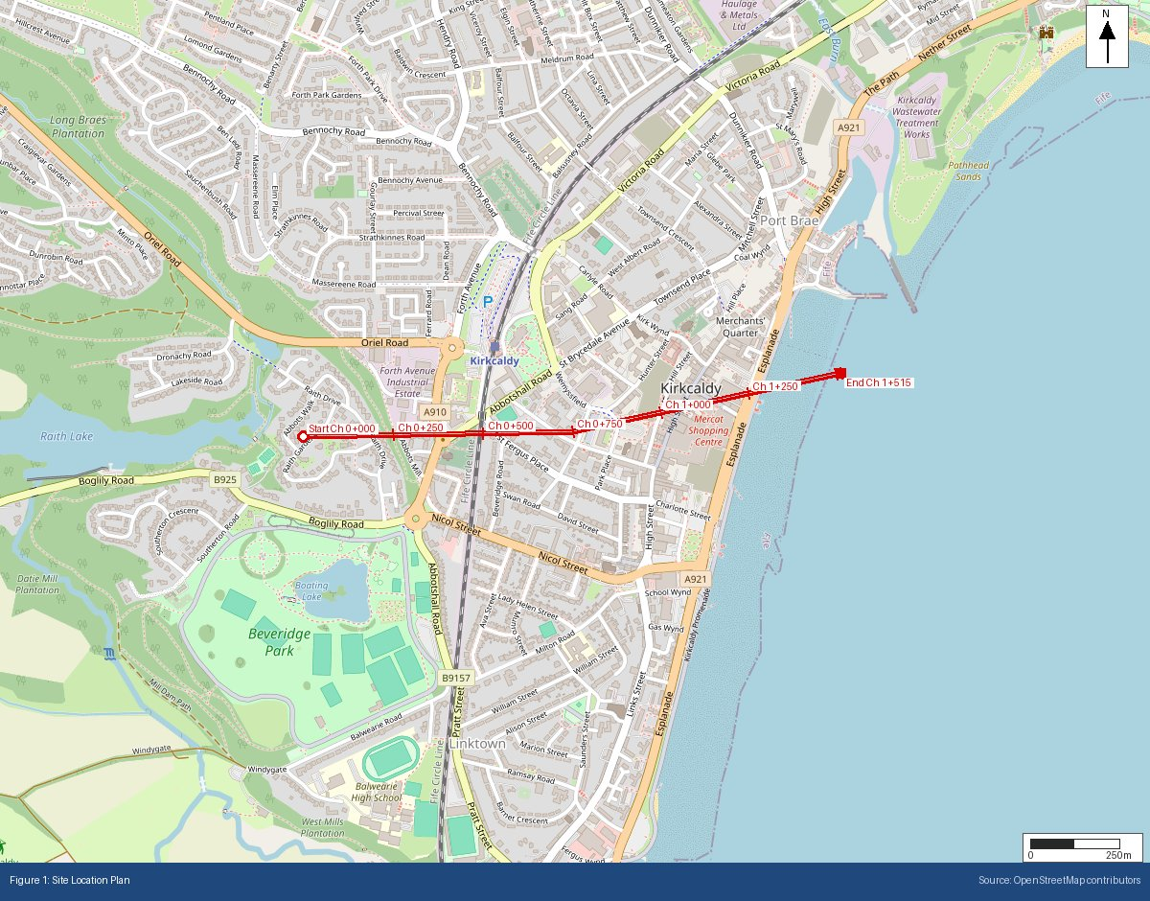

Appendix B: BGS Bedrock Geology Extract
BGS 1:625,000 bedrock geology at site location
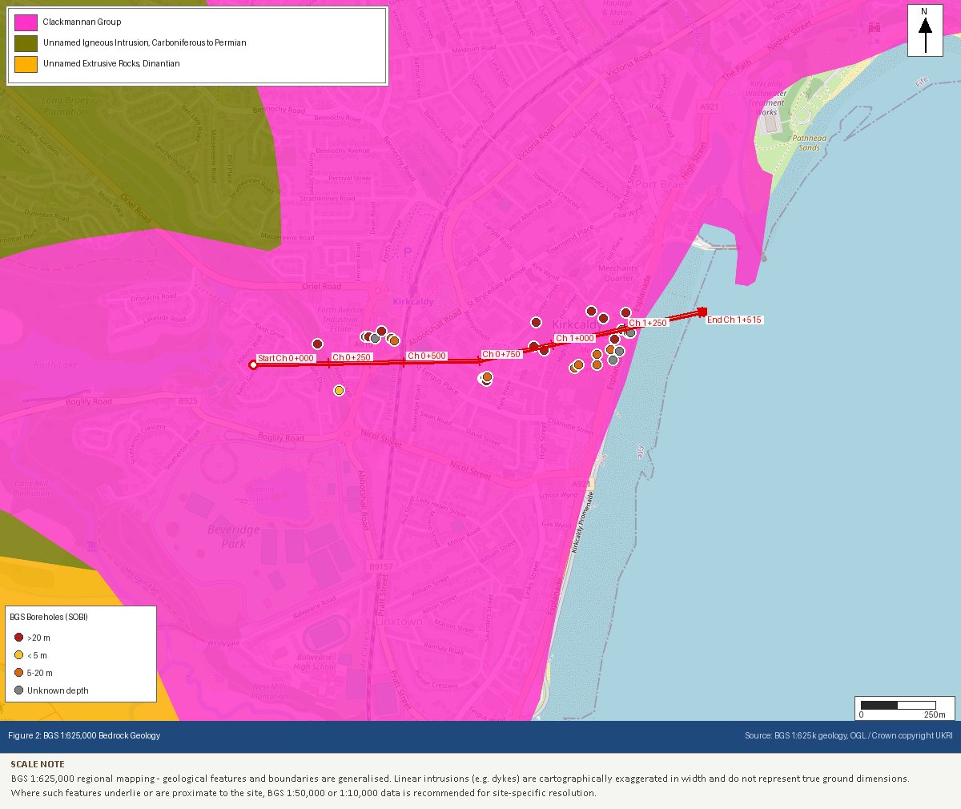

Appendix C: BGS Superficial Geology Extract
BGS 1:625,000 superficial deposits at site location
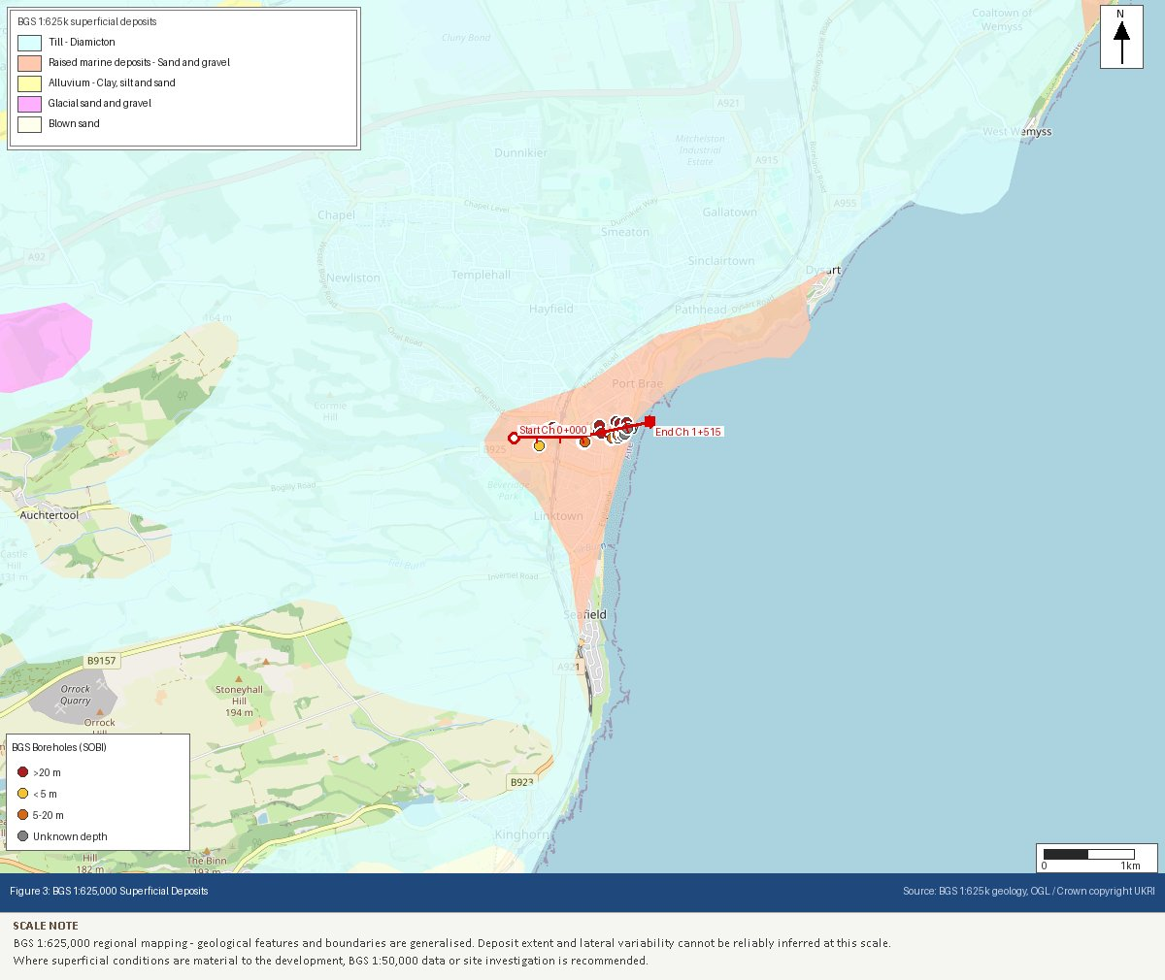

Appendix D: SEPA Flood Map Extract (River and Coastal)
SEPA flood map likelihood classification
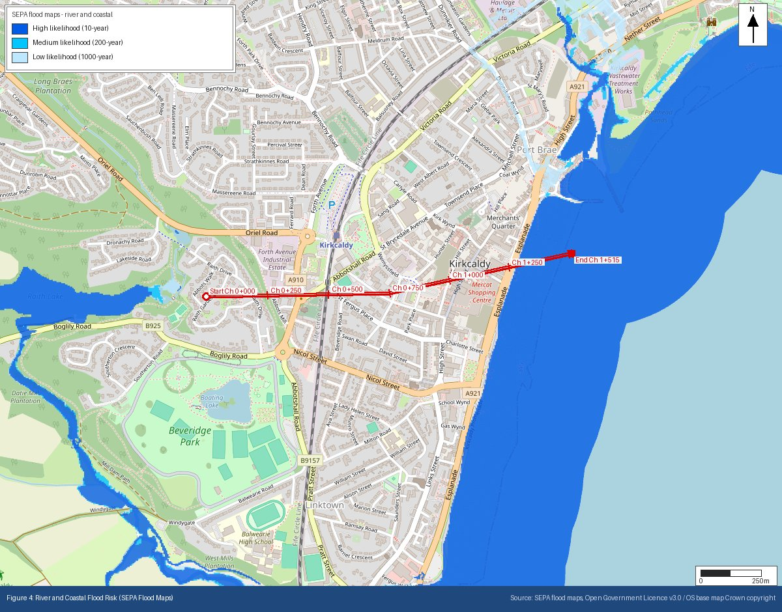

Appendix E: Heritage Designations (Historic Environment Scotland)
Listed buildings, scheduled monuments and conservation areas within 500m
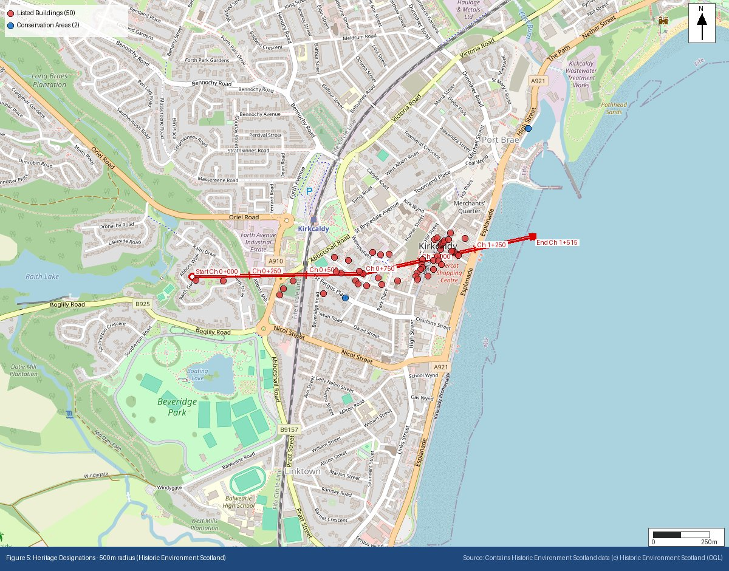

Appendix F: Ecological Designations (NatureScot)
SSSI, SAC, SPA, Ramsar, National Scenic Area and National Park designations within search radii
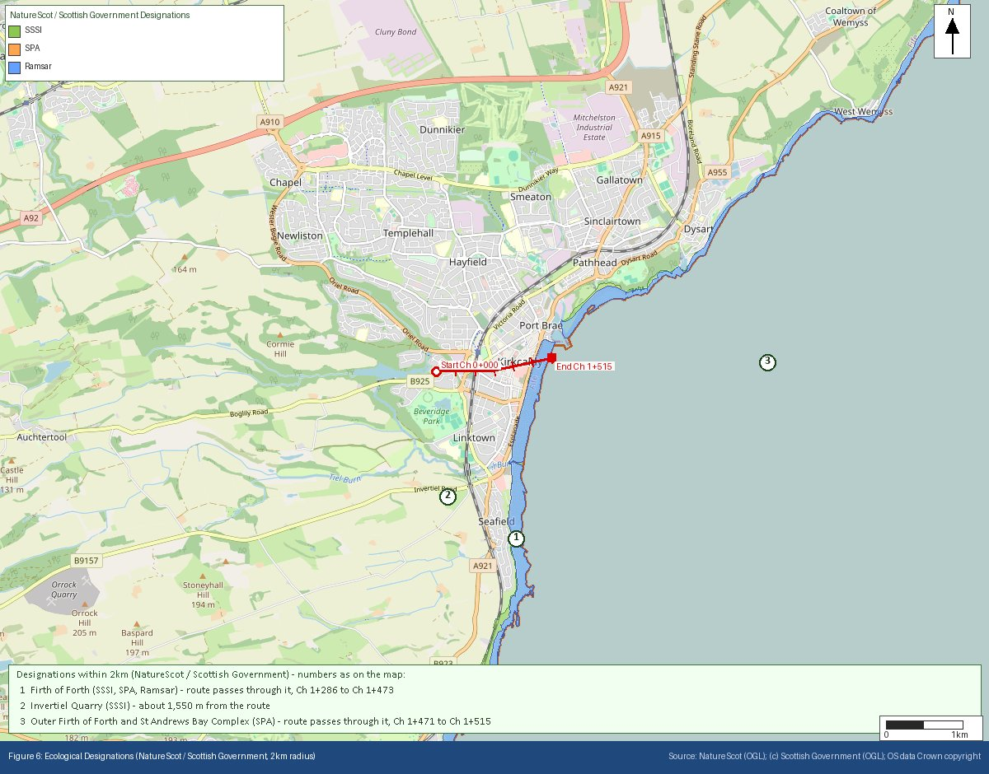

Appendix G: Mining Remediation Authority Output
MRA development risk and mine entries data
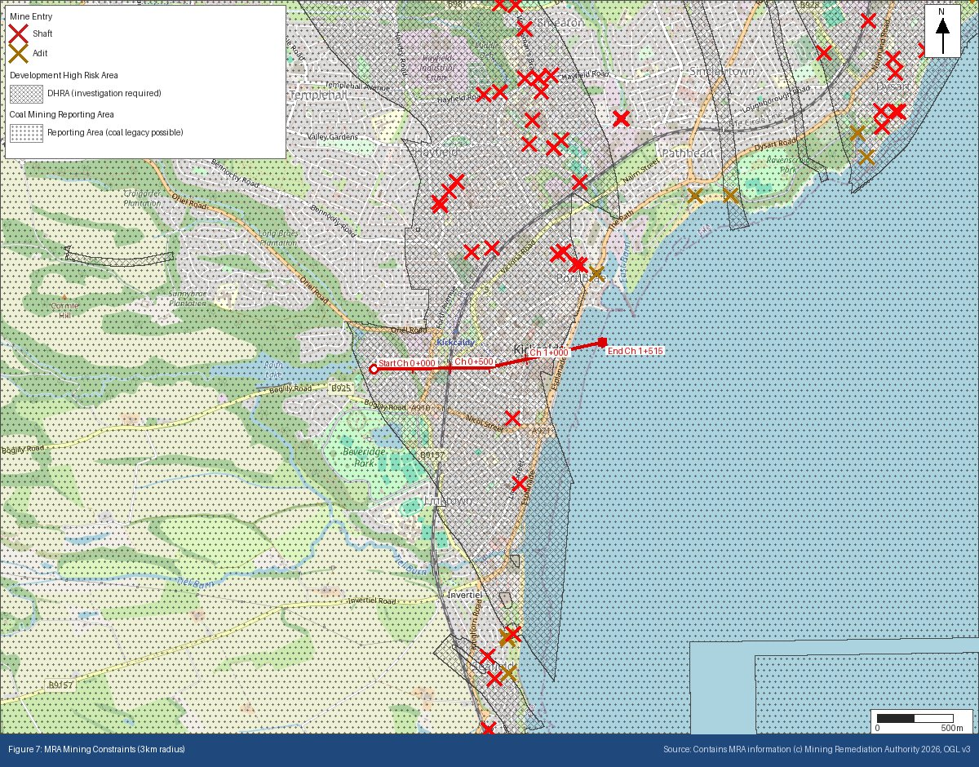

Appendix H: BGS/UKHSA Radon Potential Extract
Radon potential classification at site location
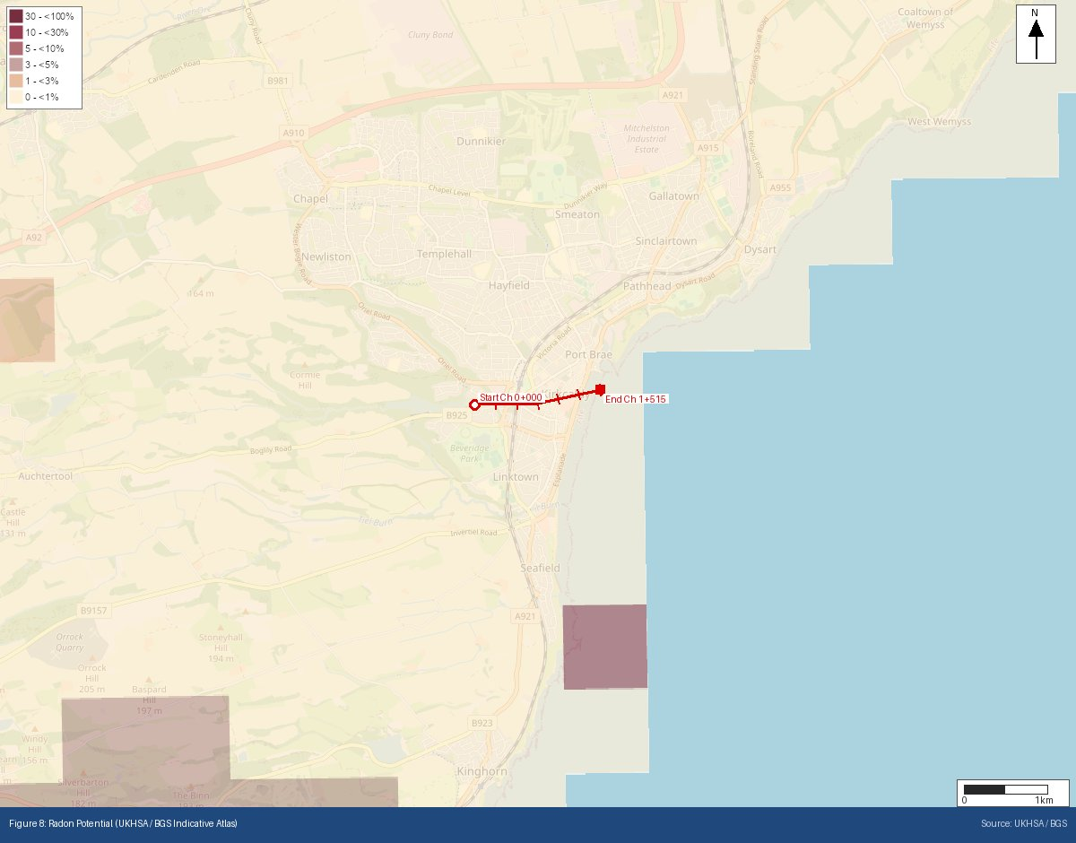
Appendix I: Historical OS Mapping (1885–1903)
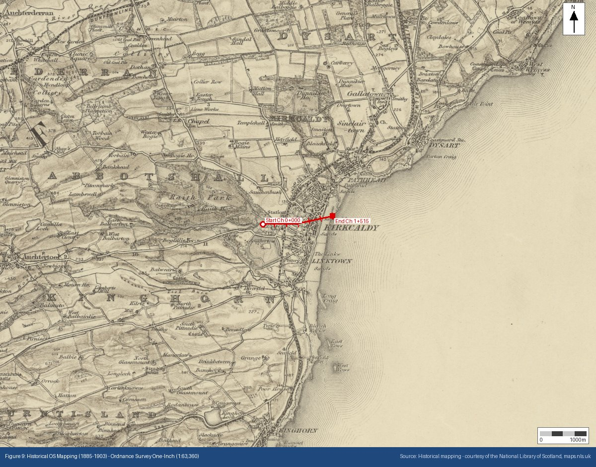

Appendix J: Historical OS Mapping (1888–1913)
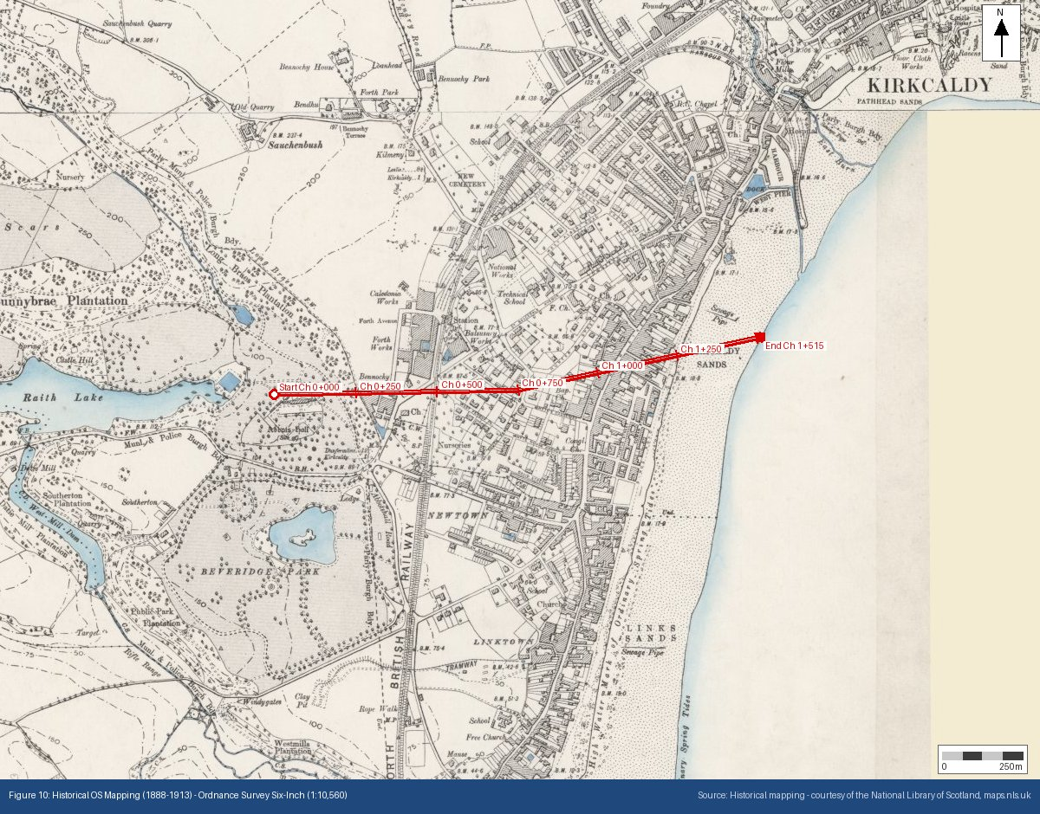

Appendix K: Historical OS Mapping (1919–1947)
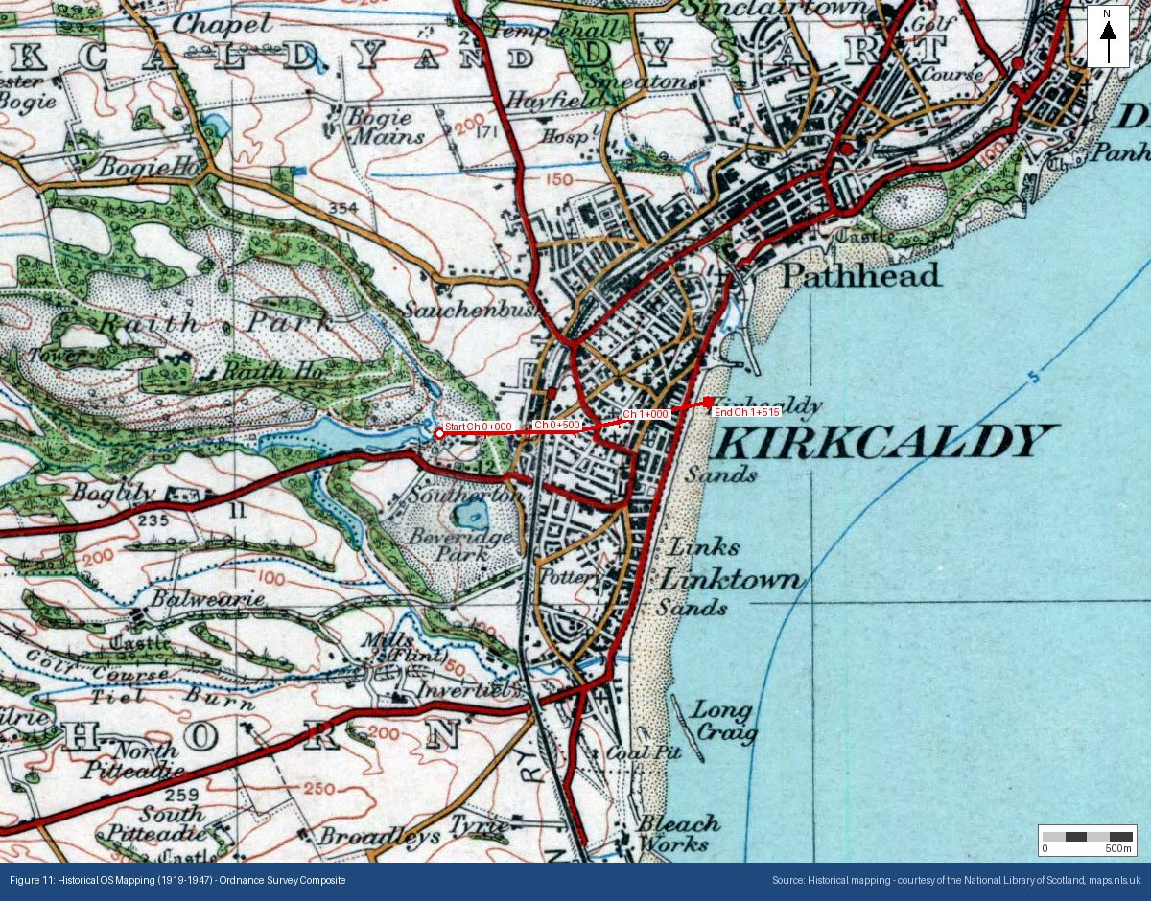

Appendix L: Surface Water Flood Risk (SEPA)
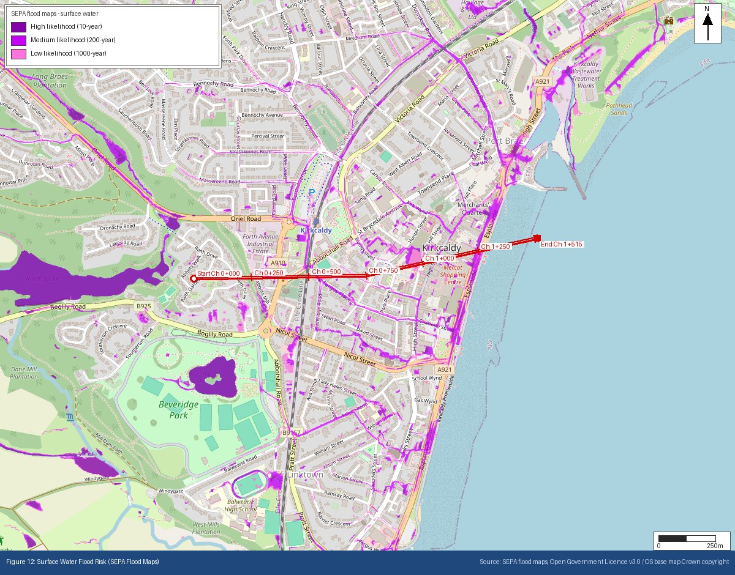
Appendix M: Public Water Supply Catchments (Scottish Water / SEPA)
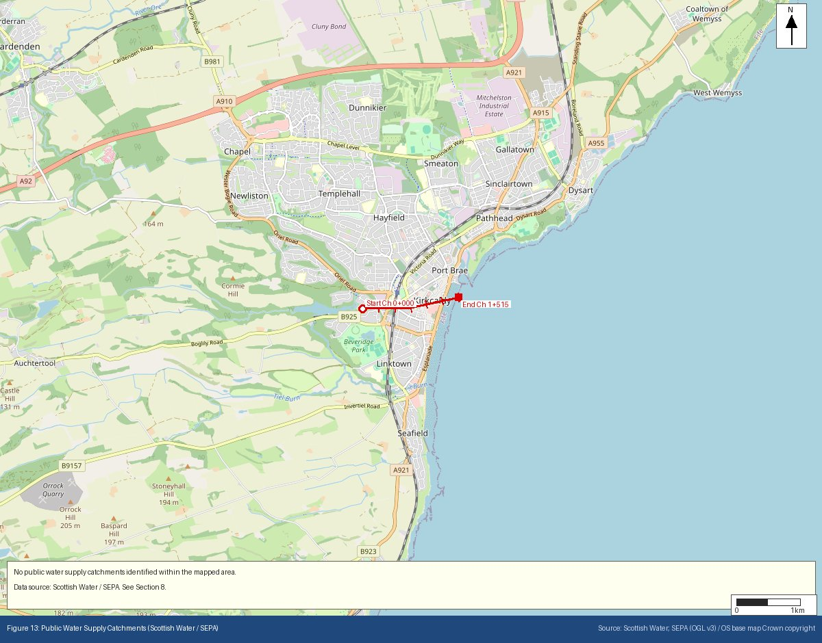
Appendix N: Site Topography — Scottish Public Sector LiDAR Digital Terrain Model
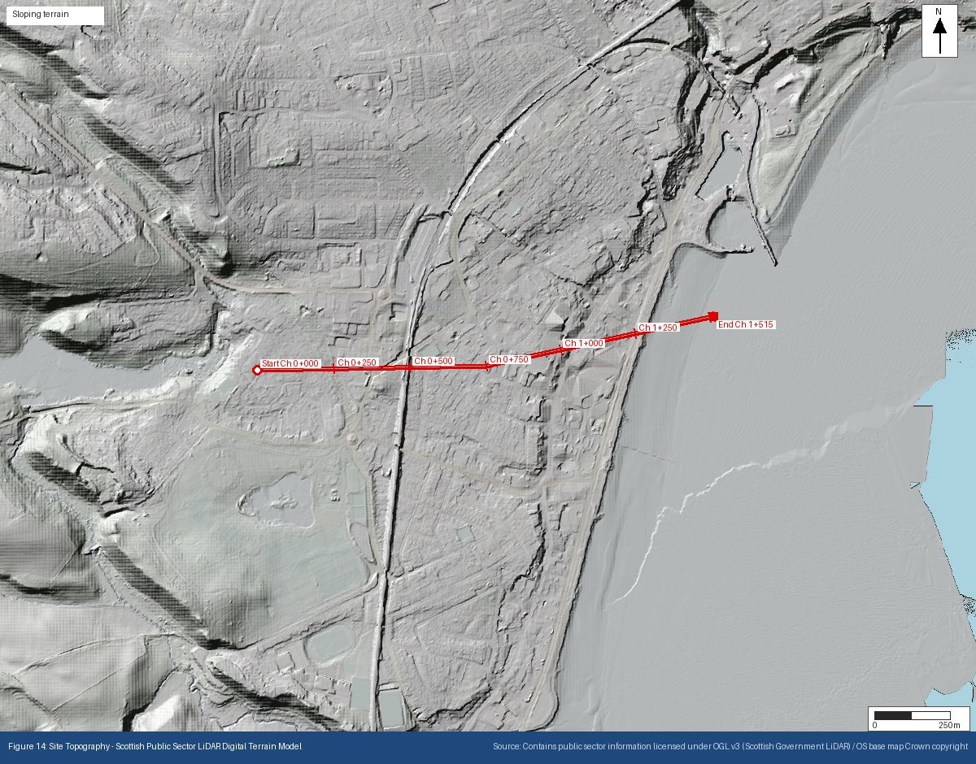
Appendix O: Permitted Regulated Facilities — SEPA Granted Authorisations
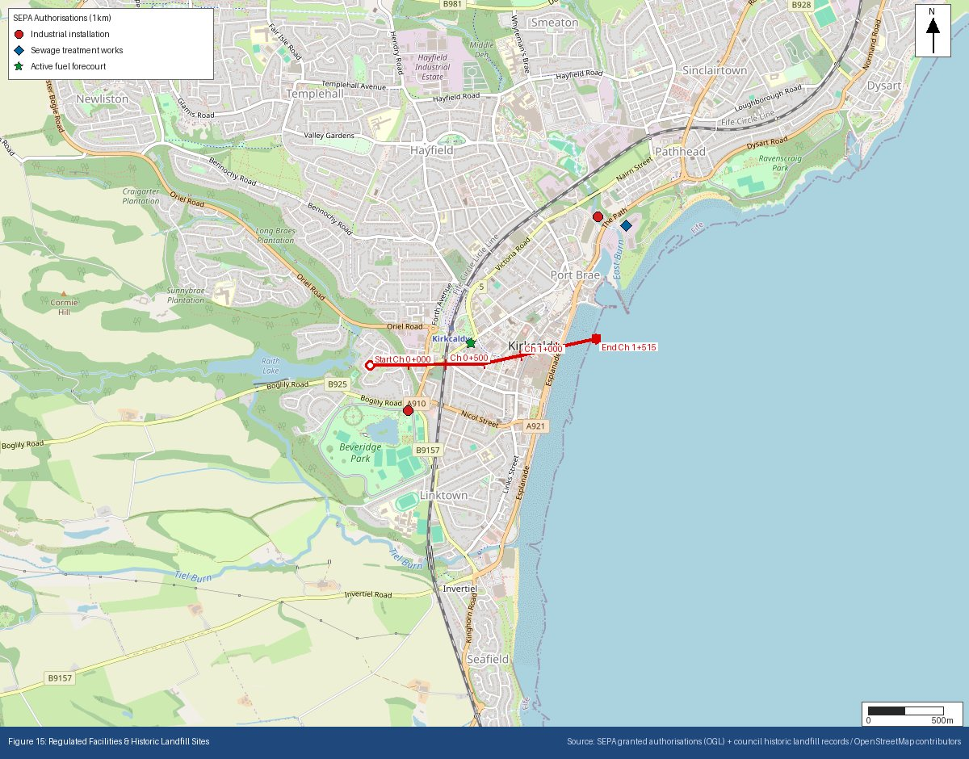
Appendix P: Historical & Current Map Features
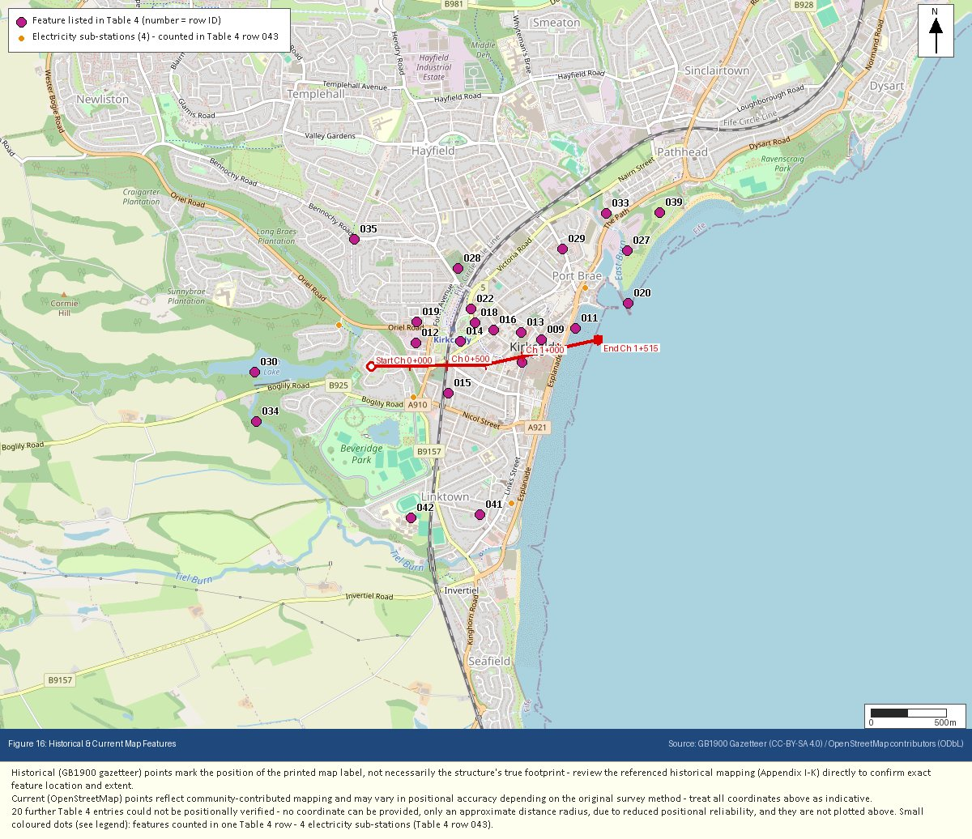
Appendix Q: Underground & Buried Structures
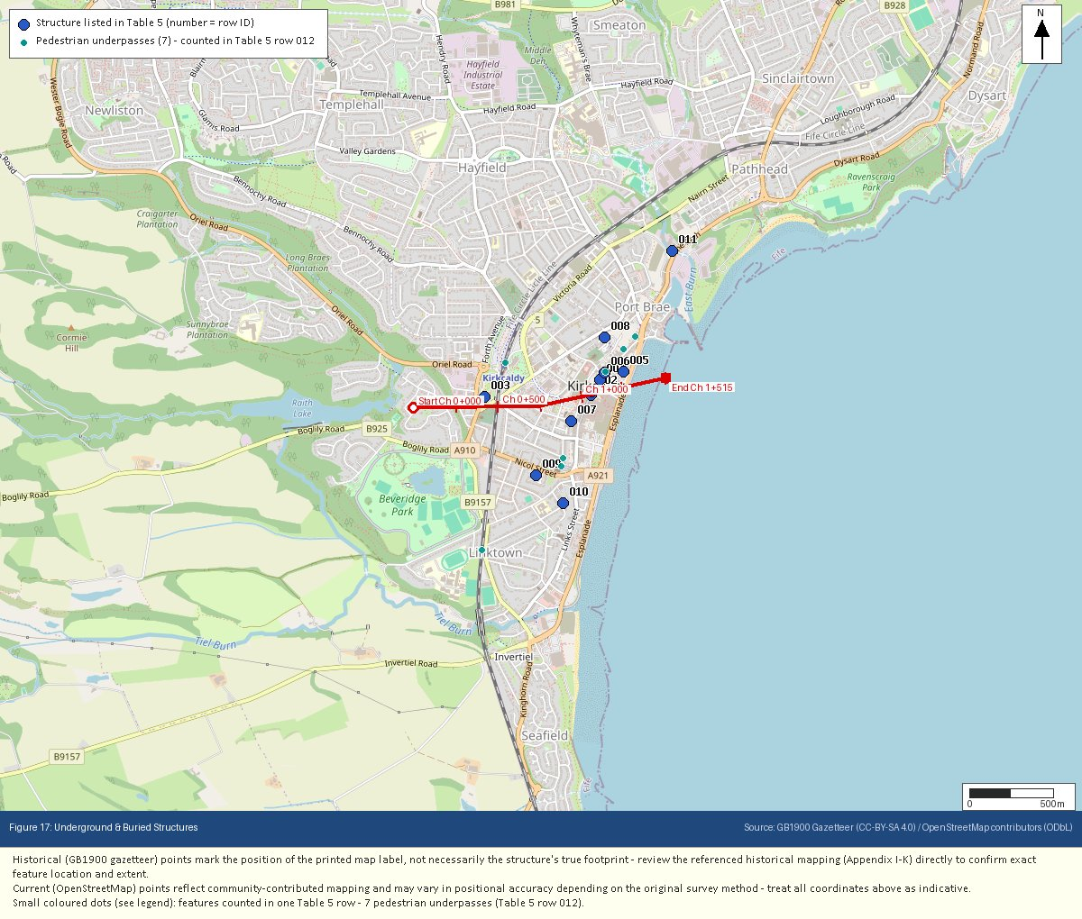
Appendix R: Flood Risk – Reference (Climate Change)
