
PRELIMINARY GEOTECHNICAL
GROUND RISK SCREENING REPORT

RM1 3EJ
RM1 3EJ
OS NGR: 551388 189207

Prepared for: | Magnum GSI
Report Reference: | GEO-5DC2BF49
Date of Issue: | 13 August 2026
Version: | 1.0
Classification: | Indicative — Not for Design
Prepared by: | GeoScreen™ | Magnum GSI Ltd
Prepared by GeoScreen™, an automated reporting platform developed and operated by Magnum GSI Ltd

DOCUMENT CONTROL
Report Title | RM1 3EJ — Preliminary Ground Risk Screening Report
Client | Magnum GSI
Site Address | RM1 3EJ
OS National Grid Reference | 551388 189207
Report Reference | GEO-5DC2BF49
Date of Issue | 13 August 2026
Data Collection Date | 13 August 2026

DISCLAIMER AND SCOPE LIMITATIONS
IMPORTANT NOTICE — PLEASE READ BEFORE USING THIS REPORT
This report has been prepared using GeoScreen™, an automated ground risk screening platform developed and operated by Magnum GSI Ltd.

The report provides an indicative, desk-based assessment of ground conditions and associated constraints based solely on the interrogation and interpretation of publicly available datasets, including but not limited to British Geological Survey (BGS), Environment Agency (EA), Mining Remediation Authority (MRA), Historic England, and Natural England data sources.

This report:
• DOES NOT constitute a professional geotechnical assessment or a BS 5930:2015+A1:2020 compliant desk study
• DOES NOT include intrusive ground investigation, site walkover, or statutory searches
• IS informed by general principles derived from relevant UK geotechnical guidance, but does not constitute a desk study compliant with BS 5930:2015+A1:2020
• IS intended solely for early-stage feasibility, due diligence, and preliminary risk screening purposes

The findings presented are indicative only. Site-specific ground conditions may vary and can only be reliably established through an appropriately scoped ground investigation and professional interpretation by a suitably qualified and experienced geotechnical engineer.

CONTENTS

Executive Summary
1 Introduction
2 Site Setting
3 Planning Context
4 Sources of Information
5 Site History
6 Geology and Ground Conditions
7 Hydrogeology and Hydrology
8 Geohazard Assessment
9 Foundation and Drainage Considerations
10 Conclusions
11 Recommendations
12 Limitations and Liability Statement

Appendices A–R

EXECUTIVE SUMMARY
Site address | RM1 3EJ
Current use | Not confirmed
Proposed development | Residential development
OS Grid Reference | 551388 189207
Local Planning Authority | Havering Council
Geological setting (bedrock) | Thames Group - Clay, Silt, Sand
Geological setting (superficial) | River Terrace Deposits (Undifferentiated)
Overall risk rating | Medium

Key takeaway: The site is assessed as Medium geotechnical risk, with shrink-swell clays and surface water flood risk as the principal considerations. The Thames Group clay-rich succession exhibits moderate shrink-swell potential, requiring careful foundation design to mitigate seasonal ground movement.
Primary constraint:
Shrink-swell clays within the Thames Group succession.
Implication:
Foundation design must account for seasonal ground movement and differential settlement risk.
Required next step:
Undertake intrusive ground investigation to characterise ground conditions and assess shrink-swell potential; review surface water drainage strategy to mitigate localised flood risk.
Overall risk:
Medium.
The site at RM1 3EJ is proposed for residential development, underlain by the Thames Group clay-silt-sand succession. Shrink-swell clays within this formation present moderate ground movement risk, requiring foundation design measures to mitigate seasonal volume change and differential settlement. Heritage assets are recorded within 500m, and a Heritage Impact Assessment may be required to assess impacts on their setting; no statutory ecological designations were identified within the search radii, though a Preliminary Ecological Appraisal may be required to assess protected species and habitats.

Geohazard Overview
Geohazard | Risk Rating | Key Data Source
Mining Legacy | Low | Mining Remediation Authority (Appendix G)
Compressible Ground | Low | BGS 1:625,000 geological mapping (formation analysis)
Shrink-Swell Clays | Medium | BGS 1:625,000 geological mapping (formation analysis)
Slope Instability | Low | BGS 1:625,000 geological mapping + EA LiDAR DTM
Dissolution Features | Low | BGS 1:625,000 geological mapping (formation analysis)
Made Ground | Low | BGS Superficial Geology / Address context
River and Coastal Flood Risk | Low | EA Flood Map for Planning (Appendix D)
Surface Water Flood Risk | Medium | EA Risk of Flooding from Surface Water (RoFSW) (Appendix L)
Radon | Low | BGS/UKHSA Radon Atlas (Appendix H)
Ground Gas | Low | EA Permitted + Historic Landfill (500m)
Aggressive Ground | Low | BGS Geology / Formation lookup
Source Protection Zone | Not identified | EA Source Protection Zones mapping (Appendix M)
Note: Geohazard numbering follows the GeoScreen reference scheme. GH11 (Unexploded Ordnance) is not assessed in this Tier 1 report; this hazard will be incorporated in a future GeoScreen platform release.
Recommendations
– Commission a professional BS 5930:2015+A1:2020 desk study and intrusive ground investigation to characterise ground conditions, assess foundation design parameters, and quantify geotechnical risks.
– Undertake a site walkover to identify surface features, drainage patterns, and potential constraints not evident from desk-based sources.
– Obtain utility searches to identify buried services and inform safe ground investigation planning.
– Commission a heritage impact assessment to evaluate potential effects on nearby designated heritage assets and inform planning strategy.
– Incorporate surface water drainage design measures to mitigate surface water flood risk and address shrink-swell clay ground movement potential through appropriate foundation solutions.
Development Implications
Foundation type: Shallow foundations may be suitable for this lightly loaded residential development subject to structural loading details and ground investigation confirmation, with particular attention to shrink-swell potential in the Thames Group clay horizons.
Key cost risk: Shrink-swell clay (Medium) may require deeper foundation depths or engineered solutions to mitigate seasonal ground movement, with associated cost implications for foundation design.
Planning constraints: Heritage assets identified within 500m — Heritage Impact Assessment may be required and early pre-application engagement with the Local Planning Authority is recommended.
Overall suitability: No significant constraints to development have been identified at this preliminary desk-based stage, subject to confirmation by a professional geotechnical desk study and intrusive ground investigation.

1 INTRODUCTION

1.1 Scope and Purpose
This preliminary ground risk screening report has been prepared for Magnum GSI in respect of land at RM1 3EJ (hereafter referred to as 'the Site'). The report has been prepared by GeoScreen™ (Magnum GSI Ltd) using automated interrogation of publicly available geotechnical and environmental datasets.
The purpose of this report is to provide a high-level, indicative assessment of the ground conditions, environmental constraints, and planning context relevant to the Site, based solely on a review of publicly available data. The report is intended to support early-stage site appraisal, land acquisition decisions, and pre-planning risk screening, and to inform the scope of any subsequent professional ground investigation or planning submission.
This assessment does not include intrusive ground investigation, physical site walkover, statutory environmental searches, or utilities searches. Accordingly, actual site conditions may differ from those described. A professional desk study prepared by a suitably qualified Chartered Geotechnical Engineer, followed by site-specific ground investigation, is recommended to inform design, planning, and construction decisions.

1.2 Site Details
The Site is located at RM1 3EJ. The approximate OS National Grid Reference for the centre of the Site is Easting 551388, Northing 189207.

1.3 Proposed Development
Residential development

1.4 Assessment Methodology
This report has been prepared by automated interrogation of publicly available digital datasets, including those listed in Section 4. Data was collected automatically from each source using the site's OS National Grid Reference as the search point. The findings have been interpreted using AI-assisted interpretation and structured report generation informed by applicable UK standards and guidance.
Each geohazard is assigned a risk rating (Low, Medium, High, or Very High) and a data confidence level. Confidence levels reflect the reliability and completeness of the available data for the assessed geohazard, as defined in Table 2 below.
Table 1 – Geohazard Risk Rating Scale
Risk Rating | Description | Development Implication
Very High | A major geohazard has been identified at or close to the site. The hazard presents a significant constraint to development based on available data. | Comprehensive ground investigation and specialist assessment required. Significant design mitigation or planning constraint is anticipated.
High | A significant geohazard has been identified that is likely to affect the development and requires further investigation. | Targeted ground investigation and specialist assessment required. Design mitigation measures should be anticipated.
Medium | A geohazard has been identified that may influence the development. Further assessment during detailed design is recommended. | Mitigation measures may be required; targeted investigation or specialist assessment is advised.
Low | No significant geohazard has been identified from available data. The hazard is unlikely to materially affect development, subject to confirmation by ground investigation. | No specific mitigation measures are anticipated at this stage; standard design approaches are likely to be suitable.
Table 2 – Data Confidence Levels
Confidence Level | Definition
High | Multiple corroborating data sources; data returned successfully from API; formation or constraint well characterised in national datasets.
Medium | Single primary data source; partial data available; some interpretation assumptions required; formation boundary may be uncertain.
Low | Limited data available; API query returned no data or failed; significant uncertainty in the basis of the assessment.

2 SITE SETTING

2.1 Location and Topography
2.1.1 The site is located at RM1 3EJ, centred on Ordnance Survey National Grid Reference E551388 N189207 (latitude 51.58140, longitude 0.18357). The site lies within the administrative area of Havering Council, in the London Borough of Havering, approximately 15km northeast of central London. The site is situated within the Greater London urban area, in the eastern suburbs of the capital.
2.1.2 The Environment Agency LiDAR Digital Terrain Model indicates that the site occupies gently undulating terrain. The broader landscape is characterised by low-lying ground typical of the Thames Basin, with modest topographic variation reflecting the underlying geology and historical fluvial processes associated with the River Thames and its tributaries. The site lies within a predominantly urban setting where natural topography has been modified by residential and infrastructure development.
2.1.3 Current Ordnance Survey mapping indicates that the site comprises a cemetery. Surrounding land uses include residential development to the north, west, and east, with Coronation Garden, a public garden, located approximately 200m to the southeast. Raphael's Park, a public park, is situated approximately 400m to the northeast. A mainline railway line is present approximately 400m to the south, with Romford railway station located over 1km from the site. The River Rom, a named watercourse, is recorded over 1km from the site. A pond is identified on mapping over 1km to the north. These observations are based on desk-based mapping review only; no site walkover has been undertaken as part of this preliminary assessment.

3 PLANNING CONTEXT

3.1 Local Planning Authority
Planning decisions at the Site are made by Havering Council, which acts as the Local Planning Authority (LPA) for the area.
LPA Name | Havering Council
Planning portal | https://www.planningportal.co.uk
General enquiries | Contact via LPA website

Note: LPA contact details should be verified directly via the planning portal before submission of any pre-application enquiry or planning application.
3.1.1 The proposed residential development at RM1 3EJ falls within the jurisdiction of Havering Council as the Local Planning Authority. The National Planning Policy Framework (NPPF) 2023 provides the overarching policy context for development proposals in England. Chapter 16 (Conserving and enhancing the historic environment) is directly relevant given the presence of eight listed buildings within 500m of the site, including one Grade II* listed building and seven Grade II listed buildings, together with the Romford Conservation Area within 500m. Paragraph 189 of the NPPF requires that planning applications are supported by adequate information on ground conditions, including contamination and land stability, to ensure that development is appropriate for its location and does not contribute to unacceptable risks from land instability or contamination.
3.1.2 Based on the desk-based assessment, Havering Council may require the following technical documents as part of the planning process, subject to confirmation with the Local Planning Authority: a Heritage Impact Assessment to address the proximity of listed buildings and the Romford Conservation Area; a professional geotechnical desk study and intrusive ground investigation to characterise ground conditions, foundation suitability, and any geotechnical or geoenvironmental constraints; and a contaminated land assessment if historical land uses or made ground are identified during site investigation works. Pre-application consultation with Havering Council is strongly recommended to confirm the scope and extent of technical assessments required for this site.

3.2 Heritage Designations
3.2.1 A review of Historic England's National Heritage List for England (NHLE) open data identified 8 listed buildings within 500m of the site, comprising 1 Grade II* listed building and 7 Grade II listed buildings. No scheduled monuments were identified within 500m, and no World Heritage Sites were identified within 5km. One conservation area, Romford Conservation Area, was identified within 500m of the site. The NHLE dataset covers designated heritage assets only; non-designated heritage assets and locally listed buildings may be present but are not captured in this desk-based review.
3.2.2 The presence of designated heritage assets within proximity to the site triggers consideration under Chapter 16 of the National Planning Policy Framework (NPPF), which requires development proposals to conserve and enhance the historic environment. The proposed residential development will need to demonstrate that it avoids harm to the significance of nearby heritage assets, including their settings. A Heritage Impact Assessment is likely to be required to support any planning application, particularly given the presence of Grade II* and Grade II listed buildings within 500m and the site's proximity to Romford Conservation Area. Early consultation with the Local Planning Authority's conservation officer is recommended to establish heritage assessment requirements and to identify any non-designated heritage assets that may also require consideration.
3.2.3 The 1 Grade II* listed building within 500m represents a heritage asset of more than special interest, and its setting will require careful consideration in the design and layout of the proposed development. The 7 Grade II listed buildings within the search radius are of special architectural or historic interest, and their settings must also be assessed. The proximity of Romford Conservation Area indicates that the site lies within a historically sensitive context, and the design of the residential development will need to respond appropriately to the character and appearance of the conservation area. Detailed heritage assessment during the planning stage will be required to identify specific sensitivities and to inform design mitigation measures.

3.3 Ecological Designations
3.3.1 A desk-based review of statutory ecological designations within 2km of the site was undertaken using Natural England's ArcGIS FeatureServer. No Sites of Special Scientific Interest (SSSI), Special Areas of Conservation (SAC), Special Protection Areas (SPA), Ramsar sites, Areas of Outstanding Natural Beauty (AONB), or National Parks were identified within the search radii.
3.3.2 No statutory ecological designations were identified within the search radii at this desk-based stage. This does not preclude the presence of protected species, habitats, or other ecological sensitivities not assessed by this review; an ecological appraisal may be required at planning stage. The proposed residential development should be considered in the context of NPPF Chapter 15 (Conserving and enhancing the natural environment), which requires planning decisions to contribute to and enhance the natural and local environment. Compliance with the Wildlife and Countryside Act 1981 (as amended) and the Conservation of Habitats and Species Regulations 2017 remains a statutory requirement regardless of proximity to designated sites. Early consultation with the Local Planning Authority is recommended to confirm ecological assessment requirements, including protected species surveys and Biodiversity Net Gain (BNG) obligations under the Environment Act 2021.

4 SOURCES OF INFORMATION

4.1 Data Sources Consulted
All data was collected automatically on 13 August 2026 using the site's National Grid Reference as the search point.
Table 3 — Data Sources Consulted
# | Data Source | Provider | Purpose
DS01 | BGS 1:625,000 Bedrock Geology | British Geological Survey | Bedrock geology  (Appendix B)
DS02 | BGS 1:625,000 Superficial Deposits | British Geological Survey | Superficial deposits  (Appendix C)
DS03 | BGS 1:625,000 Formation Analysis | British Geological Survey | Formation-based ground stability assessment (GH02-GH05)
DS04 | BGS Borehole Index (SOBI) | British Geological Survey | Historical borehole records
DS05 | BGS 1:625,000 Geological Faults (OGC API) | British Geological Survey | Major geological fault lines (structural context and figure overlay)
DS06 | EA Flood Map for Planning | Environment Agency | Flood zone classification (Appendix D)
DS07 | BGS Mining Hazard (Non-Coal) 1km Hex Grid v8 | British Geological Survey / UKRI | Non-coal mining hazard (vein minerals, chalk, evaporites, building stone)
DS08 | Mining Remediation Authority WMS | Mining Remediation Authority | Mining legacy (Appendix G)
DS09 | NLS Historical OS Mapping (via MapTiler Cloud) | National Library of Scotland | Historical OS mapping c.1885, 1888–1913 and 1919–1947 (Figs 9–11) (Appendix I-K)
DS10 | Historic England NHLE (ArcGIS FeatureServer) | Historic England | Heritage designations (listed buildings, scheduled monuments, WHS, conservation areas)  (Appendix E)
DS11 | Natural England ArcGIS FeatureServer | Natural England / DEFRA | Ecological designations (SSSI, SAC, SPA, Ramsar, AONB, National Parks) (Appendix F)
DS12 | BGS/UKHSA Radon Indicative Atlas | BGS / UKHSA | Radon potential (Appendix H)
DS14 | OS Names API | Ordnance Survey | Geocoding and LPA lookup (Appendix A)
DS15 | EA Permitted Waste Sites (Authorised Landfill Site Boundaries) | Environment Agency | Ground gas / landfill proximity (500m buffer)
DS16 | EA Historic Landfill Sites | Environment Agency | Ground gas / landfill proximity (500m buffer)
DS17 | BGS GeoIndex Hydrogeology (ArcGIS REST identify) | British Geological Survey | EA aquifer designation (Principal / Secondary A/B / Unproductive Strata)
DS18 | EA Source Protection Zones | Environment Agency | Groundwater source protection zone designation (S3 planning context / S7 hydrogeology) (Appendix M)
DS19 | EA Risk of Flooding from Surface Water (RoFSWExtent1in30 / RoFSWExtent1in100) | Environment Agency | Pluvial / surface water flood risk (GH08 geohazard)  (Appendix L)
DS20 | EA WFD River and Canal Water Bodies Cycle 2 (ArcGIS FeatureServer) | Environment Agency | Named receiving watercourse identification (S7 hydrogeology)
DS21 | OpenStreetMap (local extract, amenity=fuel) | OpenStreetMap contributors (ODbL) | Petrol filling stations within 500m (S5 site history / CSM)
DS22 | EA National LiDAR Programme — Composite DTM 1m (WCS 2.0.1) | Environment Agency (OGL v3) | Site topography, terrain descriptor, slope analysis (S2 site setting, Figure 14 Appendix N)
DS23 | EA Environmental Permitting Register (EPR) — CSV bulk download | Environment Agency (OGL v3) | Environmental permits, registered facilities and flood defence assets within 1km (S5.3, Figure 15 Appendix O)
DS24 | OpenStreetMap (local extract) — infrastructure and land-use sites | OpenStreetMap contributors (ODbL) | Gas holders, sewage/water works, sub-stations, power stations, emergency services, military, aviation, port, quarry and industrial sites within 1km (S5 Historical Features table, Figure 16 Appendix P / S8 CSM sources)
DS25 | Historical Map Feature Positioning (derived from GB1900 Gazetteer, abridged) | Great Britain Historical GIS / GB1900 partners and volunteers (CC-BY-SA 4.0, creativecommons.org/licenses/by-sa/4.0/legalcode) | Historical map feature position (distance/bearing derived from GB1900 gazetteer label coordinates, OS Six-Inch County Series 1888-1913) for S5 Historical Features table, Figure 16 Appendix P
DS26 | OpenStreetMap (local extract) — tunnel, subway and underground structure geometry | OpenStreetMap contributors (ODbL) | Tunnel, subway and underground structure entry/midpoint/exit points within 1km (S5.2 Underground and Buried Structures table, Figure 17 Appendix Q)
DS27 | EA NAFRA2 – Risk of Flooding from Rivers/Sea and Surface Water (4-band, defended/residual risk) | Environment Agency (OGL v3) | Defended/residual flood risk shown for reference only in Figure 18 (Appendix R) – does not affect the GH07/GH08 ratings above

5 SITE HISTORY

5.1 Historical Land Use Review
A limited AI-assisted historical mapping review has been undertaken using Ordnance Survey mapping from three historical epochs (c.—1885, c.—1888–1913, and c.—1919–1947), accessed via the National Library of Scotland (NLS). Historical mapping provides indicative information regarding former land uses, structures, watercourses, and potential ground disturbance not evident from current mapping. Key features identified are summarised in Table 4 below. See Appendix P for mapped locations.
The AI-assisted review included in this report is indicative only and has not been verified by a competent professional. It does not constitute a formal historical land use survey. Where a more detailed professional historical mapping review is required — for example to confirm made ground extent and inform design and planning decisions — this should be commissioned as part of a professional desk study or Tier 2/3 report service.
5.1.1 Historical Ordnance Survey mapping was reviewed via the National Library of Scotland (NLS) digital archive, accessed through MapTiler Cloud. The following map series were examined: Ordnance Survey Six-Inch (1:10,560) covering the period 1888–1913; Ordnance Survey One-Inch (1:63,360) covering the period 1885–1903; and Ordnance Survey Composite (Various scales) covering the period 1919–1947. Copies of the historical mapping are provided as figures in Appendix I (1888–1913), Appendix J (1885–1903), and Appendix K (1919–1947). Post-war Ordnance Survey mapping (post-1947) has not been reviewed as part of this assessment.
5.1.2 Historical mapping indicates that the site has been occupied by a cemetery since at least 1888, with this land use persisting through to the present day. A mainline railway is recorded approximately 400m south of the site, present on all historical map series reviewed and on current OS mapping. A brewery is shown approximately 650m south-southwest on the 1888–1913 and 1919–1947 mapping, representing a potential source of industrial contamination and made ground. A hospital is recorded approximately 640m east-northeast on the 1888–1913 mapping, indicating potential for buried fuel tanks or contaminated ground associated with institutional land use. An Esso fuel station is identified approximately 239m from the site on current OS mapping, representing a potential hydrocarbon contamination source.
5.1.3 This historical mapping review has been undertaken using automated AI-based analysis and has not been verified by a qualified geotechnical engineer. A thorough manual review by a geotechnical professional is recommended as part of a BS 5930-compliant desk study. The six-inch mapping (1888–1913) provides the highest spatial resolution for site-specific interpretation. Post-war Ordnance Survey mapping (post-1947) has not been reviewed as part of this assessment. Such mapping requires a licence from a commercial data supplier and falls outside the scope of this automated desk study. Current OS 1:25,000 mapping has been checked for references to former, old, and disused land uses; however, historical land uses that were active after 1947 and have subsequently been cleared may not be identifiable from current mapping and could therefore be missed by this assessment. A detailed review of post-war mapping should be undertaken as part of a detailed desk study prepared in accordance with BS 5930, ahead of any intrusive ground investigation.
Table 4 — Historical and Current Map Features of Note (indicative — AI-assisted review of NLS/OS mapping and OpenStreetMap data; requires professional verification)
ID | Feature / Land Use | Type | Proximity to Site | Grid Ref | Map Period | Geotechnical Note
001 | Cemetery | Other | On site | E551377 N189217 | Six-inch OS 1888-1913, OS Composite 1919-1947, Current (OS mapping) | Cemetery — potential for soft/disturbed ground; burial ground may affect foundation design and groundwater quality
002 | Coronation Garden | Other | ~200m |  | Current (OS mapping) | Public garden adjacent to cemetery — potential for landscaped/made ground
003 | Police Station (Romford Police Station) | Public Services | ~207m NE | E551568 N189314 | Current (OpenStreetMap data) | Vehicle fleet fuel/maintenance storage — potential hydrocarbon contamination.
004 | Marshalls | Other | ~360m NW | E551132 N189466 | Six-inch OS 1888-1913 | Named area — function unclear from map; potential for historical land use not otherwise labelled
005 | Hospital (Black's Bridge Hospital) | Institutional | ~384m NE | E551654 N189488 | Six-inch OS 1888-1913 | Former hospital — potential for buried medical waste, fuel tanks, or contaminated ground; institutional land use
006 | Railway line | Railway | ~400m |  | Six-inch OS 1888-1913, One-inch OS 1885-1903, OS Composite 1919-1947, Current (OS mapping) | Mainline railway — potential ground-borne vibration; embankments or cuttings may indicate made ground or excavated ground
007 | Raphael's Park | Other | ~400m |  | Current (OS mapping) | Public park — potential for made ground from landscaping, infilled ponds, or former estate features; compare with historical mapping for land use change
008 | Electricity Sub-Station | Utility | ~644m E | E552037 N189221 | Current (OpenStreetMap data) | Electrical infrastructure — potential historic oil-based contamination from transformer equipment.
009 | Brewery | Industrial | ~650m SSW | E551169 N188600 | Six-inch OS 1888-1913, OS Composite 1919-1947 | Brewery — potential for organic contamination, fuel storage, and made ground associated with industrial processes
010 | Electricity Sub-Station (Romford Primary Substation) | Utility | ~734m S | E551268 N188482 | Current (OpenStreetMap data) | Electrical infrastructure — potential historic oil-based contamination from transformer equipment.
011 | Post Depot / Sorting Office (North Street Post Office) | Public Services | ~829m NW | E550638 N189563 | Current (OpenStreetMap data) | Vehicle fleet fuel storage — potential hydrocarbon contamination.
012 | Great Eastern Railway | Railway | ~830m ESE | E552163 N188903 | Six-inch OS 1888-1913, One-inch OS 1885-1903, OS Composite 1919-1947 | Major railway line — potential for made ground from embankments, cuttings, and associated railway infrastructure; already identified but named here for completeness
013 | Stadium (Gidea Park Lawn Tennis Club) | Landmark | ~963m NE | E552085 N189877 | Current (OpenStreetMap data) | Landmark/orientation reference only — no inherent geotechnical or contamination relevance.
Note: entries above showing an approximate distance with no compass direction and no Grid Ref are based solely on AI-assisted interpretation of historical map imagery, with no independent positional cross-check available (e.g. from the GB1900 historical gazetteer or OS/OpenStreetMap current mapping) for these specific features. No coordinate can be provided for these entries — only an approximate distance radius — due to reduced positional reliability, and they are not plotted on Figure 16 (Appendix P). These entries should be verified against the referenced source mapping (Appendix I-K) by a qualified person before being relied upon.

5.2 Underground and Buried Structures
Tunnels, subway lines, and underground passages within 1000m of the site have been identified from historical Ordnance Survey mapping (1888–1913, via the GB1900 gazetteer) and current OpenStreetMap data. Reported positions represent surveyed historical portal locations or, for current infrastructure, entry, midpoint and exit points sampled from the mapped route — indicative of a structure’s presence and approximate alignment only, not a precise underground survey.
This is a partial dataset: the absence of a feature here does not indicate the absence of underground structures at or near the site. It does not capture all historical tunnels, privately-held structures, or utility and service tunnel infrastructure, which requires a dedicated utility search. Key features identified are summarised in Table 5 below. See Appendix Q for mapped locations.
Table 5 — Underground and Buried Structures (indicative — derived from GB1900 historical gazetteer and OpenStreetMap current mapping; entry/exit/midpoint point data, not a precise underground survey)
ID | Structure / Name | Type | Proximity to Site | Grid Ref | Source | Note
001 | Pedestrian Underpass | Buried Structure | ~93m SSE | E551413 N189117 | Current (OpenStreetMap data) | Current buried structure identified via OpenStreetMap tunnel tagging — potential for made ground, voids, or design constraints near its route; exact alignment, depth, and construction not confirmed by this desk-based review.
002 | Pedestrian Underpass | Buried Structure | ~133m SSE | E551425 N189079 | Current (OpenStreetMap data) | Current buried structure identified via OpenStreetMap tunnel tagging — potential for made ground, voids, or design constraints near its route; exact alignment, depth, and construction not confirmed by this desk-based review.
003 | Pedestrian Underpass (Laurie Walk) | Buried Structure | ~166m S | E551383 N189041 | Current (OpenStreetMap data) | Current buried structure identified via OpenStreetMap tunnel tagging — potential for made ground, voids, or design constraints near its route; exact alignment, depth, and construction not confirmed by this desk-based review.
004 | Road Tunnel | Buried Structure | ~213m ENE | E551593 N189267 | Current (OpenStreetMap data) | Current buried structure identified via OpenStreetMap tunnel tagging — potential for made ground, voids, or design constraints near its route; exact alignment, depth, and construction not confirmed by this desk-based review.
005 | Pedestrian Underpass | Buried Structure | ~225m SSE | E551439 N188988 | Current (OpenStreetMap data) | Current buried structure identified via OpenStreetMap tunnel tagging — potential for made ground, voids, or design constraints near its route; exact alignment, depth, and construction not confirmed by this desk-based review.
006 | Pedestrian Underpass | Buried Structure | ~262m SE | E551542 N188994 | Current (OpenStreetMap data) | Current buried structure identified via OpenStreetMap tunnel tagging — potential for made ground, voids, or design constraints near its route; exact alignment, depth, and construction not confirmed by this desk-based review.
007 | Pedestrian Underpass | Buried Structure | ~284m SSE | E551478 N188937 | Current (OpenStreetMap data) | Current buried structure identified via OpenStreetMap tunnel tagging — potential for made ground, voids, or design constraints near its route; exact alignment, depth, and construction not confirmed by this desk-based review.
008 | Pedestrian Underpass | Buried Structure | ~293m SSE | E551459 N188922 | Current (OpenStreetMap data) | Current buried structure identified via OpenStreetMap tunnel tagging — potential for made ground, voids, or design constraints near its route; exact alignment, depth, and construction not confirmed by this desk-based review.
009 | Pedestrian Underpass | Buried Structure | ~337m S | E551367 N188871 | Current (OpenStreetMap data) | Current buried structure identified via OpenStreetMap tunnel tagging — potential for made ground, voids, or design constraints near its route; exact alignment, depth, and construction not confirmed by this desk-based review.
010 | Pedestrian Underpass (Liberty Square) | Buried Structure | ~344m S | E551358 N188864 | Current (OpenStreetMap data) | Current buried structure identified via OpenStreetMap tunnel tagging — potential for made ground, voids, or design constraints near its route; exact alignment, depth, and construction not confirmed by this desk-based review.
011 | Pedestrian Underpass | Buried Structure | ~366m WSW | E551067 N189029 | Current (OpenStreetMap data) | Current buried structure identified via OpenStreetMap tunnel tagging — potential for made ground, voids, or design constraints near its route; exact alignment, depth, and construction not confirmed by this desk-based review.
012 | Pedestrian Underpass | Buried Structure | ~372m WSW | E551042 N189068 | Current (OpenStreetMap data) | Current buried structure identified via OpenStreetMap tunnel tagging — potential for made ground, voids, or design constraints near its route; exact alignment, depth, and construction not confirmed by this desk-based review.
013 | Pedestrian Underpass | Buried Structure | ~392m S | E551351 N188816 | Current (OpenStreetMap data) | Current buried structure identified via OpenStreetMap tunnel tagging — potential for made ground, voids, or design constraints near its route; exact alignment, depth, and construction not confirmed by this desk-based review.
014 | Pedestrian Underpass (Westway) | Buried Structure | ~396m S | E551339 N188814 | Current (OpenStreetMap data) | Current buried structure identified via OpenStreetMap tunnel tagging — potential for made ground, voids, or design constraints near its route; exact alignment, depth, and construction not confirmed by this desk-based review.
015 | Pedestrian Underpass | Buried Structure | ~411m WSW | E551010 N189042 | Current (OpenStreetMap data) | Current buried structure identified via OpenStreetMap tunnel tagging — potential for made ground, voids, or design constraints near its route; exact alignment, depth, and construction not confirmed by this desk-based review.
016 | Pedestrian Underpass (Lockwood Walk) | Buried Structure | ~424m S | E551366 N188784 | Current (OpenStreetMap data) | Current buried structure identified via OpenStreetMap tunnel tagging — potential for made ground, voids, or design constraints near its route; exact alignment, depth, and construction not confirmed by this desk-based review.
017 | Pedestrian Underpass (Stewards Walk) | Buried Structure | ~441m S | E551380 N188766 | Current (OpenStreetMap data) | Current buried structure identified via OpenStreetMap tunnel tagging — potential for made ground, voids, or design constraints near its route; exact alignment, depth, and construction not confirmed by this desk-based review.
018 | Culverted Watercourse (River Rom) | Buried Structure | ~481m WSW | E550972 N188962 | Current (OpenStreetMap data) | Current buried structure identified via OpenStreetMap tunnel tagging — potential for made ground, voids, or design constraints near its route; exact alignment, depth, and construction not confirmed by this desk-based review.
019 | Road Tunnel | Buried Structure | ~516m SW | E550972 N188900 | Current (OpenStreetMap data) | Current buried structure identified via OpenStreetMap tunnel tagging — potential for made ground, voids, or design constraints near its route; exact alignment, depth, and construction not confirmed by this desk-based review.
020 | Culverted Watercourse (Black's Brook) | Buried Structure | ~598m ENE | E551924 N189475 | Current (OpenStreetMap data) | Current buried structure identified via OpenStreetMap tunnel tagging — potential for made ground, voids, or design constraints near its route; exact alignment, depth, and construction not confirmed by this desk-based review.
021 | Pedestrian Underpass | Buried Structure | ~607m SSW | E551163 N188643 | Current (OpenStreetMap data) | Current buried structure identified via OpenStreetMap tunnel tagging — potential for made ground, voids, or design constraints near its route; exact alignment, depth, and construction not confirmed by this desk-based review.
022 | Pedestrian Underpass | Buried Structure | ~668m SW | E550976 N188680 | Current (OpenStreetMap data) | Current buried structure identified via OpenStreetMap tunnel tagging — potential for made ground, voids, or design constraints near its route; exact alignment, depth, and construction not confirmed by this desk-based review.
023 | Pedestrian Underpass | Buried Structure | ~691m SW | E550964 N188660 | Current (OpenStreetMap data) | Current buried structure identified via OpenStreetMap tunnel tagging — potential for made ground, voids, or design constraints near its route; exact alignment, depth, and construction not confirmed by this desk-based review.
024 | Pedestrian Underpass | Buried Structure | ~712m SW | E550969 N188630 | Current (OpenStreetMap data) | Current buried structure identified via OpenStreetMap tunnel tagging — potential for made ground, voids, or design constraints near its route; exact alignment, depth, and construction not confirmed by this desk-based review.
025 | Pedestrian Underpass | Buried Structure | ~806m W | E550586 N189311 | Current (OpenStreetMap data) | Current buried structure identified via OpenStreetMap tunnel tagging — potential for made ground, voids, or design constraints near its route; exact alignment, depth, and construction not confirmed by this desk-based review.
026 | Pedestrian Underpass (Battis Way Subway) | Buried Structure | ~892m SSW | E551106 N188360 | Current (OpenStreetMap data) | Current buried structure identified via OpenStreetMap tunnel tagging — potential for made ground, voids, or design constraints near its route; exact alignment, depth, and construction not confirmed by this desk-based review.
027 | Pedestrian Underpass | Buried Structure | ~897m WNW | E550609 N189657 | Current (OpenStreetMap data) | Current buried structure identified via OpenStreetMap tunnel tagging — potential for made ground, voids, or design constraints near its route; exact alignment, depth, and construction not confirmed by this desk-based review.
028 | Road Tunnel | Buried Structure | ~972m SW | E550787 N188441 | Current (OpenStreetMap data) | Current buried structure identified via OpenStreetMap tunnel tagging — potential for made ground, voids, or design constraints near its route; exact alignment, depth, and construction not confirmed by this desk-based review.
029 | Pedestrian Underpass | Buried Structure | ~980m NNW | E550903 N190060 | Current (OpenStreetMap data) | Current buried structure identified via OpenStreetMap tunnel tagging — potential for made ground, voids, or design constraints near its route; exact alignment, depth, and construction not confirmed by this desk-based review.

5.3 Current Regulatory Context
EA-registered permitted facilities and fuel stations identified within 1km of the assessed site location are summarised in Table 6 below. See Appendix O for mapped locations.
Table 6 — EA Registered Permitted Facilities and Fuel Stations (1km radius)
Facility Name | Category / Type | Distance | Direction
Esso | Active fuel forecourt | 239m | E
Sainsbury's Petrol | Active fuel forecourt | 700m | SW
BP Connect | Active fuel forecourt | 998m | NW

5.4 Recorded Mine Shafts
Mine entries (shafts, adits, and gutter pits) recorded by the Mining Remediation Authority within 500m of the assessed site location are summarised in Table 7 below. See Figure 7 (Appendix G) for mapped locations.
Mine entry positions are approximate, derived from automated analysis of the Mining Remediation Authority’s Mine Entry map layer image rather than a surveyed or attribute-based query — the underlying service does not currently support direct coordinate or attribute retrieval.
Each position is accurate to within approximately 50m. No depth, diameter, treatment status, or colliery name is available from this dataset; to obtain this information, it is recommended that a CON29M Coal Mining Search and, where more detail is required, a Consultants Coal Mining Report are obtained from the Mining Remediation Authority. This table lists entries within 500m of the site; the GH01 Mining Legacy rating in Section 8 considers a wider 1000m radius, so an entry between 500m and 1000m may be referenced there without appearing in this table.
Table 7 — Recorded Mine Shafts (500m radius)
ID | Type | Proximity | Grid Reference
No mine entries (shafts, adits, or gutter pits) were recorded by the Mining Remediation Authority within 500m of the site at the time of this assessment.

6 GEOLOGY AND GROUND CONDITIONS

6.1 Data Sources
The geological assessment is based on a review of BGS 1:625,000 digital geological map (OpenGeoscience WMS) and the BGS Single Onshore Borehole Index (SOBI). No intrusive investigation or site-specific borehole data has been reviewed as part of this study.

6.2 Geological Assessment
6.2.1 The geological assessment is based on BGS regional-scale 1:625,000 digital mapping, which is indicative only. The Thames Group (THAM) — clay, silt, and sand — forms the bedrock at the site. This geological unit is of Palaeogene age and represents a sequence of estuarine and shallow marine sediments deposited during the Eocene epoch. The Thames Group typically comprises stiff to very stiff overconsolidated clays interbedded with silty and sandy horizons, which are generally competent for foundation purposes. Engineering properties are variable depending on the proportion of clay, silt, and sand within the succession, and on the degree of weathering at shallow depth. The clay-rich horizons may exhibit moderate to high plasticity and are susceptible to shrink-swell behaviour, whilst the sandy and silty beds provide more granular, free-draining conditions. Foundation design will need to account for this lithological variability and the potential for differential settlement where clay and sand units are juxtaposed.
6.2.2 No additional bedrock formations were identified within 1km of the site, indicating that the Thames Group succession is laterally extensive across the local area. The broader geological setting is characterised by Palaeogene sediments deposited in a shallow marine to estuarine environment following the retreat of the Chalk seas at the end of the Cretaceous period. The Thames Group represents a transitional depositional phase, with fluctuating sea levels and sediment supply resulting in the interbedded clay, silt, and sand lithologies observed. The geological sequence is relatively uniform at regional scale, although localised variations in lithology and thickness are common and cannot be resolved by 1:625,000 mapping. The absence of significant structural complexity or major lithological boundaries within the immediate vicinity suggests that ground conditions are likely to be broadly consistent across the site, subject to confirmation by intrusive investigation.
6.2.3 Superficial deposits are present at the site, comprising River Terrace Deposits (Undifferentiated) of Quaternary age. These deposits are typically composed of sand and gravel with subordinate silt and clay, representing fluvial sediments laid down by former river systems during periods of higher base level. River Terrace Deposits are generally free-draining and provide competent foundation conditions, although thickness and grading may vary locally. The presence of these deposits indicates that the site lies within a former river valley or terrace landscape, and the superficial cover may mask the underlying Thames Group bedrock at shallow depth. The thickness of the River Terrace Deposits is not known from desk-based sources and will require confirmation by ground investigation. Where present, these deposits may influence shallow foundation design and excavation conditions, particularly if groundwater is encountered within the granular strata.
6.2.4 A total of 65 BGS borehole records were identified within 500m of the site, indicating that the local area has been subject to previous geotechnical investigation. The nearest record is Romford Ring Road R11, located approximately 110m from the site and drilled in 1962 to a depth of 3.05m. The deepest nearby record is Market Place Romford Essex 3, which reached 14.5m depth. The ten nearest boreholes are listed in Table 3. Whilst the density of borehole coverage in the vicinity is relatively high, the age and limited depth of many records means that detailed stratigraphic and geotechnical information may not be available for all logs. The borehole data provides indicative evidence of subsurface conditions in the local area, but cannot be relied upon to characterise ground conditions at the site itself. Intrusive ground investigation will be required to confirm the thickness and engineering properties of the superficial deposits, the depth to bedrock, groundwater conditions, and the suitability of the strata for the proposed residential development.

6.3 Historical Borehole Records
The table below summarises BGS borehole records identified within 500m of the site from the BGS Single Onshore Borehole Index (SOBI). Where scan records are available, these can be accessed via the BGS borehole viewer. All borehole data is indicative and should be verified against original records.
Table 8 — Historical Borehole Records (BGS SOBI, 500m radius. Borehole records can be searched via BGS GeoIndex Onshore)
BGS Reference | Name | Approx. NGR | Distance | Depth (m) | Year
TQ58NW252 | Romford Ring Road R11 | E551440 N189110 | 110m | 3.05m | 1962
TQ58NW256 | Romford Ring Road S7 | E551390 N189090 | 117m | 6.1m | 1962
TQ58NW251 | Romford Ring Road R10 | E551330 N189100 | 122m | 3.05m | 1962
TQ58NW258 | Romford Ring Road S9 | E551410 N189080 | 129m | 6.1m | 1962
TQ58NW250 | Romford Ring Road R9 | E551280 N189110 | 145m | 2.44m | 1962
TQ58NW260 | Market Place Romford Essex 2 | E551294 N189094 | 147m | 9.0m | 1983
TQ58NW89 | Havering Courthouse Romford BH1 | E551530 N189250 | 148m | 4.0m | Unknown
TQ58NW255 | Romford Ring Road S6 | E551430 N189050 | 163m | 6.1m | 1962
TQ58NW259 | Market Place Romford Essex 1 | E551325 N189054 | 165m | 14.0m | 1983
TQ58NW261 | Market Place Romford Essex 3 | E551274 N189066 | 181m | 14.5m | 1983
Note: Table shows the 8 nearest borehole records within 500m, plus the 2 deepest record(s) from the same radius not already listed, sorted by distance. Records with recorded depth data and an available scan log are prioritised over nearby records without, where available. BGS References are hyperlinked to available scan logs where shown. Source: BGS Single Onshore Borehole Index (SOBI).

7 HYDROGEOLOGY AND HYDROLOGY
7.1.1 Environment Agency Flood Map for Planning indicates that the site lies within Flood Zone 1 (Low Probability), defined as land with less than 0.1% annual probability of river or sea flooding. Under the NPPF Sequential Test, a Flood Risk Assessment is not typically required for most development types in Flood Zone 1. The site is located approximately 473m from the Rom (Bourne Brook to Ravensbourne), the corridor of which falls within a higher flood zone. Surface water flood risk is assessed separately under Section 8.
7.1.2 BGS 1:625,000 hydrogeological mapping classifies the Thames Group bedrock as having essentially no groundwater (rocks with negligible hydraulic conductivity). Groundwater sensitivity is low and formal EA aquifer designation is unlikely to apply; however, perched groundwater may still be encountered in superficial deposits or locally fractured zones. The EA aquifer designation for this site should be confirmed directly from EA Groundwater mapping prior to finalising drainage strategy or where infiltration drainage or dewatering is proposed.
7.1.3 The Rom (Bourne Brook to Ravensbourne) is the nearest named watercourse and represents the likely receiving watercourse for surface water discharge from the proposed residential development. No Source Protection Zone applies to the site. Drainage strategy should be agreed with the Local Planning Authority and where relevant the Environment Agency. Where discharge to a watercourse or sewer may be required, EA consent or permits may be required depending on the receiving watercourse and discharge route.

8 GEOHAZARD ASSESSMENT
The following sections assess each principal geohazard category relevant to the Site. Risk ratings are based on desk-based data only and should be treated as indicative. Actual risk levels can only be determined following site-specific intrusive investigation.
8.1 Mining Legacy (including subsidence and instability): The site does not lie within the MRA Coal Mining Reporting Area, and the MRA WMS dataset records no Development High Risk Area designation and no recorded mine entries within 1,000m of the site. BGS 1:625,000 digital geological mapping indicates that the site is underlain by the Thames Group, a Palaeogene clay-silt-sand succession not associated with coal-bearing strata. The BGS non-coal mining dataset (1km hexagonal grid v8) returns no classification for this location, indicating no known record of non-coal mining activity. On the basis of the available desk-based data, mining legacy is assigned a Low geotechnical risk rating with High confidence. No mining-related constraints to the proposed residential development have been identified at this stage.
8.2 Compressible Ground: As described in Section 6, the site is underlain by the Thames Group, a Palaeogene succession comprising clay, silt, and sand. The Thames Group is not typically associated with significant primary compressibility, though localised zones of soft or loose alluvial deposits may be present where the succession includes fine-grained estuarine or lagoonal facies. BGS 1:625,000 digital geological mapping indicates no superficial deposits at the site, reducing the likelihood of highly compressible recent alluvium or peat. On the basis of the available desk-based data, compressible ground is assigned a Low geotechnical risk rating with Medium confidence. The Medium confidence reflects the generalised scale of the mapping and the absence of site-specific ground investigation data to characterise the engineering properties of the Thames Group at this location. Foundation design should account for the potential variability in stiffness and compressibility within the Thames Group succession, and settlement calculations should be informed by ground investigation data once available.
8.3 Shrink-Swell Clays: As described in Section 6, the site is underlain by the Thames Group, a Palaeogene succession comprising clay, silt, and sand. The clay-rich horizons within the Thames Group are known to exhibit moderate shrink-swell potential in response to seasonal moisture variation, particularly where the clay content is high and the depth to the water table is sufficient to permit desiccation. BGS 1:625,000 digital geological mapping indicates that the Thames Group is present at rockhead, with no superficial cover recorded. On the basis of the available desk-based data, shrink-swell clays are assigned a Medium geotechnical risk rating with Medium confidence. The Medium confidence reflects the generalised scale of the mapping and the absence of site-specific data on clay mineralogy, plasticity, and depth to the water table. Foundation design for the proposed residential development should incorporate measures to mitigate the effects of shrink-swell, including appropriate foundation depth, heave precautions, and consideration of tree proximity in accordance with NHBC Standards Chapter 4.2. Ground investigation should include laboratory testing to determine the plasticity index and shrinkage characteristics of the Thames Group clay at this location.
8.4 Slope Instability: EA LiDAR DTM terrain data indicates that the site is characterised by gently undulating terrain, with no evidence of steep slopes, escarpments, or geomorphological features indicative of active or relict landsliding. BGS 1:625,000 digital geological mapping indicates that the site is underlain by the Thames Group, a Palaeogene clay-silt-sand succession not typically associated with large-scale slope instability, though localised shallow failures may occur on steeper slopes where clay-rich horizons are present. The assessment is based on desk-based LiDAR terrain analysis only, without a site walkover or geomorphological inspection to confirm slope geometry and ground conditions in the field. On the basis of the available desk-based data, slope instability is assigned a Low geotechnical risk rating with Low confidence. The Low confidence reflects the absence of a site walkover and the generalised scale of the geological mapping. A site walkover is recommended to confirm the terrain characteristics and identify any localised features that may require further assessment.
8.5 Dissolution Features: BGS 1:625,000 digital geological mapping indicates that the site is underlain by the Thames Group, comprising clay, silt, and sand. These clastic sedimentary lithologies are not susceptible to dissolution processes, which are associated with soluble bedrock such as chalk, limestone, gypsum, anhydrite, rock salt, and dolomite. No dissolution-prone strata are recorded at the site. The dissolution hazard is therefore assessed as Low, with Medium confidence reflecting the regional scale of the available geological mapping.
8.6 Made Ground: BGS 1:625,000 digital geological mapping records superficial deposits at the site, comprising natural alluvial or glacial sediments. The site is not located within a Mining Remediation Authority (MRA) Development High Risk Area (DHRA), and an AI-assisted historical mapping review (Section 5) has been undertaken to identify potential anthropogenic ground disturbance; however, this review has not been verified by a competent professional and should not be solely relied upon. Based on the available data, the presence of significant made ground is considered unlikely, and the hazard is assessed as Low, with Medium confidence reflecting the limitations of desk-based assessment and the unverified nature of the historical mapping interpretation.
8.7 River and Coastal Flood Risk: Environment Agency Flood Map for Planning (WMS) data indicates that the site lies within Flood Zone 1, representing land assessed as having a low probability of fluvial or tidal flooding (less than 0.1% annual exceedance probability). The site is not subject to the NPPF Sequential Test for flood risk, and no flood risk assessment is required for planning purposes on this basis. The river and coastal flood risk is assessed as Low, with High confidence reflecting the statutory nature of the Flood Zone classification.
8.8 Surface Water Flood Risk: Environment Agency Risk of Flooding from Surface Water (RoFSW) mapping indicates that the site lies within the NAFRA2 surface water flood extent, with modelled depths exceeding 0.2m. Surface water flooding (pluvial flooding) results from intense rainfall overwhelming drainage capacity, rather than from river overtopping, and represents a distinct hazard from fluvial flood risk. The NPPF Sequential Test applies to surface water flood risk, and a surface water drainage strategy will be required to demonstrate that the proposed residential development can be designed to manage surface water runoff without increasing flood risk on-site or elsewhere. The surface water flood risk is assessed as Medium, with High confidence reflecting the quality of the modelled flood extent data. For reference, defended/residual flood risk accounting for existing flood defences is shown in Figure 18 (Appendix R); this does not alter the statutory Flood Zone classification used above.
8.9 Radon: Low
BGS radon mapping indicates that the site falls within a radon Class 1 area (see Figure 8, Appendix H), where less than 1% of homes are estimated to exceed the BR 211 Action Level. Radon protective measures are not required for this classification; however, radon potential should be reviewed during detailed design in accordance with BR 211:2015.
8.10 Ground Gas: Low
No landfill or waste sites have been identified within 500m of the site based on Environment Agency permitted and historic landfill datasets. The absence of proximal waste facilities suggests that ground gas generation from off-site sources is unlikely. Ground gas risk is considered Low for this residential development.
8.11 Aggressive Ground Conditions: Low
BGS 1:625,000 digital geological mapping indicates that the site is underlain by the Thames Group, comprising clay, silt, and sand. These deposits are not typically associated with aggressive ground chemistry. The risk of aggressive ground conditions affecting buried concrete or metallic services is considered Low; however, standard BRE SD1 testing during ground investigation is recommended to confirm sulphate and pH conditions for concrete specification.
8.12 Source Protection Zone: Not identified
The site does not lie within a groundwater Source Protection Zone as defined by the Environment Agency. No specific constraints relating to groundwater abstraction or aquifer protection have been identified.
8.13 Heritage Assessment:
Historic England National Heritage List for England (NHLE) data identifies 8 listed buildings within 500m of the site, comprising 1 Grade II* and 7 Grade II listed structures. No scheduled monuments are recorded within 500m, and no World Heritage Sites are present within 5km. One conservation area, Romford, lies within 500m of the site. The presence of a listed building does not preclude development, but may require assessment of impacts on its setting. A full heritage assessment is provided in Section 3.2.
8.14 Ecological Designations:
Natural England designated site data indicates that no Sites of Special Scientific Interest, Special Areas of Conservation, Special Protection Areas, Ramsar sites, Areas of Outstanding Natural Beauty, or National Parks are present within 2km of the site. No ecological constraints requiring pre-application engagement have been identified. A full ecological assessment is provided in Section 3.3.
8.15 Unexploded Ordnance:
UXO risk has not been assessed as part of this automated desk study and cannot be ruled out. A specialist UXO Preliminary Risk Assessment may be required depending on site-specific risk factors. Specialist providers include Igne (www.igne.com) and Zetica (www.zetica.com).

Table 9 — Geohazard Risk Assessment Summary
Ref | Geohazard | Risk Rating | Data Confidence | Recommended Action
GH01 | Mining Legacy | Low | High | No action required
GH02 | Compressible Ground | Low | Medium | No action required
GH03 | Shrink-Swell Clays | Medium | Medium | Monitor / confirm by investigation
GH04 | Slope Instability | Low | Low | No action required
GH05 | Dissolution Features | Low | Medium | No action required
GH06 | Made Ground | Low | Medium | No action required
GH07 | River and Coastal Flood Risk | Low | High | No action required
GH08 | Surface Water Flood Risk | Medium | High | Monitor / confirm by investigation
GH09 | Radon | Low | High | No action required
GH10 | Ground Gas | Low | High | No action required
GH12 | Aggressive Ground | Low | Medium | No action required
SPZ | Source Protection Zone | Not identified | High | No action required

9 FOUNDATION AND DRAINAGE CONSIDERATIONS
This section provides a preliminary, desk-based assessment of foundation suitability based on the geological findings in Section 6. This assessment is indicative only and must be confirmed through site-specific ground investigation.
9.1.1 Based on the identified geology (Section 6) and geohazard assessment (Section 8), foundation design should consider the variable nature of the Thames Group bedrock and the presence of River Terrace Deposits at the surface. The Medium shrink-swell classification indicates that shallow foundations may require careful design to accommodate seasonal ground movement, particularly in areas where clay-rich horizons are present within the Thames Group succession. The Low compressible ground rating suggests that settlement risk is not anticipated to be a primary constraint; however, the variable lithology of the Thames Group may result in localised zones of differential bearing conditions. All foundation recommendations remain indicative and subject to confirmation through intrusive ground investigation, including trial pitting and laboratory testing to determine ground conditions, bearing characteristics, and appropriate foundation solutions for the proposed residential development.
9.1.2 Drainage design and surface water management should consider the permeability characteristics of the River Terrace Deposits and underlying Thames Group bedrock, as described in Section 6. The granular nature of the River Terrace Deposits suggests that infiltration-based drainage solutions, including soakaways and sustainable drainage systems (SuDS), may be feasible in principle; however, the presence of clay-rich horizons within the Thames Group may result in localised zones of low permeability that could limit infiltration potential. No infiltration test data is available at this desk-based stage, and all drainage design assumptions must be validated through intrusive ground investigation, including soakaway testing in accordance with BRE Digest 365 to confirm infiltration rates and groundwater conditions. The Flood Zone 1 classification (Section 7) indicates that surface water drainage is unlikely to be constrained by fluvial flood risk.
9.1.3 This desk study has not included a review of statutory utility records, and no searches have been undertaken with utility providers or the local authority. The presence, depth, and condition of existing services, including water mains, sewers, gas pipelines, electricity cables, and telecommunications infrastructure, remain unknown and must be confirmed through statutory utility searches prior to detailed design and construction. Early engagement with utility providers is recommended to identify any constraints on site layout, foundation design, or drainage proposals, and to ensure that appropriate protection measures are incorporated where existing services are present.

10 CONCLUSIONS
10.1.1 This preliminary geotechnical desk study has been prepared to inform early-stage planning and development considerations for a proposed residential development at RM1 3EJ, Havering. The assessment is informed by BS 5930:2015+A1:2020 principles and comprises a Tier 1 desk-based review of publicly available geological, hydrogeological, geohazard, and planning constraint data. Data collection was undertaken on 13 August 2026. This report provides an initial geotechnical risk screening to inform early-stage design and planning decisions; it does not constitute a formal planning submission document and should be read in conjunction with the limitations set out in Section 12.
10.1.2 Planning, heritage, and ecological context is summarised in Section 3. The site lies within the administrative area of Havering Council. Heritage asset review identified 8 listed buildings within 500m of the site (comprising 1 Grade II* and 7 Grade II structures), no scheduled monuments within 500m, and 1 conservation area (Romford) within 500m, as detailed in Section 3.2. The presence of a listed building does not preclude development, but may require assessment of impacts on its setting. No ecological designations were identified within the search radii applied (Section 3.3); ecological assessment may be required to address potential impacts on habitats or protected species at the site level.
10.1.3 The geological setting is described in Section 6. BGS 1:625,000 digital geological mapping indicates that bedrock geology comprises the Thames Group (THAM), recorded as clay, silt, and sand of Palaeogene age. Superficial deposits are mapped as River Terrace Deposits (Undifferentiated), comprising sand and gravel of Quaternary age. Foundation design considerations are discussed in Section 9.
10.1.4 Hydrogeology and flood risk are assessed in Section 7. Flood mapping indicates that the site lies within Flood Zone 1, representing a low probability of fluvial or tidal flooding (less than 0.1% annual chance). BGS 1:625,000 hydrogeological mapping is broadly consistent with the EA Unproductive Strata aquifer category, though this has not been confirmed for this specific site. Groundwater conditions and drainage design should be reviewed during intrusive ground investigation.
10.1.5 The geotechnical risk assessment identifies Medium geotechnical risk associated with Shrink-Swell Clays and Surface Water Flood Risk. The Thames Group bedrock comprises clay-rich strata with moderate shrink-swell potential, requiring careful foundation design to accommodate seasonal ground movement. EA mapping indicates that surface water flow-paths traverse the site, presenting a Medium surface water flood risk that will require drainage design measures to manage surface water runoff and prevent localised flooding. Radon protective measures are not required for this classification; however, radon potential should be reviewed during detailed design in accordance with BR 211:2015. Ground gas risk is rated as Low based on the absence of significant landfill proximity or other gas-generating sources, though routine gas monitoring during intrusive investigation is recommended to confirm baseline conditions. No recorded mine entries are present within 1000m of the site, and the site does not lie within an MRA Development High Risk Area, indicating that mining legacy constraints are unlikely to affect development.
10.1.6 Nine heritage assets were identified within 500m of the site, comprising eight listed buildings and one conservation area. A Heritage Impact Assessment may be required to evaluate potential impacts on the setting of these assets, and early pre-application engagement with the Local Planning Authority is recommended to establish heritage assessment requirements. No European ecological designations were identified within 2km of the site, and no SSSI, AONB, or National Park designations are present within this search radius.
10.1.7 The site is assigned a Medium overall geotechnical risk rating, with Shrink-swell Clays (Medium) and Surface Water Flood Risk (Medium) as the principal considerations. The Thames Group bedrock comprises clay-rich strata that exhibit moderate shrink-swell potential, requiring careful foundation design to accommodate seasonal ground movement. Surface water flood mapping indicates that parts of the site lie within areas susceptible to pluvial flooding, which will require appropriate drainage design and finished floor level mitigation for the proposed residential development. Radon is rated Low (Class 1, less than 1 per cent of homes above the Action Level). Radon protective measures are not required for this classification; however, radon potential should be reviewed during detailed design in accordance with BR 211:2015.
10.1.8 Confidence in the overall risk assessment is Medium, reflecting the desk-based nature of this study and the absence of site-specific ground investigation data. Key limitations include the automated review of historical mapping without manual interpretation, the lack of aquifer and groundwater designation data, and the absence of a specialist UXO risk assessment. An intrusive ground investigation is recommended to characterise ground conditions, confirm shrink-swell potential, assess bearing capacity and settlement characteristics, and inform foundation design for the proposed residential development. Surface water drainage design should be informed by topographic survey and hydrological modelling to address the identified pluvial flood risk. A specialist UXO preliminary risk assessment should be commissioned from a competent provider (e.g. Igne: www.igne.com, Zetica: www.zetica.com) to inform safe site investigation and construction planning.
Table 10 — Preliminary Source-Pathway-Receptor Conceptual Site Model (indicative — desk-based only; subject to revision following ground investigation)
Category | Principal Features Identified
Sources | • potential former industrial sources associated with historical Brewery operations (possible process residues, made ground, or demolition material)  • potential former industrial sources associated with Great Eastern Railway infrastructure (possible fuel storage, ash deposits, or made ground)  • potential contamination from off-site petrol filling station (Esso) approximately 239m from site  • potential vehicle fleet fuel storage contamination associated with Romford Police Station approximately 207m from site  • potential made ground associated with historical Hospital development and Railway line construction
Pathways | • vertical migration through River Terrace Deposits (Undifferentiated) to underlying Thames Group  • lateral migration through permeable granular horizons within River Terrace Deposits and Thames Group Sand units  • surface water runoff and infiltration in areas of medium surface water flood risk  • direct contact, ingestion, and inhalation of impacted soils and dusts during construction or landscaping activities
Receptors | • site users and construction workers via direct contact, ingestion, and inhalation pathways  • controlled waters including secondary aquifer (River Terrace Deposits) and underlying Thames Group aquifer units  • buried concrete and services infrastructure subject to potential aggressive ground conditions  • adjacent land users and ecological receptors via off-site migration pathways

11 RECOMMENDATIONS
11.1.1 Physical Site Walkover: A physical site walkover should be undertaken to verify desk-based findings and identify any surface features not evident from historical mapping or aerial imagery. Key objectives include inspection of existing structures and ground conditions, identification of any visible signs of instability or ground disturbance, and assessment of site access constraints. The walkover should be undertaken by a suitably qualified geotechnical engineer and documented with annotated photographs.
11.1.2 Professional Desk Study: Where this report is to be used to inform design, planning submission, lending, or construction decisions, a professional desk study should be commissioned in accordance with BS 5930:2015+A1:2020 and EN 1997-2:2007. This should include review of borehole records, trial pit logs, and site investigation reports held by the British Geological Survey and local authority; consultation of Mining Remediation Authority (MRA) mine abandonment plans and shaft records; and review of Environment Agency groundwater, abstraction, and flood risk data. The professional desk study should inform the scope and design of any subsequent intrusive ground investigation.
11.1.3 Pre-Application Planning Engagement: Early engagement with the Local Planning Authority is recommended to discuss the proposed residential development and identify any planning policy requirements or constraints not evident from this preliminary assessment. This engagement should include discussion of heritage considerations given the presence of listed buildings within 500m of the site boundary, and confirmation of any site-specific policy requirements relating to flood risk, drainage, and sustainable construction. Pre-application advice will help to inform the scope of supporting assessments required as part of the planning process.
11.1.4 Heritage Impact Assessment: A Heritage Impact Assessment should be commissioned to assess the potential impacts of the proposed residential development on the setting of the listed buildings within 500m of the site boundary. The assessment should be undertaken by a suitably qualified heritage consultant and should identify any design measures required to mitigate impacts on heritage assets. The presence of listed buildings does not preclude development but may require careful consideration of building heights, massing, materials, and landscaping to preserve or enhance their setting.
11.1.5 Ground Investigation: An intrusive ground investigation is recommended to inform design and planning decisions. The investigation should confirm the depth, thickness, and engineering properties of the Thames Group clay strata, with particular attention to volume-change potential in accordance with NHBC Chapter 4.2 guidance. Boreholes should extend to a competent founding horizon and establish groundwater conditions. Samples should be obtained for chemical testing to assess the suitability of the ground for concrete in accordance with BRE SD1:2005.
11.1.6 UXO Preliminary Risk Assessment: A specialist UXO Preliminary Risk Assessment may be required depending on site-specific risk factors. Specialist providers include Igne (www.igne.com) and Zetica (www.zetica.com).
11.1.7 Statutory Utility Searches: Statutory utility searches should be undertaken via LSBUD or individual undertaker enquiries prior to any ground-disturbing works.

12 LIMITATIONS AND LIABILITY STATEMENT
This report has been prepared using GeoScreen™, an automated ground risk screening platform developed and operated by Magnum GSI Ltd, for the sole benefit of the named client, Magnum GSI, for the specific purpose of preliminary, indicative desk-based appraisal of land at RM1 3EJ.

The report is based entirely on a desk-based review, drawing upon publicly available information, mapping, and datasets as listed in Section 4. No intrusive investigations, physical site inspection, utilities searches, ecological surveys, or statutory authority searches have been undertaken. Accordingly, actual site conditions may differ materially from those described.

The findings and opinions expressed in this report are indicative and do not constitute a guarantee of planning permission, development feasibility, ground conditions, environmental status, or contamination status. The risks identified are perceived risks based on available information and are not exhaustive. Actual risks can only be assessed through site-specific intrusive investigation and professional interpretation.

This report has been generated using automated analysis and AI-assisted interpretation. It does not constitute site-specific advice issued by a Chartered Geotechnical Engineer or other qualified professional, and should be read alongside the limitations set out in this section.

This report has been prepared exclusively for the named client. No responsibility or liability is accepted for reliance placed on this report by any third party — including purchasers, lenders, solicitors, planners, designers, or contractors — without prior written consent.

The information contained herein reflects the state of publicly available data at the time of automated data retrieval on 13 August 2026. No obligation is accepted to update this report for subsequent changes in circumstances, legislation, published datasets, or guidance.

To the fullest extent permitted by law, GeoScreen™ and Magnum GSI Ltd accept no liability for any loss, damage, cost, or expense arising from the use of this report beyond its stated purpose or intended use.

This report should not be relied upon as a substitute for a professional geotechnical desk study prepared and signed off by a Chartered Geotechnical Engineer in accordance with BS 5930:2015+A1:2020, nor for site-specific ground investigation or planning advice.

12.1 Limitations of Automated Assessment
This report has been generated using an automated, algorithm-based system which applies rule-based logic and AI-assisted interpretation to available digital datasets.
While reasonable care has been taken in the development and operation of this platform:
• The assessment is inherently probabilistic in nature
• Not all site-specific hazards, anomalies, or constraints may be identified
• The system may not capture localised conditions or site-specific variations that are not represented in underlying datasets
Accordingly, the report should be treated as a screening tool only, and not as a substitute for professional advice.

12.2 Data Sources and Accuracy
All information used in the preparation of this report is obtained from third-party data providers.
Magnum GSI Ltd:
• Does not independently verify the accuracy, completeness, or currency of underlying datasets
• Accepts no responsibility for errors, omissions, or inaccuracies within source data
• Makes no representation that all relevant datasets or constraints have been identified
The report reflects the state of data at the time of retrieval only, and no obligation is accepted to update the report for subsequent changes.

12.3 Reliance and Use
This report is produced solely for the benefit of the named client for the stated purpose.
It:
• Should not be relied upon solely for design, planning submission, construction, or investment decisions without appropriate professional advice and intrusive ground investigation
• Should not be used as a substitute for a professional desk study or geotechnical investigation
• Should only be used as part of a wider risk assessment process
• Must not be altered, redacted, or modified from the version as originally delivered; the version delivered by email and archived by Magnum GSI Ltd constitutes the definitive record
Any decisions taken based on this report are made at the sole risk of the user. This report must not be reproduced, distributed, or relied upon by any party other than the named commissioning client without the prior written consent of Magnum GSI Ltd. This does not prevent the client sharing this report, unmodified, with professional advisers directly engaged on the Site (for example, an architect, planning consultant, lender, or contractor instructed by the client) for purposes connected with that engagement; such sharing does not extend any duty of care to, or permit reliance by, the recipient (see Section 12.5).

12.4 Professional Advice
Outputs generated by GeoScreen™:
• Do not constitute site-specific advice issued by a Chartered Geotechnical Engineer
• Do not replace the requirement for professional input in accordance with BS 5930:2015+A1:2020, Eurocode 7, and NPPF requirements
Professional services, including detailed desk studies, ground investigations, and geotechnical design advice, should be commissioned where required.
Where this report is commissioned by or reviewed by a qualified geotechnical engineer or engineering geologist, that professional is responsible for applying independent judgement when interpreting these findings and for meeting their own duty of care when advising clients.

12.5 Liability
Nothing in this Section 12.5 excludes or limits liability for death or personal injury caused by negligence, fraud or fraudulent misrepresentation or any other liability that cannot lawfully be excluded or limited.
To the fullest extent permitted by law:
• Magnum GSI Ltd shall not be liable for any indirect, consequential, or economic loss arising from reliance upon this report, and accepts no liability for any loss, damage, cost, or expense arising from the use of this report beyond its stated purpose or intended use
• No duty of care is owed to any third party, and no reliance may be placed upon this report by any party other than the named client without prior written consent of Magnum GSI Ltd
• The report is provided on an “as is” basis without warranty, express or implied. No warranty is given that all risks, constraints, or site conditions have been identified
Where liability cannot be lawfully excluded, the total liability of Magnum GSI Ltd shall not exceed the cap set out in Clause 12.1 of the Company’s Terms of Service (available at geoscreen.uk) in effect at the date of this report.

APPENDICES
Map extracts are provided for indicative purposes only. All maps are generated from publicly available data sources as listed in Section 4. Users should refer to the original data sources for authoritative information. Scales and extents are approximate.
Appendix A: Site Location Plan
OS base mapping showing site location and surroundings
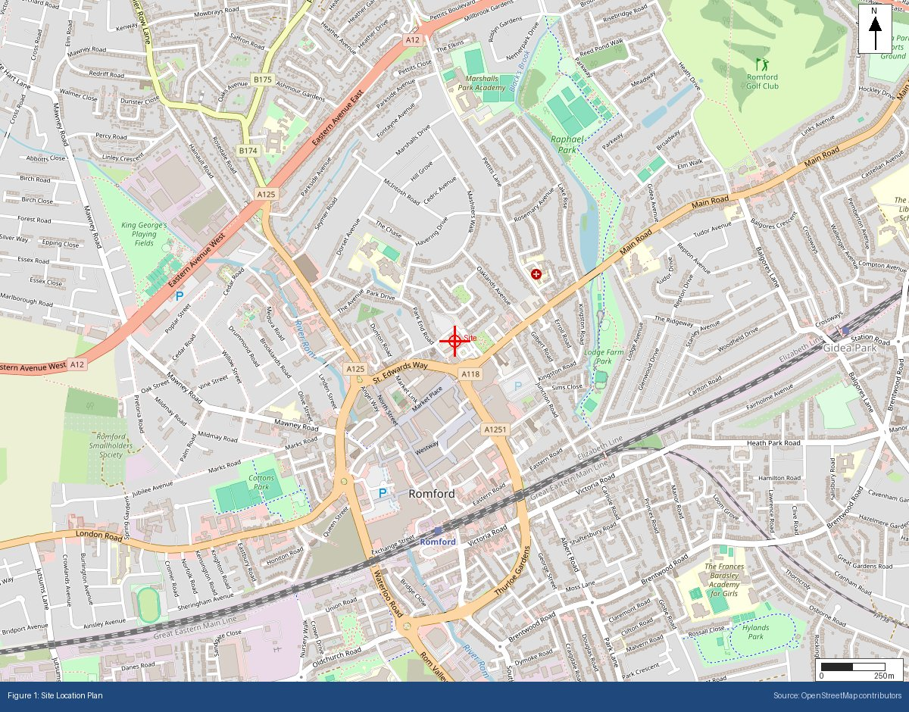

Appendix B: BGS Bedrock Geology Extract
BGS 1:625,000 bedrock geology at site location
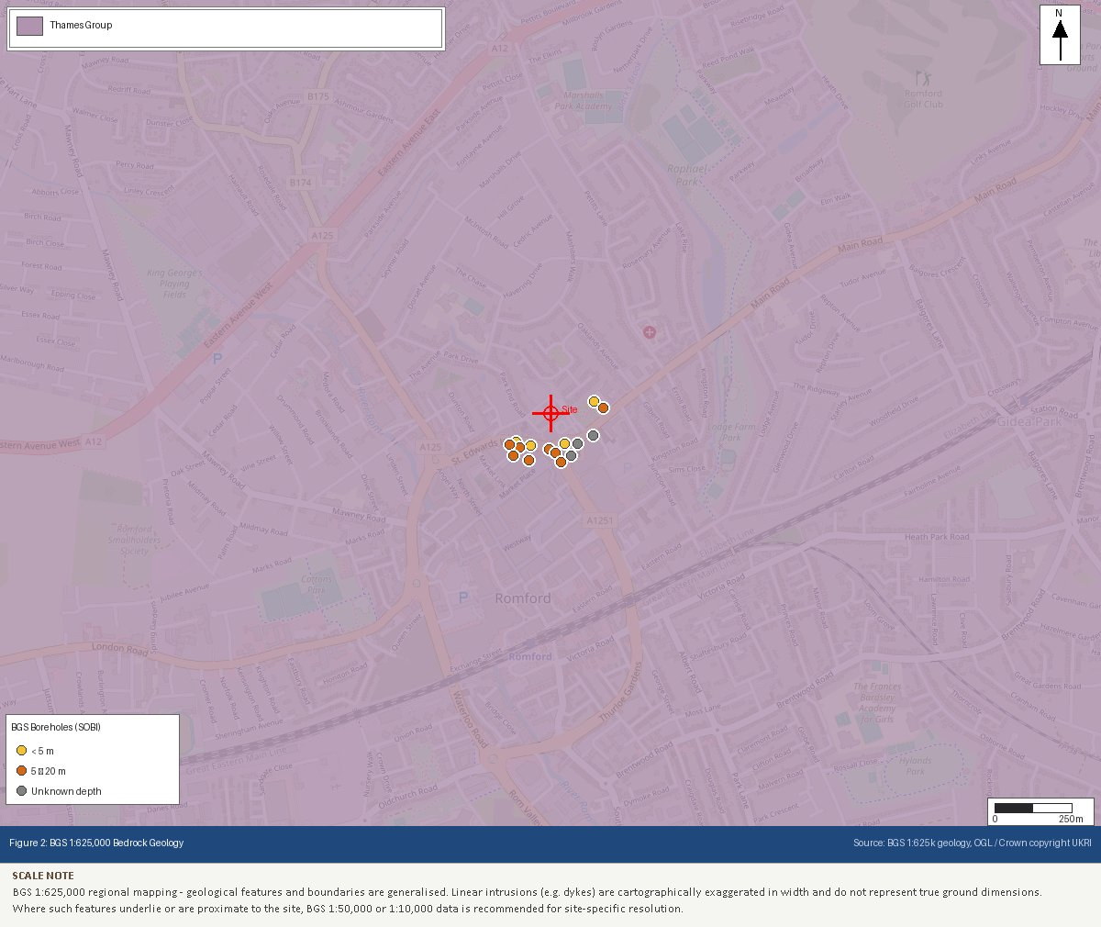

Appendix C: BGS Superficial Geology Extract
BGS 1:625,000 superficial deposits at site location
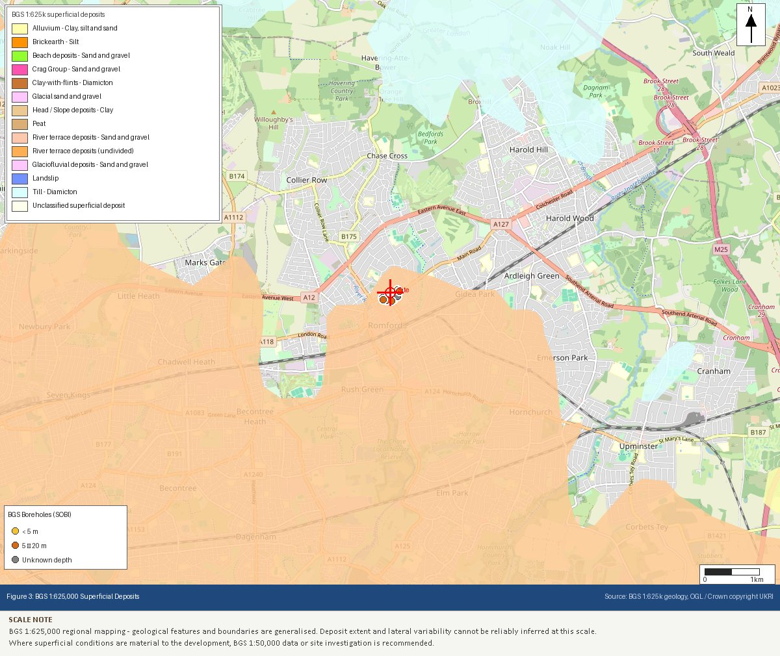

Appendix D: EA Flood Map for Planning Extract
Environment Agency flood zone classification
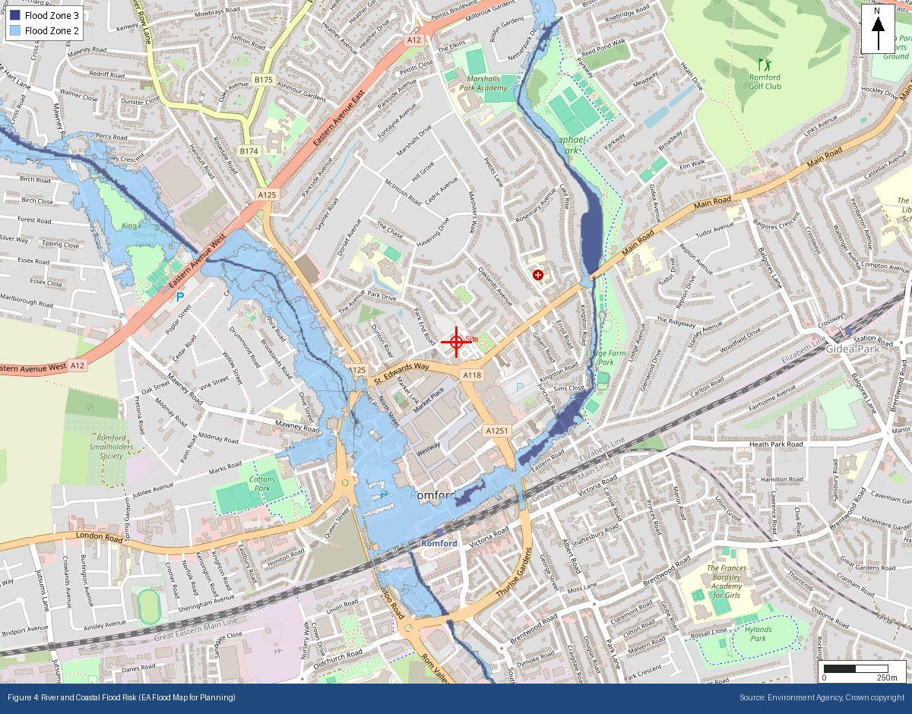

Appendix E: Heritage Designations (Historic England NHLE)
Listed buildings, scheduled monuments and conservation areas within 500m
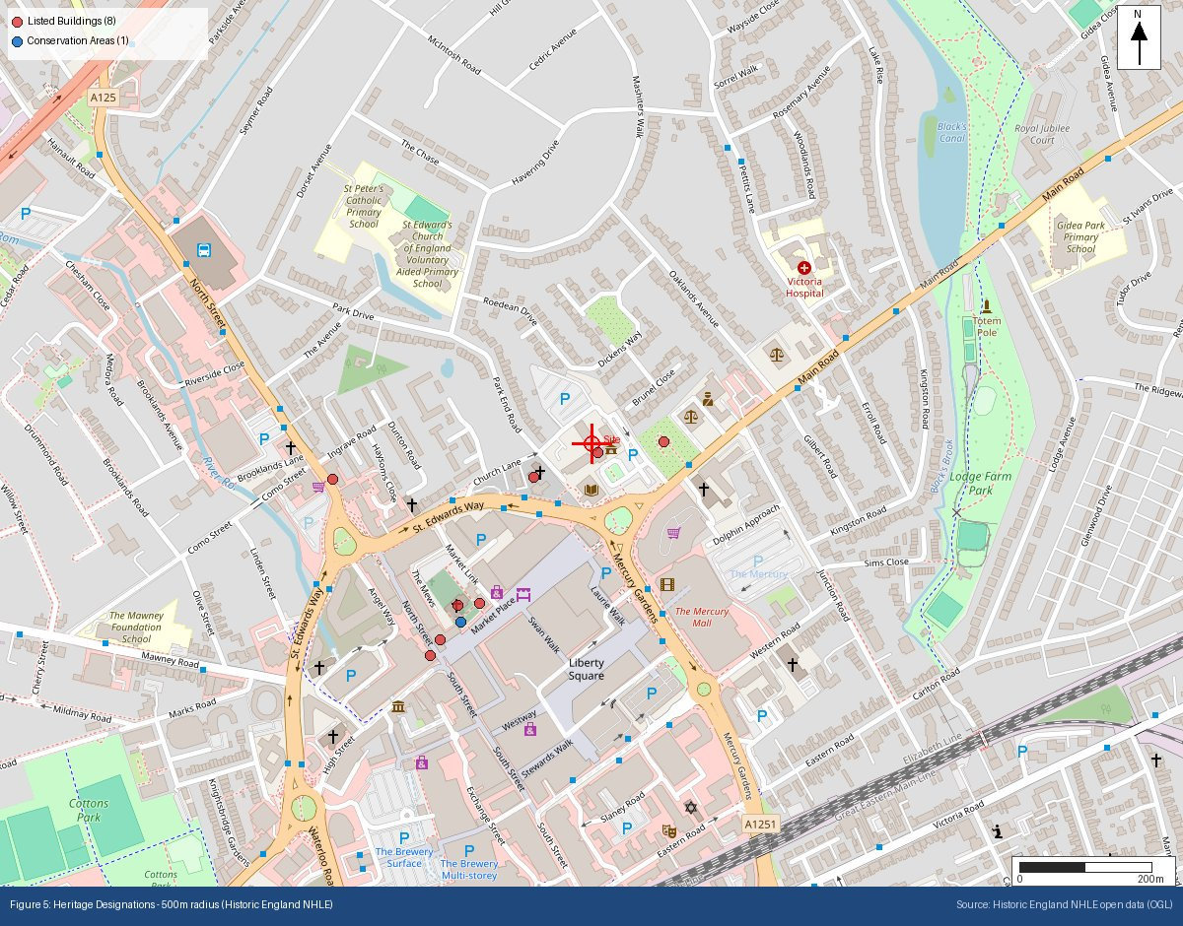

Appendix F: Ecological Designations (Natural England)
SSSI, SAC, SPA, Ramsar, AONB and National Park designations within search radii
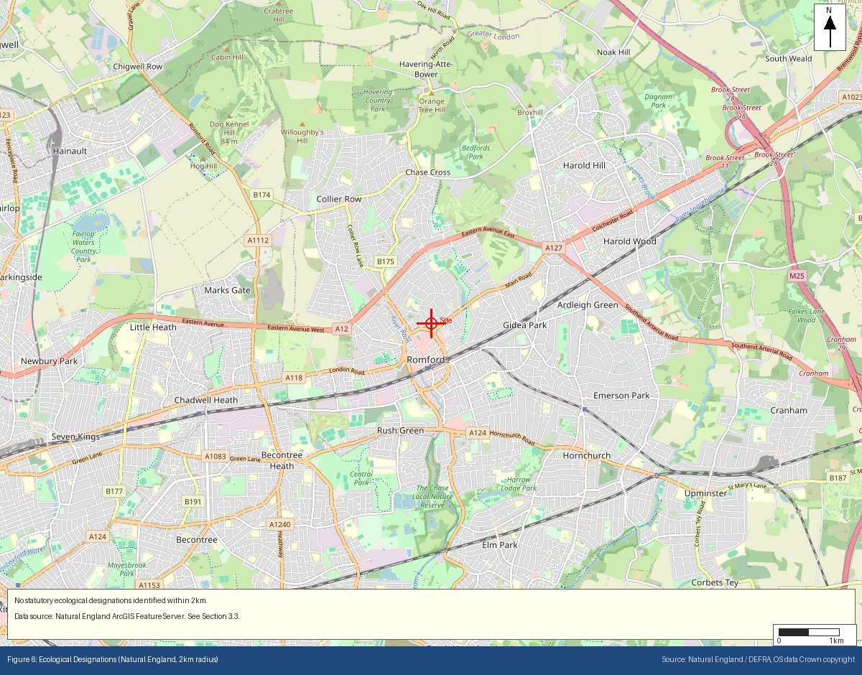

Appendix G: Mining Remediation Authority Output
MRA development risk and mine entries data
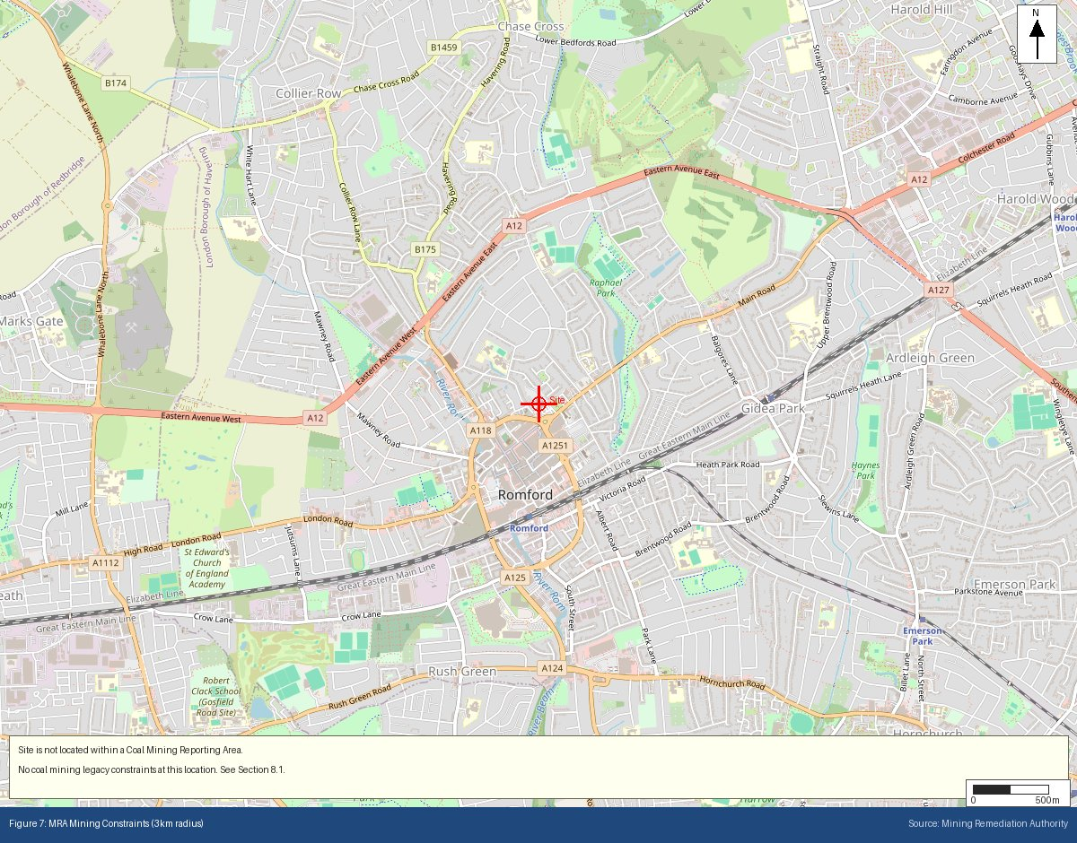

Appendix H: BGS/UKHSA Radon Potential Extract
Radon potential classification at site location
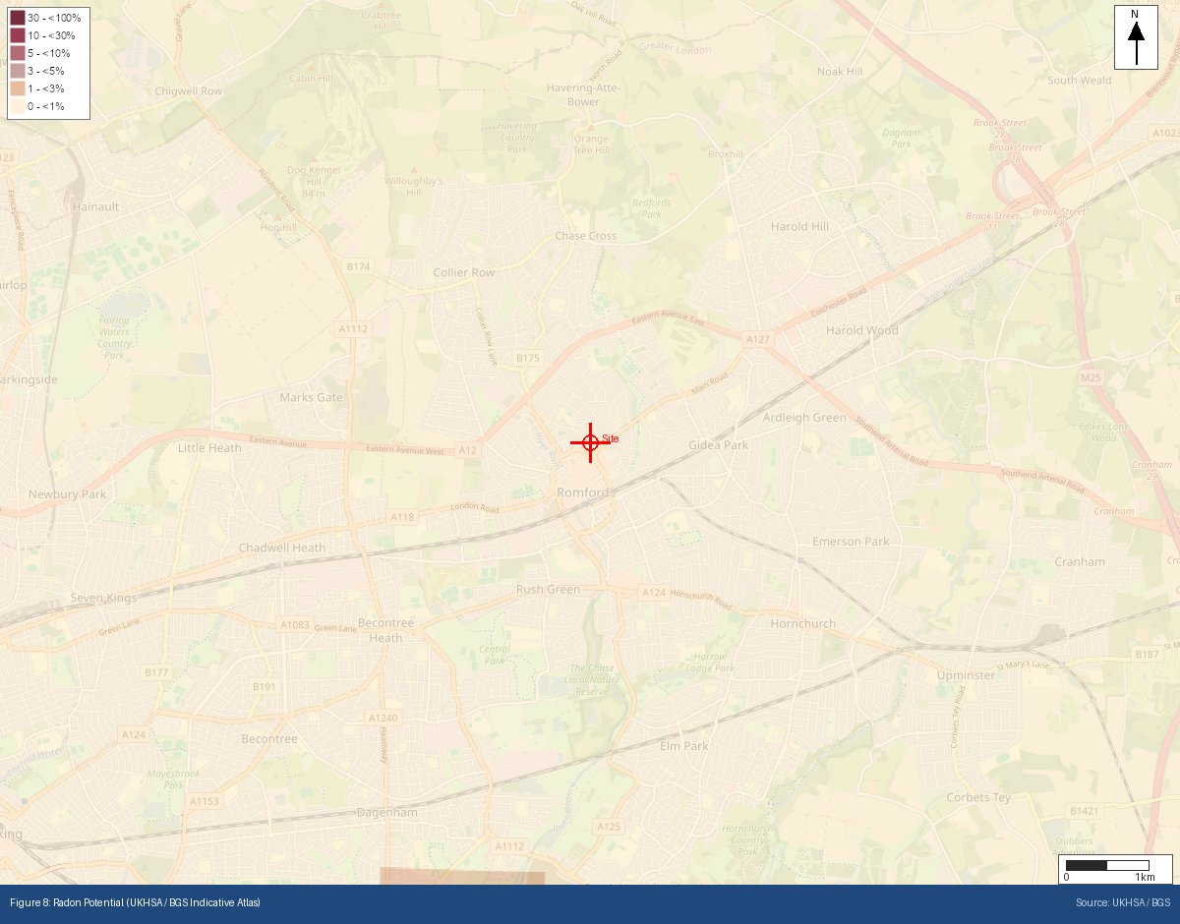
Appendix I: Historical OS Mapping (1885–1903)
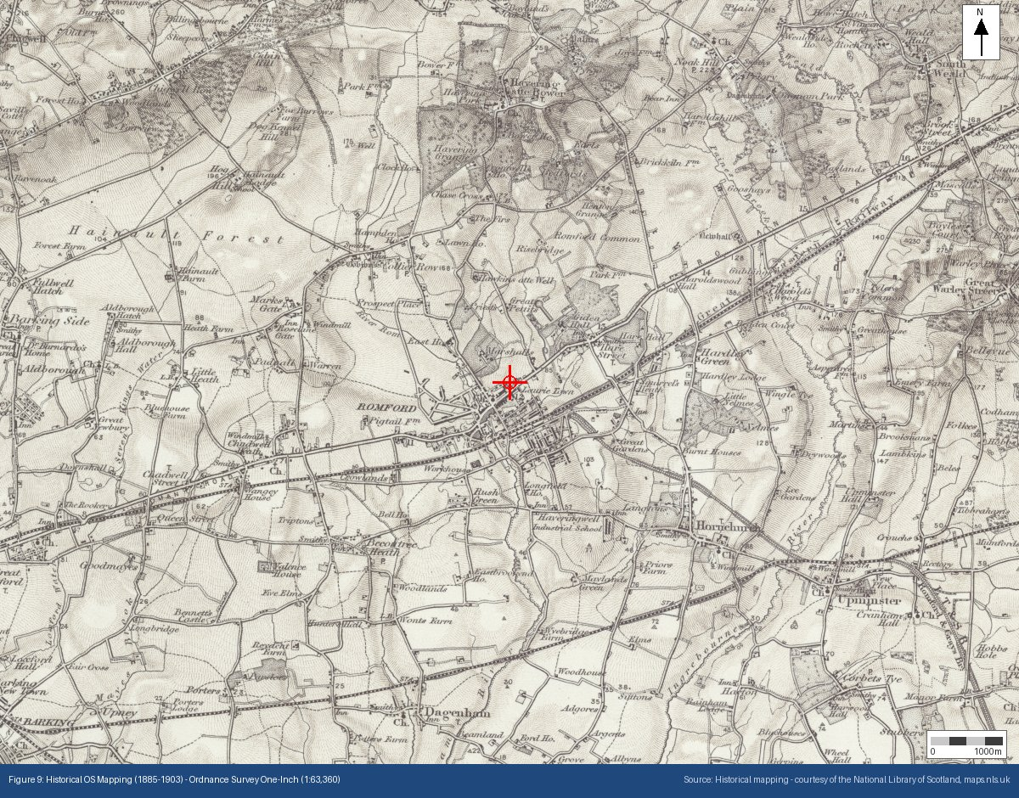

Appendix J: Historical OS Mapping (1888–1913)
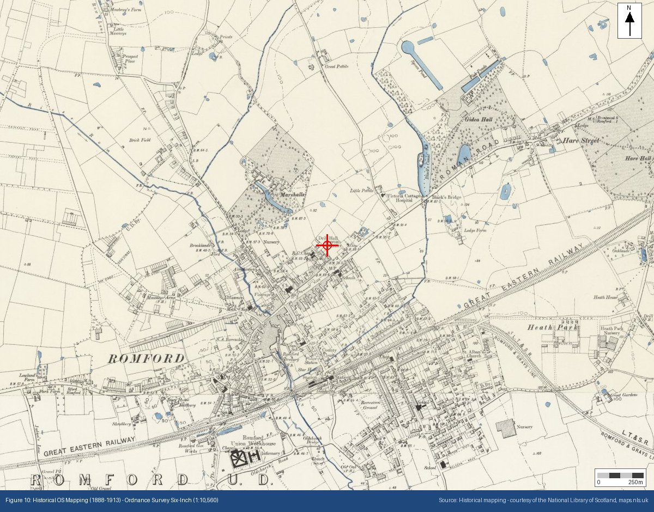

Appendix K: Historical OS Mapping (1919–1947)
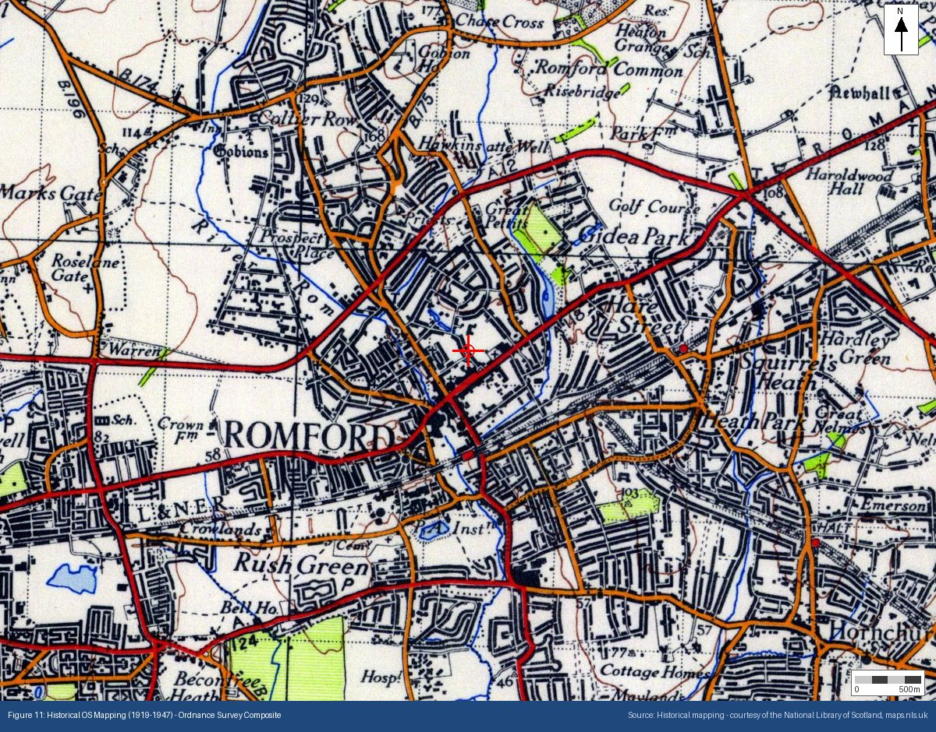

Appendix L: Surface Water Flood Risk (NAFRA2)
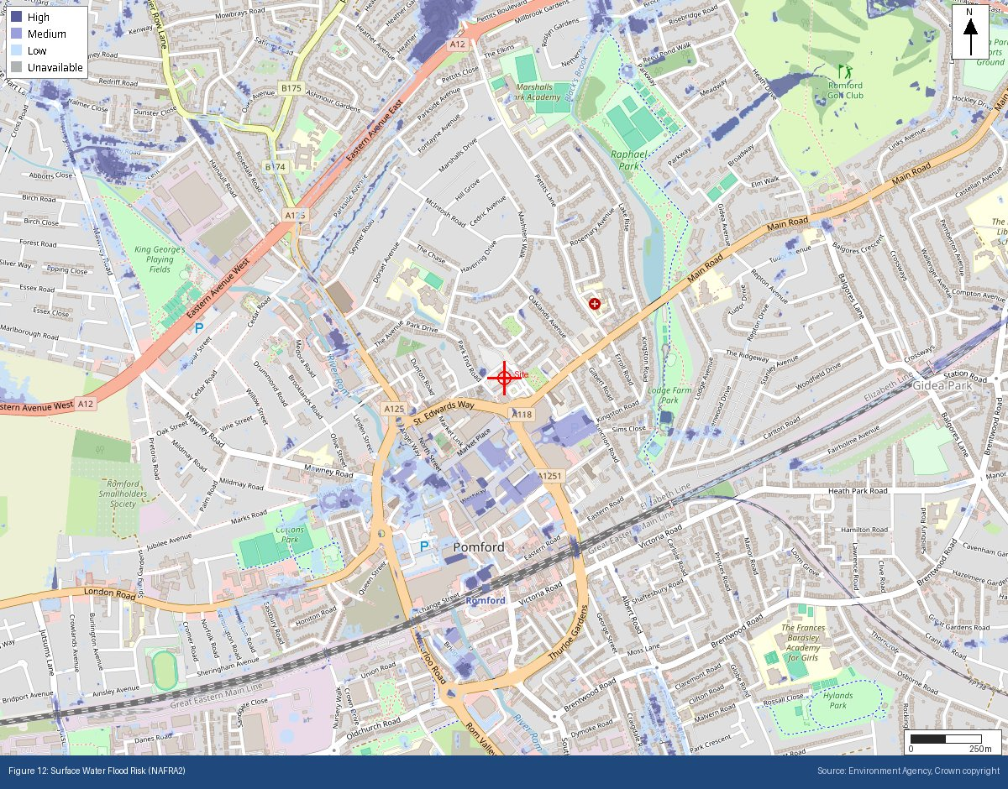
Appendix M: Source Protection Zones (Environment Agency)
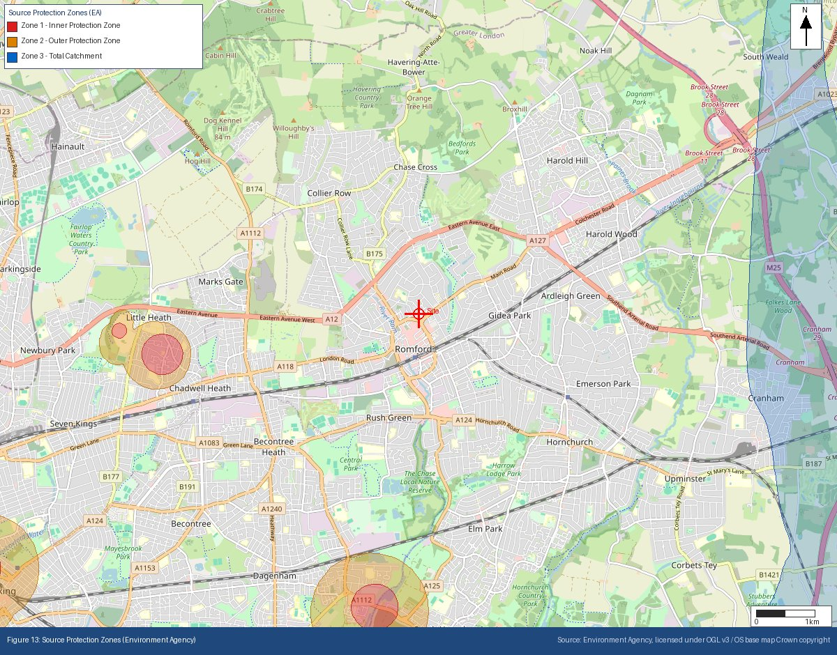
Appendix N: Site Topography — EA LiDAR Digital Terrain Model
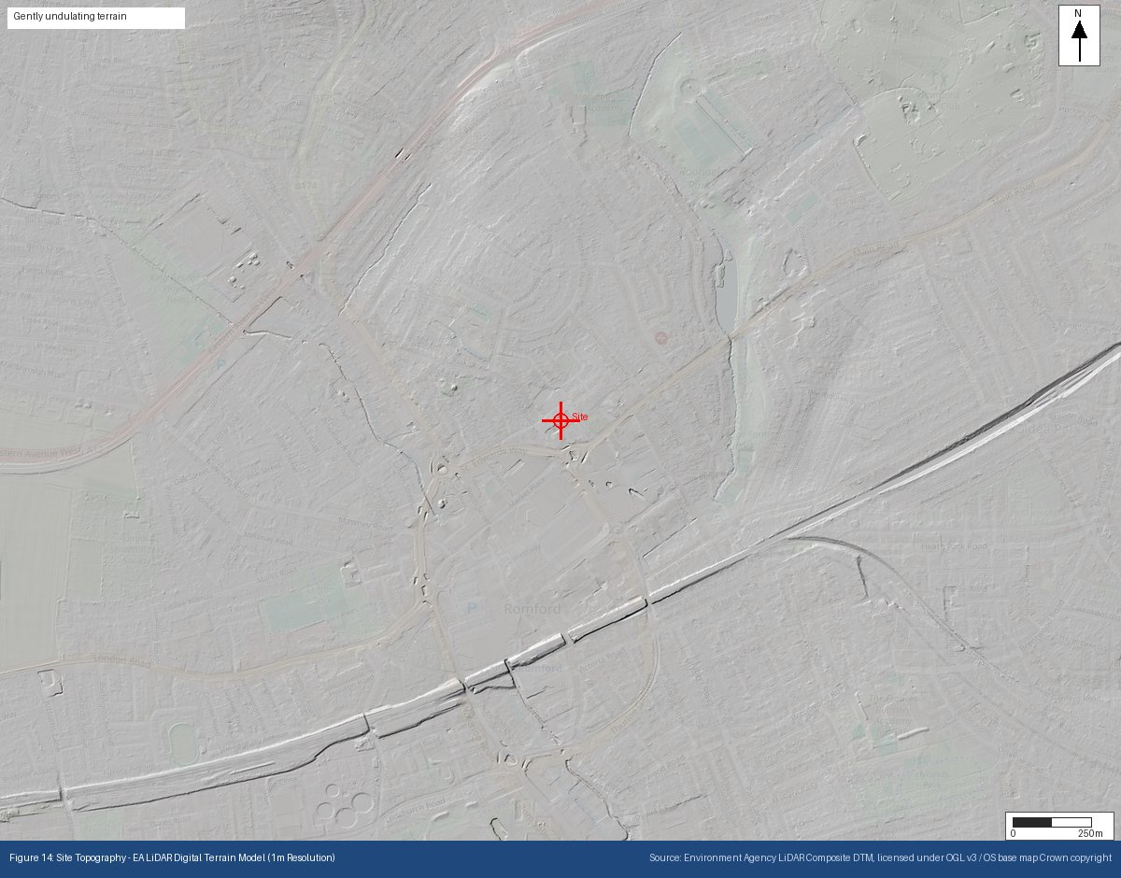
Appendix O: Permitted Regulated Facilities — EA Environmental Permitting Register
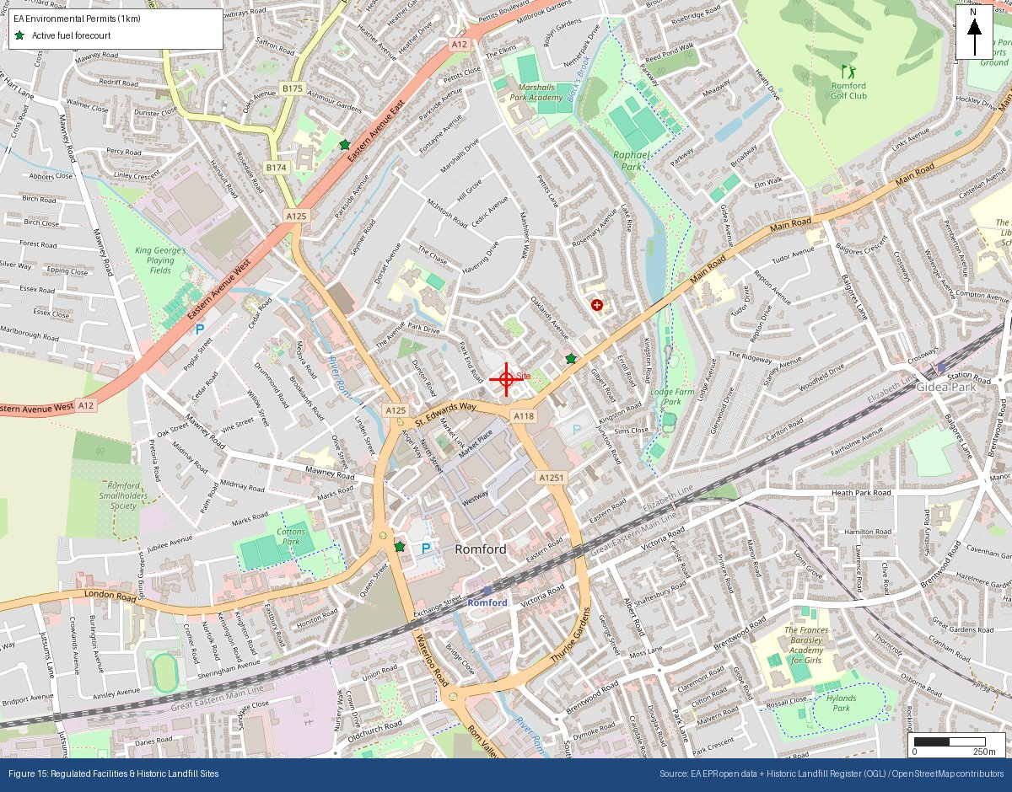
Appendix P: Historical & Current Map Features
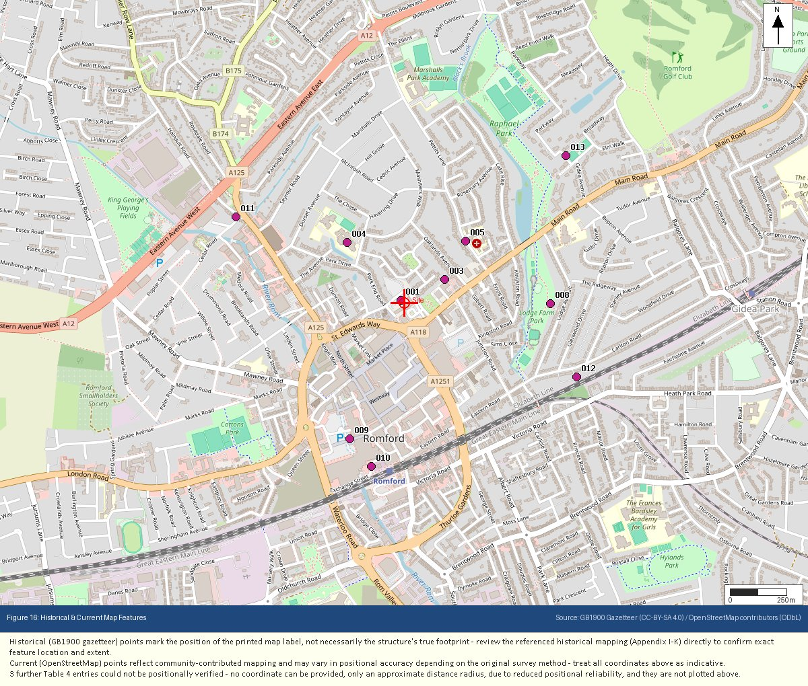
Appendix Q: Underground & Buried Structures
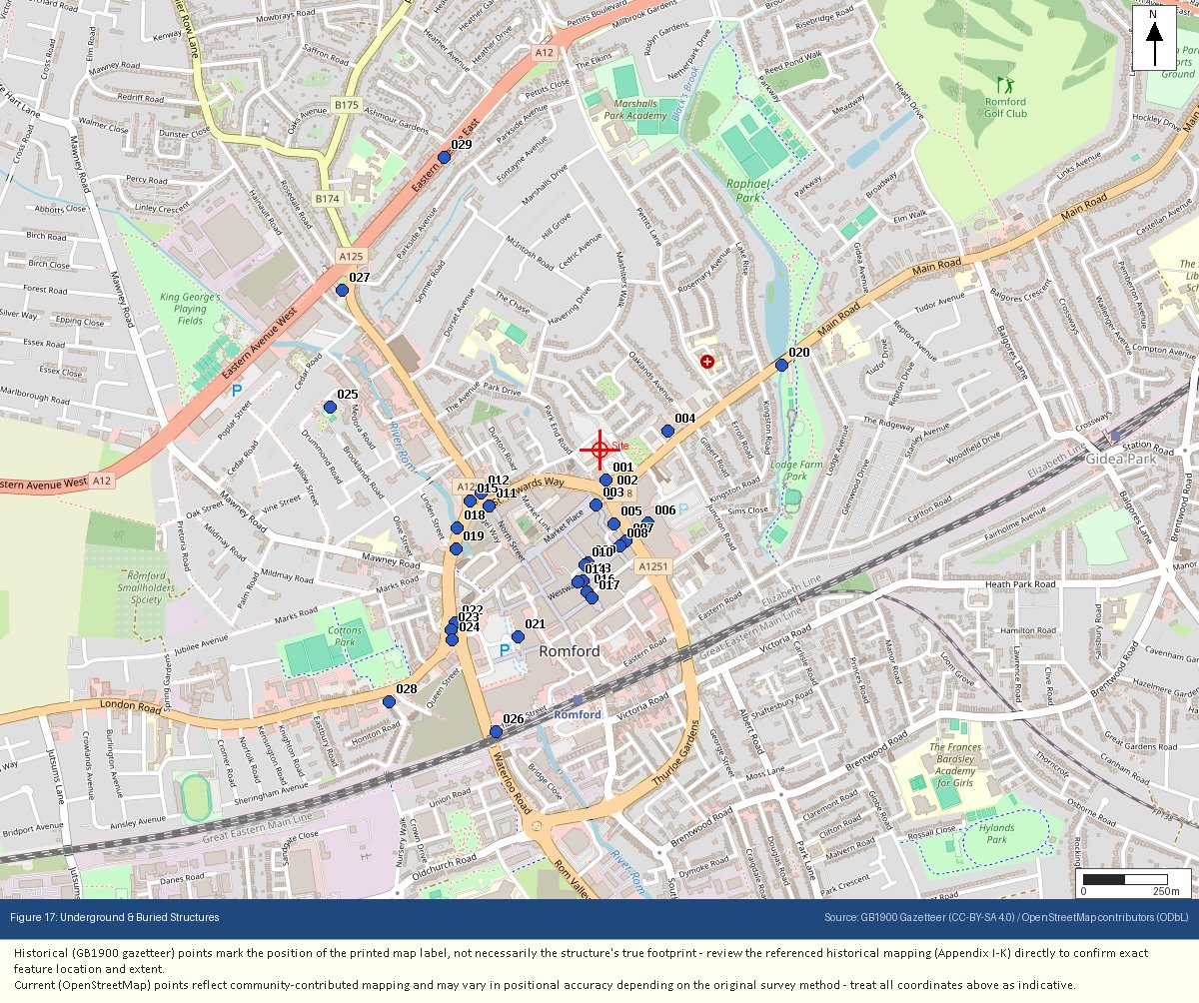
Appendix R: Flood Risk – Reference (Defended / Residual Risk)
