
PRELIMINARY GEOTECHNICAL
GROUND RISK SCREENING REPORT

GL20 5RD
GL20 5RD (site boundary c. 6.00 ha)
OS NGR: 389610 232780

Prepared for: | Magnum GSI
Report Reference: | GEO-C4946596
Date of Issue: | 20 October 2026
Version: | 1.0
Classification: | Indicative — Not for Design
Prepared by: | GeoScreen® | Magnum GSI Ltd
Prepared by GeoScreen®, an automated reporting platform developed and operated by Magnum GSI Ltd

DOCUMENT CONTROL
Report Title | GL20 5RD — Preliminary Ground Risk Screening Report
Client | Magnum GSI
Site Address | GL20 5RD (site boundary c. 6.00 ha)
OS National Grid Reference | 389610 232780
Report Reference | GEO-C4946596
Date of Issue | 20 October 2026
Data Collection Date | 20 October 2026

DISCLAIMER AND SCOPE LIMITATIONS
IMPORTANT NOTICE — PLEASE READ BEFORE USING THIS REPORT
This report has been prepared using GeoScreen®, an automated ground risk screening platform developed and operated by Magnum GSI Ltd.

The report provides an indicative, desk-based assessment of ground conditions and associated constraints based solely on the interrogation and interpretation of publicly available datasets, including but not limited to British Geological Survey (BGS), Environment Agency (EA), Mining Remediation Authority (MRA), Historic England, and Natural England data sources.

This report:
• DOES NOT constitute a professional geotechnical assessment or a BS 5930:2015+A1:2020 compliant desk study
• DOES NOT include intrusive ground investigation, site walkover, or statutory searches
• IS informed by general principles derived from relevant UK geotechnical guidance, but does not constitute a desk study compliant with BS 5930:2015+A1:2020
• IS intended solely for early-stage feasibility, due diligence, and preliminary risk screening purposes

The findings presented are indicative only. Site-specific ground conditions may vary and can only be reliably established through an appropriately scoped ground investigation and professional interpretation by a suitably qualified and experienced geotechnical engineer.

CONTENTS

Executive Summary
1 Introduction
2 Site Setting
3 Planning Context
4 Sources of Information
5 Site History
6 Geology and Ground Conditions
7 Hydrogeology and Hydrology
8 Geohazard Assessment
9 Foundation and Drainage Considerations
10 Conclusions
11 Recommendations
12 Limitations and Liability Statement

Appendices A–R

EXECUTIVE SUMMARY
Site address | GL20 5RD (site boundary c. 6.00 ha)
Current use | Not confirmed
Proposed development | Residential development
OS Grid Reference | 389610 232780
Local Planning Authority | Tewkesbury Borough Council
Geological setting (bedrock) | Lias Group - Mudstone, Siltstone, Limestone; Triassic Rocks (Undifferentiated) - Mudstone, Siltstone
Geological setting (superficial) | Alluvium
Overall risk rating | High

Key takeaway: The site is assessed as High geotechnical risk, driven primarily by Compressible Ground, Shrink-Swell Clays, River and Coastal Flood Risk (see Appendix D), and Surface Water Flood Risk (see Appendix L).
Primary constraint:
Flood exposure and clay-related ground movement across parts of the site.
Implication:
Higher ground risk, foundation and drainage design cost, and flood mitigation needs that may affect layout and programme.
Required next step:
Undertake intrusive ground investigation to characterise ground conditions, and review flood risk through a site-specific flood risk assessment to inform design and planning decisions.
Overall risk:
High.
The site lies at GL20 5RD within Tewkesbury Borough Council's area and is proposed for residential development, with the Lias Group mudstone, siltstone, and limestone at its centre. Part of the site is exposed to flooding, with about 18% in Flood Zones 2 and 3 and about 7% affected by surface water flood depths above 0.2m, while clay-rich ground and soft alluvium can shrink, swell, or settle under load. The Compressible Ground and Shrink-Swell Clays ratings are based on regional-scale mapping and carry Medium or lower data confidence, so they may be revised by a detailed desk study or ground investigation. The site lies about 260m outside the boundary of Severn Ham, Tewkesbury SSSI, so ecological assessment may be required, and nearby heritage assets may call for a Heritage Impact Assessment.

Geohazard Overview
Geohazard | Risk Rating | Key Data Source
Mining Legacy | Low | Mining Remediation Authority (Appendix G)
Compressible Ground | High | BGS 1:625,000 geological mapping (formation analysis)
Shrink-Swell Clays | High | BGS 1:625,000 geological mapping (formation analysis)
Slope Instability | Medium | BGS 1:625,000 geological mapping + EA LiDAR DTM
Dissolution Features | Medium | BGS 1:625,000 geological mapping (formation analysis)
Made Ground | Low | BGS Superficial Geology / OSM railway land / Address context
River and Coastal Flood Risk | High | EA Flood Map for Planning (Appendix D)
Surface Water Flood Risk | High | EA Risk of Flooding from Surface Water (RoFSW) (Appendix L)
Radon | Low | BGS/UKHSA Radon Atlas (Appendix H)
Ground Gas | Medium | EA Permitted + Historic Landfill (500m)
Aggressive Ground | Medium | BGS Geology / Formation lookup
Source Protection Zone | Not identified | EA Source Protection Zones mapping (Appendix M)
Note: Geohazard numbering follows the GeoScreen reference scheme. GH11 (Unexploded Ordnance) is not assessed in this Tier 1 report; this hazard will be incorporated in a future GeoScreen platform release.
Recommendations
– Undertake a site walkover, commission a professional BS 5930 desk study, and obtain utility searches to verify the findings of this preliminary assessment and identify buried services and constraints within the site boundary.
– Commission an intrusive ground investigation, including groundwater monitoring and geotechnical and chemical testing, to characterise the compressible alluvial deposits, shrink-swell clay behaviour, ground gas, and aggressive ground conditions beneath the proposed residential development.
– Obtain a site-specific flood risk assessment and surface water drainage strategy to address the River and Coastal Flood Risk and Surface Water Flood Risk identified within the site boundary, noting that a specialist study of compressible ground and shrink-swell clays may be required, subject to the findings of the professional desk study and ground investigation.
– Undertake a heritage impact assessment, given the high-significance heritage assets identified in the vicinity of the site.
– Undertake an ecological assessment, including consideration of potential effects on Severn Ham, Tewkesbury SSSI, which lies about 260m from the site boundary.
Development Implications
Foundation type: Deeper or engineered foundation solutions may be required where compressible alluvial deposits and high shrink-swell clay potential are present, with shallow foundations potentially suitable only in more competent areas, subject to structural loading details and ground investigation confirmation.
Key cost risk: Compressible Ground (High) is the principal cost risk, as soft or variable alluvial deposits within the site boundary may require ground improvement or deeper foundations, with Shrink-Swell Clays (High), River and Coastal Flood Risk (High), and Surface Water Flood Risk (High) adding mitigation costs.
Planning constraints: Heritage assets were identified within 500m, so a Heritage Impact Assessment may be required and early pre-application engagement with the local planning authority is recommended; Severn Ham, Tewkesbury SSSI lies about 260m from the site boundary, so ecological assessment may be required.
Overall suitability: Development is feasible subject to appropriate mitigation of the identified geotechnical risks, principally Compressible Ground, Shrink-Swell Clays, and subject to confirmation by intrusive ground investigation.

1 INTRODUCTION

1.1 Scope and Purpose
This preliminary ground risk screening report has been prepared for Magnum GSI in respect of land at GL20 5RD (site boundary c. 6.00 ha) (hereafter referred to as 'the Site'). The report has been prepared by GeoScreen using automated interrogation of publicly available geotechnical and environmental datasets.
The purpose of this report is to provide a high-level, indicative assessment of the ground conditions, environmental constraints, and planning context relevant to the Site, based solely on a review of publicly available data. The report is intended to support early-stage site appraisal, land acquisition decisions, and pre-planning risk screening, and to inform the scope of any subsequent professional ground investigation or planning submission.
This assessment does not include intrusive ground investigation, physical site walkover, statutory environmental searches, or utilities searches. Accordingly, actual site conditions may differ from those described. A professional desk study prepared by a suitably qualified Chartered Geotechnical Engineer, followed by site-specific ground investigation, is recommended to inform design, planning, and construction decisions.

1.2 Site Details
The Site is located at GL20 5RD (site boundary c. 6.00 ha). The approximate OS National Grid Reference for the centre of the Site is Easting 389610, Northing 232780.

1.3 Proposed Development
Residential development

1.4 Assessment Methodology
This report has been prepared by automated interrogation of publicly available digital datasets, including those listed in Section 4. Data was collected automatically from each source using the site's OS National Grid Reference as the search point. The findings have been interpreted using AI-assisted interpretation and structured report generation informed by applicable UK standards and guidance.
Each geohazard is assigned a risk rating (Low, Medium, High, or Very High) and a data confidence level. Confidence levels reflect the reliability and completeness of the available data for the assessed geohazard, as defined in Table 2 below.
Table 1 – Geohazard Risk Rating Scale
Risk Rating | Description | Development Implication
Very High | A major geohazard has been identified at or close to the site. The hazard presents a significant constraint to development based on available data. | Comprehensive ground investigation and specialist assessment required. Significant design mitigation or planning constraint is anticipated.
High | A significant geohazard has been identified that is likely to affect the development and requires further investigation. | Targeted ground investigation and specialist assessment required. Design mitigation measures should be anticipated.
Medium | A geohazard has been identified that may influence the development. Further assessment during detailed design is recommended. | Mitigation measures may be required; targeted investigation or specialist assessment is advised.
Low | No significant geohazard has been identified from available data. The hazard is unlikely to materially affect development, subject to confirmation by ground investigation. | No specific mitigation measures are anticipated at this stage; standard design approaches are likely to be suitable.
Table 2 – Data Confidence Levels
Confidence Level | Definition
High | Multiple corroborating data sources; data returned successfully from API; formation or constraint well characterised in national datasets.
Medium | Single primary data source; partial data available; some interpretation assumptions required; formation boundary may be uncertain.
Low | Limited data available; API query returned no data or failed; significant uncertainty in the basis of the assessment.

2 SITE SETTING

2.1 Location and Topography
2.1.1 The site comprises an area of approximately 6.00 ha (perimeter about 1,000 m) at postcode GL20 5RD, centred at OS National Grid Reference E389610 N232780 (latitude 51.99337, longitude -2.15273). It lies within the administrative area of Tewkesbury Borough Council, in the county of Gloucestershire, in the south-west of England. The proposed development is residential development. The site lies in the lowland vale landscape of the Severn and Avon valleys, a region characterised by gently undulating agricultural land, river corridors, and market-town settlement.
2.1.2 The Environment Agency LiDAR Digital Terrain Model indicates that the site occupies an elevated plateau position relative to its immediate surroundings. The wider landscape is a low-lying vale, with ground generally falling towards the River Avon and River Severn to the north-west and towards the Tirle Brook to the south. The plateau setting suggests that the site is likely to be relatively well drained in topographic terms, although the lower margins of the site boundary may lie closer to the floodplain of the adjacent watercourses, as discussed in Section 7. No specific ground levels are quoted, and the topographic description is qualitative and based on desk-based review only.
2.1.3 Review of current Ordnance Survey mapping identified several features in the surrounding area. The River Avon (Mill Avon) lies approximately 236 m to the north-west, and the River Severn lies approximately 684 m to the north-west, with mapped areas marked as liable to flooding associated with the Severn corridor. The Tirle Brook lies approximately 184 m to the south of the site boundary, and allotment gardens are located approximately 300 m to the north-east. These distances are measured from the nearest edge of the site boundary. The proximity of the named watercourses is relevant to flood risk and surface water drainage, which are addressed in Section 7 and Section 8. This description of current site use and surroundings is based on desk study mapping review only, and no site walkover has been undertaken.

3 PLANNING CONTEXT

3.1 Local Planning Authority
Planning decisions at the Site are made by Tewkesbury Borough Council, which acts as the Local Planning Authority (LPA) for the area.
LPA Name | Tewkesbury Borough Council
Planning portal | https://www.planningportal.co.uk
General enquiries | Contact via LPA website

Note: LPA contact details should be verified directly via the planning portal before submission of any pre-application enquiry or planning application.
3.1.1 The National Planning Policy Framework (August 2026) is the principal national policy document relevant to this desk-based review. Chapter 18 (Managing flood risk and coastal change) is triggered because the site includes land within Flood Zone 3, Flood Zone 2, and Flood Zone 1 according to Environment Agency mapping. Chapter 20 (Conserving and enhancing the historic environment) is relevant given the presence of 50 listed buildings within 500m of the site boundary. Chapter 19 (Conserving and enhancing the natural environment) is relevant because two SSSIs lie within 2km of the site boundary. Policy P2 (Chapter 17) also requires that sites are suitable for their proposed use, taking account of ground conditions, including land instability and contamination.
3.1.2 Based on the data reviewed, the Local Planning Authority (Tewkesbury Borough Council) may require, subject to confirmation, the following documents as part of the planning process. A Flood Risk Assessment may be required given the Flood Zone 3 and 2 coverage within the site boundary. A Heritage Impact Assessment may be required in view of nearby listed buildings, and an Ecological Appraisal may be required given the SSSIs within 2km. A professional desk study and intrusive ground investigation may also be requested to inform design. These requirements are indicative only and are based on desk-based data; pre-application guidance should be confirmed directly with the Local Planning Authority.

3.2 Heritage Designations
3.2.1 A desk-based review of Historic England National Heritage List for England (NHLE) open data identified 50 listed buildings within 500m of the site boundary, comprising 3 Grade II* listed buildings and 47 Grade II listed buildings. No Grade I listed buildings were recorded. The data shows no scheduled monuments, conservation areas, registered parks and gardens, or registered battlefields within 500m of the site boundary, and no World Heritage Sites within 5km. Beyond the 500m search band, the scheduled monuments Site Of St Mary'S Abbey (approximately 520m) and Holm Castle, Site Of (approximately 640m) lie within 1km of the site; works affecting a scheduled monument require Scheduled Monument Consent. The data confidence for this dataset is High, although NHLE covers designated heritage assets only and does not record undesignated assets or archaeological potential.
3.2.2 Under the NPPF (August 2026), Chapter 20 (Conserving and enhancing the historic environment), the significance of heritage assets, including the contribution made by their setting, is a material planning consideration for the proposed residential development. The number of listed buildings in the surrounding area, including three Grade II* assets, suggests that the planning authority is likely to expect a proportionate assessment of the effect of the proposals on their significance and setting. A Heritage Impact Assessment is therefore likely to be required, and early consultation with the Local Planning Authority (LPA) and its conservation officer is advisable. The absence of conservation areas, registered parks and gardens, and registered battlefields within 500m reduces the number of designation types that may need to be addressed. This assessment is desk-based and indicative, and the presence and status of designations should be verified with the LPA and the current NHLE record.
3.2.3 Three Grade II* listed buildings lie within 500m of the site boundary. Grade II* is a distinct, higher grade than Grade II and denotes buildings of more than special interest, so these assets are likely to be treated by the LPA as being of greater sensitivity than the surrounding Grade II listed buildings. The principal sensitivities are likely to relate to the setting of these buildings, including views to and from them, and to the potential for construction activity to affect their fabric. This may include vibration, ground movement, and changes to drainage and groundwater conditions, which should be considered when planning earthworks and foundation construction. The individual assets, their precise locations relative to the site boundary, and their specific sensitivities were not assessed at this stage and should be reviewed against the NHLE list entries as part of any Heritage Impact Assessment.

3.3 Ecological Designations
3.3.1 A desk-based review of Natural England statutory designation data identified two Sites of Special Scientific Interest (SSSI) within 2km of the site boundary: Severn Ham, Tewkesbury SSSI, which lies about 260m outside the boundary, and Old River Severn, Upper Lode SSSI, which lies about 1160m outside the boundary. No Special Areas of Conservation, Special Protection Areas, Ramsar sites, National Nature Reserves, National Landscapes (AONBs), or National Parks were identified within 2km of the site boundary. The data confidence for this search is high. This review covers statutory designated sites only; protected species, non-statutory habitats, and Biodiversity Net Gain (BNG) were not assessed.
3.3.2 For the proposed residential development, the relevant planning and legislative framework includes the Wildlife and Countryside Act 1981, which provides statutory protection for SSSIs, and Chapter 19 (Conserving and enhancing the natural environment) of the NPPF (August 2026). Because no SAC, SPA, or Ramsar designations were identified, Habitats Regulations 2017 assessment is not triggered on the basis of this dataset. However, the presence of SSSIs within 2km means that ecological assessment may be required, and early pre-application consultation with the Local Planning Authority (LPA) and Natural England is recommended to establish whether the proposals could affect the notified features of either site. Natural England is a statutory consultee on development likely to affect an SSSI, and the proximity of Severn Ham, Tewkesbury SSSI in particular suggests that impact pathways should be considered at an early stage.
3.3.3 Severn Ham, Tewkesbury SSSI lies about 260m outside the site boundary, and Old River Severn, Upper Lode SSSI lies about 1160m outside it. Both sites are associated with the River Severn corridor, and the Flood Map for Planning shows that parts of the site lie within Flood Zones 2 and 3. This suggests a potential hydrological relationship between the site and the river corridor that may be relevant to the sensitivities of these designations, particularly in relation to surface water drainage, water quality, and flood storage. The specific notified features, citations, and sensitivities of each SSSI were not reviewed as part of this desk-based assessment and should be obtained from Natural England. Any proposals for drainage, earthworks, or discharge to watercourses should be considered against the potential for effects on these designated sites. The findings are indicative only and based on desk-based data; they do not replace a formal ecological appraisal.

4 SOURCES OF INFORMATION

4.1 Data Sources Consulted
All data was collected automatically on 20 October 2026 using the site's National Grid Reference as the search point.
Table 3 — Data Sources Consulted
# | Data Source | Provider | Purpose
DS01 | BGS 1:625,000 Bedrock Geology | British Geological Survey | Bedrock geology  (Appendix B)
DS02 | BGS 1:625,000 Superficial Deposits | British Geological Survey | Superficial deposits  (Appendix C)
DS03 | BGS 1:625,000 Formation Analysis | British Geological Survey | Formation-based ground stability assessment (GH02-GH05)
DS04 | BGS Borehole Index (SOBI) | British Geological Survey | Historical borehole records
DS05 | BGS 1:625,000 Geological Faults (OGC API) | British Geological Survey | Major geological fault lines (structural context and figure overlay)
DS06 | EA Flood Map for Planning | Environment Agency | Flood zone classification (Appendix D)
DS07 | BGS Mining Hazard (Non-Coal) 1km Hex Grid v8 | British Geological Survey / UKRI | Non-coal mining hazard (vein minerals, chalk, evaporites, building stone)
DS08 | Mining Remediation Authority open data: Development High/Low Risk Areas and Mine Entries | Mining Remediation Authority (OGL v3). Contains Mining Remediation Authority information © Mining Remediation Authority, 2026 | Mining legacy (Appendix G)
DS09 | NLS Historical OS Mapping (via MapTiler Cloud) | National Library of Scotland | Historical OS mapping c.1885, 1888–1913 and 1919–1947 (Figs 9–11) (Appendix I-K)
DS10 | Historic England NHLE (ArcGIS FeatureServer) | Historic England | Heritage designations (listed buildings, scheduled monuments, WHS, conservation areas)  (Appendix E)
DS11 | Natural England ArcGIS FeatureServer | Natural England / DEFRA | Ecological designations (SSSI, SAC, SPA, Ramsar, AONB, National Parks) (Appendix F)
DS12 | BGS/UKHSA Radon Indicative Atlas | BGS / UKHSA | Radon potential (Appendix H)
DS14 | OS Names API | Ordnance Survey | Geocoding and LPA lookup (Appendix A)
DS15 | EA Permitted Waste Sites (Authorised Landfill Site Boundaries) | Environment Agency | Ground gas / landfill proximity (500m buffer). Data reflects EA records at the time this report was generated and may be subject to change (e.g. new or updated permits).
DS16 | EA Historic Landfill Sites | Environment Agency | Ground gas / landfill proximity (500m buffer). Data reflects EA records at the time this report was generated and may be subject to change (e.g. new or updated permits).
DS17 | BGS GeoIndex Hydrogeology (ArcGIS REST identify) | British Geological Survey | EA aquifer designation (Principal / Secondary A/B / Unproductive Strata)
DS18 | EA Source Protection Zones | Environment Agency | Groundwater source protection zone designation (S3 planning context / S7 hydrogeology) (Appendix M)
DS19 | EA Risk of Flooding from Surface Water (RoFSWExtent1in30 / RoFSWExtent1in100) | Environment Agency | Pluvial / surface water flood risk (GH08 geohazard)  (Appendix L)
DS20 | EA WFD River and Canal Water Bodies Cycle 2 (ArcGIS FeatureServer) | Environment Agency | Named receiving watercourse identification (S7 hydrogeology)
DS21 | OpenStreetMap (local extract, amenity=fuel) | OpenStreetMap contributors (ODbL) | Petrol filling stations within 500m (S5 site history / CSM)
DS22 | EA National LiDAR Programme — Composite DTM 1m (WCS 2.0.1) | Environment Agency (OGL v3) | Site topography, terrain descriptor, slope analysis (S2 site setting, Figure 14 Appendix N)
DS23 | EA Environmental Permitting Register (EPR) — CSV bulk download | Environment Agency (OGL v3) | Environmental permits, registered facilities and flood defence assets within 1km (S5.3, Figure 15 Appendix O). Data reflects EA records at the time this report was generated and may be subject to change (e.g. new or updated permits).
DS24 | OpenStreetMap (local extract) — infrastructure and land-use sites | OpenStreetMap contributors (ODbL) | Gas holders, sewage/water works, sub-stations, power stations, emergency services, military, aviation, port, quarry and industrial sites within 1km (S5 Historical Features table, Figure 16 Appendix P / S8 CSM sources); railway land and sidings within 50m of the site (S8 Made Ground)
DS25 | Historical Map Feature Positioning (derived from GB1900 Gazetteer, abridged) | Great Britain Historical GIS / GB1900 partners and volunteers (CC-BY-SA 4.0, creativecommons.org/licenses/by-sa/4.0/legalcode) | Historical map feature position (distance/bearing derived from GB1900 gazetteer label coordinates, OS Six-Inch County Series 1888-1913) for S5 Historical Features table, Figure 16 Appendix P
DS26 | OpenStreetMap (local extract) — tunnel, subway and underground structure geometry | OpenStreetMap contributors (ODbL) | Tunnel, subway and underground structure entry/midpoint/exit points within 1km (S5.2 Underground and Buried Structures table, Figure 17 Appendix Q)
DS27 | EA NAFRA2 – Risk of Flooding from Rivers/Sea and Surface Water (4-band, defended/residual risk) | Environment Agency (OGL v3) | Defended/residual flood risk shown for reference only in Figure 18 (Appendix R) – does not affect the GH07/GH08 ratings above
DS28 | OS Open Rivers (local extract) — named watercourse network | Ordnance Survey (OGL v3). Contains OS data © Crown copyright and database rights 2026 | Distance, bearing and grid reference of named streams and rivers in Table 4 / Figure 16 (Appendix P), measured to the nearest point of the watercourse rather than its historical map label; also the named watercourses in Section 7

5 SITE HISTORY

5.1 Historical Land Use Review
A limited AI-assisted historical mapping review has been undertaken using Ordnance Survey mapping from three historical epochs (c.—1885, c.—1888–1913, and c.—1919–1947), accessed via the National Library of Scotland (NLS). Historical mapping provides indicative information regarding former land uses, structures, watercourses, and potential ground disturbance not evident from current mapping. Key features identified are summarised in Table 4 below. See Appendix P for mapped locations.
The AI-assisted review included in this report is indicative only and has not been verified by a competent professional. It does not constitute a formal historical land use survey. Where a more detailed professional historical mapping review is required — for example to confirm made ground extent and inform design and planning decisions — this should be commissioned as part of a professional desk study or Tier 2/3 report service.
5.1.1 Historical Ordnance Survey mapping provided by the National Library of Scotland was reviewed for the site and its surroundings. This comprised One-Inch mapping (1:63,360, 1885-1903) in Appendix I, Six-Inch mapping (1:10,560, 1888-1913) in Appendix J, and Composite mapping (1919-1947) in Appendix K. Post-war Ordnance Survey mapping (post-1947) has not been reviewed as part of this assessment.
5.1.2 Historical mapping indicates that unnamed works-type buildings, together with a church and school in the north-western part, occupied the site, suggesting potential made ground and buried foundations. Railway sidings (about 50m north), a railway line and station, a former gasworks (about 300m north-north-west), and further industrial premises lay nearby. Land liable to flooding lay to the south and east. The Environment Agency register records a closed landfill about 310m north-east of the site boundary. A fuel station (Morrisons, about 250m) is a potential hydrocarbon source.
5.1.3 This is an automated assessment: the maps have been analysed by AI but not verified by a qualified engineer, and a thorough manual review by a geotechnical professional is recommended as part of a BS 5930-compliant desk study. The six-inch mapping (1888-1913) provides the highest spatial resolution for site-specific interpretation. Post-war Ordnance Survey mapping (post-1947) has not been reviewed, as it requires a licence from a commercial data supplier and falls outside the scope of this automated desk study. Current OS 1:25,000 mapping has been checked for references to former, old, and disused land uses; however, land uses active after 1947 and since cleared may not be identifiable from current mapping and could therefore be missed. A detailed review of post-war mapping should be undertaken as part of a detailed desk study prepared in accordance with BS 5930, ahead of any intrusive ground investigation.
Table 4 — Historical and Current Map Features of Note (indicative — AI-assisted review of NLS/OS mapping and OpenStreetMap data; requires professional verification)
ID | Feature / Land Use | Type | Proximity to Site | Grid Ref | Map Period | Geotechnical Note
Within the site or within 100 m of it (5)
001 | Church and School (Church / Schs.) | Institutional | Within site |  | Six-inch OS 1888-1913 | Historic church and school within site boundary; potential old foundations, burial ground and made ground.
002 | Factory / Works (unnamed industrial buildings) | Industrial | Within site |  | Six-inch OS 1888-1913 | Dense building footprints with works-type layout shown within the site outline on the six-inch map; potential made ground, foundations/basements from demolished structures and possible localised contamination.
003 | Railway sidings | Railway | ~50m |  | Six-inch OS 1888-1913 | Railway sidings adjacent to site; potential for made ground, hydrocarbons, heavy metals and ballast contamination.
004 | Almshouses | Institutional | ~100m |  | Six-inch OS 1888-1913 | Historic institutional buildings; minor relevance, possible old foundations and made ground.
005 | Bench marks / spot heights on low-lying ground (Liable to Floods land) (Meadows (Rudge Meadow area)) | Water | ~100m |  | Six-inch OS 1888-1913 | Low-lying meadow ground south of the site labelled as liable to flood; soft alluvial soils and high groundwater likely.
Wider study area - 100 m to 1 km from the site (24 features)
006 | Land liable to flooding (Liable to Floods) | Water | ~150m |  | Six-inch OS 1888-1913 | Mapped flood-prone land to south and east of site; high groundwater and alluvial soils likely.
007 | Gas Works / Industrial area (former works near Cotswold Place) | Industrial | ~164m N | E389778 N233043 | Six-inch OS 1888-1913 | Dense urban/industrial development north of site; potential made ground.
008 | Tirle Brook | Water | ~184m S | E389802 N232501 | Current (OS mapping) | Named watercourse — potential flood risk and surface water drainage constraint; refer to flood risk assessment.
009 | Post Depot / Sorting Office (Tewkesbury Post Office) | Public Services | ~212m N | E389381 N233077 | Current (OpenStreetMap data) | Vehicle fleet fuel storage — potential hydrocarbon contamination.
010 | River Avon / Mill Avon | Water | ~236m NW | E389276 N233028 | All historical maps; Current (OS mapping) | Named watercourse — potential flood risk and surface water drainage constraint; refer to flood risk assessment.
011 | Hospital | Institutional | ~250m |  | Six-inch OS 1888-1913 | Historic hospital; potential for localised contamination and made ground.
012 | Gas Works | Industrial | ~300m |  | Six-inch OS 1888-1913 | Former gasworks; potential for coal tar, PAH, phenol and cyanide contamination of soil and groundwater, with possible migration towards site.
013 | Allotments | Agricultural | ~300m |  | Current (OS mapping) | Allotment gardens; possible localised made ground/imported soils.
014 | Orchards | Agricultural | ~100–300m S and E |  | Six-inch OS 1888-1913 | Historic orchards on surrounding land; potential pesticide residues (arsenic, lead, copper).
015 | Railway (Ashchurch, Tewkesbury & Evesham line) with station | Railway | ~331m N | E389533 N233211 | Six-inch OS 1888-1913; OS Composite 1919-1947 | Railway embankments/cuttings and station likely to include made ground and potential contamination (ash, fuel, oils).
016 | Historic Landfill Site (Old Railway Cutting off Ashchurch Road) | Waste/Landfill | ~390m E | E390137 N232979 | EA Historic Landfill Register (closed); railway line and cutting visible on Six-inch OS 1888-1913 | Closed former landfill recorded on EA Historic Landfill Register, within an old railway cutting; potential for made ground, landfill gas and leachate migration. Position taken from register distance; cutting corresponds with the railway alignment NE of the site.
017 | Eagle Factory | Industrial | ~396m W | E389064 N232713 | Six-inch OS 1888-1913 | Former factory; potential for contamination and made ground.
018 | Borough Mills | Industrial | ~418m W | E389051 N232968 | Six-inch OS 1888-1913 | Former mill on the Avon; potential made ground and localised contamination.
019 | Historic Landfill Site (Priors Park) | Waste/Landfill | ~535m S | E389388 N232150 | EA Historic Landfill Register (closed); open ground/park in historical mapping | Closed former landfill recorded on EA Historic Landfill Register; open ground on historical maps does not preclude infilling. Potential for made ground, ground gas and leachate.
020 | River Severn | Water | ~684m NW | E388833 N233153 | All historical maps; Current (OS mapping) | Major watercourse with extensive floodplain (areas marked 'Liable to Floods'); flood risk and high groundwater.
021 | Mill / Water Works (Abbey Mills) | Industrial | ~711m W | E388762 N232547 | Six-inch OS 1888-1913 | Water-powered mill associated with the Mill Avon; potential for made ground, mill races and soft alluvial deposits.
022 | Waterworks / Pumping Station (Mythe Treatment Works) | Utility | ~745m NW | E389127 N233546 | Current (OpenStreetMap data) | Potential soft/disturbed ground and historic chemical treatment residues.
023 | Electricity Sub-Station (National Grid Electricity Distribution) | Utility | ~796m SW | E388818 N232210 | Current (OpenStreetMap data) | Electrical infrastructure — potential historic oil-based contamination from transformer equipment.
024 | Old Clay Pit | Industrial | >800m NNW |  | Six-inch OS 1888-1913 | Historic clay extraction; potential infilled ground (distant from site).
025 | Electricity Sub-Station (National Grid Electricity Distribution Plc) | Utility | ~835m E | E390558 N233127 | Current (OpenStreetMap data) | Electrical infrastructure — potential historic oil-based contamination from transformer equipment.
026 | Sewage Treatment Works | Utility | ~878m SW | E388728 N232195 | Current (OpenStreetMap data) | Sewage treatment works — potential soft/contaminated ground and ground gas risk.
027 | Brick Works | Industrial | ~900m |  | Six-inch OS 1888-1913 | Brick works with associated clay extraction west of the town across the Severn Ham; potential infilled clay pits and made ground (just inside the 1km study area).
028 | Tewkesbury Water Works | Utility | ~917m SW | E388889 N231962 | Six-inch OS 1888-1913 | Water supply infrastructure; limited relevance.
029 | Railway cutting / embankment (Ashchurch, Tewkesbury & Malvern Branch (M.R.)) | Railway | ~941m NE | E390624 N233253 | Six-inch OS 1888-1913; OS Composite 1919-1947 | Railway earthworks (cutting/embankment) adjacent to the NE; potential for made ground, ballast and railway-related contamination (hydrocarbons, metals, herbicides). The later infilling of a railway cutting is recorded in the EA landfill register.
Note: entries above showing an approximate distance with no compass direction and no Grid Ref are based solely on AI-assisted interpretation of historical map imagery, with no independent positional cross-check available (e.g. from the GB1900 historical gazetteer or OS/OpenStreetMap current mapping) for these specific features. No coordinate can be provided for these entries — only an approximate distance radius — due to reduced positional reliability, and they are not plotted on Figure 16 (Appendix P). These entries should be verified against the referenced source mapping (Appendix I-K) by a qualified person before being relied upon.

5.2 Underground and Buried Structures
Tunnels, subway lines, and underground passages within 1000m of the site have been identified from historical Ordnance Survey mapping (1888–1913, via the GB1900 gazetteer) and current OpenStreetMap data. Reported positions represent surveyed historical portal locations or, for current infrastructure, entry, midpoint and exit points sampled from the mapped route — indicative of a structure’s presence and approximate alignment only, not a precise underground survey.
This is a partial dataset: the absence of a feature here does not indicate the absence of underground structures at or near the site. It does not capture all historical tunnels, privately-held structures, or utility and service tunnel infrastructure, which requires a dedicated utility search. Key features identified are summarised in Table 5 below. See Appendix Q for mapped locations.
Table 5 — Underground and Buried Structures (indicative — derived from GB1900 historical gazetteer and OpenStreetMap current mapping; entry/exit/midpoint point data, not a precise underground survey)
ID | Structure / Name | Type | Proximity to Site | Grid Ref | Source | Note
Within the site or within 100 m of it (1)
001 | Road Tunnel (Barton Mews) | Buried Structure | Within site | E389644 N232732 | Current (OpenStreetMap data) | Current buried structure identified via OpenStreetMap tunnel tagging — potential for made ground, voids, or design constraints near its route; exact alignment, depth, and construction not confirmed by this desk-based review.
Wider study area - 100 m to 1 km from the site (32 structures: 8 listed, 24 counted)
002 | Rail Tunnel (Tewkesbury Quay Branch) | Buried Structure | ~265m NW | E389224 N233000 | Current (OpenStreetMap data) | Current buried structure identified via OpenStreetMap tunnel tagging — potential for made ground, voids, or design constraints near its route; exact alignment, depth, and construction not confirmed by this desk-based review.
003 | Road Tunnel | Buried Structure | ~265m NW | E389225 N233002 | Current (OpenStreetMap data) | Current buried structure identified via OpenStreetMap tunnel tagging — potential for made ground, voids, or design constraints near its route; exact alignment, depth, and construction not confirmed by this desk-based review.
004 | Culverted Watercourse (Tirle Brook) | Buried Structure | ~323m SE | E390048 N232533 | Current (OpenStreetMap data) | Current buried structure identified via OpenStreetMap tunnel tagging — potential for made ground, voids, or design constraints near its route; exact alignment, depth, and construction not confirmed by this desk-based review.
005 | Road Tunnel | Buried Structure | ~330m SE | E390051 N232524 | Current (OpenStreetMap data) | Current buried structure identified via OpenStreetMap tunnel tagging — potential for made ground, voids, or design constraints near its route; exact alignment, depth, and construction not confirmed by this desk-based review.
006 | Culverted Watercourse (Carrant Brook) | Buried Structure | ~457m N | E389609 N233337 | Current (OpenStreetMap data) | Current buried structure identified via OpenStreetMap tunnel tagging — potential for made ground, voids, or design constraints near its route; exact alignment, depth, and construction not confirmed by this desk-based review.
007 | Road Tunnel | Buried Structure | ~504m N | E389664 N233384 | Current (OpenStreetMap data) | Current buried structure identified via OpenStreetMap tunnel tagging — potential for made ground, voids, or design constraints near its route; exact alignment, depth, and construction not confirmed by this desk-based review.
008 | Road Tunnel | Buried Structure | ~519m N | E389691 N233399 | Current (OpenStreetMap data) | Current buried structure identified via OpenStreetMap tunnel tagging — potential for made ground, voids, or design constraints near its route; exact alignment, depth, and construction not confirmed by this desk-based review.
009 | Road Tunnel | Buried Structure | ~568m SW | E388978 N232379 | Current (OpenStreetMap data) | Current buried structure identified via OpenStreetMap tunnel tagging — potential for made ground, voids, or design constraints near its route; exact alignment, depth, and construction not confirmed by this desk-based review.
010 | Pedestrian underpasses (24) | Buried Structure | ~116-553m | Each plotted on Figure 17 (Appendix Q) | Current (OpenStreetMap data) | 24 pedestrian underpasses between 100 m and 1 km from the site; nearest ~116m W. Low significance at this distance; counted rather than listed. Positions on Figure 17 (Appendix Q).

5.3 Current Regulatory Context
EA-registered permitted facilities and fuel stations identified within 1km of the site boundary are summarised in Table 6 below. See Appendix O for mapped locations.
Table 6 — EA Registered Permitted Facilities and Fuel Stations (1km radius)
Facility Name | Category / Type | Distance | Direction
Wider study area - 100 m to 1 km from the site (6 facilities)
Morrisons | Active fuel forecourt | 250m | E
Shell | Active fuel forecourt | 508m | N
MYTHE WATER TREATMENT WORKS | Trade water discharge | 779m | NW
Severn Trent Water Limited | Industrial installation | 791m | NW
Gulf | Active fuel forecourt | 853m | E
COTTESWOLD DAIRY LIMITED | Industrial installation | 983m | NE

5.4 Recorded Mine Shafts
Mine entries (shafts, adits, and gutter pits) recorded by the Mining Remediation Authority within 500m of the site boundary are summarised in Table 7 below. See Figure 7 (Appendix G) for mapped locations.
Mine entry positions are approximate, derived from automated analysis of the Mining Remediation Authority’s Mine Entry map layer image rather than a surveyed or attribute-based query — the underlying service does not currently support direct coordinate or attribute retrieval.
Each position is accurate to within approximately 50m. No depth, diameter, treatment status, or colliery name is available from this dataset; to obtain this information, it is recommended that a CON29M Coal Mining Search and, where more detail is required, a Consultants Coal Mining Report are obtained from the Mining Remediation Authority. This table lists entries within 500m of the site boundary; the GH01 Mining Legacy rating in Section 8 considers a wider 1000m radius, so an entry between 500m and 1000m may be referenced there without appearing in this table.
Table 7 — Recorded Mine Shafts (500m radius)
ID | Type | Proximity | Grid Reference
No mine entries (shafts, adits, or gutter pits) were recorded by the Mining Remediation Authority within 500m of the site at the time of this assessment.

6 GEOLOGY AND GROUND CONDITIONS

6.1 Data Sources
The geological assessment is based on a review of BGS 1:625,000 digital geological map (OpenGeoscience WMS) and the BGS Single Onshore Borehole Index (SOBI). No intrusive investigation or site-specific borehole data has been reviewed as part of this study.

6.2 Geological Assessment
6.2.1 The geological assessment is based on BGS regional-scale 1:625,000 digital mapping, which is indicative only. The Lias Group (LI) — predominantly mudstone and siltstone with interbedded limestone — forms the bedrock at the centre of the site, and the mapping also shows Triassic Rocks (Undifferentiated) — mudstone and siltstone — elsewhere within the site boundary. The mapped extent of each unit across the site cannot be resolved at this scale, so the boundary between them is not precisely located. The Lias Group succession is typically a sequence of alternating mudstone and limestone beds of variable strength. Where weathered, the mudstone and siltstone horizons commonly degrade to firm to stiff clay, and bearing conditions are likely to be variable depending on the degree of weathering and the proportion of limestone present. Unweathered rock at depth is generally competent, but its upper weathered profile may be prone to volume change and softening if exposed. The Triassic mudstone and siltstone is likewise expected to range from moderately strong rock at depth to stiff, weathered clay near the surface. Differential conditions between the two units and across the weathering profile should therefore be anticipated in the design of foundations for residential development.
6.2.2 The wider 1km study area also intersects Triassic Rocks (Undifferentiated) — mudstone and siltstone. The Lias Group and the Triassic sequence are separate geological units of different age and depositional character, so the area is geologically varied and the lateral change in bedrock across the site boundary is a recognised feature of the local setting. The Triassic rocks were laid down predominantly in continental fluvial and lacustrine conditions in an arid to semi-arid climate, whereas the overlying Lias Group records a progressive marine transgression, with alternating muddy and calcareous sediments deposited in shallow marine environments during the Early Jurassic. This transition from non-marine to marine deposition accounts for the contrasting lithological character of the two sequences. For design purposes, the presence of two bedrock units suggests that ground conditions may not be uniform across a site of this size, and that stratigraphic, strength, and weathering characteristics should be established separately for each unit during ground investigation.
6.2.3 BGS mapping records superficial deposits of Alluvium of Quaternary age within the area. Alluvium typically comprises soft to firm clays and silts, with local sandy or gravelly lenses and organic or peaty horizons, and is generally associated with river floodplains. These materials are commonly compressible and of low strength, and can give rise to differential settlement and elevated groundwater levels, with implications for the design of shallow foundations, ground floor slabs, and shallow excavations. The extent and thickness of alluvium within the site boundary cannot be determined from regional-scale mapping, and the deposits may be discontinuous or locally absent. Ecological data refers to river-associated designations (Severn Ham, Tewkesbury SSSI and Old River Severn, Upper Lode SSSI) in the vicinity, which indicates that alluvial deposits may be present within the wider valley setting. Thickness variability, buried channels, and organic horizons should be assumed possible until proven otherwise by intrusive investigation.
6.2.4 The BGS Single Onshore Borehole Index identified 20 borehole records within 500m of the site boundary. Table 8 lists 10 records: the 1 record within the site boundary or within 100m of it, and 9 further records from within 500m. The closest listed record is Tewkesbury Fire Station at approximately 60m from the site boundary (drilled date unknown, depth 3.04m), and the deepest nearby record is Cotteswold Road, Tewkesbury at 67.05m depth. The shallow record is unlikely to have proved the full bedrock profile, whereas the deeper record may provide useful information on the thickness and character of the underlying succession. The index records the existence, location, and depth of boreholes only, and the underlying logs have not been reviewed as part of this assessment. Records of unknown date or investigation standard may also be of limited reliability. The desk-based review therefore cannot confirm the depth to rock, the thickness of alluvium, groundwater levels, or the variability between the two mapped bedrock units. Intrusive ground investigation may be required to establish subsurface conditions and to inform foundation design for the proposed residential development, and the available borehole logs should be obtained and reviewed at that stage.

6.3 Historical Borehole Records
The table below summarises BGS borehole records identified within 500m of the site from the BGS Single Onshore Borehole Index (SOBI). Where scan records are available, these can be accessed via the BGS borehole viewer. All borehole data is indicative and should be verified against original records.
Table 8 — Historical Borehole Records (BGS SOBI, 500m radius. Borehole records can be searched via BGS GeoIndex Onshore)
BGS Reference | Name | Approx. NGR | Distance | Depth (m) | Year
SO83SE25 | Tewkesbury Fire Station | E389400 N232800 | 60m | 3.04m | Unknown
SO83SE39 | Shopping Precinct Develop 8 | E389380 N232970 | 120m | Not recorded | Unknown
SO83SE37 | Shopping Precinct Develop 6 | E389430 N233000 | 124m | Not recorded | Unknown
SO83SE19 | Tewkesbury Garage,Hight Street | E389350 N233000 | 163m | 23.77m | Unknown
SO83SE18 | Cotteswold Road, Tewkesbury | E389710 N233280 | 400m | 67.05m | Unknown
SO83SE10 | King Johns Bridge NO.2 | E389310 N233310 | 455m | 8.89m | Unknown
SO83SE11 | King Johns Bridge NO.3 | E389300 N233310 | 459m | 5.66m | Unknown
SO83SE12 | King Johns Bridge NO.4 | E389300 N233320 | 468m | 3.65m | Unknown
SO83SE8 | Adjacent To R.Bridge-R.Avon 8 | E389480 N233360 | 480m | 7.62m | Unknown
SO83SE9 | King Johns Bridge NO.1 | E389290 N233330 | 481m | 9.32m | Unknown
Note: The one borehole record within the site boundary or within 100m of it is listed. The table is completed to 10 rows with 9 further records from within 500m, chosen as for a point report (records with recorded depth and a scan log first, then nearest); rows are sorted by distance from the site boundary. 20 records lie within 500m. All records can be viewed on the BGS GeoIndex (mapapps2.bgs.ac.uk/geoindex); positions are as recorded by BGS, and some older records are located only to the nearest 100m. Records with recorded depth data and an available scan log are prioritised over nearby records without, where available. BGS References are hyperlinked to available scan logs where shown. Source: BGS Single Onshore Borehole Index (SOBI).

7 HYDROGEOLOGY AND HYDROLOGY
7.1.1 The Environment Agency Flood Map for Planning shows that the site boundary spans more than one flood zone: Flood Zone 3 (high probability, greater than 1% annual chance) covers about 2% of the site, Flood Zone 2 covers about 16%, and Flood Zone 1 covers about 82%. The centre of the site lies in Flood Zone 1. The worst-case classification within the site boundary is Flood Zone 3a. The site is located in proximity to the River Swilgate, approximately 102m from the site boundary, with Tirle Brook, the Mill Avon, and Quay Pit also lying within 1km. Part of the site lies within a higher flood zone, so a site-specific Flood Risk Assessment is likely to be required for residential development. Surface water flood risk is assessed separately under Section 8.
7.1.2 BGS 1:625,000 hydrogeological mapping shows that groundwater conditions differ across the site. At the centre of the site, the geology is classified as having essentially no groundwater (rocks with negligible hydraulic conductivity), whereas elsewhere within the site boundary it is classified as low productivity with fissure flow. Groundwater sensitivity is therefore considered low, and a formal Environment Agency aquifer designation is unlikely to apply. However, perched groundwater may still be encountered in superficial deposits or locally fractured zones. The EA aquifer designation for this site should be confirmed directly from EA Groundwater mapping prior to finalising drainage strategy or where infiltration drainage or dewatering is proposed.
7.1.3 The River Swilgate, the nearest mapped watercourse at about 102m from the site boundary, is the likely receiving watercourse for surface water discharge, although this should be confirmed during drainage design. No Source Protection Zone applies to the site. The drainage strategy should therefore be agreed with the Local Planning Authority and, where relevant, the Environment Agency. Where discharge to a watercourse or sewer is proposed, EA consent or permits may be required depending on the receiving watercourse and discharge route. The Severn Ham, Tewkesbury SSSI, about 260m from the site boundary, may be hydrologically linked to downstream watercourses (see Section 3.3). Infiltration potential appears limited by the low-permeability geology, so this desk-based review is indicative only.

8 GEOHAZARD ASSESSMENT
The following sections assess each principal geohazard category relevant to the Site. Risk ratings are based on desk-based data only and should be treated as indicative. Actual risk levels can only be determined following site-specific intrusive investigation.
8.1 Mining Legacy (including subsidence and instability): Low (confidence: High). The Mining Remediation Authority (MRA) open data shows that no part of the site lies within a Development High Risk Area, and no recorded coal mine entries lie within 1000 m of the site boundary. The site also does not lie within the MRA Coal Mining Reporting Area. BGS non-coal mining mapping (1 km hex grid) carries no classification for the site, and no known record of non-coal mining activity was identified within the site boundary. On this basis, no evidence of mining-related subsidence or ground instability was identified at this desk-based stage, and mining legacy is not considered a significant constraint for the proposed residential development.
8.2 Compressible Ground: High (confidence: Medium). The rating is based on BGS 1:625,000 digital geological mapping, which shows Alluvium mapped within the site boundary. As described in Section 6, the site is underlain by the Lias Group and Triassic Rocks, with the Alluvium forming a superficial cover. Alluvial deposits are commonly soft, organic-rich or silty and clayey, and can be associated with variable thickness, low strength, and potential for consolidation settlement under imposed loads. The mudstone bedrock beneath is generally not typically associated with significant primary compressibility, so the principal concern relates to the alluvial cover and the transition between deposits and bedrock. This is relevant to foundation design for residential development, particularly where Alluvium thickness varies across the site, and could lead to differential settlement if not accommodated. Ground investigation is recommended to establish the thickness, composition and engineering properties of the Alluvium and inform foundation design.
8.3 Shrink-Swell Clays: High (confidence: Medium). The rating is derived from BGS 1:625,000 digital geological mapping and formation analysis. The Lias Group and Triassic mudstone and siltstone sequences, together with fine-grained alluvial deposits, include clay-rich materials that can undergo volume change in response to seasonal moisture variation. Such behaviour is influenced by clay plasticity, the depth of desiccation, and the presence of mature trees or hedgerows, which can intensify moisture extraction. For residential development, shrink-swell movement is a recognised cause of damage to shallow foundations and may require deeper foundations or appropriate design allowances, with attention to the influence of existing and proposed vegetation. Ground investigation is recommended to characterise clay plasticity and volume change potential and inform foundation design in accordance with relevant guidance.
8.4 Slope Instability: Medium (confidence: Low). The rating is based on desk-based LiDAR terrain analysis only, which indicates that the site occupies an elevated plateau position, without a site walkover or geomorphological inspection. As described in Section 6, the site is underlain by mudstone-dominated strata, which can be susceptible to shallow slope movement where slopes are steepened, saturated or disturbed. No specific evidence of existing landslides or unstable ground was identified at this desk-based stage, but the low confidence reflects the absence of field verification and the potential for localised changes in gradient, particularly towards the margins of the plateau and any areas of alluvial deposits or drainage features. A site walkover is recommended to confirm slope geometry, identify any evidence of past movement, and verify ground conditions, so that any localised stability constraints can be taken into account in the layout and earthworks design for the proposed residential development.
8.5 Dissolution Features: The dissolution susceptibility is rated Medium, with medium confidence, based solely on BGS 1:625,000 digital geological mapping, which shows Lias Group mudstone, siltstone, and limestone within the site boundary. As described in Section 6, the site is underlain by the Lias Group, where dissolution potential is confined to the limestone horizons, and the interbedded mudstone and siltstone are not dissolution-prone. Localised dissolution-related ground instability associated with limestone horizons within the Lias Group succession cannot be discounted at this desk-based stage, although the interbedded clastic strata would be expected to limit the scale and continuity of any such features. Dissolution features are therefore considered a secondary consideration that should be reviewed during detailed design, and no specific investigation is prescribed at this stage.
8.6 Made Ground: The Made Ground hazard is rated Low, with medium confidence. BGS 1:625,000 mapping shows superficial deposits (Alluvium) within the site boundary, but this mapping scale does not record Made Ground, and the site does not lie within a Mining Remediation Authority (MRA) Development High Risk Area. The AI-assisted historical mapping review in Section 5 has not been verified by a competent professional and should not be solely relied upon, so it is treated here only as unverified supporting context. On this basis, extensive or deep Made Ground is not anticipated, although thin or localised fill associated with field boundaries, access tracks, drainage works, or minor earthworks cannot be excluded and may be encountered during ground investigation. This is not considered to materially affect the proposed residential development at this stage, but the presence and nature of any Made Ground should be established during detailed design.
8.7 River and Coastal Flood Risk: The river and coastal flood risk is rated High, with high confidence, based on the Environment Agency Flood Map for Planning. Across the site boundary, Flood Zone 3 covers about 2% of the site, Flood Zone 2 about 16%, and Flood Zone 1 about 82%. The centre of the site lies in Flood Zone 1, but the rating reflects the worst case anywhere within the site boundary, namely the Flood Zone 3a (high probability, greater than 1% annual chance) area on the margins of the site. Flood risk is therefore not uniform, with the majority of the site outside the mapped fluvial floodplain and a minor part exposed to high probability flooding. This is likely to influence the layout of the residential development and the design of finished floor levels and drainage, and a site-specific flood risk assessment is likely to be required to define the extent and depth of flooding within the site boundary and inform design and planning decisions.
8.8 Surface Water Flood Risk: The surface water flood risk is rated High, with high confidence, based on the Environment Agency Risk of Flooding from Surface Water (RoFSW) mapping. Modelled flood depths greater than 0.3 m affect about 2% of the site, and depths greater than 0.2 m affect about 7% of the site, so the condition applies to part of the site rather than the whole. Surface water (pluvial) flooding results from intense rainfall overwhelming drainage capacity rather than from river overtopping, and the affected areas are likely to correspond to low-lying ground and natural flow paths within the site boundary. A surface water drainage strategy is likely to be required for the residential development, including consideration of overland flow routes and exceedance flows, and the layout and finished levels should take account of the mapped extents. For reference, defended/residual flood risk accounting for existing flood defences is shown in Figure 18 (Appendix R); this does not alter the statutory Flood Zone classification used above.
8.9 Radon: Radon is rated Low (confidence: High). BGS radon mapping indicates that the site falls within a radon Class 2 area (see Figure 8, Appendix H), where 1 to 3% of homes are estimated to exceed the UKHSA Action Level. This rating applies to the worst case anywhere within the site boundary. Radon protective measures are not required for this classification; however, radon potential should be reviewed during detailed design in accordance with BR 211:2023. This is a desk-based finding and does not replace site-specific radon testing where required for the proposed residential development.
8.10 Ground Gas: Ground gas is rated Medium (confidence: High). The landfill data review identified two historic landfill sites within 500m of the site boundary: Old Railway Cutting off Ashchurch Road at approximately 311m, and Priors Park at approximately 449m. Both are recorded as historic (surrendered) sites. Their separation from the site boundary and surrendered status suggest that the potential for gas migration onto the site is limited, but it cannot be discounted at desk-study level. The Medium rating reflects this residual uncertainty. Ground gas should be considered further as the proposals for residential development are progressed, and the findings should be treated as indicative only.
8.11 Aggressive Ground Conditions: Aggressive ground conditions are rated Medium (confidence: Medium). The assessment is based on the BGS 1:625,000 digital geological mapping, which shows Lias Group mudstone, siltstone, and limestone, together with Triassic mudstone and siltstone and alluvium elsewhere within the site boundary. These clay-rich and fine-grained deposits can contain sulfate-bearing minerals and may give rise to elevated sulfate or acidity in the ground or groundwater. The Medium rating reflects this potential, together with the lower confidence of a desk-based assessment. Sulfate and pH conditions should be established before buried concrete specifications are finalised for the proposed residential development.
8.12 Source Protection Zone: No Source Protection Zone was identified within or near the site boundary (confidence: High). The site is therefore not considered to be constrained by groundwater abstraction protection requirements for public water supply. This finding is based on the data reviewed and should be read alongside the hydrogeological assessment in Section 7.
8.13 Heritage Assessment: Historic England National Heritage List for England (NHLE) open data records 50 listed buildings within 500m of the site boundary, comprising 0 Grade I, 3 Grade II*, and 47 Grade II listed structures. No scheduled monuments, World Heritage Sites, conservation areas, registered parks and gardens, or registered battlefields were identified within the respective search distances. Beyond the 500m search band, the scheduled monuments Site Of St Mary'S Abbey (approximately 520m) and Holm Castle, Site Of (approximately 640m) lie within 1km of the site; works affecting a scheduled monument require Scheduled Monument Consent. The presence of listed buildings does not preclude development, but may require assessment of impacts on their setting. The full heritage assessment is presented in Section 3.2.
8.14 Ecological Designations: Natural England data records two Sites of Special Scientific Interest (SSSI) within 2km of the site. The site lies about 260m outside the boundary of Severn Ham, Tewkesbury SSSI, and about 1160m outside the boundary of Old River Severn, Upper Lode SSSI. No Special Areas of Conservation, Special Protection Areas, Ramsar sites, National Landscapes, National Parks, or National Nature Reserves were identified within 2km. Given the proximity of Severn Ham, Tewkesbury SSSI, ecological assessment may be required to consider potential effects of the proposed residential development. The full assessment is presented in Section 3.3.
8.15 Unexploded Ordnance: The risk from unexploded ordnance (UXO) has not been assessed as part of this automated desk study and cannot be ruled out. A specialist UXO Preliminary Risk Assessment (PRA) may be required depending on site-specific risk factors. Specialist providers include Igne (www.igne.com) and Zetica (www.zetica.com).

Table 9 — Geohazard Risk Assessment Summary
Ref | Geohazard | Risk Rating | Data Confidence | Recommended Action
GH01 | Mining Legacy | Low | High | No action required
GH02 | Compressible Ground | High | Medium | See Section 11
GH03 | Shrink-Swell Clays | High | Medium | See Section 11
GH04 | Slope Instability | Medium | Low | Monitor / confirm by investigation
GH05 | Dissolution Features | Medium | Medium | Monitor / confirm by investigation
GH06 | Made Ground | Low | Medium | No action required
GH07 | River and Coastal Flood Risk | High | High | See Section 11
GH08 | Surface Water Flood Risk | High | High | See Section 11
GH09 | Radon | Low | High | No action required
GH10 | Ground Gas | Medium | High | Monitor / confirm by investigation
GH12 | Aggressive Ground | Medium | Medium | Monitor / confirm by investigation
SPZ | Source Protection Zone | Not identified | High | No action required

9 FOUNDATION AND DRAINAGE CONSIDERATIONS
This section provides a preliminary, desk-based assessment of foundation suitability based on the geological findings in Section 6. This assessment is indicative only and must be confirmed through site-specific ground investigation.
9.1.1 Based on the identified geology (Section 6) and geohazard assessment (Section 8), foundation design for the proposed residential development should consider the High shrink-swell clay and compressible ground ratings, which suggest that bearing conditions may be variable across the 6.00 ha site. Shallow foundations may be suitable in areas of competent strata, subject to ground investigation confirmation, although the presence of Alluvium and clay-rich soils may require engineered solutions or deeper foundation solutions to mitigate differential settlement and volume change, subject to structural loading and investigation. Foundation depths, ground improvement, and the need for specialist design in alluvial areas cannot be determined at this stage. As aggressive ground conditions are rated Medium, concrete in contact with the ground should be designed with reference to BRE Special Digest 1:2005, subject to confirmation of the Design Sulfate Class by site-specific chemical testing. All foundation conclusions are indicative and desk-based, and require intrusive ground investigation.
9.1.2 The permeability of the ground should be considered in the context of the geology described in Section 6. BGS 1:625,000 mapping and hydrogeology data show that groundwater potential is limited, with essentially no groundwater at the centre of the site and Low productivity (fissure flow) elsewhere. Clay-rich soils and mudstone-dominated strata are generally of low permeability, so infiltration-based drainage such as soakaways is unlikely to be effective across much of the site, and any drainage design should be informed by site-specific infiltration testing. Flood Map for Planning data indicates that part of the site lies within Flood Zone 3 (about 2% of the site) and Flood Zone 2 (about 16% of the site), which suggests that elevated groundwater and surface water may further constrain infiltration and that areas of Alluvium may be prone to seasonally high water levels. Sustainable Drainage Systems (SuDS) that do not rely on infiltration, such as attenuation storage, swales, and controlled discharge to a watercourse or sewer, are therefore likely to be more appropriate, subject to confirmation of ground conditions and discharge consents. No percolation or infiltration test data were available for this desk study.
9.1.3 The presence, location, and depth of buried utilities and services within the site boundary have not been assessed as part of this desk-based study. Statutory undertaker searches and utility records were not undertaken and do not form part of this report. Detailed searches and, where appropriate, intrusive or geophysical surveys should be carried out before design and construction to establish the position of existing services, easements, and wayleaves, and to identify any potential constraints on foundation layout, drainage routes, and ground works.

10 CONCLUSIONS
10.1.1 This Tier 1 preliminary desk study of the 6.00 ha site at GL20 5RD has been prepared to inform early-stage planning and development considerations for the proposed residential development, with reference to the principles of BS 5930:2015+A1:2020. It is an automated, desk-based screening of published datasets collected on 20 October 2026, and its findings are indicative only. It does not replace professional input, intrusive ground investigation, or site-specific design.
10.1.2 Fifty listed buildings lie within 500m of the site boundary (Grade I: 0, Grade II*: 3, Grade II: 47), and no scheduled monuments, conservation areas, registered parks and gardens, or registered battlefields were recorded within 500m. Beyond the 500m search band, the scheduled monuments Site Of St Mary'S Abbey (approximately 520m) and Holm Castle, Site Of (approximately 640m) lie within 1km of the site; works affecting a scheduled monument require Scheduled Monument Consent. The presence of a listed building does not preclude development, but may require assessment of impacts on its setting (Section 3.2). For ecology, two Sites of Special Scientific Interest (SSSIs) were recorded within 2km: the site lies about 260m outside the boundary of Severn Ham, Tewkesbury SSSI and about 1160m outside the boundary of Old River Severn, Upper Lode SSSI, so ecological assessment may be required (Section 3.3). No other statutory ecological designation types were recorded within 2km. The site falls within the administrative area of Tewkesbury Borough Council.
10.1.3 BGS 1:625,000 digital geological mapping shows more than one bedrock unit within the site boundary. The Lias Group (Mudstone, Siltstone, Limestone; BGS code LI) is mapped at the centre of the site, with Triassic Rocks (Undifferentiated; mudstone and siltstone) mapped elsewhere within it, and Alluvium is mapped as the superficial deposit. The proportion of the site underlain by each unit has not been established from this scale of mapping. Alluvium commonly comprises soft, compressible clays, silts, and peats, and the interbedded mudstone-dominated bedrock may exhibit variable weathering and shrink-swell characteristics. Ground conditions are therefore likely to vary across the site and should be established by intrusive ground investigation, with the implications for foundation design considered in Section 9 (geology is described in Section 6).
10.1.4 The Flood Map for Planning shows that about 2% of the site lies within Flood Zone 3 (the most severe zone is Flood Zone 3a, a high probability of flooding with a greater than 1% annual chance), about 16% within Flood Zone 2, and about 82% within Flood Zone 1, with the centre of the site in Flood Zone 1. Surface water flood extents with depths exceeding 0.3m cover about 2% of the site, and those exceeding 0.2m cover about 7%. BGS GeoIndex hydrogeology mapping at 1:625k scale indicates Unproductive Strata, which is broadly consistent with the EA Unproductive Strata category, though this has not been confirmed for this specific site. A site-specific flood risk assessment will be required, and the layout and floor levels of the residential development should be informed by it (Section 7).
10.1.5 The dominant geohazards at this site are four High-rated hazards: Compressible Ground, Shrink-Swell Clays, River and Coastal Flood Risk, and Surface Water Flood Risk. No hazard was rated Very High. Compressible Ground and Shrink-Swell Clays are rated High with medium confidence. They reflect the mudstone and alluvial geology shown by BGS 1:625,000 digital geological mapping, and they are likely to influence foundation type, founding depths, and the need for ground improvement or heave and settlement mitigation for the residential development. River and Coastal Flood Risk and Surface Water Flood Risk are each rated High with high confidence. EA mapping shows that about 2% of the site lies within Flood Zone 3 and about 16% within Flood Zone 2, with the remaining 82% in Flood Zone 1, and that surface water flooding to depths greater than 0.3m affects about 2% of the site. These findings are likely to constrain site layout, finished floor levels, and drainage design for part of the site, and a site-specific flood risk assessment would be expected. Slope Instability, Dissolution Features, Ground Gas, and Aggressive Ground Conditions are each rated Medium and warrant consideration in any subsequent investigation. Mining Legacy is rated Low, with no recorded mine entries within 1000m and the site not within a Development High Risk Area. Radon is rated Low, and the data indicates a Class 2 classification, with 1–3% of homes above the UKHSA Action Level. Radon protective measures are not required for this classification; however, radon potential should be reviewed during detailed design in accordance with BR 211:2023.
10.1.6 Heritage assets were identified within 500m of the site, comprising 50 listed buildings, with no scheduled monuments or conservation areas recorded. The presence of listed buildings does not preclude development, but may require assessment of impacts on their setting. A Heritage Impact Assessment may therefore be required, and early pre-application engagement with the local planning authority is recommended. Two Sites of Special Scientific Interest lie within 2km of the site. The site lies about 260m outside the boundary of Severn Ham, Tewkesbury SSSI and about 1160m outside the boundary of Old River Severn, Upper Lode SSSI. No SAC, SPA, Ramsar, National Nature Reserve, National Landscape, or National Park designations were identified within 2km. Ecological assessment may therefore be required, and early consultation with the local planning authority and Natural England is recommended. No planning constraint that would preclude development was identified at this desk-based stage, although the heritage and flood-related matters above should be addressed at an early stage of project planning.
10.1.7 The site is assigned a High overall geotechnical risk rating, driven primarily by Compressible Ground, Shrink-Swell Clays, River and Coastal Flood Risk, and Surface Water Flood Risk, which share the same High rating. The Compressible Ground and Shrink-Swell Clays ratings are based on regional-scale mapping and carry Medium or lower data confidence, so they may be revised by a detailed desk study or ground investigation. Flood Map for Planning data shows that about 2% of the site lies within Flood Zone 3 and about 16% within Flood Zone 2, with the remaining 82% in Flood Zone 1, and surface water flood extents affect about 2% to 7% of the site depending on depth. The key implication for the proposed residential development is that foundation design, ground movement mitigation, and the layout of dwellings, access roads, and drainage should be developed with these constraints in mind, and the more flood-prone parts of the site may require avoidance or specific mitigation. Slope Instability, Dissolution Features, Ground Gas, and Aggressive Ground Conditions are rated Medium and should be considered alongside these principal constraints. Mining Legacy and Made Ground are rated Low, the site does not lie within an MRA Development High Risk Area, and no mine entries are recorded within 1000m of the site boundary. Radon is rated Low (Class 2, with 1 to 3% of homes above the UKHSA Action Level). Radon protective measures are not required for this classification; however, radon potential should be reviewed during detailed design in accordance with BR 211:2023.
10.1.8 This assessment is an automated desk-based review and should be treated as indicative only, with confidence ranging from Low to High depending on the hazard. The principal limitations are that no site-specific ground investigation has been undertaken, that the historical Ordnance Survey mapping has been reviewed through an automated process and has not been manually interpreted, and that groundwater levels, flow direction, and groundwater quality have not been measured. Unexploded ordnance risk has not been assessed, and a specialist pre-construction risk assessment is recommended from a provider such as Igne (www.igne.com) or Zetica (www.zetica.com). Landfill proximity was screened using the EA permitted and historic landfill datasets within a 500m buffer, but non-landfill waste sites were not assessed. The recommended next steps are to commission an intrusive ground investigation in accordance with BS 5930:2015+A1:2020 to characterise the Compressible Ground and Shrink-Swell Clay conditions and the extent of any dissolution-related features. A site-specific flood risk assessment should also be prepared, together with a manual review of the historical mapping and a specialist UXO risk assessment, to inform design and planning decisions.
Table 10 — Preliminary Source-Pathway-Receptor Conceptual Site Model (indicative — desk-based only; subject to revision following ground investigation)
Category | Principal Features Identified
Sources | • Potential off-site landfill gas migration from historic landfill sites within 500m (including Old Railway Cutting off Ashchurch Road and Priors Park) - primary ground gas source  • Potential former gasworks contamination associated with Gas Works / Industrial area near Cotswold Place (approximately 164m from the site) and a second Gas Works (approximately 300m from the site) - off-site, vicinity influence only  • Potential petrol filling station contamination (Morrisons, approximately 250m from the site), potential vehicle fleet fuel storage contamination (Tewkesbury Post Office, approximately 212m from the site) and potential fire station contamination (Tewkesbury Fire Station, approximately 331m from the site) - all off-site  • Potential made ground, road runoff and agricultural inputs within the site boundary, with alluvium and clay-rich deposits giving potential for aggressive ground conditions
Pathways | • Lateral and vertical migration of landfill gas through permeable alluvial and made ground deposits, and along dissolution-related preferential flow paths in the Lias Group limestone beds, towards the site boundary  • Flood Zone 3 and 2 conditions across about 18% of the site, and surface water flooding (depth >0.3m across about 2% of the site, >0.2m across about 7%), providing potential for mobilisation and redistribution of contaminants and surface runoff  • Shallow groundwater movement through alluvium, with essentially no groundwater in the Lias Group at the centre of the site and low productivity (fissure flow) elsewhere within it, giving limited bedrock pathway potential  • Direct contact, ingestion and inhalation by construction workers and future users during groundworks; aggressive ground attack on buried concrete and services; compressible and shrink-swell soils affecting foundations
Receptors | • Construction workers and future site users (residential/commercial occupants) exposed to ground gas, contaminated soils and floodwater  • Proposed buildings, foundations and buried services (concrete degradation, ground movement, gas accumulation in confined spaces)  • Surface water and groundwater in alluvium and adjacent watercourses (River Avon / Swilgate system) and downstream water users  • Adjacent land users and neighbouring properties exposed to off-site migration or flood displacement effects

11 RECOMMENDATIONS
11.1.1 Physical Site Walkover: A site walkover by a suitably qualified geotechnical engineer or engineering geologist is recommended to verify the desk-based findings and inform the scope of any intrusive ground investigation. The principal field objectives should be to record evidence of soft or compressible ground, particularly along the mapped alluvial deposits within the site boundary, and any indications of shrink-swell clay behaviour such as desiccation cracking, mature trees close to proposed structures, or historic structural distress in neighbouring properties. The walkover should also record watercourses, drainage features, ponding, and flood-prone ground within the parts of the site shown by mapping to be at risk of river and surface water flooding, together with any visible made ground or earthworks.
11.1.2 Professional Desk Study: Where this report is to be used to inform design, planning submission, lending, or construction decisions, a professional desk study should be commissioned to extend this preliminary assessment in accordance with BS 5930:2015+A1:2020 and EN 1997-2 (Eurocode 7, Part 2). This should include detailed review of historical mapping, British Geological Survey borehole records, and available Environment Agency data on flood risk, groundwater, and surface water, as well as a review of any ground investigation data from neighbouring sites. The study should refine the preliminary conceptual ground model and define the scope, extent, and depth of intrusive ground investigation needed to characterise the compressible alluvial deposits and shrink-swell clays identified within the site boundary.
11.1.3 Pre-Application Planning Engagement: Early engagement with the Local Planning Authority (LPA) and the Lead Local Flood Authority is recommended to establish expectations on the constraints identified in this report. Discussions should focus on the flood risk affecting parts of the site, including the need for a site-specific Flood Risk Assessment and an appropriate sequential approach to the layout of the residential development, together with surface water drainage strategy requirements and the extent of ground investigation the LPA expects to see. The proximity of Severn Ham, Tewkesbury SSSI and the number of listed buildings in the surrounding area should also be raised. No Mining Remediation Authority (MRA) Development High Risk Area has been identified, so no Coal Mining Risk Assessment requirement is expected on that basis.
11.1.4 Heritage Impact Assessment: A heritage impact assessment is recommended, as 50 listed buildings lie within 500m of the site boundary. The assessment should be scoped to the designated heritage assets present, with particular attention to the potential effects of the residential development on the setting and significance of nearby listed buildings, including views to and from them. The presence of listed buildings within 500m of the site boundary does not preclude development, but may require assessment of the impact on their setting and appropriate design mitigation to inform early-stage planning and development considerations.
11.1.5 Ecological Survey: A preliminary ecological appraisal is recommended, informed by the presence of two Sites of Special Scientific Interest within 2km: Severn Ham, Tewkesbury SSSI, which lies about 260m outside the site boundary, and Old River Severn, Upper Lode SSSI, which lies about 1160m outside the site boundary. No SAC, SPA, Ramsar, National Nature Reserve, National Landscape, or National Park designations were identified within 2km, so Habitats Regulations Assessment screening is not anticipated. Ecological assessment may be required, including consideration of impacts on the SSSIs through hydrological connectivity, drainage, and construction activities, together with habitat and protected species surveys at the appropriate seasons.
11.1.6 Ground Investigation: An intrusive ground investigation should be undertaken to inform design and planning decisions for the proposed residential development. It should confirm the founding stratum across the Lias Group and Alluvium, establish groundwater conditions, and assess the chemical suitability of the ground for concrete. Samples should be obtained for sulphate and sulphide classification in accordance with BRE SD1, given the Medium rating for aggressive ground conditions. The investigation should establish the depth, thickness, and compressibility of soft or organic layers within the Alluvium, and confirm the clay type and volume-change potential of the Lias Group mudstone in accordance with NHBC Chapter 4.2. It should also identify any solution features associated with limestone horizons within the Lias Group succession, assess the continuity of the founding horizon, and screen for ground gas. The investigation should additionally characterise the stability of any sloping ground within the site boundary. Although no MRA mine entries are recorded within 1000 m and the site lies outside an MRA Development High Risk Area and Coal Mining Reporting Area, the investigation should screen for potential unrecorded shallow workings.
11.1.7 Specialist Studies: Given the High ratings for Compressible Ground and Shrink-Swell Clays, a specialist settlement and ground movement assessment may be required, subject to the findings of the professional desk study and ground investigation. Given the High river and coastal flood risk rating, with about 18% of the site within Flood Zones 2 and 3, and the High surface water flood risk rating, a site-specific flood risk assessment should be prepared as part of the planning process, with reference to the NPPF. Its scope should include the surface water flood extents affecting parts of the site and the implications for finished floor levels, drainage design, and the layout of the residential development. Where ground investigation indicates elevated ground gas potential, a ground gas risk assessment in accordance with CIRIA C665 should be carried out.
11.1.8 UXO Preliminary Risk Assessment: Unexploded ordnance (UXO) risk has not been assessed by this automated platform. A specialist UXO Preliminary Risk Assessment may be required depending on site-specific risk factors, and could be obtained from providers such as Igne (www.igne.com) or Zetica (www.zetica.com).
11.1.9 Statutory Utility Searches: Statutory utility searches should be carried out via LinesearchbeforeUdig (LSBUD), or by direct enquiry to individual undertakers, prior to any ground-disturbing works. This will identify buried services within or adjacent to the site boundary and inform the safe planning of ground investigation and construction activities.

12 LIMITATIONS AND LIABILITY STATEMENT
This report has been prepared using GeoScreen®, an automated ground risk screening platform developed and operated by Magnum GSI Ltd, for the sole benefit of the named client, Magnum GSI, for the specific purpose of preliminary, indicative desk-based appraisal of land at GL20 5RD (site boundary c. 6.00 ha).

The report is based entirely on a desk-based review, drawing upon publicly available information, mapping, and datasets as listed in Section 4. No intrusive investigations, physical site inspection, utilities searches, ecological surveys, or statutory authority searches have been undertaken. Accordingly, actual site conditions may differ materially from those described.

The findings and opinions expressed in this report are indicative and do not constitute a guarantee of planning permission, development feasibility, ground conditions, environmental status, or contamination status. The risks identified are perceived risks based on available information and are not exhaustive. Actual risks can only be assessed through site-specific intrusive investigation and professional interpretation.

This report has been generated using automated analysis and AI-assisted interpretation. It does not constitute site-specific advice issued by a Chartered Geotechnical Engineer or other qualified professional, and should be read alongside the limitations set out in this section.

This report has been prepared exclusively for the named client. No responsibility or liability is accepted for reliance placed on this report by any third party — including purchasers, lenders, solicitors, planners, designers, or contractors — without prior written consent.

The information contained herein reflects the state of publicly available data at the time of automated data retrieval on 20 October 2026. No obligation is accepted to update this report for subsequent changes in circumstances, legislation, published datasets, or guidance.

To the fullest extent permitted by law, GeoScreen® and Magnum GSI Ltd accept no liability for any loss, damage, cost, or expense arising from the use of this report beyond its stated purpose or intended use.

This report should not be relied upon as a substitute for a professional geotechnical desk study prepared and signed off by a Chartered Geotechnical Engineer in accordance with BS 5930:2015+A1:2020, nor for site-specific ground investigation or planning advice.

12.1 Limitations of Automated Assessment
This report has been generated using an automated, algorithm-based system which applies rule-based logic and AI-assisted interpretation to available digital datasets.
While reasonable care has been taken in the development and operation of this platform:
• The assessment is inherently probabilistic in nature
• Not all site-specific hazards, anomalies, or constraints may be identified
• The system may not capture localised conditions or site-specific variations that are not represented in underlying datasets
Accordingly, the report should be treated as a screening tool only, and not as a substitute for professional advice.
This report assesses the site boundary drawn or uploaded by the client at the time of order. Ratings reflect the most significant conditions identified anywhere within it, and distances are measured from its edge. The boundary is used as supplied and has not been checked against title plans or a survey. Source datasets have their own positional accuracy (for example, generalised administrative boundaries to about 20 m, and historical map labels placed for legibility rather than position), so features close to the boundary should be confirmed on site.

12.2 Data Sources and Accuracy
All information used in the preparation of this report is obtained from third-party data providers.
Magnum GSI Ltd:
• Does not independently verify the accuracy, completeness, or currency of underlying datasets
• Accepts no responsibility for errors, omissions, or inaccuracies within source data
• Makes no representation that all relevant datasets or constraints have been identified
The report reflects the state of data at the time of retrieval only, and no obligation is accepted to update the report for subsequent changes.

12.3 Reliance and Use
This report is produced solely for the benefit of the named client for the stated purpose.
It:
• Should not be relied upon solely for design, planning submission, construction, or investment decisions without appropriate professional advice and intrusive ground investigation
• Should not be used as a substitute for a professional desk study or geotechnical investigation
• Should only be used as part of a wider risk assessment process
• Must not be altered, redacted, or modified from the version as originally delivered; the version delivered by email and archived by Magnum GSI Ltd constitutes the definitive record
Any decisions taken based on this report are made at the sole risk of the user. This report must not be reproduced, distributed, or relied upon by any party other than the named commissioning client without the prior written consent of Magnum GSI Ltd. This does not prevent the client sharing this report, unmodified, with professional advisers directly engaged on the Site (for example, an architect, planning consultant, lender, or contractor instructed by the client) for purposes connected with that engagement; such sharing does not extend any duty of care to, or permit reliance by, the recipient (see Section 12.5).

12.4 Professional Advice
Outputs generated by GeoScreen®:
• Do not constitute site-specific advice issued by a Chartered Geotechnical Engineer
• Do not replace the requirement for professional input in accordance with BS 5930:2015+A1:2020, Eurocode 7, and NPPF requirements
Professional services, including detailed desk studies, ground investigations, and geotechnical design advice, should be commissioned where required.
Where this report is commissioned by or reviewed by a qualified geotechnical engineer or engineering geologist, that professional is responsible for applying independent judgement when interpreting these findings and for meeting their own duty of care when advising clients.

12.5 Liability
Nothing in this Section 12.5 excludes or limits liability for death or personal injury caused by negligence, fraud or fraudulent misrepresentation or any other liability that cannot lawfully be excluded or limited.
To the fullest extent permitted by law:
• Magnum GSI Ltd shall not be liable for any indirect, consequential, or economic loss arising from reliance upon this report, and accepts no liability for any loss, damage, cost, or expense arising from the use of this report beyond its stated purpose or intended use
• No duty of care is owed to any third party, and no reliance may be placed upon this report by any party other than the named client without prior written consent of Magnum GSI Ltd
• The report is provided on an “as is” basis without warranty, express or implied. No warranty is given that all risks, constraints, or site conditions have been identified
Where liability cannot be lawfully excluded, the total liability of Magnum GSI Ltd shall not exceed the cap set out in Clause 12.1 of the Company’s Terms of Service (available at geoscreen.uk) in effect at the date of this report.

APPENDICES
Map extracts are provided for indicative purposes only. All maps are generated from publicly available data sources as listed in Section 4. Users should refer to the original data sources for authoritative information. Scales and extents are approximate.
Appendix A: Site Location Plan
OS base mapping showing site location and surroundings
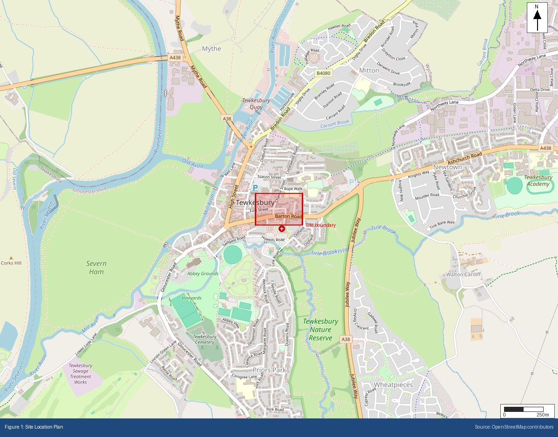

Appendix B: BGS Bedrock Geology Extract
BGS 1:625,000 bedrock geology at site location
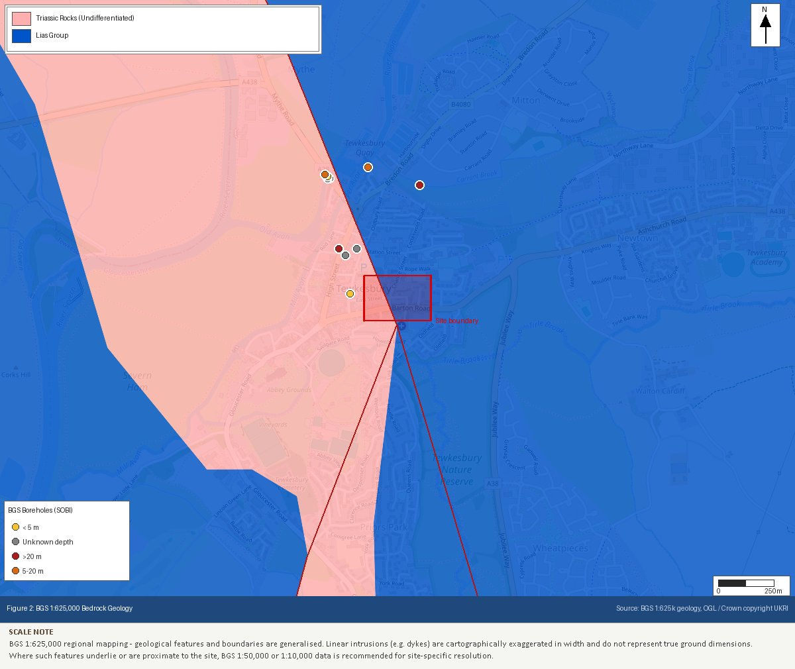

Appendix C: BGS Superficial Geology Extract
BGS 1:625,000 superficial deposits at site location
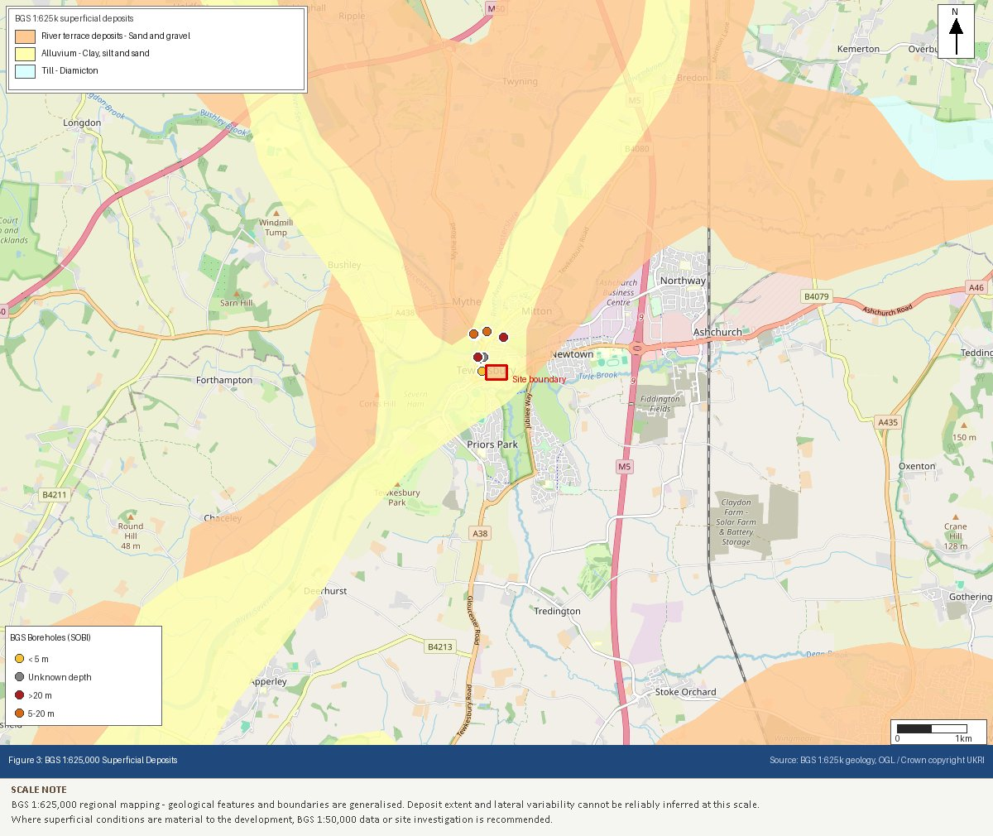

Appendix D: EA Flood Map for Planning Extract
Environment Agency flood zone classification
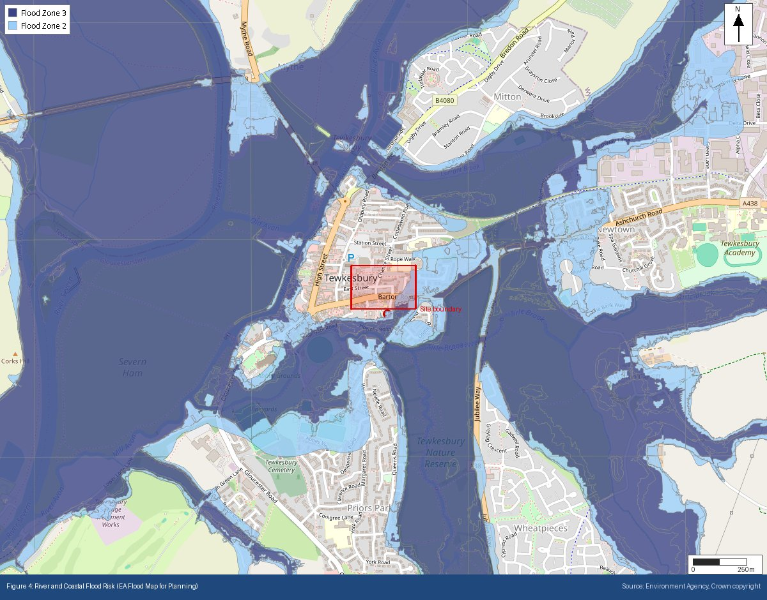

Appendix E: Heritage Designations (Historic England NHLE)
Listed buildings, scheduled monuments and conservation areas within 500m
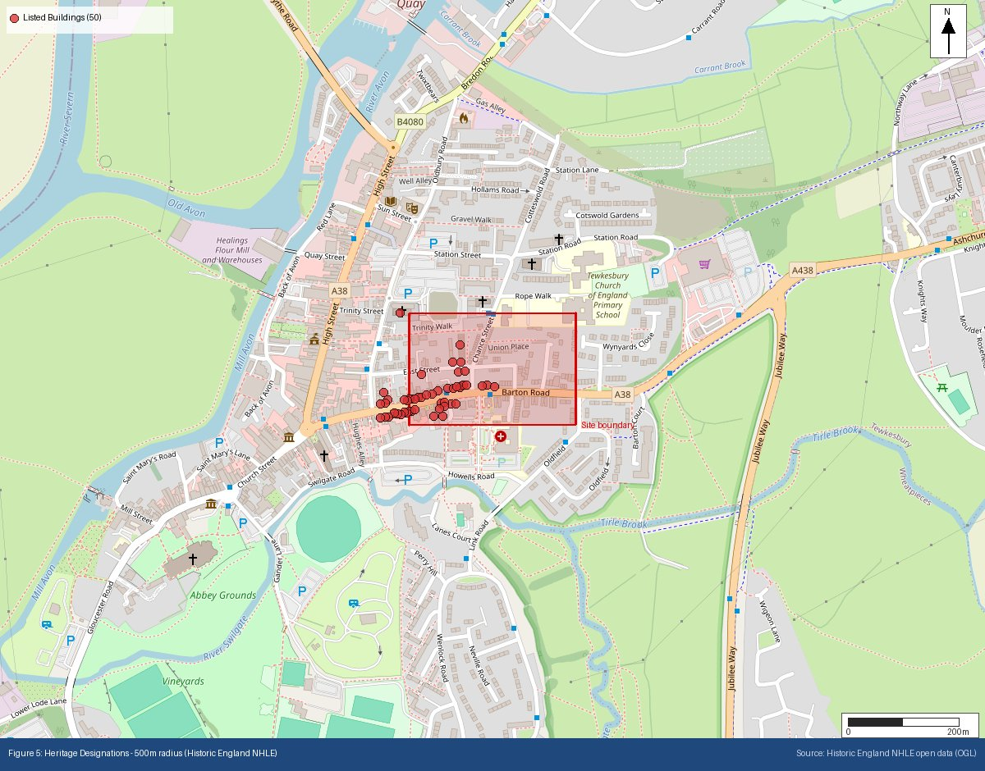

Appendix F: Ecological Designations (Natural England)
SSSI, SAC, SPA, Ramsar, AONB and National Park designations within search radii
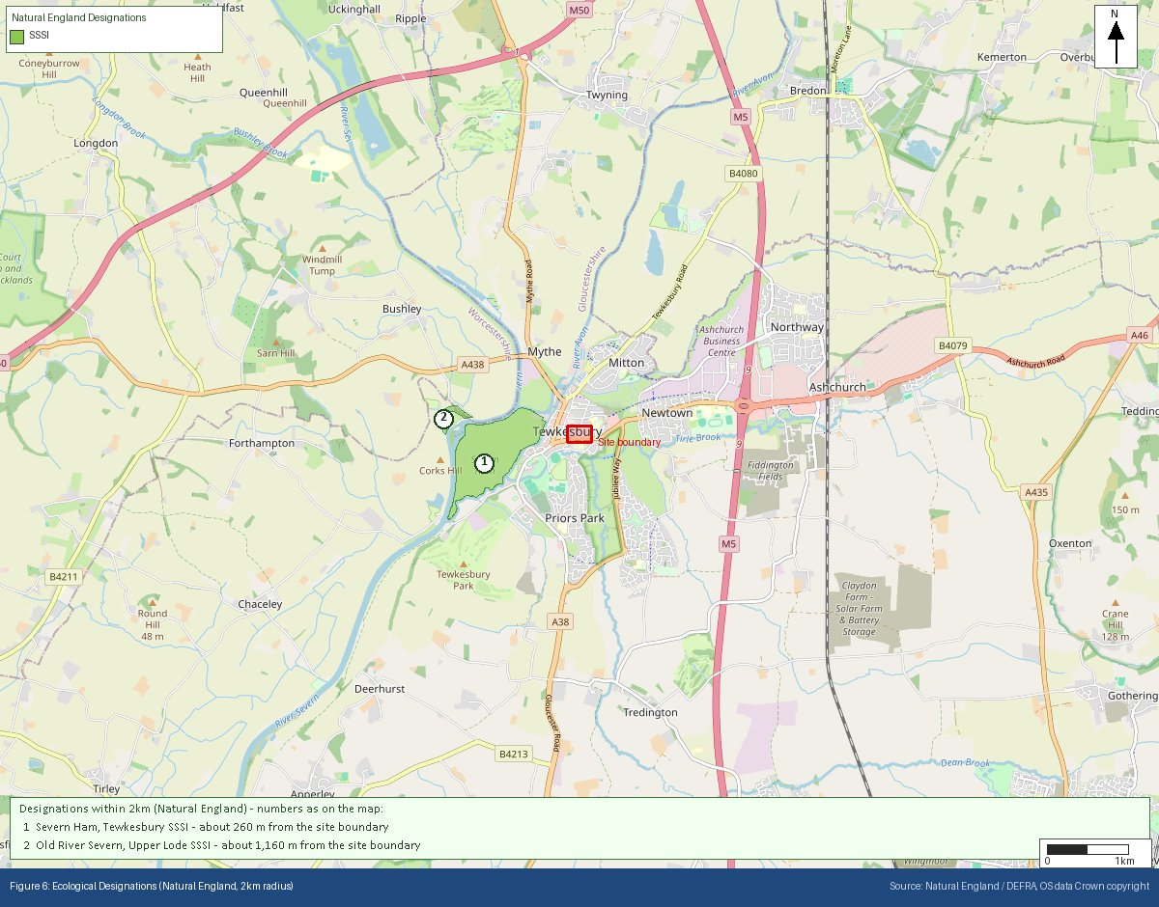

Appendix G: Mining Remediation Authority Output
MRA development risk and mine entries data
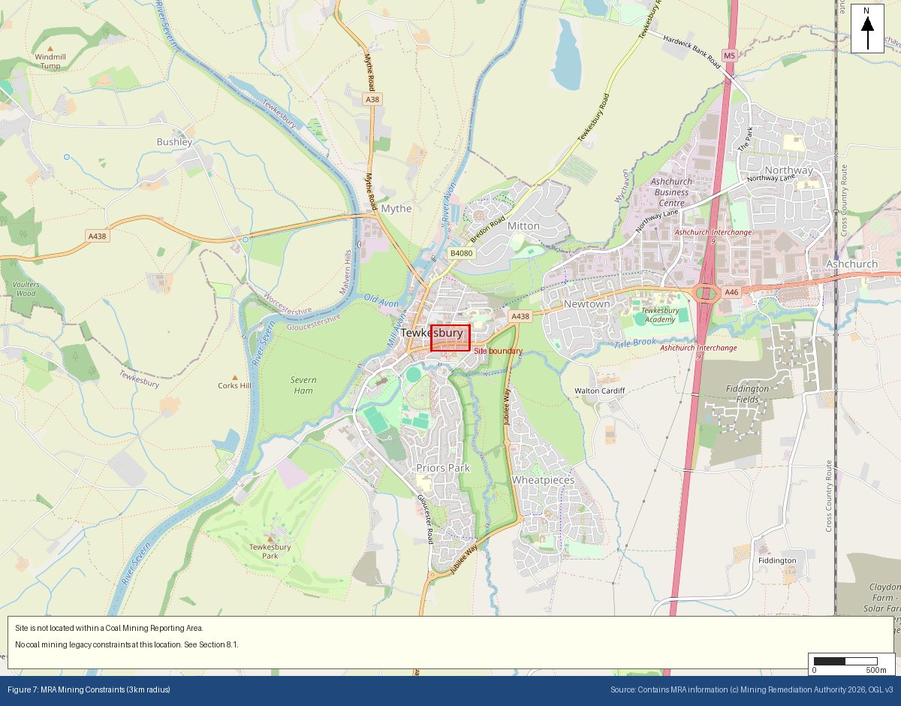

Appendix H: BGS/UKHSA Radon Potential Extract
Radon potential classification at site location
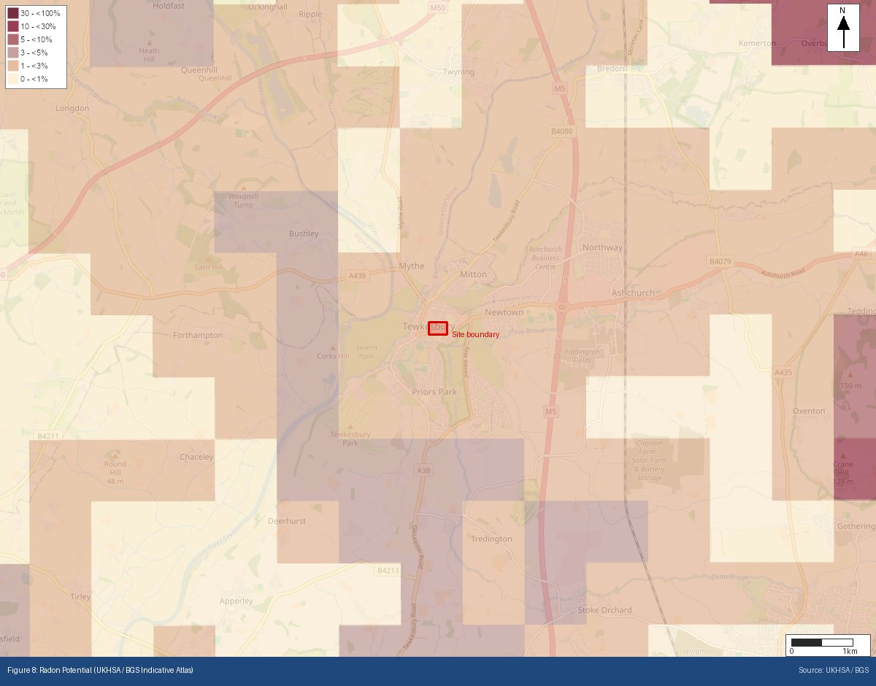
Appendix I: Historical OS Mapping (1885–1903)
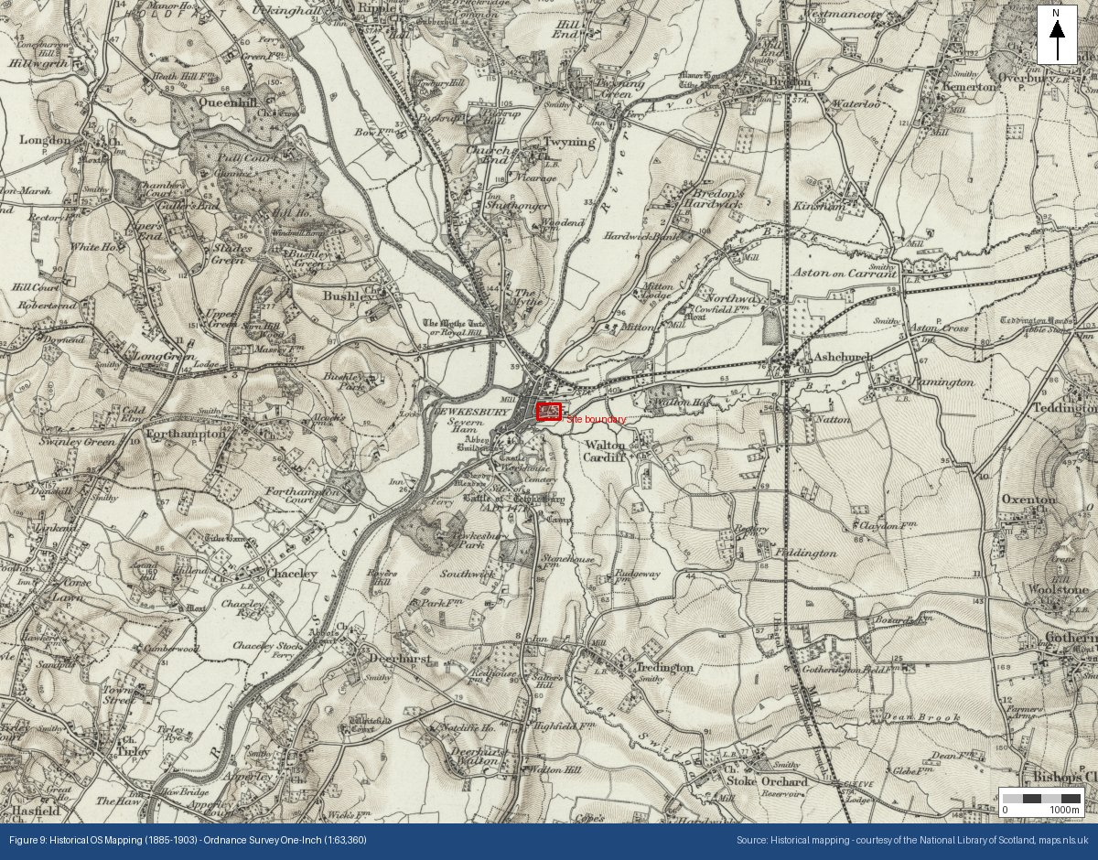

Appendix J: Historical OS Mapping (1888–1913)
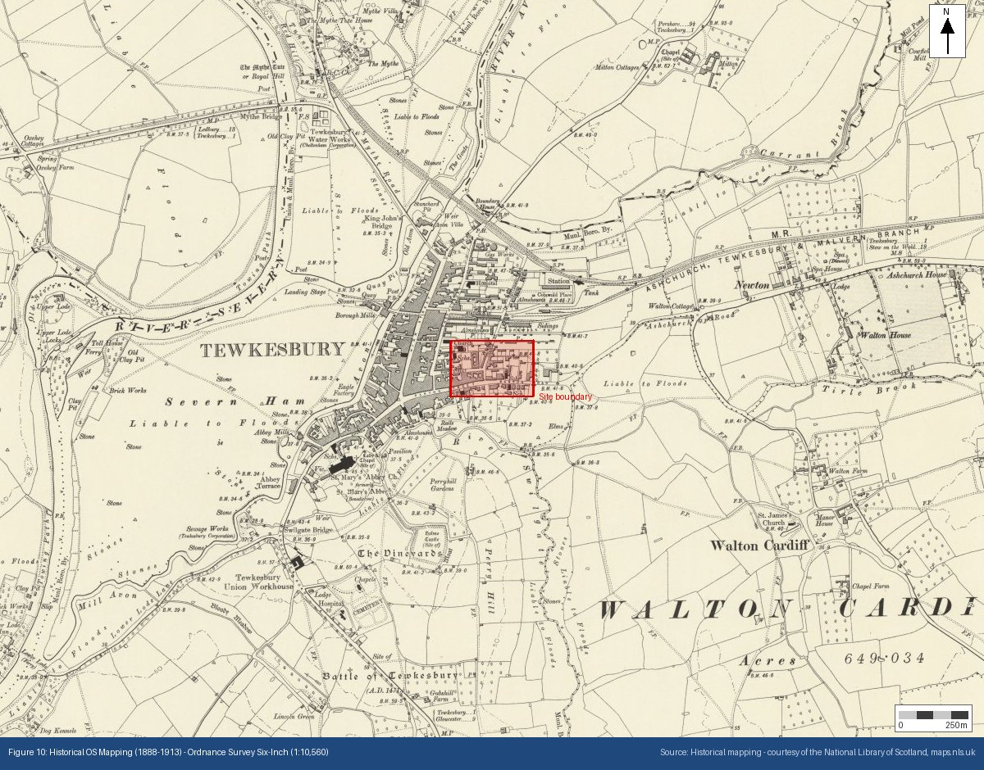

Appendix K: Historical OS Mapping (1919–1947)
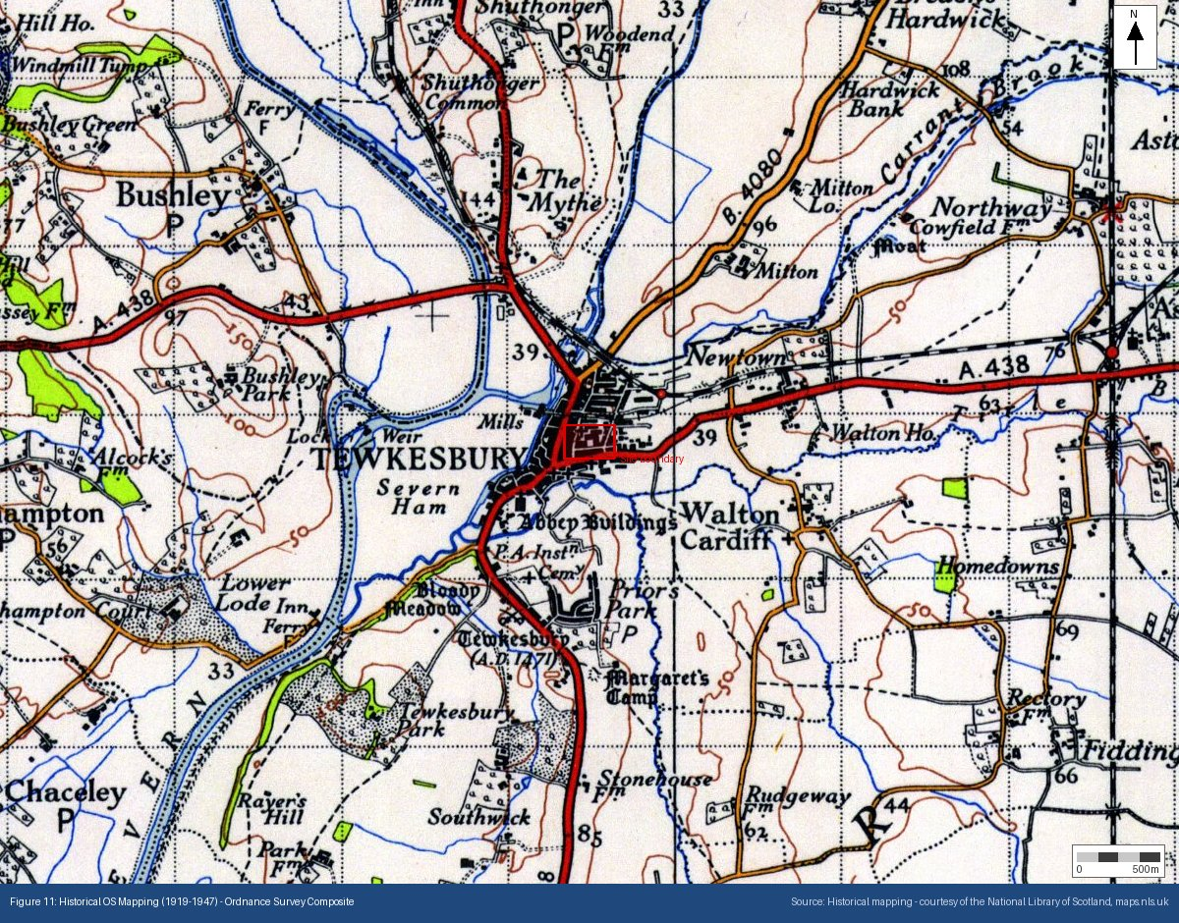

Appendix L: Surface Water Flood Risk (NAFRA2)
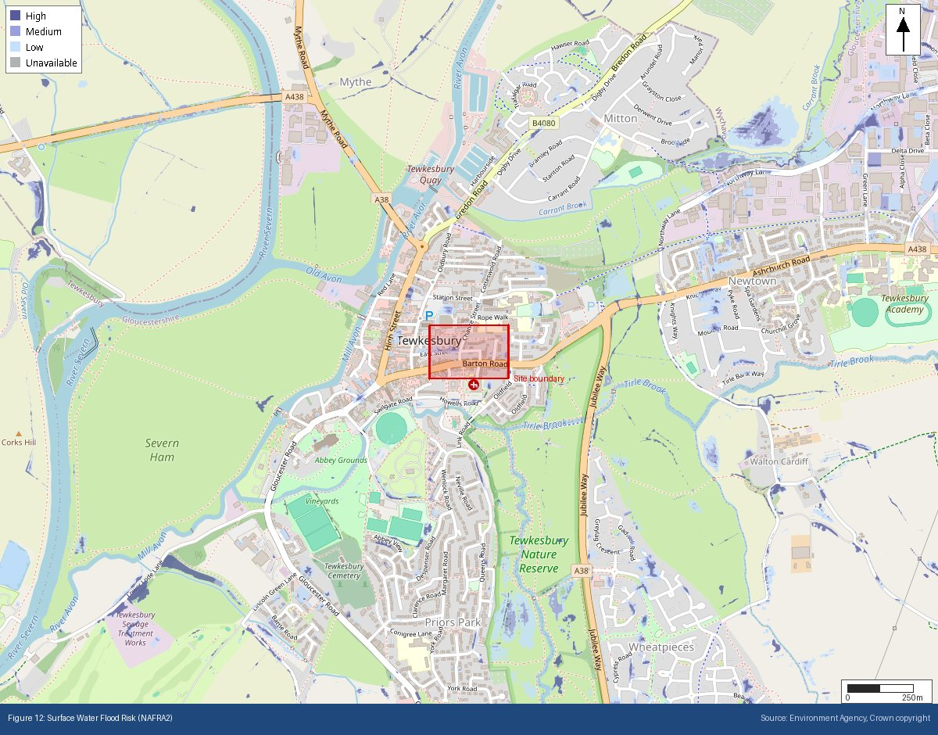
Appendix M: Source Protection Zones (Environment Agency)
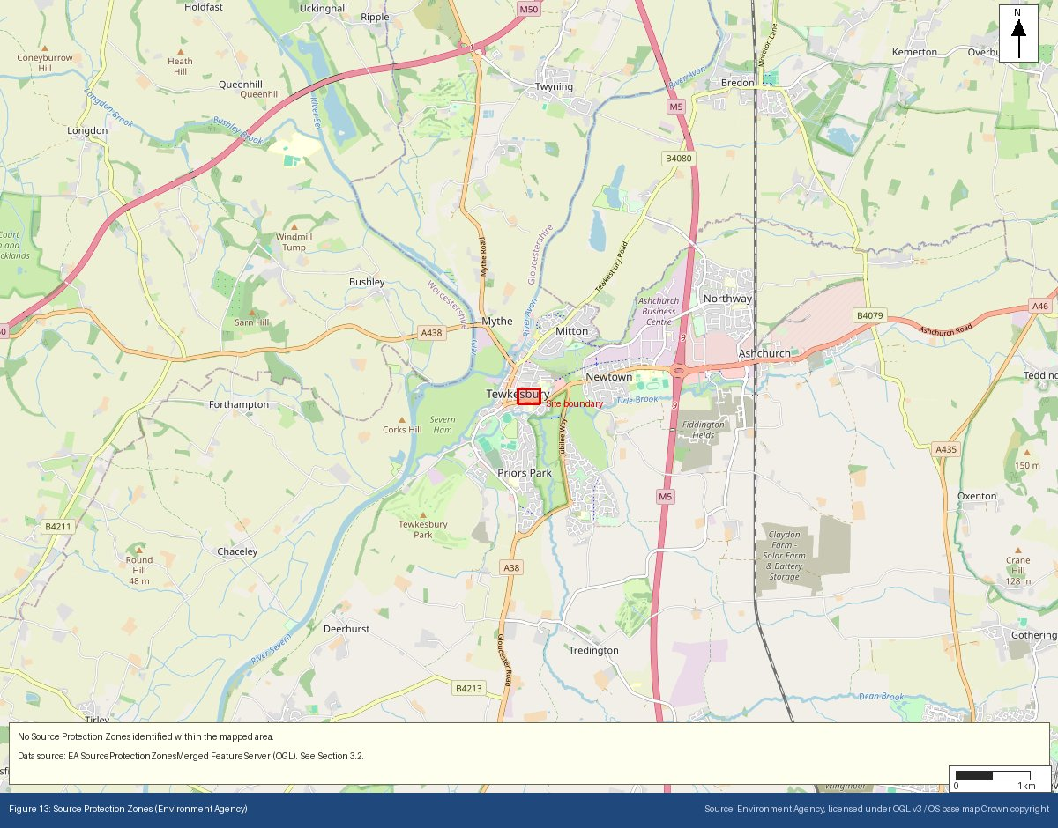
Appendix N: Site Topography — EA LiDAR Digital Terrain Model
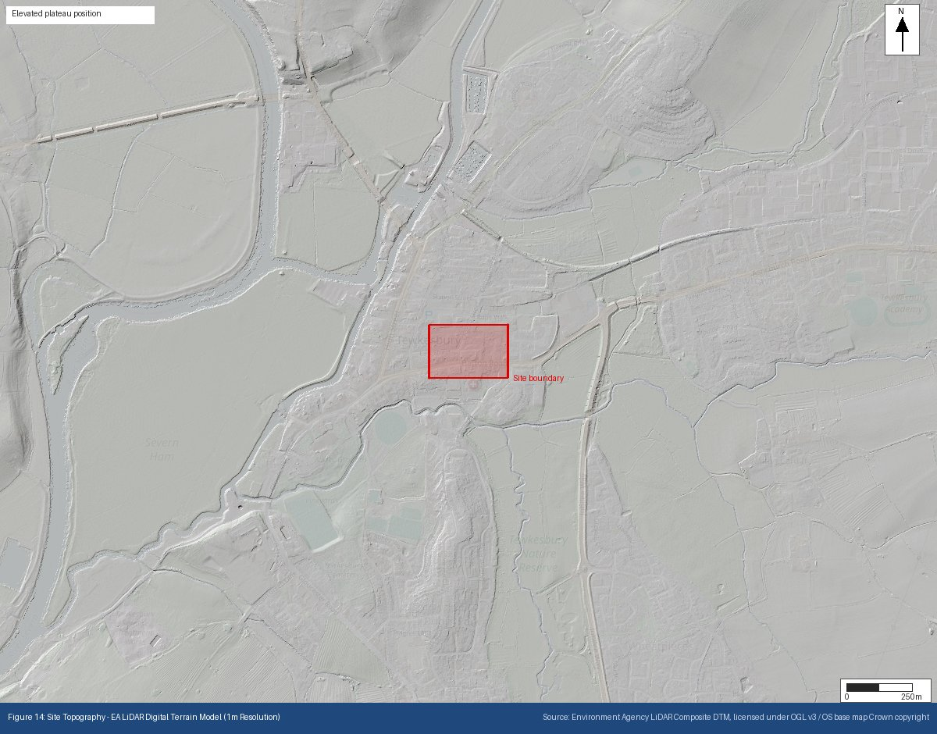
Appendix O: Permitted Regulated Facilities — EA Environmental Permitting Register
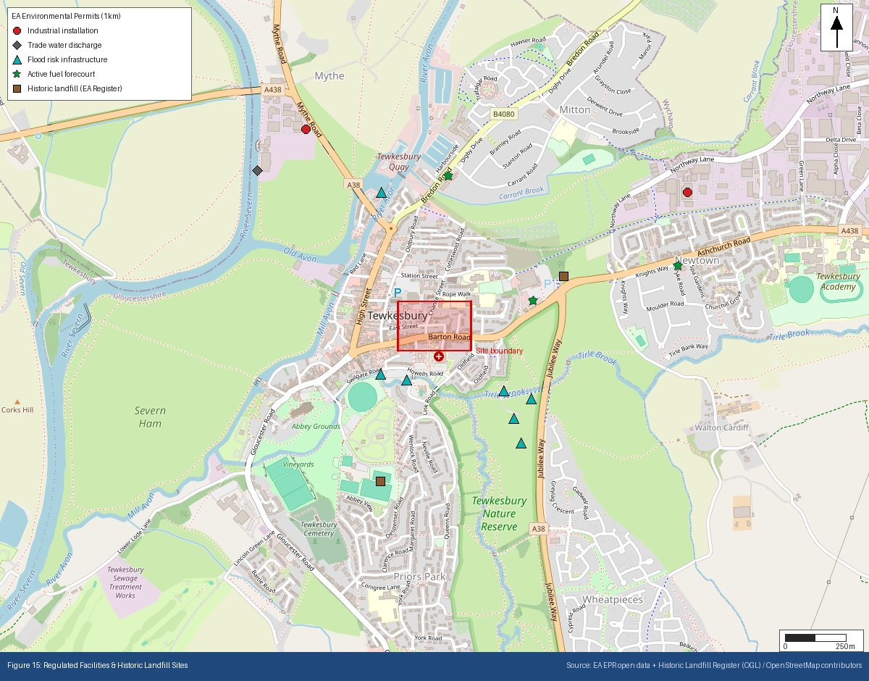
Appendix P: Historical & Current Map Features
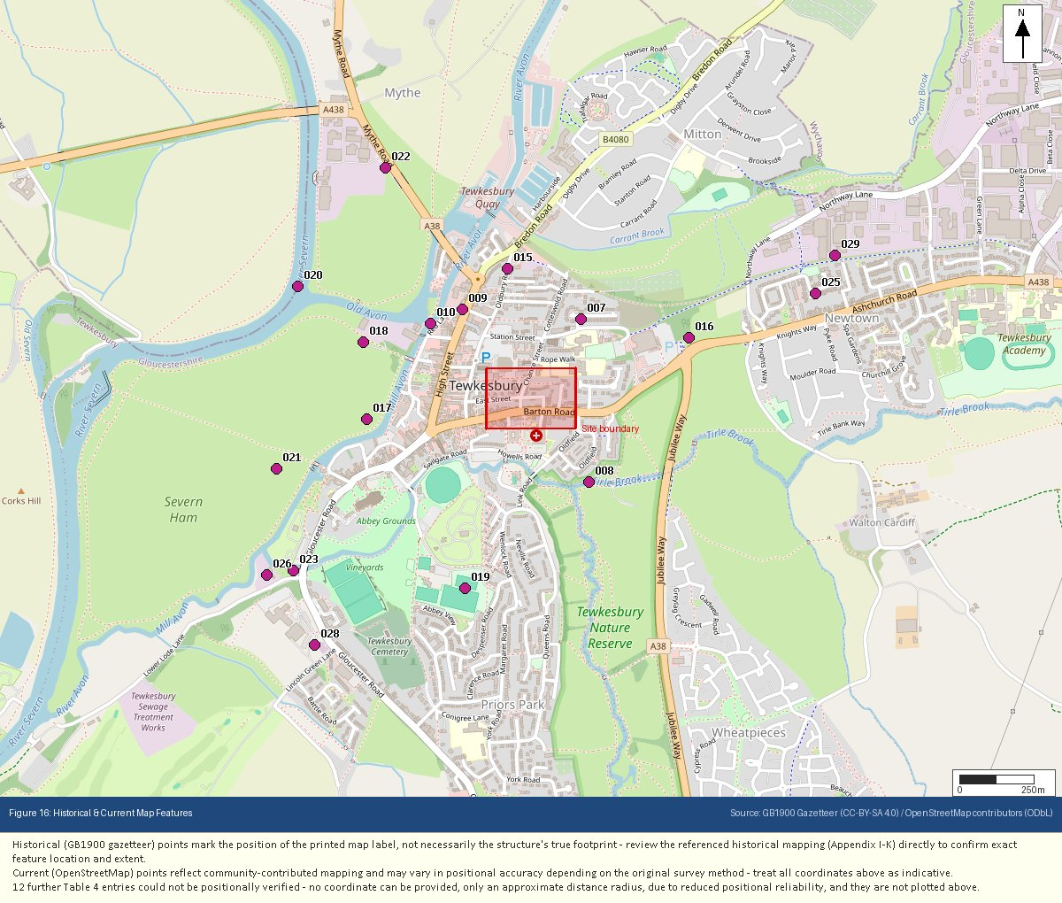
Appendix Q: Underground & Buried Structures
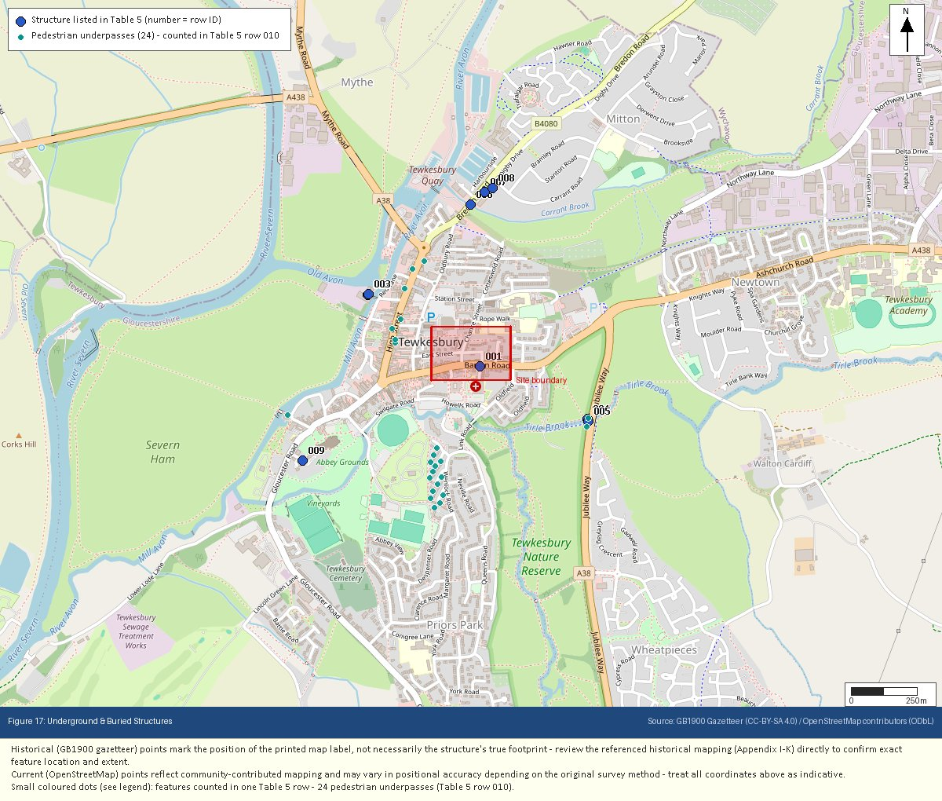
Appendix R: Flood Risk – Reference (Defended / Residual Risk)
